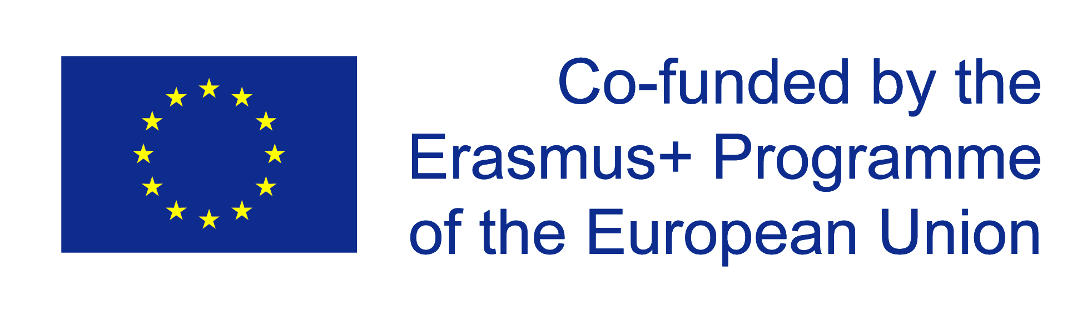
Erasmus Mundus APPLICATION FORM
for entry to EUROSUD in September 2021

Please complete this form then print, sign, scan and upload as a PDF document to your South European Studies Erasmus Mundus International Master IntM (EUROSUD) application (University of Glasgow online application system) along with all other supporting documentation
Apply Now

Personal and Contact Information

Title | Click here to enter text.
First name | Click here to enter text.
Family name | Click here to enter text.
Date of birth dd/mm/yyyy | Click here to enter a date.
Country of birth | Click here to enter text.
City/Town of birth | Click here to enter text.
Nationality** | Click here to enter text.
**A candidate with multiple nationalities must decide at the application stage under which ONE nationality he/she will apply.
Passport number | Click here to enter text.
Country of residence*** | Click here to enter text.
*** The Erasmus Mundus scholarship contribution to travel and installation costs takes into account ONLY the residence of the scholarship holder at the time of application (regardless of nationality). Please provide the address where you are living as at 14 January 2021
Address:
Street, Number | Click here to enter text.
City, State, Postal code | Click here to enter text.
Country | Click here to enter text.
Email | Click here to enter text.
Phone number | Click here to enter text.
Mobile number | Click here to enter text.
Do you consider yourself to have a disability? | Choose an item.

2. UNIVERSITY EDUCATION
University  (Name of university, city and country) | Academic Years  (from  – to) | Field of Study | Degree  (BA, BSc, MA, MSc, PhD, etc.) | Graduation Grade  (Indicate grade and scale, e.g. 7.34/10).*
* If you have not yet graduated, please state: a) your current GPA and b) the number of courses you still have to pass. This should be confirmed by an official document from your university.

3. LANGUAGE SKILLS
Level and Knowledge of South European Languages | Certificate  (with year issued) | Grade / Score

4. WORK / RESEARCH EXPERIENCE (if any)
Period  (from – to) | Organization | Capacity/Brief Job Description

5. PUBLICATIONS (if any)

To be eligible for an Erasmus Mundus Scholarship, you:
- | must not have previously received an Erasmus Mundus Master Course (Action 1) Scholarship
- | must not have applied to more than 3 Erasmus Mundus programmes in the same year
- | must complete this application form and return it, as instructed, no later than  14 January 2021 to be considered for an Erasmus Mundus Scholarship commencing September 2021
- | must have submitted ALL of the required supporting documents by 14 January 2021. If your offer status is 'holding for documents' then you will NOT be considered for a scholarship unless you submit the required documents by 14 January 2021. The only exception to this is final degree certificates where the applicant has not yet completed their bachelor degree at the time of application, and English language proficiency certificates.
- | must have addressed all the requirements described on the EUROSUD website.

6. Partner Country or Programme Country Applicant
If applying for a scholarship, you must apply as either a “Programme Country” applicant or a “Partner Country” applicant. A list of Programme and Partner countries is available at: https://www.gla.ac.uk/media/media_487586_en.pdf
An Erasmus+ Programme Country applicant must be;
- a national of a Programme Country
or
- a national of a Partner Country who has been resident or has carried out their main activity (studies, training or work) for more than a total of 12 months over the last five years in any Programme Country/Countries. The five-year period is calculated backwards from the submission deadline, i.e. 14 January 2021

All other scholarship applicants should apply as a Partner Country applicant.

6.1 Please indicate what type of applicant you are: Choose an item.

6.2 If your Erasmus Mundus scholarship application was unsuccessful, how interested would you be in joining the programme as a self-funding applicant? Choose an item.

Scholarship announcement and self-funding applicants

The results of the Erasmus Mundus scholarship competition will be announced on
2 April 2021. Unsuccessful scholarship applicants, who meet the entry requirements for the programme, will have the option to secure their place as self-funding students by
30 June 2021. Self-funding applications will remain open only until the programme reaches full capacity.

7. Personal Statement

Please be as precise as you can when writing your supporting personal statement. Do not repeat yourself and do not exceed the total word limit for the personal statement (600 words). You must address the following questions in your personal statement:

- What is your main motivation for applying to the EUROSUD postgraduate degree?
- Why is your selected pathway the appropriate choice for you?
- How will your educational background and/or work experience inform your engagement with this programme?
- How will this programme support your future career development?
TOP TIPS: An excellent personal statement will
- give strong reasons as to why you want to study on the EUROSUD programme
- state why you wish to study on the particular pathway/at the particular institutions you have selected.
- mention relevant study - including projects, dissertations, essays - or work experience
- provide evidence of your key skills including, research, critical thinking, communication, organisation, planning and time-management and show how you can contribute to the programme’s academic community
- draw on your other experiences: for example, are you a member of a society, have you written any papers or won any awards, scholarships or prizes?
- highlight your career aspirations and show how the course will help you achieve them.
- AND MOST IMPORTANTLY - show what makes you stand out as a candidate

Note: Samples of academic work will not be considered and should not be submitted.

Please complete your Personal Statement using 600 words maximum
Click here to enter text.

8. Pathways Choices

All students on the programme will spend the first mobility period Semester (Year 1) at the University of Glasgow. The second mobility period will take place during the Second Semester (Year 1). The third mobility period will take place throughout Year 2 (Semesters 3 and 4). Please note that students may not spend Year 2 at the institution where they studied in Semester 2. One of the criteria for assessing students‘ applications will be suitability for the particular pathway. Please make sure you have chosen the pathway you really want as permission to switch to a different pathway will rarely be granted.

Please note that in order to study at Aix-Marseille you must be proficient in French language to minimum level B2 as most of the courses are taught in French.
Please note in Madrid some courses are taught in Spanish. However, it is still possible to follow a curriculum taught entirely in English in the Madrid pathway.

8.1 Semester 2 (Year 1): Choose an item.

8.2 Semesters 3 and 4 (Year 2): Choose an item.

If you have chosen Aix-Marseille, have you submitted a certificate of proficiency in the French language (minimum level acceptable B2)

If your pathway of choice is not available, would you be interested in studying on a different pathway? YES / NO

9. I hereby declare that:
- | I have indicated correctly whether I am applying as a Programme Country, Partner Country or self-funding applicant.
- | I have addressed all the requirements described on the EUROSUD website
- | I have completed sections 1-5 above
 | Furthermore, if applying for an Erasmus Mundus scholarship, I confirm that:
- | I have not previously received an Erasmus Mundus Master Course (Action 1) Scholarship
- | I have not applied to more than 3 Erasmus Mundus programmes in this year

(please write your signature in the box and do not type here)

Signature................................................................................ Date: ……………………………………….

Note: The one exemption to this rule is academic references. In addition to accepting references uploaded to your online application, the EUROSUD Consortium will also accept references on officially headed institutional paper which are sent directly to the Postgraduate Admissions Team (pgadmissions@glasgow.ac.uk) as scanned email attachments. All references must be received by the University of Glasgow by the application deadline. For scholarship applications this is 14 January 2021.

