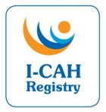
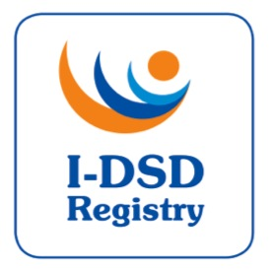

11th International-DSD/CAH Registry Steering Committee Meeting

Tuesday 31st October 2017, 13:00-14:30 GMT

Webex conference

Agenda

- Welcome

- Apologies

- Approval of Minutes of 10th SC Minutes

- Proposed plan for membership (FA) Appendix 1

- Collaboration with Diurnal (FA)

- I-DSD/CAH workshop, Athens 2018 (FA)

- I-DSD/CAH Symposium, Sao Paulo 2019 (BM)

- European Registries for Rare Endocrine Conditions (EuRRECa) (JB) Appendix 2

- AOB. Ideas for further funding (All)

Invited Participants:

Name | Role | Affiliation
Anna Nordenstrom | Chair | Karolinska Institute
Faisal Ahmed | Project Lead | University of Glasgow
Olaf Hiort | Member | University of Lübeck
Rodolfo Rey | Member | Centro de Investigaciones Endocrinológicas, Buenos Aires | apols
Anu Bashamboo | Member | Institut Pasteur | apols
Stephanie Bernstein | Member | Universität Göttingen
Amy Wisniewski | Member | University of Oklahoma
Richard Ross | Member | University of Sheffield
Jillian Bryce | Project Manager | University of Glasgow
Martina Rodie | Co-Investigator | University of Glasgow
Sam Okure | Database developer | University of Glasgow
Hannah van Hove | Admin Support (Minutes) | University of Glasgow | apols

These are the corresponding times for your meeting:
Location | Local Time | Time Zone | UTC Offset
Glasgow (United Kingdom - Scotland) | Tuesday, 31 October 2017, 13:00:00 | GMT | UTC
Paris (France - Île-de-France) | Tuesday, 31 October 2017, 14:00:00 | CET | UTC+1 hour
Berlin (Germany - Berlin) | Tuesday, 31 October 2017, 14:00:00 | CET | UTC+1 hour
Stockholm (Sweden) | Tuesday, 31 October 2017, 14:00:00 | CET | UTC+1 hour
São Paulo (Brazil - São Paulo) | Tuesday, 31 October 2017, 11:00:00 | BRST | UTC-2 hours
Buenos Aires (Argentina) | Tuesday, 31 October 2017, 10:00:00 | ART | UTC-3 hours
Dallas (USA - Texas) | Tuesday, 31 October 2017, 08:00:00 | CDT | UTC-5 hours
Corresponding UTC (GMT) | Tuesday, 31 October 2017, 13:00:00

