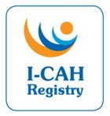
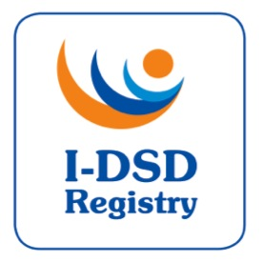

9th International-DSD/CAH Registry Steering Committee Meeting

Friday 30th June 2017, 08:00-09:00am

Meeting Room 93, Rigshospitalet, Copenhagen

Agenda

 | Item |  | Papers (to be precirculated)
1. | Welcome | Chair (AN)
2. | Approval of Minutes of 8th SC | Chair (AN) | Minutes
3. | Action List – update | FA | Action List  (see Minutes)
4. | Current Tasks  - Ongoing revisions  - Modules  - PRO-CAH  - Phenotyping (DSDnet)  - Portuguese Registry  - Users  - Patient Access  - Centre Details  - Metrics  - Research Activities  - I-DSD/CAH Research Support fund | FA  FA  JB | Patient view with  Centre details  Metrics  List of Studies
5. | EndoERN & DSDnet | OH
6. | Future Directions  - Governance,  - Sustainability  - Charitable status | FA
7. | I-DSD Symposium 2019 | FA
8. | AOB - Staffing (Sam, Mariam)
 | Date for next meeting

Invited Participants:

Name | Role | Affiliation
Anna Nordenstrom | Chair | Karolinska Institute
Faisal Ahmed | Project Lead | University of Glasgow
Olaf Hiort | Member | University of Lübeck
Rodolfo Rey | Member | Centro de Investigaciones Endocrinológicas, Buenos Aires
Anu Bashamboo | Member | Institut Pasteur
Stephanie Bernstein | Member | Universität Göttingen
Amy Wisniewski | Member | University of Oklahoma
Richard Ross | Member | University of Sheffield
Jillian Bryce | Project Manager | University of Glasgow
Martina Rodie | Co-Investigator | University of Glasgow
Sam Okure | Database developer | University of Glasgow
Hannah van Hove | Admin Support (Minutes) | University of Glasgow

Map showing location of Meeting Room 93

