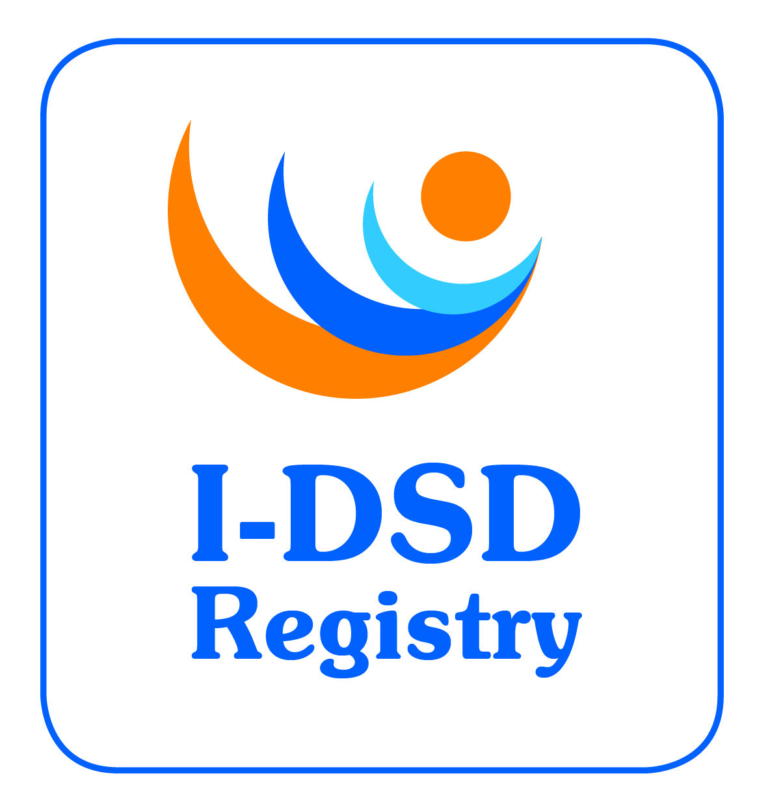
6th International-DSD Registry Steering Committee Meeting

Wednesday 27th January 2016, 12:00 – 14:00 (GMT)

Teleconference

Minutes

Attending: Faisal Ahmed, Anu Bashamboo, Stephanie Bernstein, Jillian Bryce, Olaf Hiort, Jipu Jiang, Rodolfo Rey, Martina Rodie, Richard Ross, Alexander Springer, Amy Wisniewski, John Watt
Apologies: John Achermann, Leendert Looijenga, Miriam Muscarella, Richard Sinnott

- Welcome
The chair welcomed everyone to the 6th Steering Committee Meeting.
- Approval of Minutes of 5th SC Meeting
The minutes of the 5th Steering Committee Meeting were approved.
- Action List - Update
Most action points are completed. Areas that are still developing include:
- Bulk upload of consented patients in DSDlife [ACTION: JB to chase BK]
- Develop tool to identify what studies a patient is in [ACTION: JJ/PMG]
- Pathology module and workshop [ACTION: LL]
- Patient/Parent area requires input from parents [ACTION: CP]
- Revisions to genetics module (JA reported by e-mail attached) [ACTION: JJ/PMG]
- Introduce fees for using the registry (to discuss here)
- DSDnet
Remit - to define expert centres for DSD in participating countries (delivery & acceptance of care) and develop an ERN for DSD. Advantages are Cross-border healthcare and Expert centres with added value. 8000 rare conditions to be grouped into 21 groups including bone, urogenital and endocrine – the latter will accommodate DSD. Endocrine includes HH, CAH and DSD. A WG meeting is planned for 1-2/3/16 in Lubeck to discuss application for ERN. DSDnet/I-DSD/dsdLife/EuroDSD – ready for ERN. Much information on centres was gathered from the specialists survey (expert clinical care) plus a follow-up e-mail asking about additional conditions treated. ERN requires official approval nationally.
[ACTION: OH/DSDnet to prepare ERN application]
- Current Tasks
  - Ongoing revisions
    - Modules
      - CAH module
Develop CAH module to support I-CAH research studies. RR and fellows are preparing abstract for ECE (May 16, Munich). Adverse Events and Salt Therapy studies require longitudinal data produced prospectively.
[ACTION: SC to look at module]
The module has had a few teething problems, which are being resolved, but anyone can fill it relatively quickly in the clinic (~2 mins not including test results).

      - Surgery module.
There may be a place to include a surgery module in the future but I-DSD would need input in the future. Some fields have been developed in dsdlife for collecting these data. OH highlighted that surgical fields would need to match with surgical operating codes which are agreed internationally.
      - Phenotyping module.
I-DSD is awaiting guidance from DSDnet.
[ACTION: JB to ask WG1 for update].
      - Pathology module
Being developed by Leendert Looijenga along with a DSDnet workshop.
[ACTION: LL]

    - Users
- View My Records – is a new feature that displays all records uploaded by that user.
- Centre details – to be captured at user registration and displayed in the patient view to provide personalised information about their centre.
[ACTION: SC to provide guidance on useful information to capture and display].
[ACTION: JB to approach Centre Leads for the information]
- Participant Access – is now operational and a few patients have been granted access to their core data.
[ACTION: PMG Demonstrate at ESPE Sept 2016, Paris]

    - Bulk Upload
Only the core data set can be uploaded in bulk. Uploaded data must be an exact match to options in the registry fields. To upload more than the core would take more time to develop..
[ACTION: SC invited to test the bulk upload feature].
[ACTION: JB to include in next newsletter].

    - Fees for access
For long term sustainability of the registry, FA raised that fees to access data will be introduced. Clinicians will have access to their own data for free but charges will apply to other records for clinical purposes. Searches for research studies will also incur a fee and the info will be supplied by the PMG. To encourage preliminary unfunded research, I-DSD will put a call out for competitive applications that will support the I-DSD costs. Fees will be calculate based on time required for development (JJ), data extraction and analysis (JB).
[ACTION: JB to create price model and circulate to SC for feedback].

  - Ethics Update
No revisions have been done to SOP since the last meeting. A repository of patient information sheets in multiple languages is building on the website.

  - Metrics
Over 1900 cases on the registry in November 2015. (See appendix 1 for details). Since I-CAH was launched a quarter of all cases in the registry are CAH. Looking at country participation, Turkey is very active. A median year of birth of 2000 is suitable considering adult outcome studies.

  - Research Activities
List of current and recent research studies was circulated to the SC and is available on the website (see appendix 2).
Studies are monitored at 6 month intervals (progress reports)
PAIS Outcome study - Oral communication at ENDO, manuscript submitted.

  - I-DSD Travel Grants
These grants are available to allow attendance at a conference to present research conducted using the I-DSD registry data or for an individual to travel to another group or facility to conduct research on the registry or develop an aspect of the registry (e.g. all of the activity mentioned above). It was suggested that these funds could also be used as research awards to support studies (recycling of fees).
- I-CAH
The users who are entering data into the CAH module met at ESPE 2015 and plan to meet at ESE (28-29/5/16, Munich) and ESPE (10-12 September, Paris)

- I-DSD symposium
- 2015 Feedback - on the Ghent symposium was mostly positive (see appendix 3).
- 2017 location - Istanbul was proposed as it has several active users and will attract greater international participation. Other options include: Bologna, Rotterdam, Pisa, Stockholm, Bern, Cairo – all with large number of cases in the registry. Bologna is hosting the DSDnet Training School this year. It was agreed that Istanbul is Plan A and Glasgow is Plan B as it would be easier to do this at short notice.
- Invited speakers/theme suggestions - A programme should be decided by June 2016 to give invited speakers a year’s notice. The structure would be similar to that in Ghent.
- [ACTION JB – to contact Feyza Darendelliler]
- [ACTION SC to send comments and suggest speakers/themes].
- [ACTION AN (Chair) to take suggestions from SC by end of March and develop programme].
- [ACTION JB to set up TC with a smaller group to discuss programme]

- Term of Office
New chair – Anna Nordenstrom is the new chair of I-DSD SC. It was agreed that the ESPE DSD WG chair should automatically chair I-DSD and will also become the chair of the POC for the biennial I-DSD meeting.
New members - Membership is 2-3 years. Registry users are invited but also those who express an interest.
[ACTION JB to provide list of clinical and research users to SC]
MRC have granted a no cost extension to the I-DSD project until 4/10/17. Extend membership terms/replace with new members until then.
- AOB
Work will carry on beyond the end of MRC funding. The I-DSD registry server and its management will become incorporated into the University of Glasgow College of Medicine, Veterinary & Life Sciences (MVLS) IT department.

Date for next meeting tbc
ACTION LIST
WHO | ACTIONS | DUE
ALL | SC to continue exploring new research ideas suitable for Registry | ongoing
JB | Contact Birgit to initiate bulk upload of consented patients in DSDlife | Feb 16
JB | Obtain update on phenotyping module from DSDnet WG1 | Feb 16
JB | Contact Feyza Darendeliler about I-DSD 2017 | Feb 16
SC | Look at CAH visits module | Feb 16
SC | Test the bulk upload feature | March 16
JB | Include Bulk Upload item in next newsletter | March
CP | Obtain input from parents for patient/parent area | March 16
SC | Provide guidance on useful centre information to capture and display in patient view | March 16
JB | Approach Centre Leads for the centre information | March 16
JB | Create price model for using the registry and circulate to SC for feedback | March 16
SC | Send comments about I-DSD 2017 and suggest speakers/themes | March 16
JJ | Develop tool to identify what studies a patient is entered into | April 16
JJ | Links to informational tools in whitespace of patient access record | April 16
JA | Revise genetic module to include genetic tests performed and where data is stored | April 16
JB | Provide SC with a list of clinical and research users to identify new members | April 16
LL | Develop requirements for Pathology module and workshop | <May 16
AN | Take suggestions and develop I-DSD 2017 programme | May/June 16
JB | Set up TC with smaller group to discuss I-DSD 2017 programme | June 16
PMG | Demonstrate functioning Participant access at ESPE Sept 2016, Paris | Sept 16

