Modelling & Experiments in Drug Delivery Systems (MEDDS)
University of Glasgow, Scotland
3rd-5th September 2018
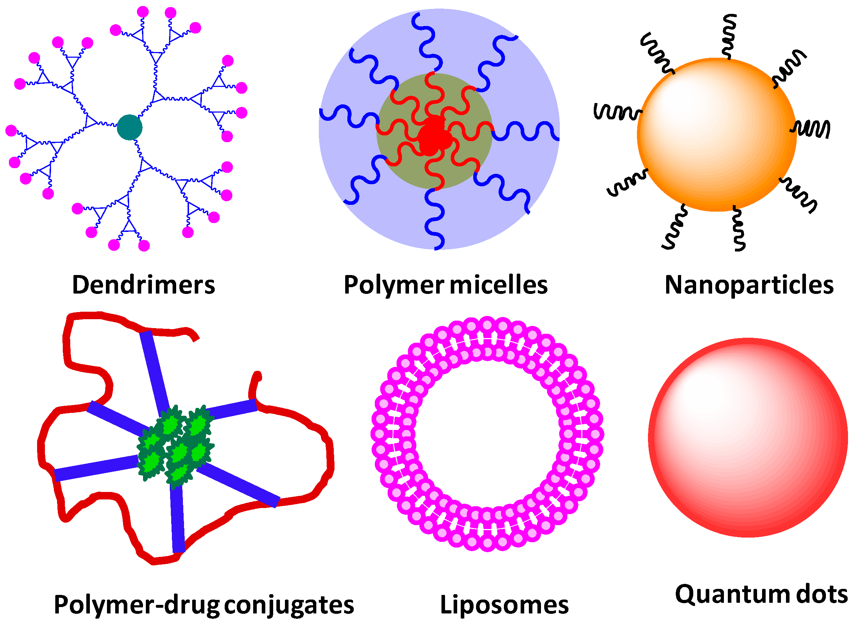
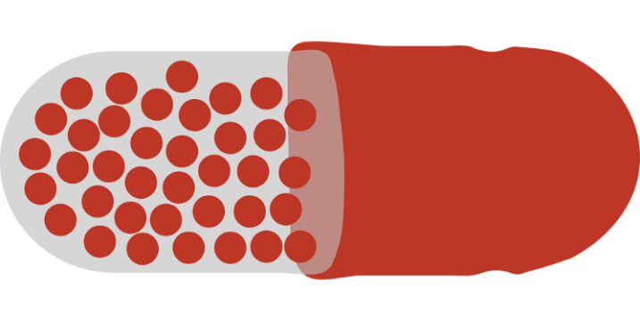
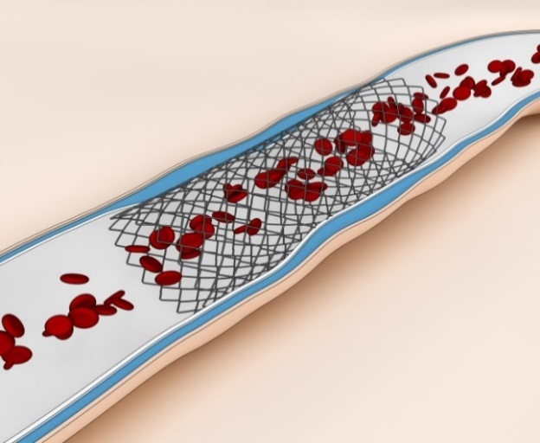
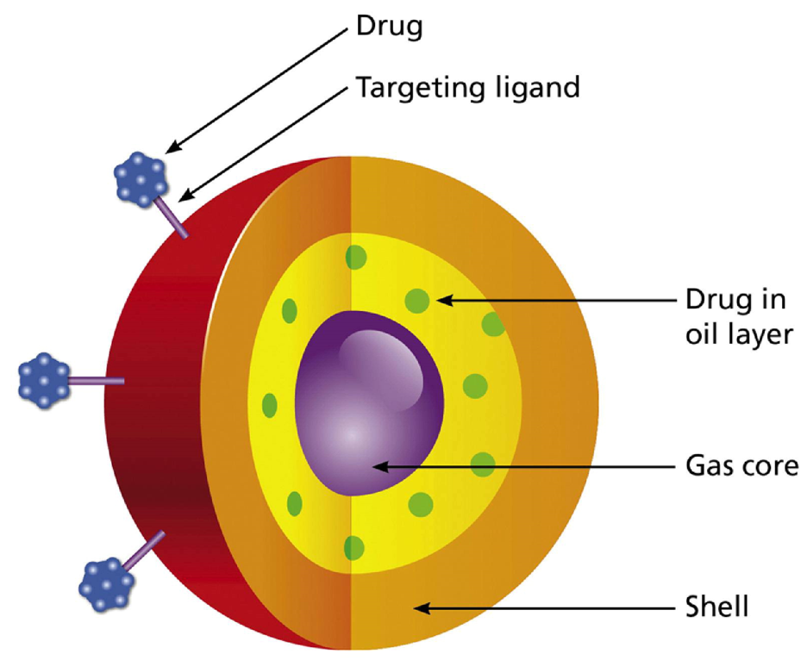
https://www.gla.ac.uk/research/az/cmals/newsevents/meddsworkshop/
Who Should Attend?
- Academics working on drug delivery from any discipline: e.g. mathematicians, chemists, biologists, engineers, …
- Clinicians
- Industrialists
Key Dates
- 15 April 2018: Abstract Submission Deadline
- 1 May 2018: Notification of Acceptance
- 17 August 2018: Registration closes

Modelling & Experiments in Drug Delivery Systems (MEDDS)
Mathematical modelling is playing an increasingly important role in the field of medicine through the use of models and simulations. These represent a useful tool to complement theoretical and experimental work and have the potential to inform personalized approaches for treatment.
Controlled drug delivery systems have become common in the clinic. These systems combine a platform or carrier with a drug in such a way that the drug is efficiently released to a target tissue or organ, while maintaining the drug concentration within a therapeutic window. Whilst many such systems have achieved successful results clinically, there remains a number of scientific and technological challenges and an opportunity for further fine-tuning and optimization. Addressing these challenges requires a multi-disciplinary approach.
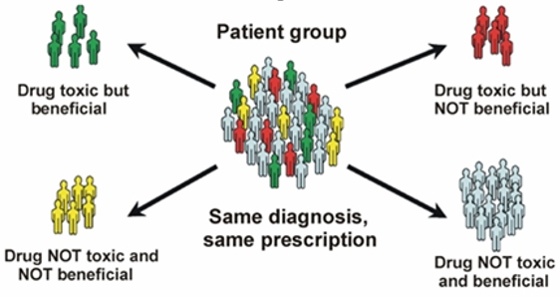
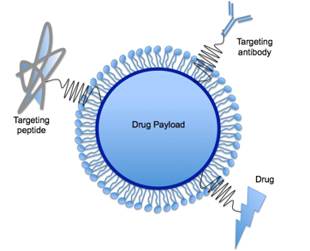
This 3 day workshop will bring together theoretical and experimental researchers, industrialists and clinicians working broadly in the area of drug delivery, so that the problems that persist may be identified from an ‘end-user’ point of view, new challenges laid down and successfully tackled.
Scope
The scope of the workshop includes (but is not limited to):
- Design, testing and optimisation of drug delivery systems and drug delivery strategies
- Identification of drug release mechanisms
- Controlled release formulations
- Biomaterials, smart polymers and hydrogels
- Clinical and industrial challenges
- Personalisation and patient-specific modelling
- Nanoparticles, microspheres, liposomes and quantum dots
- Antibody therapeutics
- Pharmacokinetics/Pharmacodynamics (PK/PD)
Mathematical, computational and experimental approaches are all within scope.
This event will build on the highly successful first edition of MEDDS (Coimbra, 2016), as well as recent symposia at ECMI2014 (Mathematical Modelling of Drug Delivery) and ECMI2016 (Applied Mathematics in Stent Development), with an added emphasis on industrial and clinical participation. To this end, the workshop will feature an evening problem solving session where interested delegates can tackle a problem brought by industry.
Keynote speakers:
David Saylor (FDA, USA), Paolo Netti (University of Naples Federico II, Italy), Keith Oldroyd (Golden Jubilee National Hospital, UK)
For full details please visit the workshop website: https://www.gla.ac.uk/research/az/cmals/newsevents/meddsworkshop/
This initiative is supported by COST Action TD1409, Mathematics for Industry Network (MI-NET)

