# The I-DSD Registry

**14 years and younger**

Your doctors and the I-DSD Registry are looking for your help. This leaflet will explain what we would like to do.

If you have any further questions after reading this leaflet, you can ask your parents, or ask your doctor who will be happy to explain further.

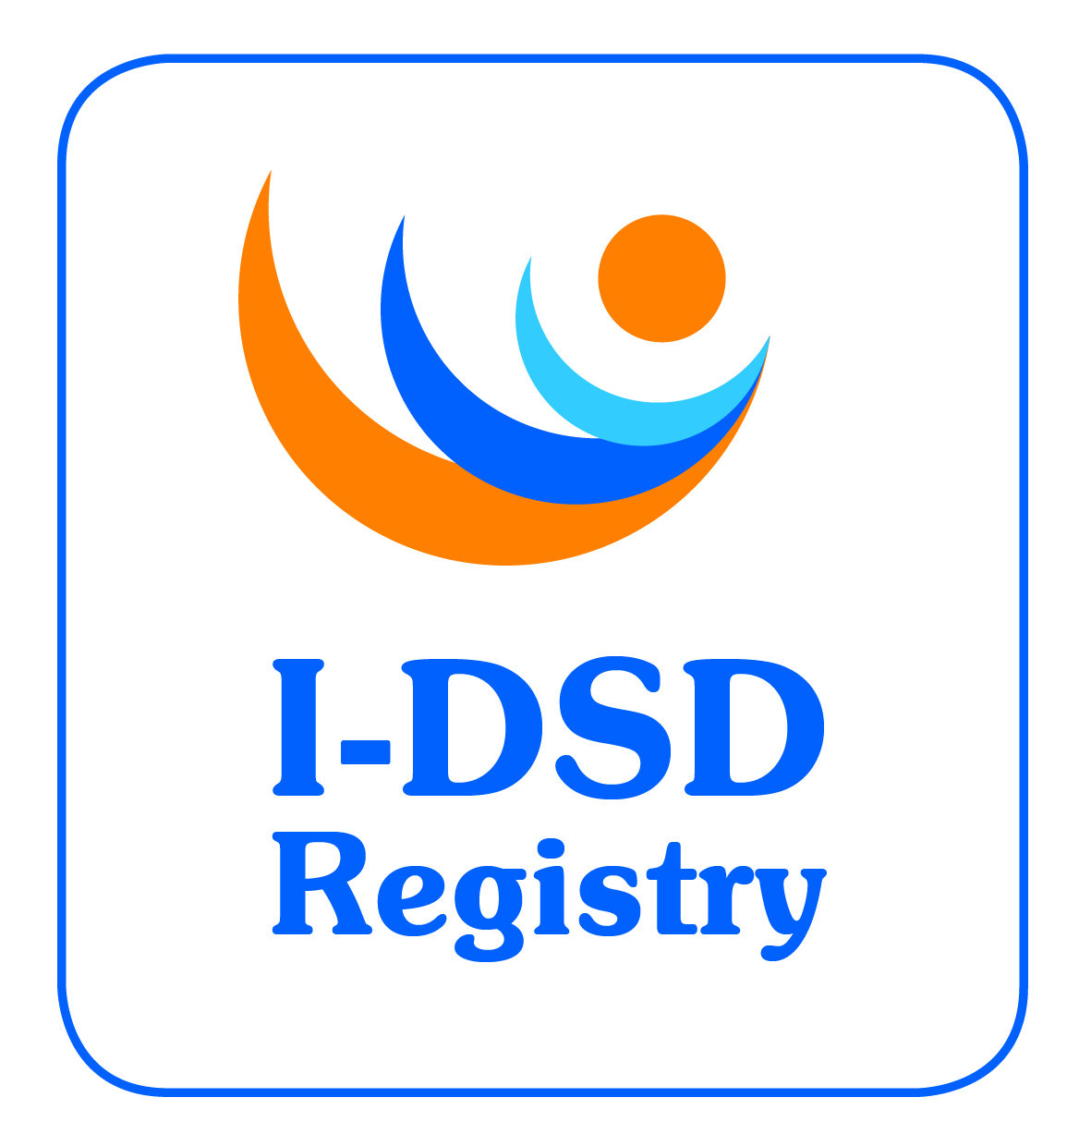

- The Registry is a place, like a database, where we keep information (data, medical records).

- This information allows us – doctors and research scientists – to learn more about how the body grows and develops.

- By studying this information and by talking to other doctors and scientists from across the world we get better at looking after children who have similar conditions like you.

- That is why we want to ask whether you will let us put your medical information in the I-DSD Registry.



Is it ok to put your details into a computer?

No one will know your name

Of course, your doctor wouldn’t do anything without also talking to your parents

If you can think of any reason you don’t want the information put into the Registry, please let your parents know about it. Let your doctor know, too.



The doctors will treat you the same way, if you want to let us use your medical information, or not.



.

When you turn 16 years old your hospital doctor will send you a more detailed leaflet to read



- The name and address of the hospital doctor who has supplied your information is:-

{Local clinician}

{Local Hospital Address}

You can also find more at www.i-dsd.org