**Betwixt and Between: John Galt, Canada and the Periodical Press**

This paper will focus on John Galt’s appearances in the periodical press in the 1820s and 1830s, both as an author and as a kind of a character or representative of British interests in Canada. (I use ‘Canada’ here as a shorthand for two of Britain’s North American provinces, Upper and Lower Canada, or present-day Ontario and Québec). I recently compiled a thrilling appendix for my DPhil thesis which lists all the prose works about Canada that were either reviewed or advertised in the *Edinburgh Review*, *Quarterly Review*, *Blackwood’s Magazine*, *Fraser’s Magazine* and *Tait’s Edinburgh Magazine* between 1802 and 1840. Of these 61 books, only five are works of fiction, one of the five being Galt’s own *Bogle Corbet* (1831)*.* All of the others are travel accounts, or statistical accounts, or pamphlets on various political and economic issues affecting Britain’s colonies. There are texts about the Earl of Selkirk’s ill-fated settlement on the Red River and about Arctic exploration; there are speeches and responses to speeches about government-sponsored emigration, which was a hot topic in the 1820s in particular. This list does not even include texts explicitly labelled as guidebooks for emigrants, which I’ve collected in a separate category; these obviously are also non-fiction. Overall, it is fair to say that Canada gives rise to a ‘literature of information rather than one of imagination’, as Bernard Bailey puts it, in the early-nineteenth-century British literary marketplace.

In articles in these periodicals Canada becomes a flashpoint for debates about emigration, due in large part to its proximity to the United States, to which it is almost always explicitly compared. Some topics under discussion include: what the government’s role in sponsoring or encouraging emigration ought to be; whether it was desirable for emigrants to remain within the British Empire or whether their ultimate destination once they were no longer a burden on the poor rates was irrelevant; whether emigration was a suitable solution to poverty or whether it ought to be about the movement of capital as much as the movement of population. In addition to publishing two novels about emigration to North America, *Bogle Corbet* and *Lawrie Todd* (1830), Galt was a frequent contributor to multiple periodicals and played a major role in shaping their coverage of colonial concerns in general and Canada in particular. He wrote for *Blackwood’s Magazine*, *Fraser’s Magazine* – he was responsible for virtually all of their articles on Canadian subjects – and the *New Monthly Magazine* in which he published a series of ‘Letters from New York’ in 1829 and 1830, written on his way back from Upper Canada. He also published in *Tait’s Edinburgh Magazine*, which is perhaps somewhat surprising given the radical political leanings of that publication – and it is worth noting that he did not write on North American affairs or emigration for *Tait’s*, whose views on those issues were very different from Galt’s.

Many of his contributions are fictional sketches; *Blackwood’s* first piece of fiction about Canada is ‘The Emigrant’s Voyage to Canada’, published in November 1821 and attributed to Galt. The first issue of *Fraser’s Magazine* in February 1830 includes ‘The Hurons: A Canadian Tale’, a lurid narrative of bloody conflict between Indians and French Canadians, by ‘The Author of “Sir Andrew Wylie”’. This piece is followed in April 1830 by ‘The Bells of St Regis’, set again in Lower Canada. Galt published a sketch called ‘The Metropolitan Emigrant’ in *Fraser’s* as late as 1835, six years after he had left Canada. He also wrote the occasional book review, including a fulsome appraisal of John Howison’s *Sketches of Upper Canada* (1821) for *Blackwood’s* in December 1821. He wrote opinion pieces about Canada’s importance to the empire, predominantly its economic importance both as a trading partner and a destination for emigrants and their capital. He also published some articles on Canada’s own political situation, though this is not something the British press was very interested in prior to the late 1830s, when rebellions led by reformist political groups in 1837 and 1838 made it, briefly, impossible to ignore.

But I actually want to begin not with something written by Galt himself, but rather with a magazine that was launched in Upper Canada some years after his departure from the province. The first issue of the *Canadian Literary Magazine*, in April 1833, features the following image:

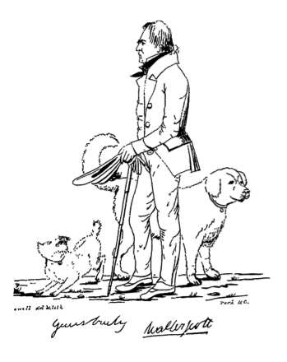

This picture of Walter Scott is touted as a great triumph for the magazine:

Mr Tazewell, our Artist, has bestowed considerable pains upon the accompanying Portrait – the first we believe ever engraved in Upper Canada – engraved too on Canadian Stone, and from thence, by means of a Canadian press, transferred to Canadian paper. The sketch is borrowed from *Fraser’s Magazine*; and we think Mr Tazewell has been extremely happy in transferring the likeness to our pages.

You can judge that for yourself – here is the original, published in November 1830:

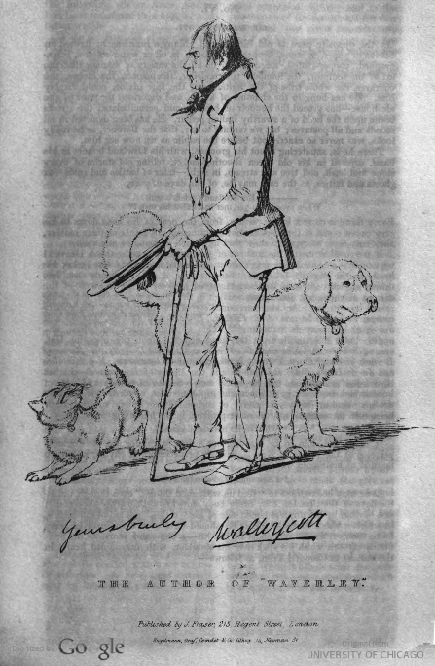

The fact that the recently-deceased Walter Scott was selected as the first subject of Canadian periodical portraiture is by no means surprising. This issue alone includes a heated discussion between two contributors about ‘the best mode of testifying respect to the memory of Sir Walter Scott in this Province’ as well as a ‘Dirge on the death of Sir Walter Scott: written, we believe by Mr D. Chisholm, of Three-rivers’. However, the article in which Scott’s likeness appears throws up an interesting wrinkle. ‘We had originally intended to have placed in our first number the Portrait of a distinguished personage intimately connected with this Colony. But a variety of unforeseen obstacles concurred to prevent this intention from being carried into effect, and we have endeavored to repair the disappointment as well as possible’. And in the very next issue in May 1833, we find out who that personage was going to be, if we hadn’t guessed already:

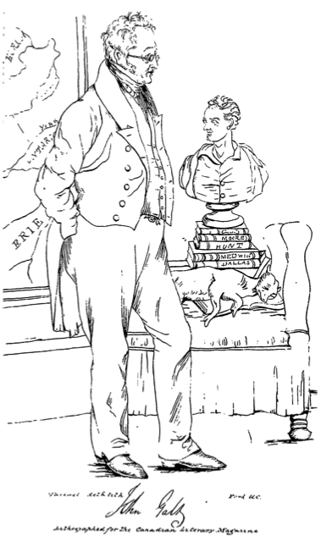

In a letter to William Blackwood in 1821, Galt remarks: ‘What a cursed fellow that Walter Scott has been, to drive me out of my old original line’. Here Scott has displaced Galt again, but for once the intention really was for Galt to have taken precedence. I’m sure that would have made him feel a lot better. In Galt’s case, however, the image is not simply transferred from *Fraser’s* Gallery of Illustrious Literary Characters to Canadian paper – it is altered. While both pictures show a map of the Great Lakes region hanging on the wall behind Galt, the *Fraser’s* original only marks Lake Ontario, and very faintly, Lake Simcoe:

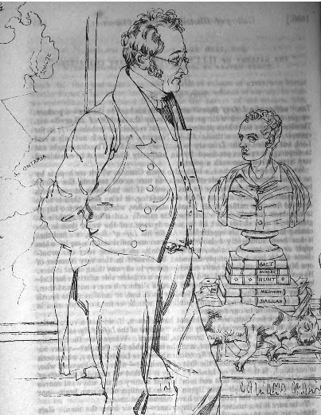

The *Canadian Literary Magazine* version makes the map clearer, with bolder lettering, and fills in more detail. Here we have Lake Erie and Lake Huron – and York, the magazine’s place of publication, is put on the map. While the magazine lays claim to Scott as the central figure of a national literary heritage that is shared by the colonies, Galt is encoded as a local figure, associated with the Canadian landscape.

This does not mean that the magazine claims any of Galt’s literary achievements for Canada; the accompanying biographical sketch enforces a strict geographical division between Galt’s two careers. ‘As an Author – not as a Superintendant of Emigrants – is Mr Galt chiefly known on the other side of the Atlantic’, while on this side, ‘Of the early history of John Galt we know nothing, except that he was born in Scotland’. The article acknowledges that ‘The name and writings of Galt have also been of considerable avail in attracting public attention in Great Britain towards Upper Canada’ but does not go into his North American writings in any detail. Instead, ‘His claim to a niche in the Temple of Fame must indeed rest solely upon his merits as a Scottish Novelist; for his Life of Lord Byron, though it has gone through several editions, is but a sorry and insipid production’. The author of this piece does not think of Galt as a ‘transatlantic’ writer as we might today but rather as a Scottish writer who also happens to have Upper Canadian ties. The possibility of a literary career that might be understood as both Scottish and Canadian remains just out of theoretical reach.

In contrast, *Blackwood’s* long-running ‘Noctes Ambrosianae’ series turns Galt into a kind of synecdoche of their overall interest in Canadian affairs. The instalment for October 1828 takes the form of a dialogue between two of the series’ regular characters, Christopher North and Timothy Tickler, about the state of Europe and the colonies. North declares that:

Canada is peevish, but we shall soon settle all that. A most honoured Contributor, and a most excellent Tory — our friend Galt — reigns there in plenitude of power; and the department of woods and forests is under the control of a Lord Warden, (The Teegger,) whose learned lucubrations have figured in the Magazine.

Because of Galt and William ‘Tiger’ Dunlop’s position within the *Blackwood’s* circle, the magazine uses their involvement in Canadian affairs as a metonym for the state of the region as a whole. The rest of the piece expands this rhetorical strategy outwards, as the great world powers are comically reduced to fit within a local (or even just a Blackwoodian) orbit, with political sympathies reconfigured as concrete personal interactions. The Russian Emperor Nicholas is regarded with relative goodwill by Christopher North because he is ‘a representative of that house which crushed the Jacobin power, and broke up the Continental System’, but also because he is ‘a good free-mason, having been made in our presence in the Canongate Kilwinning’. The Pacha of Egypt is similarly ‘An excellent fellow, lately converted to Christianity, and inrolled as a ruling elder of the Relief Kirk of Kirkintulloch’.

The secretary of a land company may be humorously likened to an Emperor or a Pacha, and invested with a similar degree of power to ‘settle’ the affairs of his domain, because they have been all been endowed equally (though not equally truthfully) with the Noctes Ambrosianae’s main guarantee of significance: a personal association with *Blackwood’s Magazine*. The wider world as portrayed, or burlesqued, in the Noctes is not merely assimilable to Scottish reference points but is, in fact, run by *Blackwood’s* contributors and personal friends.

To return at last to Galt’s own periodical writings which ‘attracted public attention in Great Britain towards Upper Canada’, of particular interest is a series of letters written for *Blackwood’s* in the persona of Bandana, who is a Glasgow manufacturer. Bandana writes a letter to Christopher North, *Blackwood’s* composite editor-figure, on various political and economic topics once or twice a year between October 1822 and September 1826. Three of these, the instalments of April 1824 and August and September 1826, state his views on emigration and ‘colonial undertakings’. Bandana’s disinterested opinions on the best way to settle Upper Canada (he is emphatically not a land company insider) constitute an extended promotional piece for Galt’s Canada Company, which was founded in the same year as the first letter appeared in *Blackwood’s* and received its official charter two years later, coinciding with letters two and three.

In his letter of September 1826, Bandana has recourse to the Company’s printed promotional material for his information. ‘By the prospectus of that Company, a copy of which is now before me, it appears to have been formed to remove at once a great obstacle to the improvement of the province of Upper Canada’. At the end of the letter a more detailed account of the company’s plans is appended, having been received ‘since the foregoing was written’. Finally, at the end of this appendix comes a note to the effect that ‘N.B. The Company has not yet published any view of their intended proceedings’ and that the reader has, therefore, received inside information, since ‘the foregoing has been made up from conversations with gentlemen in the Company’s office’. In this way, Galt posits a certain degree of already-existing public interest in the Canada Company. The invention of a supposedly general consensus on any given question is a much-used tactic in *Blackwood’s*: the claim that reports of the death of Christopher North have caused a public panic in ‘On the Late Rumour of a Change of Administration’ (December 1821), for example. The pseudonymous character of these letters, which is in keeping with the *Blackwood’s* house style, allows for an elision of commercial self-interest in favour of a public-spirited, detached evaluation of the emigration issue. This objectivity is attained not through a universalising overview but through the creation of specific fictional character.

In October 1830, two months before Galt’s entry in the Gallery of Literary Characters, *Fraser’s* runs the first in a series entitled ‘American Traditions. By John Galt, Esq’. In this piece, Galt declares that ‘All the nations of Europe have a species of legendary poetry which relates to the wars and exploits of their ancestors and founders. The Americans have nothing of this kind. They have, however, traditionary tales concerning the adventures of the first settlers not less interesting.’ He then goes on to tell a tale called ‘Cherockee – A Tradition of the Backwood’s’. In the next issue, *Fraser’s* turns Galt’s own recent exploits into a traditionary tale of their own, entitled ‘Guelph in Upper Canada’:

While the kingdom, with the Isle of Man and its dependencies, are ringing with the faults and fine things in Galt’s Life of Byron, we have the pleasure to present the advocates of emigration, with a View of Guelph, another sort of work of which he was the author and editor, in the province of Upper Canada. The renowned Doctor Dunlop has promised to write a history of this capital of the Western World – to be; in the meantime, we have accidentally obtained, with leave to make use of it, a private letter from Mr Galt to one of his friends, describing the founding of this second Rome or Babylon.

The letter gives an account of some ‘adventures of the first settlers’ which had taken place back in 1827, as Galt and Dunlop ceremonially christen the site of the new town by chopping down a ‘superb maple-tree’ which Galt ‘had the honour and glory of laying the axe to the root thereof’.

Early Canadian periodicals are also deeply concerned with the process of making history in the colonies. The first issue of the *Canadian Magazine and Literary Repository* in July 1823 announces itself as follows: ‘Let US be permitted to mark a period in the history of CANADA, and open a page in which her future historian may descry the feeble glimmer of the first rise of a great, prosperous, and independent nation!’. The *Canadian Magazine* is ‘the only publication in the country worthy of being characterised as an archive for giving permanency to literary and scientific pursuits.’ In comparison to this optimistic bombast, the ‘View of Guelph’ is both tongue in cheek and provisional – there is not yet a history of this not-yet metropolis. When the Canadian magazines’ vision of a homegrown literary tradition is realised, and retrospectively narrated, it will not have much of a place for Galt’s periodical writings – or, for the most part, for his emigrant novels. Galt’s Canadian writings constitute a body of work that hovers somewhere between two national literatures, tending to slip out of view in the historiography of both.

Illustrations from the *Canadian Literary Magazine* courtesy of *Early Canadiana Online*, produced by Canadiana.org.