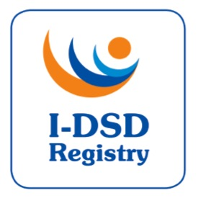

5th International-DSD Registry Steering Committee Meeting

Thursday 11th June 2015, 6:30-8:00pm

Zebra Lounge, The New Zebra, Ghent

Agenda

 | Item |  | Papers (to be precirculated)
1. | Welcome | Chair (FA)
2. | Approval of Minutes of 4th SC | Chair | Minutes
3. | Action List – update | FA | Action List
4. | Current Tasks  - Ongoing revisions  - Modules  - Users  - Patient Access  - Ethics Update  - Metrics  - Research Activities  - Travel Awards | JJ  JB  JB  JB  JB | SOP v4.0 & PIS  Metrics  List of Studies
5. | DSDnet | OH
6. | I-CAH | RR
7. | I-DSD 2015 | FA | Programme
8. | Term of Office  - New chair  - New members | JB
9. | AOB
 | Date for next meeting

Invited Participants:

Name | Role | Affiliation
Ian Ford | Chair | University of Glasgow | X
S. Faisal Ahmed | Project Lead | University of Glasgow
John Achermann | UK | University College London
Olaf Hiort | EU | University of Lübeck
Berenice Mendonca | SA | University of Sao Paulo
Leendert Looijenga | EU | ErasmusMC, Rotterdam
Alex Springer | EU | University of Vienna
Claudia Wiesemann | Ethics Adviser | Universität Göttingen
Miriam Muscarella | Patient Support Representative | Dsdteens.org
Carol Proctor | Patient Support Representative | UK
Amy Wisniewski | USA | University of Oklahoma
Richard Ross | UK | University of Sheffield
Jillian Bryce | Project Manager | University of Glasgow
Martina Rodie | Co-Investigator | University of Glasgow
Richard Sinnott | Co-Investigator | University of Melbourne
Jipu Jiang | I-DSD developer | University of Glasgow
John Watt | GRID engineer | University of Glasgow | X

