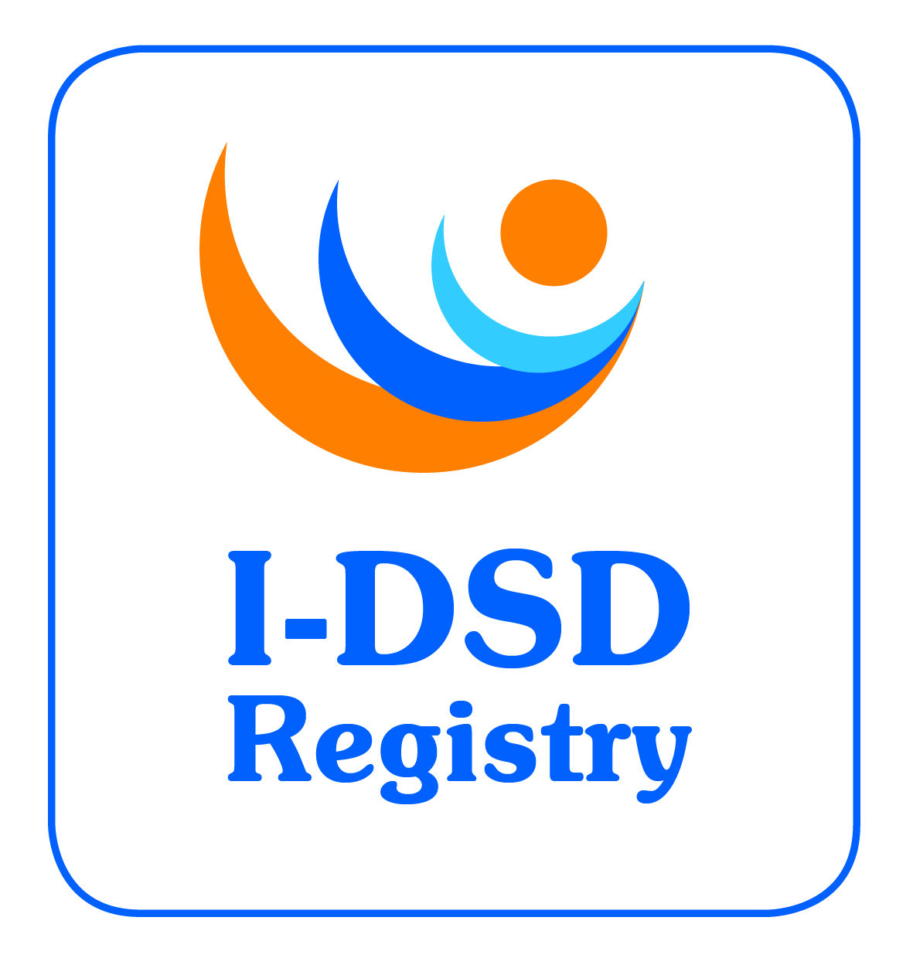
5th International-DSD Registry Steering Committee Meeting

Thursday 11th June 2015, 18:30 – 20:00

Zebra Lounge, The New Zebra, Ghent

Minutes

Attending: Faisal Ahmed (chair), John Achermann, Jillian Bryce, Olaf Hiort, Jipu Jiang, Leendert Looijenga, Berenice Mendonca, Miriam Muscarella, Carol Proctor, Martina Rodie, Richard Ross, Richard Sinnott, Claudia Wiesemann, Amy Wisniewski.
Apologies: Ian Ford, Alexander Springer, John Watt.

- Welcome
The chair welcomed everyone to the 5th Steering Committee Meeting.
- Approval of Minutes of 4th SC Meeting
The minutes of the 4th Steering Committee Meeting were approved.
- Action Points Update
Most action points are completed. Attention is required on:
The current chair, Ian Ford is retiring and need to consider a replacement.
SC to continue with exploring new research ideas suitable for Registry Action ALL
- Current Tasks
  - Ongoing revisions
    - Modules
An update on the modular development was provided. Currently all users can see all modules, but tailored modular access will be introduced with project groups arranged around this as further interest develops. For instance:
- Phenotype module as guided by DSDnet
- Psychology/Qualitative module – DSDnet is developing some guidance of what could be collected routinely
- Birgit Kohler would like to bulk upload cases from DSD life. JB will contact to initiate this. Action JB
- Bulk upload is also in the pipeline for Rotterdam and Magdeburg. The process is relatively straightforward but requires clean mapping of fields. Action JJ
- Identify what studies a patient is entered into (e.g. DSDlife, EuroDSD, others) Action JJ
- Pathology module is another suggestion to support work in this area being done by Leendert Looijenga. Action LL

    - Users
- Clinical Users – upload clinical data – can see all data for their own cases and core data of other records. In the future, a fee will be introduced for access to core data of other records. Action PMG
- Research Users – can see whole datasets of all records. Limited to 6 months access then can reapply. In the future, a fee will be introduced for modular access. Action PMG
- User – can see other user’s profiles only for networking purposes.
- Participant Access – this is a new role for the patient/parent which needs further development and can be personalised for each patient and can be used for increasing patient participation. Action CP

  - Ethics Update
The registry ethics approval of the registry has been renewed for a further 5 years.
There is an updated SOP v4.0 01/01/15 and Patient Information Sheets and consent forms for I-DSD and I-CAH – all available to download from the website.

  - Metrics
1637 cases on the registry in April 2015. See appendix 1 for details. There has been a big increase in the percentage of CAH cases since I-CAH was launched.

  - Research Activities
List of current and recent research studies is in the recent SC update June 2015. Also available on the website with lay summaries.
- DSDnet – Andreas Kyriakou, Cyprus used the I-DSD network as target group for survey
- PAIS – Angela Lucas-Herald, Glasgow received an I-DSD travel grant to visit Lubeck to gather data.
- 45X/46XY males – Marie Johansen, Copenhagen approached the registry to identify clinicians who own these cases.
I-DSD could be linked to the Australian DSD registry but this could only be limited to the common datasets. The genetic module needs a revision to add a mention of what genetic tests have been performed and where the data are stored. Action - JA

  - I-DSD Travel Grants
These grants are available to allow attendance at a conference to present research conducted using the I-DSD registry data or for an individual to travel to another group or facility to conduct research on the registry or develop an aspect of the registry (e.g. all of the activity mentioned above).
- DSDnet
OH provided an update of the activities of DSDnet and how it links to the I-DSD Registry
- I-CAH Registry
Hosted on I-DSD registry, this arose from CaHASE and is supported by grant EU-TAIN (Infacort). Diurnal are involved in Infacort and Chronocort trails and fund studies. The I-CAH website launched in 2014 is a resource for clinicians, patients and researchers and there are links to other resources. The linked I-CAH Registry has a longitudinal module which is now live. These data could be supplied to pharma if there was commercial interest.
- I-DSD 2015
Ghent 11-13th June. 215 registered participants, 80 abstracts, 24 invited speakers, 25 oral presentations, 50 posters.
Next meeting is due in 2017. An extension to the MRC grant needs to be arranged.
Budget is £25k and income from fees is used to support the I-DSD travel awards.

JB to circulate a notice to Europe based I-DSD users for venue for 2017, JB to enquire re grant extension Action JB

- Term of Office
New Chair
Ian Ford is retiring so a new chair is required. Everybody agreed that the ESPE DSD Working Group could be approached to take this role. FA to approach Anna Nordenstromm, current chair of the ESPE DSD WG. Action FA
SC membership changes:
- LL replaced by Ken MacElreavey (France) Action FA
- BM replaced by Rodolfo Rey (Argentina) Action FA
- CW to be replaced by another ethics expert to be suggested by CW Action FA
- Post meeting suggestion - Stephanie Bernstein (Gottingen)
SC agreed on the above.
- AOB
Discussion about long term sustainability and need to continue generating research and commercial activity.

Date for next meeting
27th January 2016 by teleconference ALL to note

WHO | ACTIONS | DUE
ALL | SC to continue exploring new research ideas suitable for Registry | ongoing
ALL | Suggest future modules to put into the pipeline | ongoing
FA | Approach Anna Nordenstrom about Steering Committee chair | Aug 15
JB | Contact Birgit to initiate bulk upload of consented patients in DSDlife | Aug 15
JJ/JB | Complete bulk upload of data in Rotterdam and Magdeburg | Aug 15
JB | Enquire about grant extension | Aug 15
JB | Circulate Date and location for next SC meeting: 27/1/16 via teleconference | Aug 15
JB | Circulate note to EU based I-DSD users to suggest location for next I-DSD 2017 | Sept 15
FA | Invite Ken McElreavey, Rodolfo Rey and Stephanie Bernstein to join SC | Sept 15
ALL | Suggest new members for SC | Jan 16
JJ | Develop tool to identify what studies a patient is entered into | Jan 16
LL | Develop requirements for Pathology module | Jan 16
CP | Identify what is wanted for Participant Access including personalisation | Jan 16
JJ | Links to informational tools in whitespace of patient access record | Jan 16
JA | Revise genetic module to include genetic tests performed and where data is stored | Jan 16
PMG | Develop process for introducing fees for access to core datasets (clinical users) and modules (research users) | Feb 16

