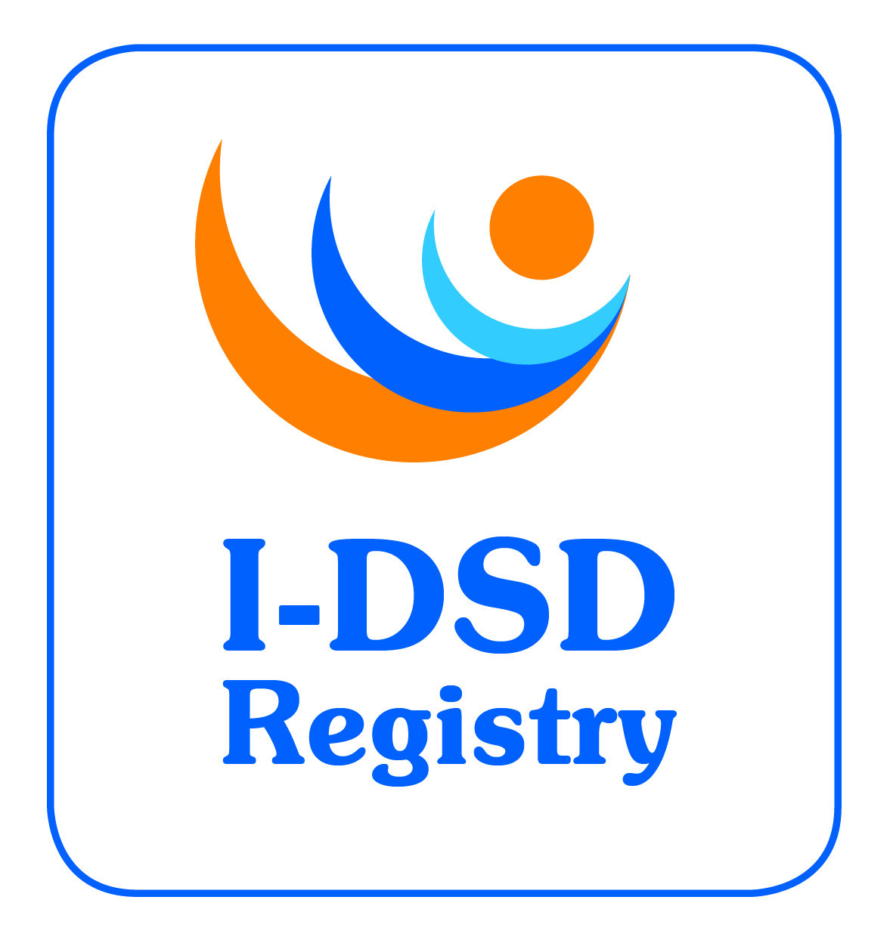
4th International-DSD Registry Steering Committee Meeting

Tuesday 10th June 2014, 12:00 noon – 2:00pm

Teleconference

Minutes

Attending: Faisal Ahmed (chair), John Achermann, Jillian Bryce, Olaf Hiort, Ieuan Hughes, Leendert Looijenga, Ellie Magritte, Miriam Muscarella, Martina Rodie, David Sandberg, Alexander Springer, Claudia Wiesemann.
Apologies: Ian Ford, Feyza Darendeliler, Jipu Jiang, Berenice Mendonca, Richard Sinnott, John Watt.
 |  |  | ACTION
- Welcome
The chair welcomed everyone to the 4th Steering Committee Meeting.
- Approval of Minutes of 3rd SC Meeting
The minutes of the 3rd Steering Committee Meeting were approved.
- Action Points Update  - Suggestions for new Steering Committee members was circulated  - I-DSD website now has a public list of Research Studies  - Autumn Newsletter reflected on I-DSD symposium  - Survey carried out on I-DSD useage. Results available on website and presented at ESPE DSD WG.  - South American questionnaire to be circulated  - Research Studies flowchart developed on I-DSD website  - Public description of I-DSD on front page of the website  - I-CAH Registry active.  - Capture output post-EuroDSD on use of registry (survey EuroDSD users)  - Next I-DSD symposium in Ghent with COST DSD net training school  - Create a video to show how the registry works for patients and professionals  - Raise awareness of the I-DSD Registry in South America  - Include links to I-DSD on DSDNet website when launched  - Encourage their own centres to think of research using the Registry |  |  | BM  JB  JJ  BM  OH  ALL
- Current Tasks  - Security breach  The Committee was informed about the recent security breach of the portal which has resulted in the registry being taken offline temporarily as a precaution. Fortunately no patient data was accessed or leaked. JW is busy rebuilding the registry on a new server.  - Ongoing revisions  - Modules  - Core module is a minimal dataset that is mandatory.  - All other modules are optional.  - New modules commissioned  - CAH (launched for the I-CAH group)  - Hypospadias (testing)  - Longitudinal CAH (planned for an I-CAH study)  - Biochemistry (planned)  - Transition (planned).  The question of consensus on the modules was raised and it was suggested that the hypospadias module be validated by COST DSDnet WG1. DSDnet’s involvement in directing some phenotype-related aspects of registry development was welcomed.  The SC were asked to suggest future modules to put into the pipeline, e.g. Pathology.  - Users  - Clinical Users – upload clinical data – can see core data only of other records  - Research Users – can’t upload data but can see whole datasets of all records  - User – can see other user’s profiles only for networking purposes.  - Patient Access  From the Registry User survey it was apparent that patient access to their own record was supported. This access may also facilitate quality control and the PMG is exploring possible methods of developing this. The SC was asked if anybody wants to help with this development. MM suggested that allowing patient access may also help with transition.  - Ethics renewal  The 5 year renewal application is now due for the registry. JB working on the IRAS update with an aim to submit early July. The SC was asked for feedback on SOP v3.0 which will accompany the Ethics renewal by end of June.  - Metrics  IH commented on the numbers of cases in the registry. There is a need to include some more detailed data in the metrics which show the source of new cases. JB to conduct survey and report to SC.  It was agreed that the dataset is currently large enough to support many research questions but that more data on e.g. novel conditions, genetic variants, translational research, biochemical data would support this even further.  The question of data reliability was raised by DS. A QA audit has not been done per se but some research studies that have been conducted have led to some data being queried for accuracy. It was suggested that due diligence should be included in the research studies protocol.  - Research Activities  List of current and recent research studies is now available on the website.  Active studies contain links to further details. DS suggested the active studies be labelled with start date and status.  Recently completed studies are linked to output such as published papers.  EuroDSD studies. Participants need to be surveyed for their output specifically using the registry data.  EM pointed out that the language used to describe some projects was not in layman’s terms. FA will look at these descriptions and a lay summary will be requested in all future applications. JA suggested that there needs to be better targetting of clinical users for specific studies and that I-DSD should ask who the study is for in order to target people to be involved in a particular study.  - I-DSD Travel Grants  These grants are available to allow attendance at a conference to present research conducted using the I-DSD registry data or for an individual to travel to another group or facility to conduct research on the registry or develop an aspect of the registry (e.g. module development). Maximum grant £500. OH suggested that these should be targetted at those who cannot access other sources of funding such as that through DSDnet. |  |  | ALL  ALL  JB  ALL  JB  JB  JB  JB  FA  JB
- DSDnet  The COST action currently has 18 EU countries involved  Support Groups  Toolbox for website  Dissemination (WP5) – Text describing ‘DSD’ in English and local languages  A networking tool with money for WG meetings, Scientific Missions, Workshops and Training Schools – which is planned over 2.5 days prior to the I-DSD symposium 2015.  All DSDnet participants to be invited to join I-DSD registry in order to search each other.  OH to send dummy DSDnet website url around the SC.  EM to send brochure to OH  Links between I-DSD and DSDnet need to be updated and brought out further in websites |  |  | JB  OH  EM  JB/OH
- I-DSD 2015 & ISHID 2015  I-DSD 2015 programme is complete with all invited speakers confirmed. It will be posted to the website soon. CW to send updated title.  ISHID 2015 will take place in Lubeck a few weeks after I-DSD (25-26 June) and this may have an effect of attendance by surgeons. The theme New Zebra should be removed from the I-DSD programme (confusing) |  |  | JB  CW  JB
- Term of Office  Some existing members of the SC are due to demit office shortly, including IH who was thanked for his contributions as he left the meeting.  Suggested new members include:  - Richard Ross (Sheffield) I-CAH Registry and adult endocrinologist  - Any Wisniewski to replace DS in November  - Carol Proctor to replace EM now  - Ken McElreavy (Paris).  There were no objections to any of the suggestions but additional suggestions were invited |  |  | ALL
- AOB
DS raised an issue with the DSD terminology and how well is it being applied across the clinical professions
Addendum
IH commented that a transcript of the recent NIH DSD workshop is anticipated which will address the issue of nomenclature, in particular use of ‘Disorders’ or ‘Differences’ in the DSD acronym.

Date for next meeting
SC meeting scheduled for Thursday 11th June 2015 (at I-DSD 2015).
WHO | ACTIONS | DUE
ALL | Encourage their own centres to think of research using the Registry | ongoing
ALL | Suggest future modules to put into the pipeline, e.g. Pathology. | ongoing
ALL | Suggest new members for SC | ongoing
CW | Send updated title for I-DSD talk | 14/6/14
JB | Remove The New Zebra theme from I-DSD programme | 14/6/14
JB | Invite DSDnet participants to join I-DSD registry | 15/6/14
OH | Include links to I-DSD on DSDNet website when launched | 30/6/14
ALL | Feedback on SOP v3.0 | 30/6/14
JB | Post I-DSD symposium programme to website | 30/6/14
JB | Submit ethics renewal application to REC | 4/7/14
JB | Include due diligence text in research studies protocol on the website | 7/7/14
JB | Label active studies with start date and status | 7/7/14
OH | Circulate dummy DSDnet url to SC | 7/7/14
OH/JB | Bring out link to I-DSD further on DSDnet website and update link from I-DSD to DSDnet | 14/7/14
JB | Capture output post-EuroDSD on use of registry (survey EuroDSD users) | 14/7/14
ALL | Express an interest in supporting the patient access development | 15/7/14
FA | Create lay summaries for all active studies | 15/7/14
EM | Send DSD brochure to OH | 20/7/14
JB | Amend researcher questionnaire to capture lay summary and target groups | 30/7/14
JB | Conduct survey on the registry data sources and upload rates and report to SC | 30/8/14

