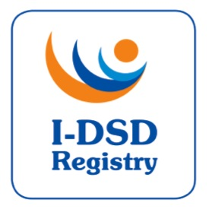

4th International-DSD Registry Steering Committee Meeting

Tuesday 10th June 2014, 12noon-2pm

Prof Ahmed’s Office & Teleconference, University of Glasgow, UK

Agenda

 | Item |  | Papers (to be precirculated)
1. | Welcome | Chair (FA)
2. | Approval of Minutes of 1st SC | Chair | Minutes
3. | Action List – update | FA | Action List
4. | Current Tasks  - Ongoing revisions  - Modules  - Users  - Patient Access  - Ethics Renewal  - Metrics  - Research Activities  - Travel Awards | JJ/JW  JB  JB  JB  JB | SOP v3.0  Metrics  List of Studies  Award docs
5. | DSDnet | OH
6. | I-DSD 2015, ISHID 2015 | FA/OH | Programme
7. | Term of Office  - New members | JB
8. | AOB
 | Date for next meeting

Invited Participants:

Name | Role | Affiliation
Prof. Ian Ford | Chair | University of Glasgow | X
Prof. S. Faisal Ahmed | Project Lead | University of Glasgow
Dr Jillian Bryce | Project Manager | University of Glasgow
Prof. John Achermann | Research Partner UK | University College London
Prof. Olaf Hiort | Research Partner EU | University of Lubeck
Prof. David Sandberg | Research Partner Other | University of Michigan
Prof. Ieuan Hughes | Clinical Partner UK | University of Cambridge
Prof. Feyza Darendeliler | Clinical Partner EU | Istanbul University | X
Prof. Berenice Mendonca | Clinical Partner Other | University of Sao Paulo | ?
Prof. Claudia Wiesemann | Ethics Adviser | Universität Göttingen
Ms. Ellie Magritte | Patient Support Representative | dsdfamilies.org
Dr. Martina Rodie | Co-Investigator | University of Glasgow
Prof. Richard Sinnott | Co-Investigator | University of Melbourne | X
Dr. Jipu Jiang | I-DSD developer | University of Glasgow
Dr. John Watt | GRID engineer | University of Glasgow | ?
Dr Leendert Looijenga | Research Partner - EU | ErasmusMC, Rotterdam
Dr Alex Springer | Clinical partner - EU | University of Vienna
Ms Miriam Muscarella | Patient Support Representative | Boston

