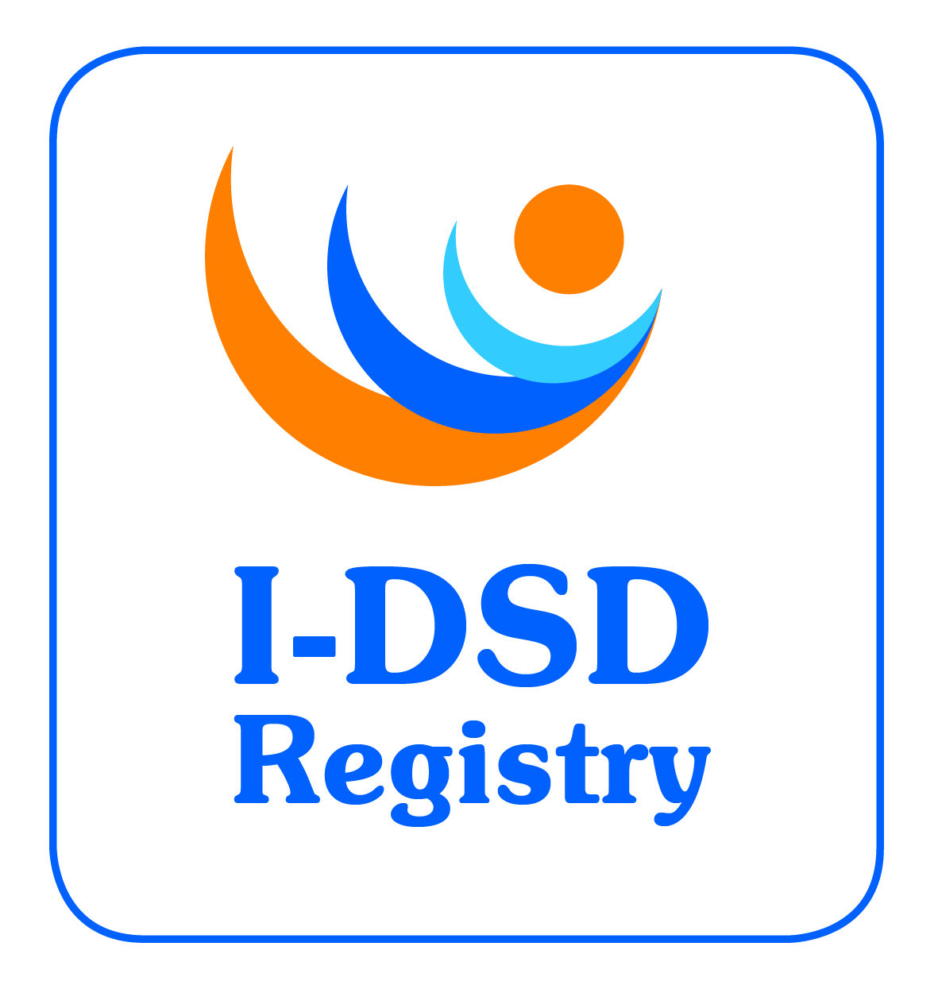

3rd International-DSD Registry Steering Committee Meeting

Friday 7th June 2013, 6.30pm – 8pm

Humanities Lecture Theatre, University of Glasgow, Glasgow, UK

Minutes

Attending: Ian Ford (chair), Faisal Ahmed, Jillian Bryce, Feyza Darendeliler, Olaf Hiort, Jipu Jiang, Ellie Magritte, Berenice Mendonca, Martina Rodie, David Sandberg, Richard Sinnott, John Watt.
Apologies: John Achermann, Ieuan Hughes, Claudia Wiesemann

 | ACTION
- Welcome
The chair welcomed everyone to the 3rd Steering Committee Meeting.
- Approval of Minutes of 2nd SC Meeting
The minutes of the 2nd Steering Committee were approved.
- Action Points Update  - All SOP revisions (including the revised patient information leaflets and consent forms) have been completed and approved by the Local Ethics Committee (v.2.0 date: 091012)  - I-DSD Symposium is now underway. FA thanked FD for her idea of a new investigator’s workshop before the symposium which seemed to have been a success  - Networks and resources were identified for publicity for I-DSD symposium.  - An empty registry was created for anybody interested in looking at an empty version of the registry  - EuroDSD website is now closed.  - A parallel session for family support groups was held at the I-DSD symposium on Saturday am  - A Research Flowchart has been added to the website in text form at the moment and will be developed further in the new web template.  - Research Studies are being collected and the list of known active, planned or recently completed studies was circulated to the Committee. A public version of this list will be added to the website.  - Feedback –Survey monkey planned to assess usefulness of the Registry  - Steering Committee term of office. JB went through the planned terms in the current Charter which are fixed. FA raised the need to diversify the composition of the committee. A list of suggestions will be circulated to SC for approval. | JB  JB  JB  FA
- Current Tasks  - Ongoing Revisions.  JJ gave a summary of recent changes to the I-DSD Registry  - Reduction of the mandatory fields to the Core Info Module. This will allow more users to enter brief details of cases.  - Password changes are enforced every 6 months.  - All registered users can see the Core Info Module on all accessible cases  - Users who enter case details can see all information on the these cases as well as the Core Info Module on all accessible cases  - Researchers will see all information on all accessible cases for a fixed period which can be extended based on a progress report  - A parallel registry for CAH is being planned  - I-DSD Symposium.  The participation of support groups in the 4th I-DSD symposium was felt to be a positive initiative which will need further development. Over 190 delegates had registered for the meeting and the low costs for registration and accommodation were useful factors.  - Metrics.  Current metrics were distributed as a tabled item.  - Research Activities  Primary research:-  - DSD Life (Birgit Kohler, Berlin) intends to use the registry.  Secondary research:-  - Zosia Kolenski (Poznan) – sex assignment trends study to be presented at I-DSD symposium and as an oral at ESPE 2013. Manuscript under preparation  - Kathryn Cox (Glasgow) - pattern of congenital anomalies study to be presented at I-DSD and as an oral at ENDO 2013. Manuscript close to submission.  Need to survey previous EuroDSD users of Registry of any publications based on the use of the Registry.  SC members were invited to encourage their own centres to think of research projects that could be performed on the current data in the Registry  Clarification on involving the SC in vetting proposed research projects was sought. In cases with no apparent conflict, it was agreed there was no need to involve the SC. In case of similar proposals the SC would encourage collaboration.  BM raised the issue of authorship or ownership and it was agreed that the Registry will encourage researchers to adhere to the ICMJE guidelines http://www.icmje.org/ethical_1author.html. | JJ/JB  JB  ALL
- Australian activity
RS described a project on Endocrine genomics (which includes DSD). The I-DSD Registry and the Australian databases have a number of identical fields. The Australian registry is currently under review for ethics approval. RS is keen to maintain commonality between the two registries
- EU & IRDiRC activity (including COST)  A new COST Action, DSDNet has been recently approved and will be led by OH. Its focus will be on developing an information website, workshops and exchange visits.COST and I-DSD could co-host the main meeting and share the costs of the next international DSD meeting in 2015. There will need to be clarity of links between I-DSD and DSDnet. | OH/FA/JB
- Latin America  BM intends to raise awareness in South America of the registry. | BM
- North America
DS provided a summary of the translational DSD research network that is developing in the USA.

- Patient & Parents Input  - RS suggested a video to show how the registry works would be useful for patients and professionals. DS was asked for input for a public summary on the I-DSD website  - There was a discussion around whether patients and parents should have access to the clinical information on the registered case.  - Miriam Muscarella, a visiting student in FA’s group is planning to perform a survey of patients and parents.. BM also has a very large questionnaire used in SA (150 questions) which she will send to the Committee for consideration.  - A better understanding of the benefits of the Registry may influence participation in studies – The development of an international network of support groups was welcomed. | JJ  DS  BM
- Term of Office
Discussed in Action List Update
- I-CAH.
To be discussed by correspondence
- AOB  Newsletter will be due by Summer 2013 (July). Need ideas for inclusion.  Need to direct more information to support groups and general public. | JB
Date for next meeting
SC meeting due in 12 months time (to be advised). Next I-DSD symposium in 18 months/2 years. Start planning in 6 months (possibly with COST)

WHO | ACTIONS | DUE
FA | Circulate list of suggestions for new Steering Committee members to invite | 7/7/13
JB | Add public version of known Research Studies to the I-DSD website | 20/7/13
JB | Summer Newsletter with focus of Symposium | 25/7/13
JB | Create Survey Monkey questionnaire to assess usefulness of the Registry | 31/7/13
BM | Send Questionnaire used in SA to Committee as a reference | 15/8/13
JB | Develop the Research Studies flowchart/instructions on the I-DSD website | 15/8/13
DS/JB | Provide input to create a public description of I-DSD on the website | 15/8/13
JB | Complete survey to provide an update to ESPE DSD WG | 30/8/13
JJ/JB | Develop parallel I-CAH Registry | 30/9/13
JB | Survey previous EuroDSD users of any publications based on the use of the Registry. | 30/10/13
JB/FA/OH | Consider options to co-host the next I-DSD symposium with other meetings | 31/11/13
JJ | Create a video to show how the registry works for patients and professionals | 31/11/13
BM | Raise awareness of the I-DSD Registry in South America | 31/11/13
OH | Include links to I-DSD on DSDNet website when launched | 30/12/13
ALL | Encourage their own centres to think of research using the Registry | ongoing

