Welcome to Employee Dashboard
Contents
Login 3
Employee View 5
Line Manager View 6
Navigation icons 8
Employee Home Page – overview 10
Profile 10
My Time 11
Payment 12
Expenses 13
More 14
View Holiday Balances – quick view 15
Submit Leave Request 17
My Time navigation 17
Book Time Off 19
Edit Request 27
Update Personal Details – My Details button 30
Next of Kin details 31
Contact Details 32
Address Details 36
Dependants Details 37
Diversity Details 43
Documents 46
Bank Details 47
Contract Details 50
My Time 53
Balance Information 54
Leave Requests 57
Learning & Development 58
Professional Bodies 58
Qualifications 63
Languages 67

Login
Navigate to the CorePortal login page using the link below:
https://hrportal.mis.gla.ac.uk/pls/coreportal_live/cp_por_public_main_page.display_login_page 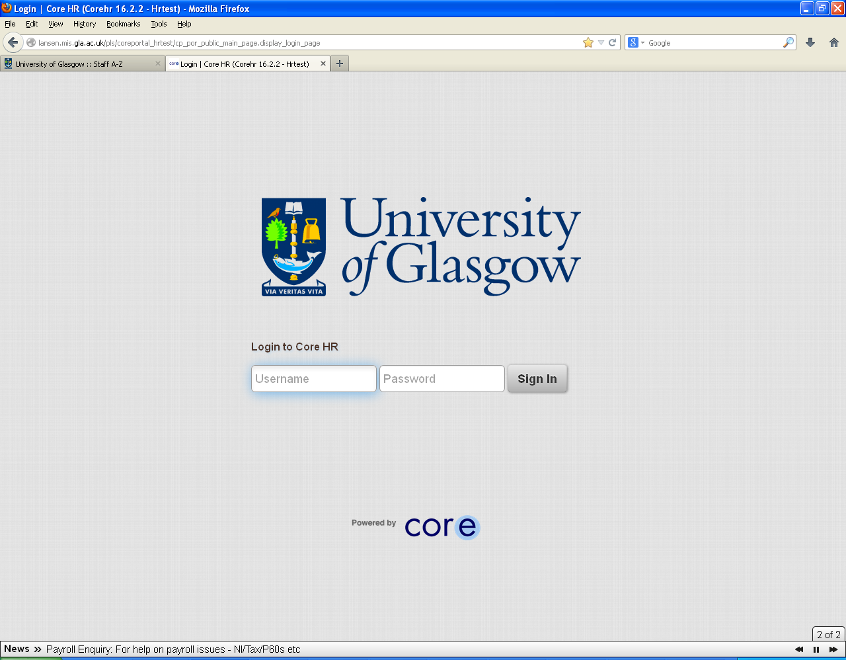
Enter your GUID in the username field > enter your password in the password field > press enter or select Sign In:
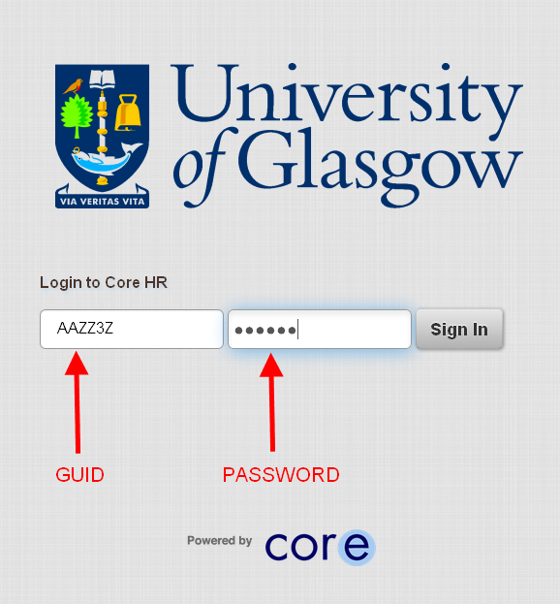

Employee View
Your home / profile page will appear detailing basic information.
Clicking home button will return you to this view

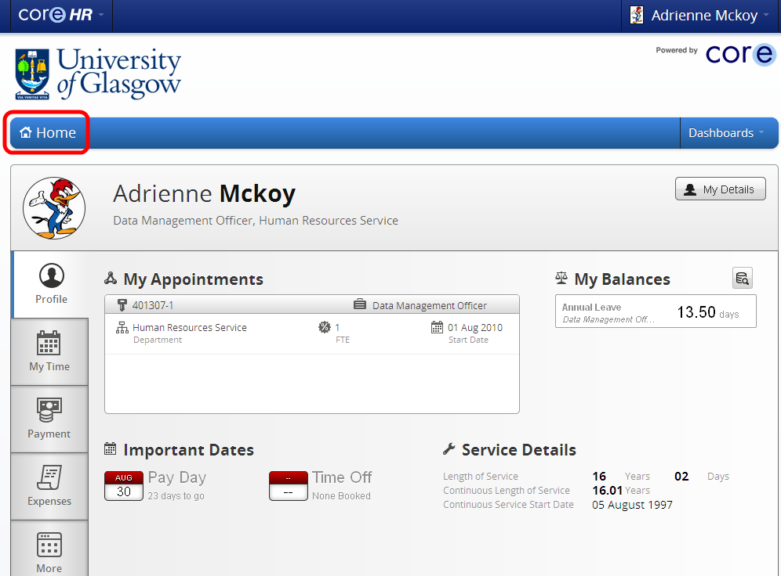

Line Manager View
If you are a line manager you will see your team when you log in
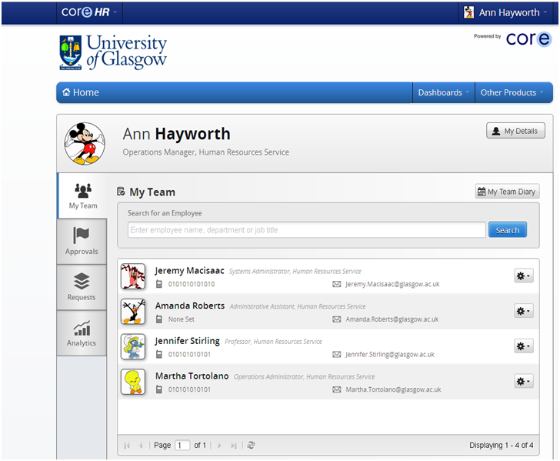
To navigate to Employee Dashboard click on CoreHR icon and choose Employee Dashboard.
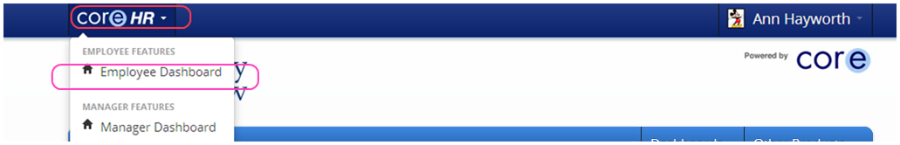

To return to Manager Dashboard repeat or Click on Home button
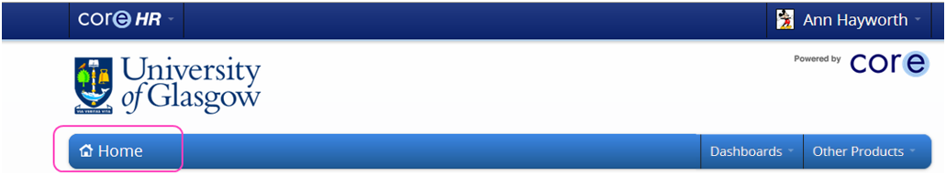

Navigation icons
Some of the useful navigation features in CorePortal include the following:
The Tools icon is available on different parts of CorePortal and selecting this will often give you relevant options for the section you are editing or updating.
The Filter icon is also available on many screens and will allow you to filter the results of what you are looking at, such as leave request type.
The View iconopens up a window to allow you to view details and sometimes to edit those details further along with other options.
The Calendar icon and provides a calendar view for you to choose dates when selected:
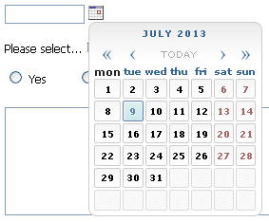 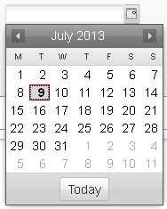
The Select Appointment icon allows you to select a different post/appointment if you have more than one job:
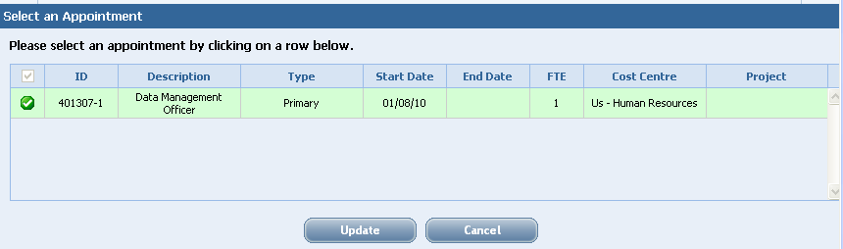

Employee Home Page – overview

Profile
Displays summary of your appointment details; balances and important dates – Payment date; next holiday date; length of continuous service
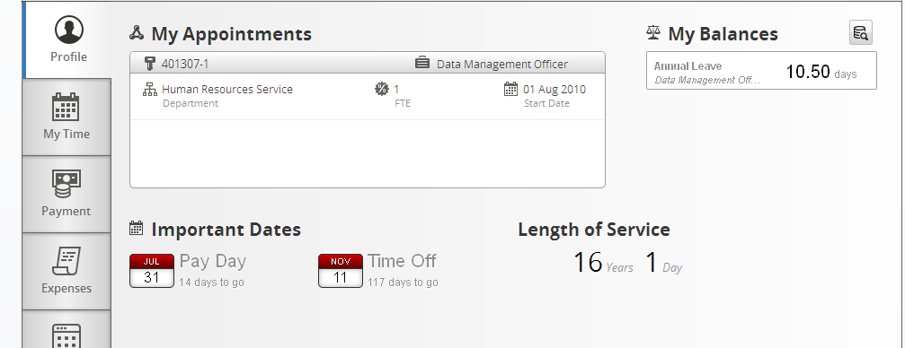

My Time
Summary of work patters and any requests made – can be accessed via My Details also
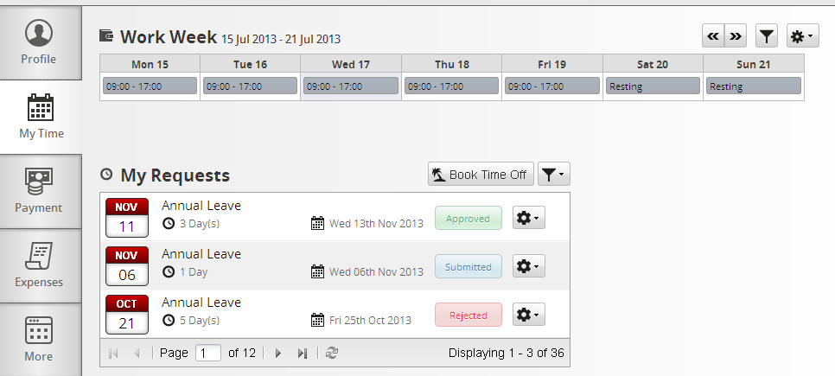

Payment
Displays pay slip details; P60 details; Bank details. Again some of these can be accessed via My Details also
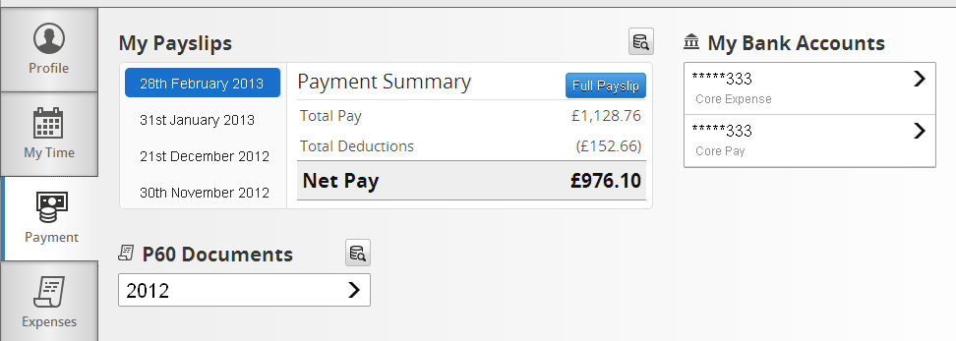

Expenses
This is where you are able to submit expenses claims and view all details relating to these. Information on how to complete is available via the Documents view on My Details or More tab
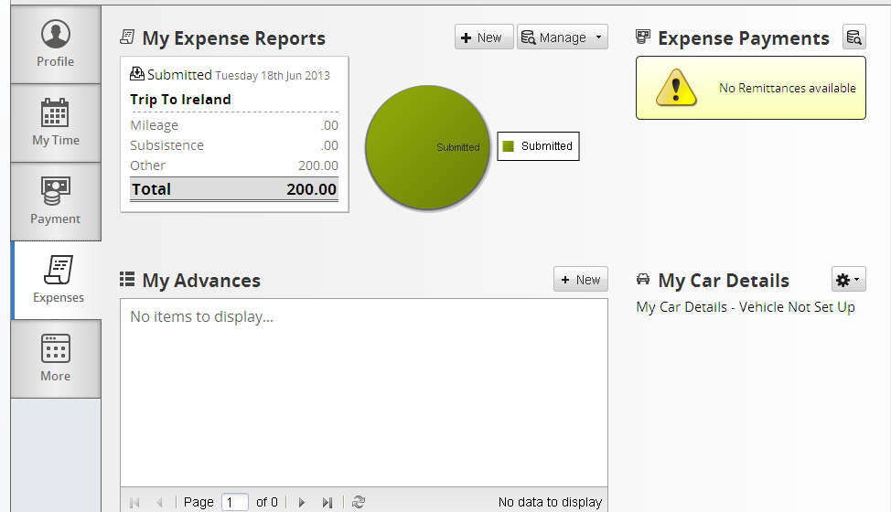

More
At present this allows you to view any documents relevant to you. Future development may add further functionality to this screen
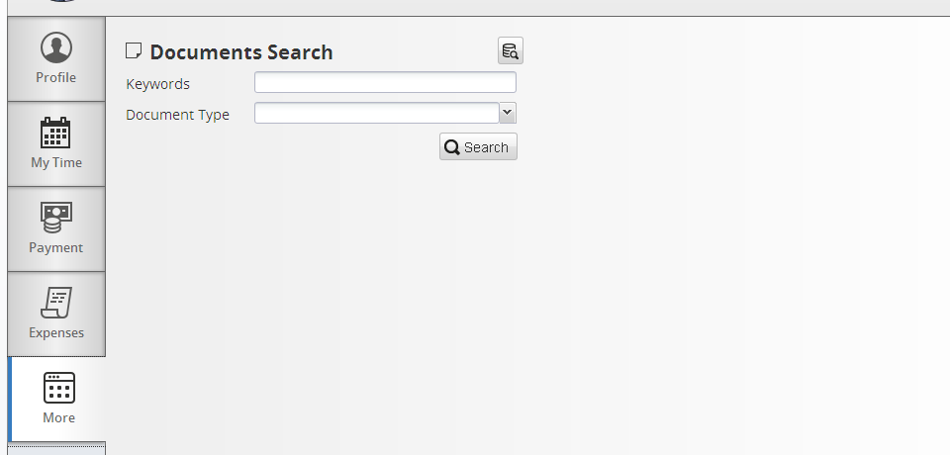

View Holiday Balances – quick view
Click on My Balances box to view detail behind balance.
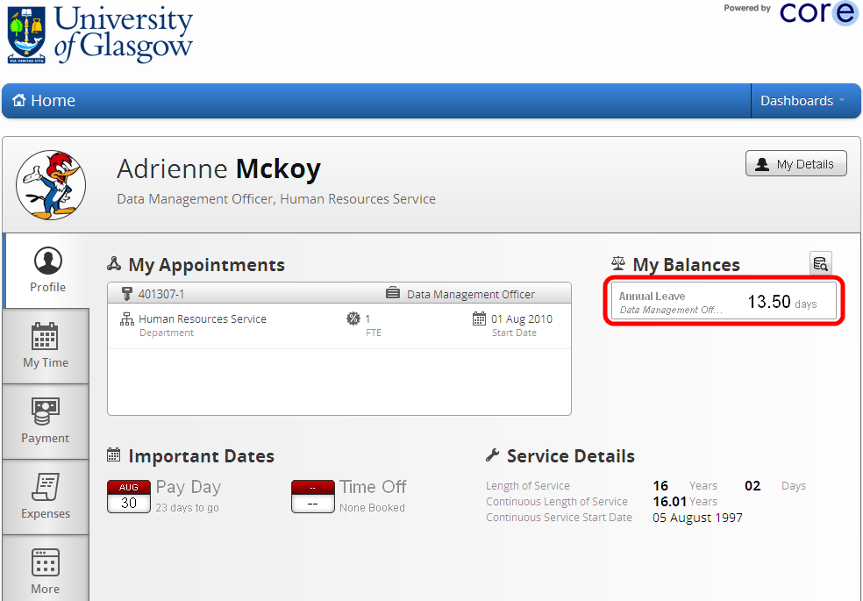
Here you can view your Annual Leave Balance Information:
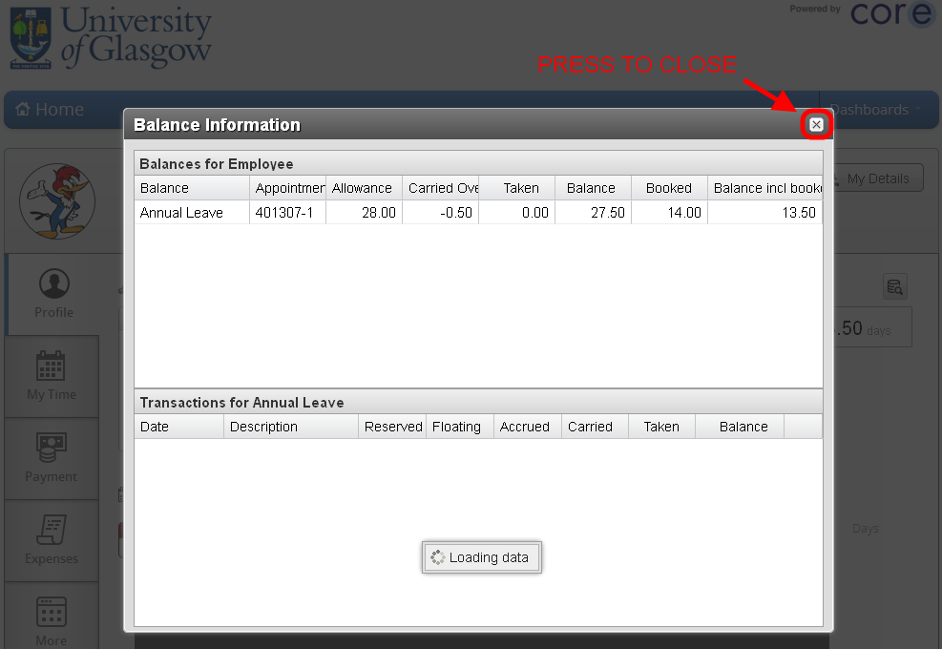
Press the X at the top right to close the window.

Submit Leave Request
My Time navigation Select the My Time tab on the left of the screen:
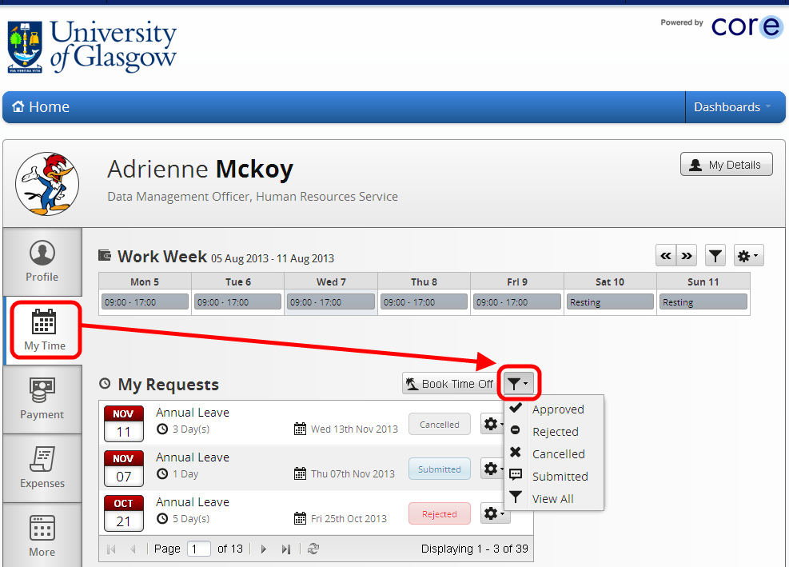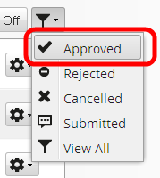
Here you can view more detailed information on your Time and Attendance. Select the filter as shown above to filter your leave request type > choose Approved.
This will show only your approved leave requests over several pages which you can navigate between using the page options highlighted below:
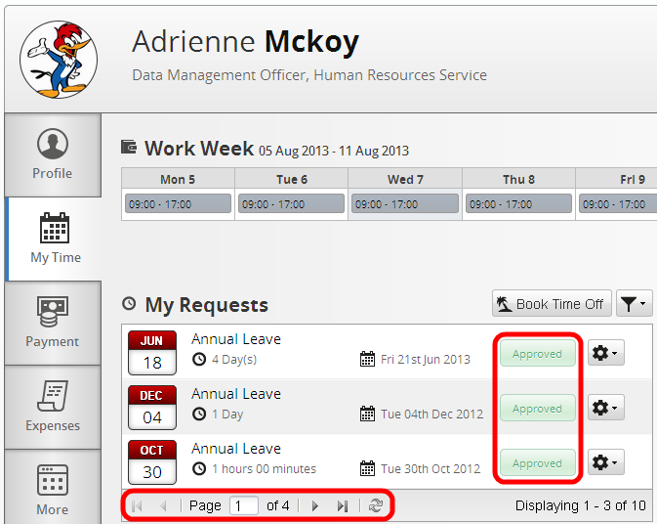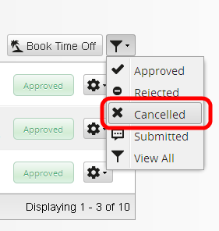
Select either Cancelled / Rejected / Submitted / View All to filter your Leave Requests accordingly.

Book Time Off
In the My Time tab select the Book Time Off button:
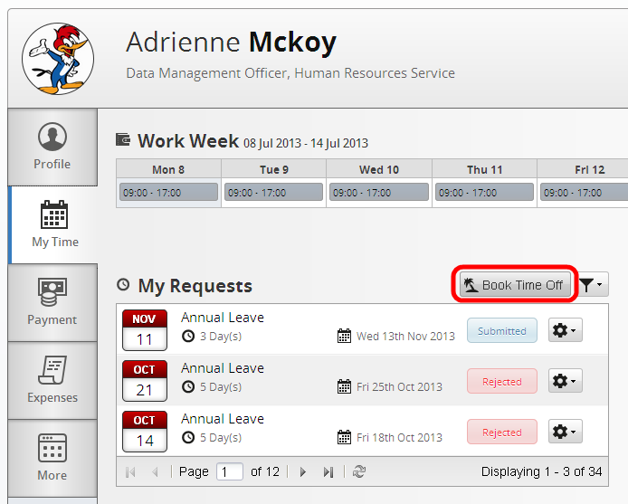

This will open up a new window where you can enter the details of the leave request you wish to submit:
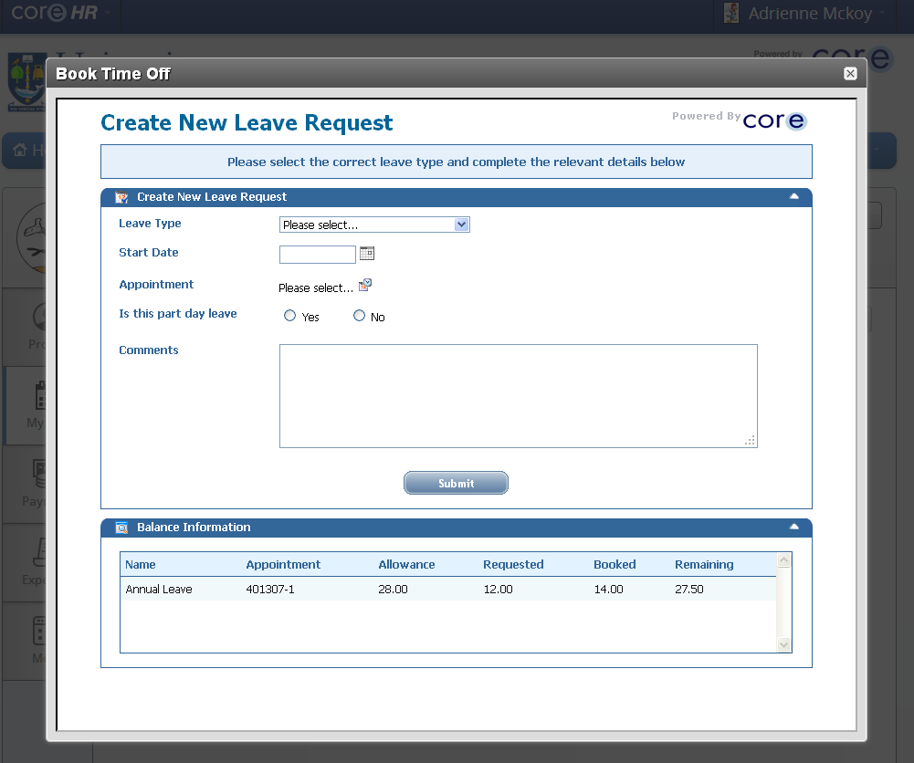
Select Annual Leave > select the calendar icon to choose the day you wish to request:
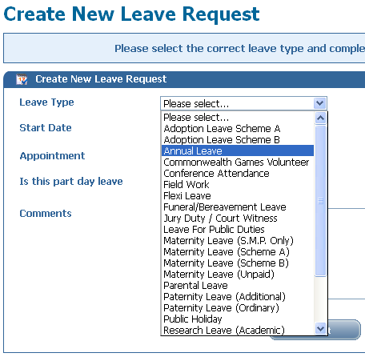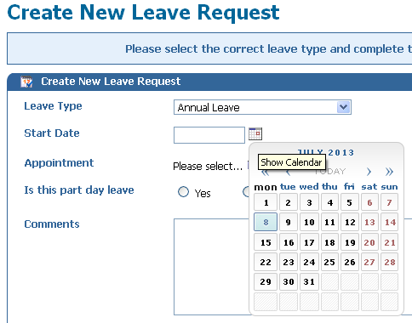
Alternatively, you can type in the date in the following format:
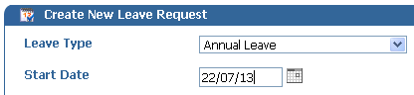

Select your Appointment ID if you have more than one post by pressing the icon on the right hand side:
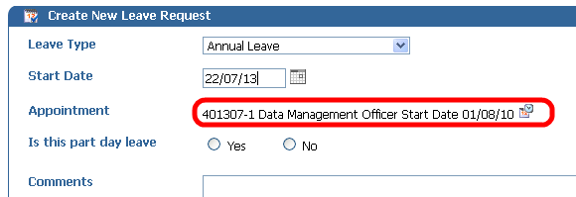
Select the Yes or No button to indicate if this is a half day leave request or not. If you select No the system will enter a default and date for a 1 day request:
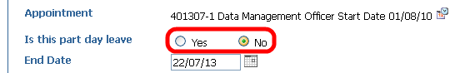
Use the calendar icon again to select a different end date if the request is for more than one day. You can also type this in the format shown above.
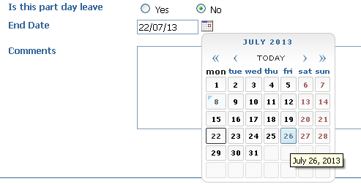
Add any relevant comments for your Line Manager > select the Submit button to submit your Annual Leave Request:
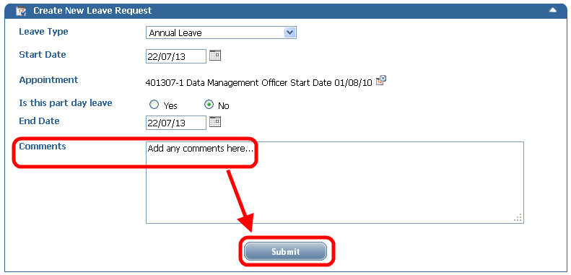
Once submitted you will see a confirmation message > select the X at the top right to close this window:
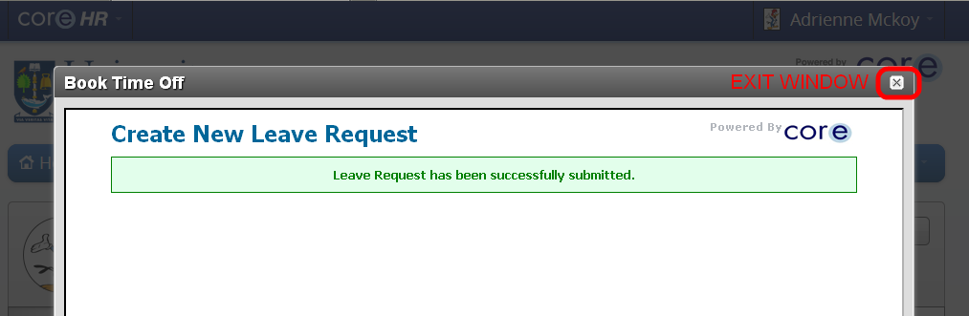
On the My Time page select the filter to display your submitted leave requests:
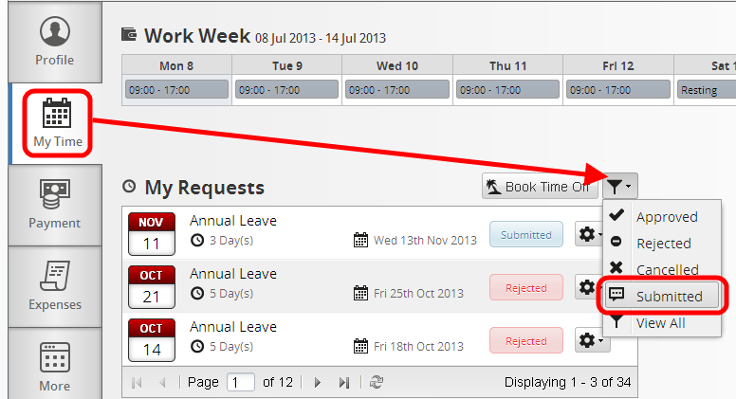
Navigate to the request you have just submitted > select the tools icon to View Details:
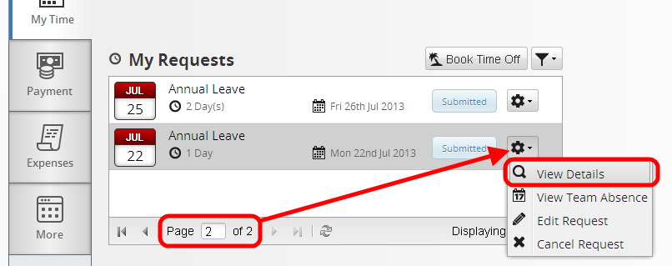
Edit Request This will display the details of the submitted leave request > select Edit Request:
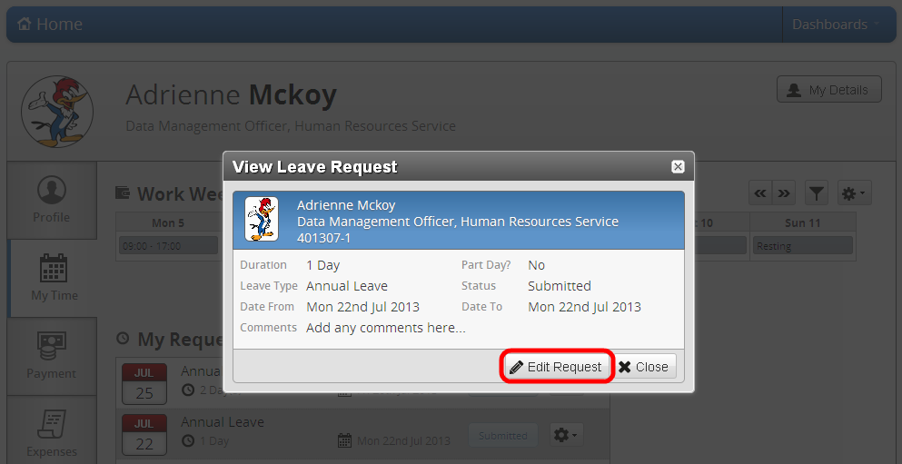
(You can also close this window by selecting the Close Button or the X at the top right)
The Edit Request – Update Leave Request window will display, you can edit any of the highlighted fields and submit the request with your changes:
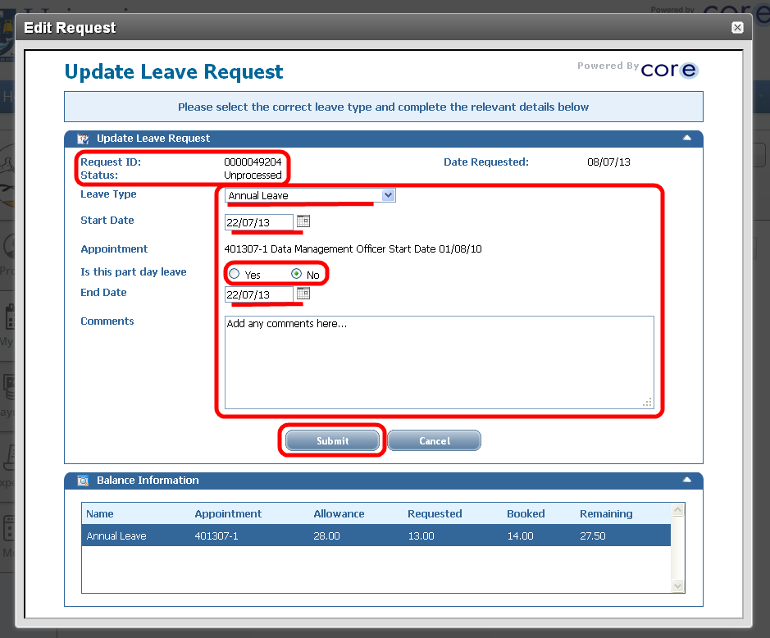
You can also select the option to Edit or Cancel Request by selecting the tools icon on the right:
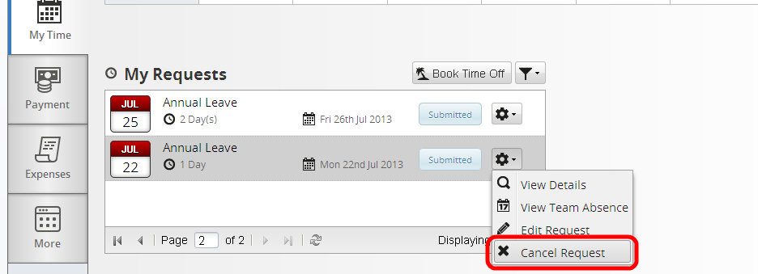

Update Personal Details – My Details button
Select the Home button to return to the Profile page > select the My Details button:
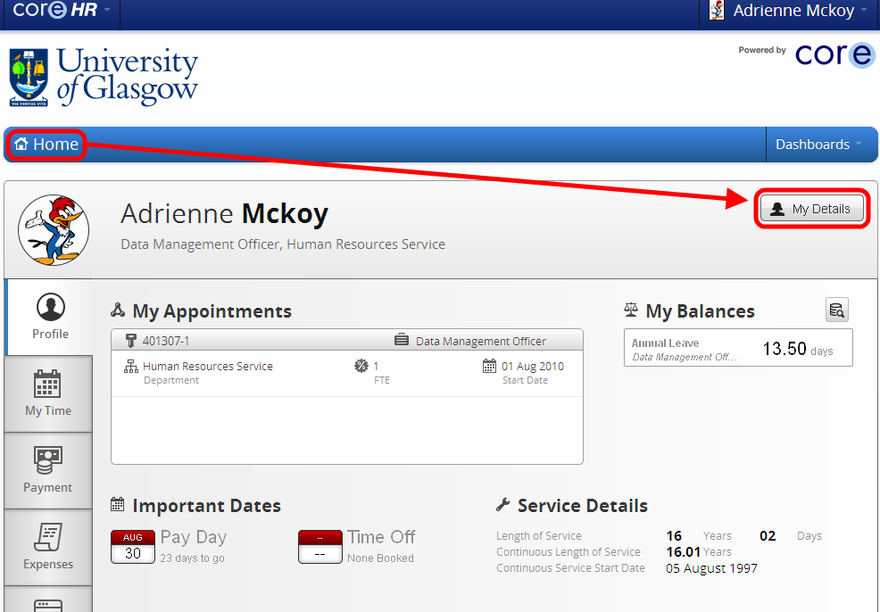

Next of Kin details
This will take you to the Employee Profile screen > My Next of Kin Details. Update any of the details below then press the Save button:
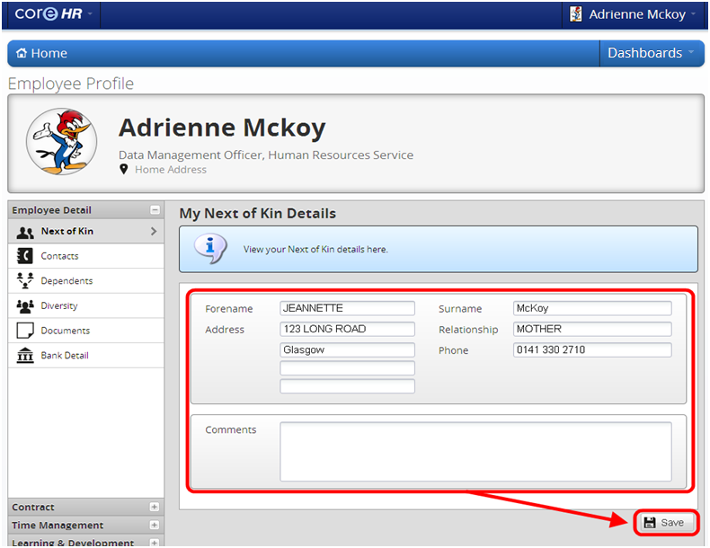

Contact Details
Select the Contacts from the Employee Detail options > select the tools icon > click to edit contact details:
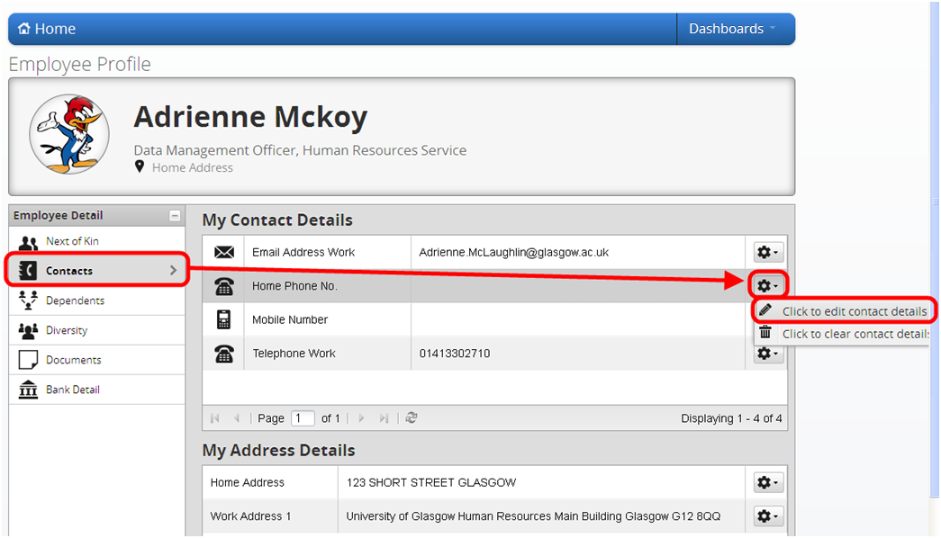
(You can also select the click to clear contact details option to blank out the contact detail you have selected.)
On the following screen we can add in a Home Phone No. to this record:
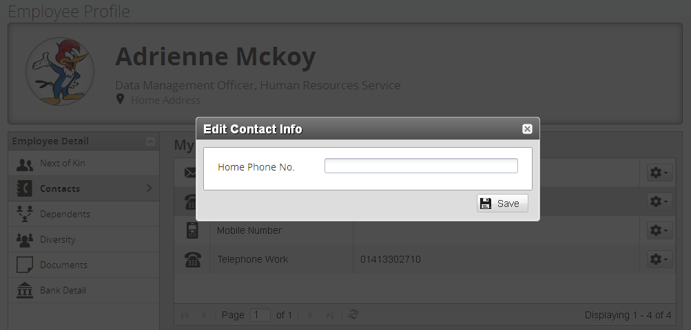
Enter a Home Phone No. then press the Save button:
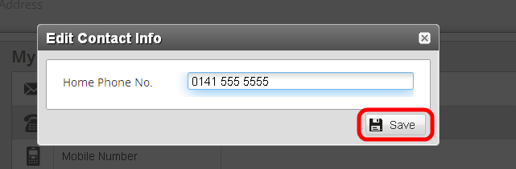
You will then return to the Contacts page and see a confirmation message “Details successfully updated”:
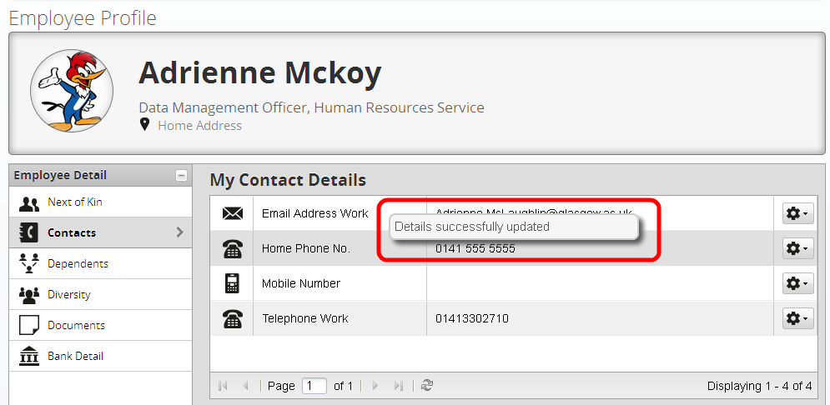

Address Details
My Address Details shows the same options as the Contact Details with the addition of a Map > select Tools > Map for:
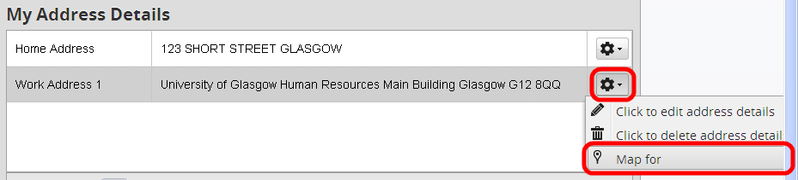

Dependants Details
On the Employee Detail section > select Dependants (the record below has no details to display) > then select the Add New button:
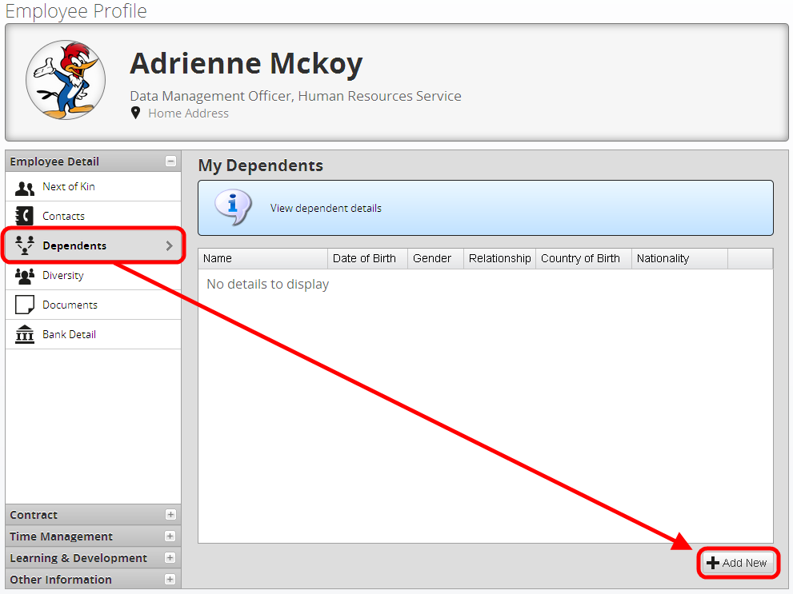
The following screen will display:
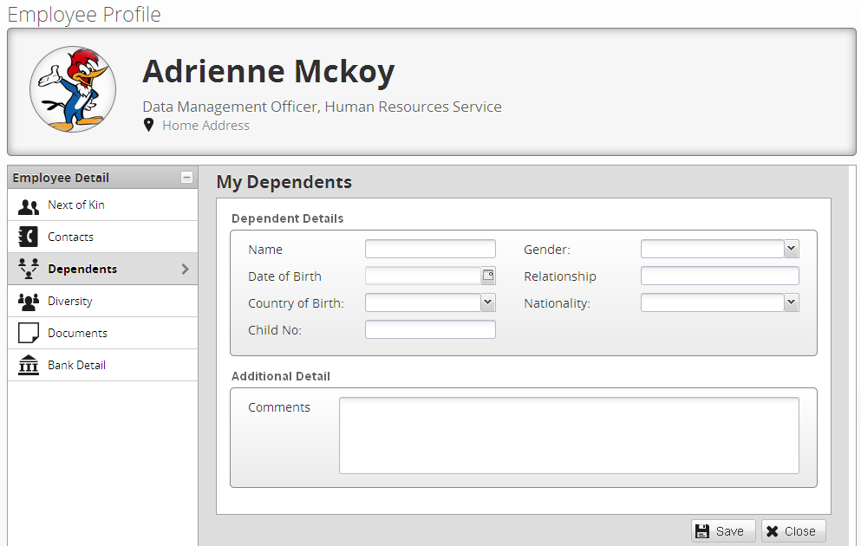
Add in all relevant details in the fields above; Name; Gender; Date of Birth; Relationship; Country; etc.
The Name, Relationship, Child No. and Comments fields are all free text. The Gender, Country of Birth and Nationality fields are drop down lists. On these you can type the beginning of the word and it will auto populate the available choices, see the examples below:
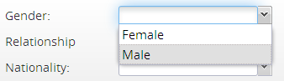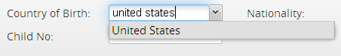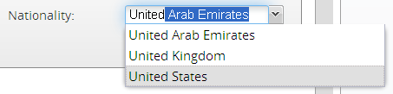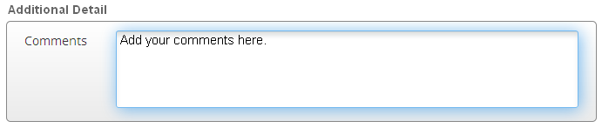
The Date of Birth field is a calendar you can select from by navigating to the correct date.
Select the Calendar icon to open the calendar pop-up display > you can use the arrows to change to the Next Month:
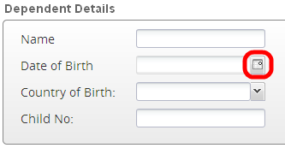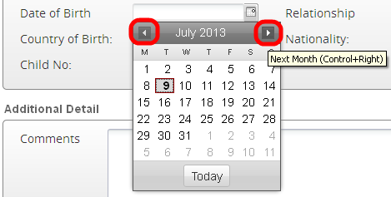
If you need to select an older date such as 09/08/1979 then you can do the following:
Select the date as indicated below:
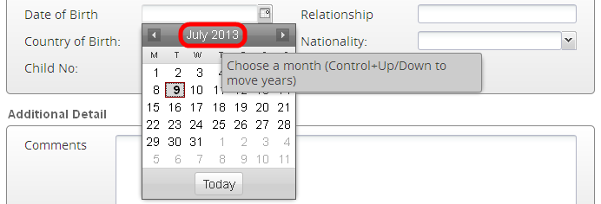
This will display two fields, one with the months and the other with the years > select the month / year you require using the mouse > press ok > then select the correct date and this will close the calendar:
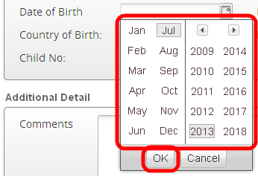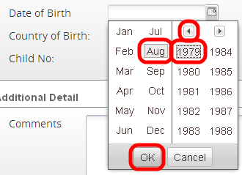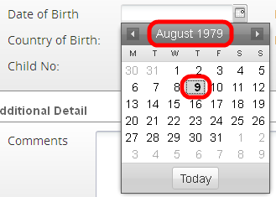
Once you have selected the day/date on the calendar the date will populate in the Date of Birth field:
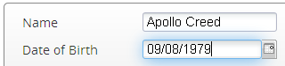
All of the fields should now be complete > press the Save button: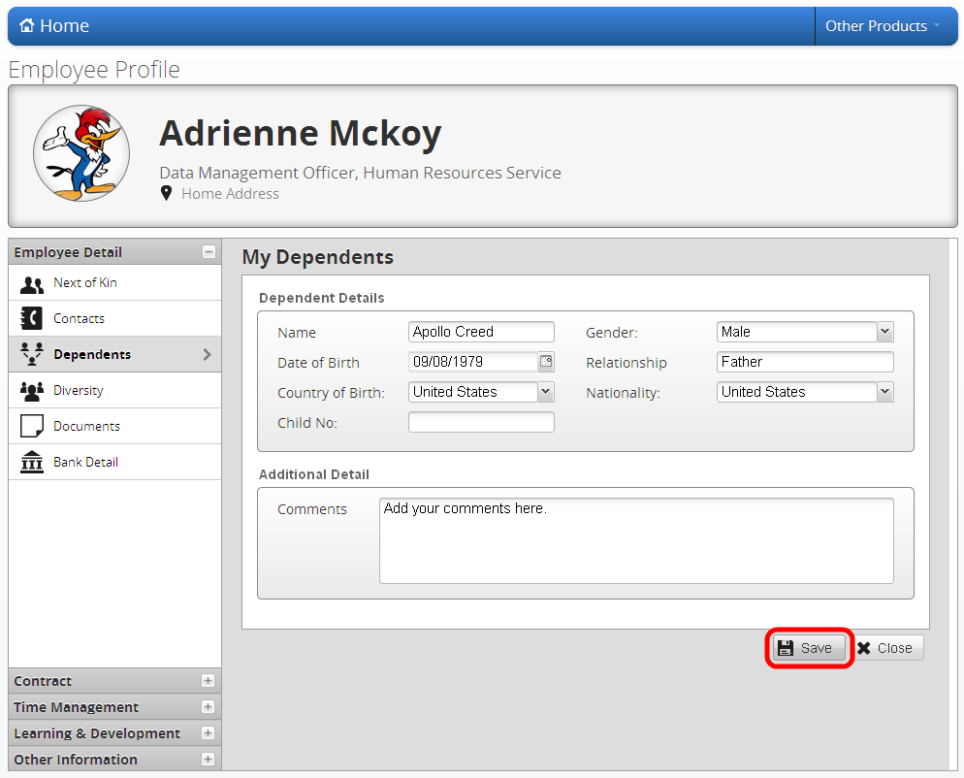
You will then see the following message:
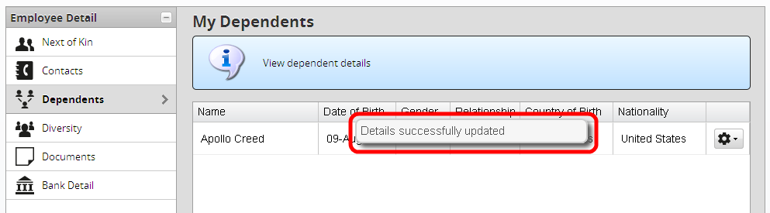
Now you are able to View/Edit or Delete this entry > select the tools icon and either View/Edit or Delete:
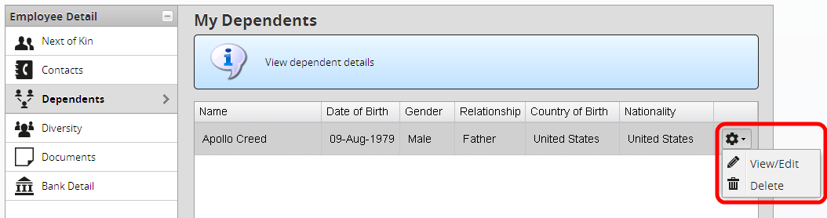

Diversity Details
On the Employee Detail section > select Diversity > then update any relevant details from the fields shown below:
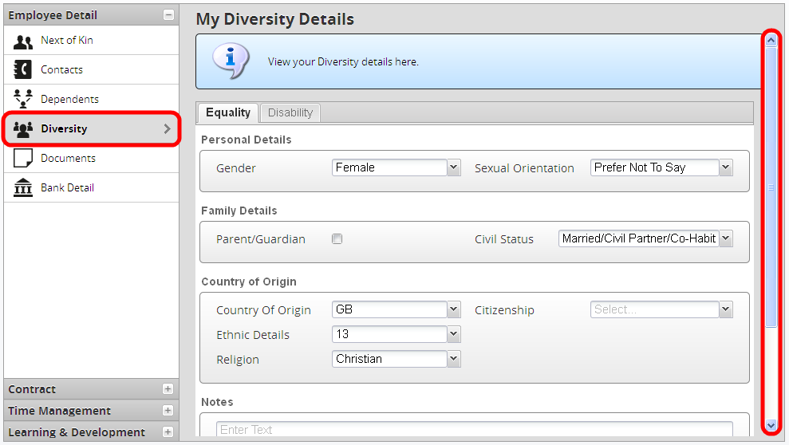
The Save button is at the bottom of the screen if you scroll down:
Select the General tab to show the following Disability fields:
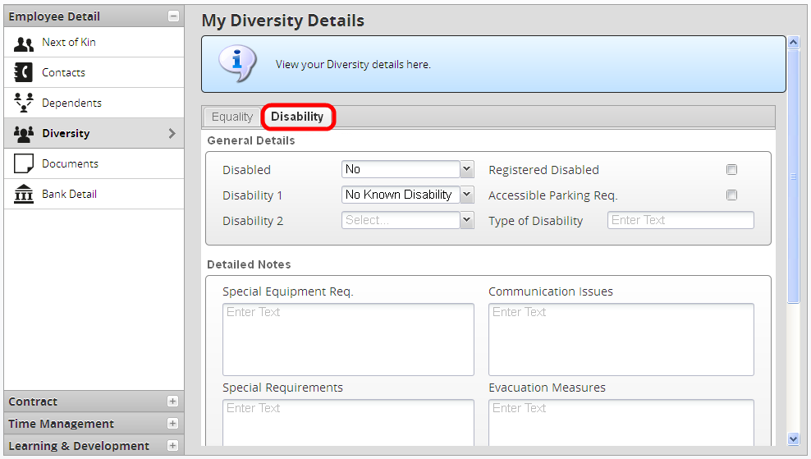

The following confirmation message will then display to confirm that Your details have been successfully updated:
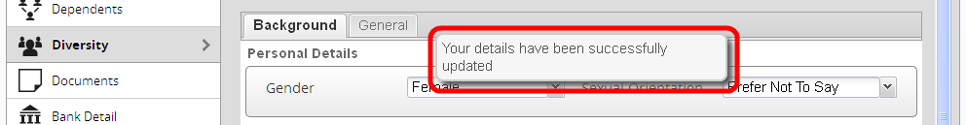

Documents
Your P60s will appear. Also any links to any relevant documents for help with CoreHR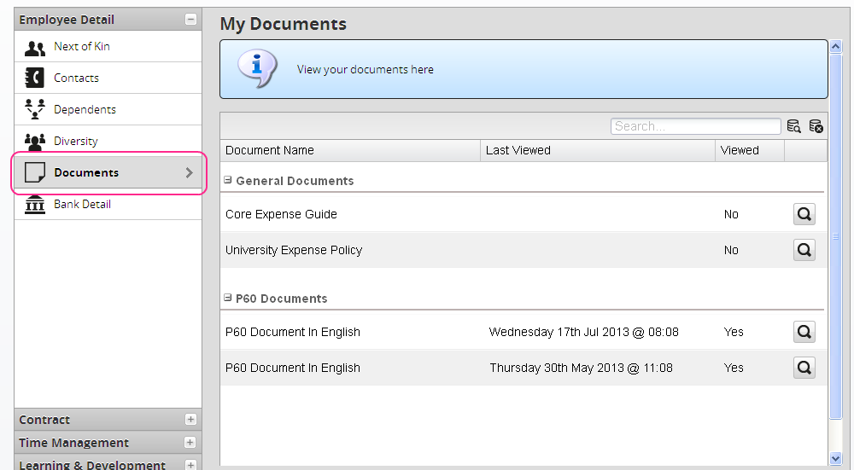

Bank Details
On the Employee Detail section > select Bank Detail to view the My Bank Detail screen below > select the view icon:
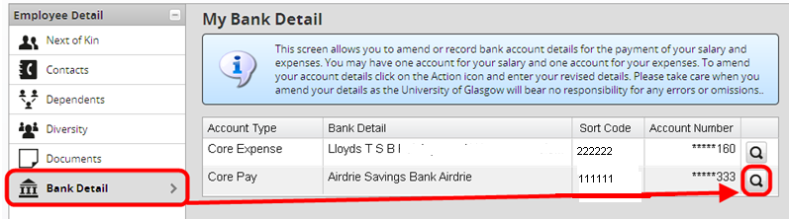
The Account Details: Core Pay window will display > update the relevant fields including the Sort Code and Account Number twice> check the Declaration then press Save:
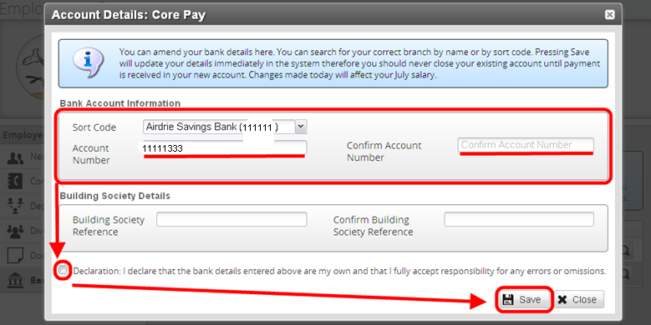
After pressing save the following password confirmation will display > enter your CorePortal password > press the Confirm button:
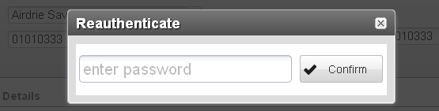
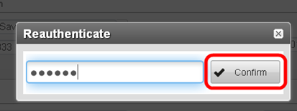
A confirmation message will display to confirm that your Bank Details saved successfully:
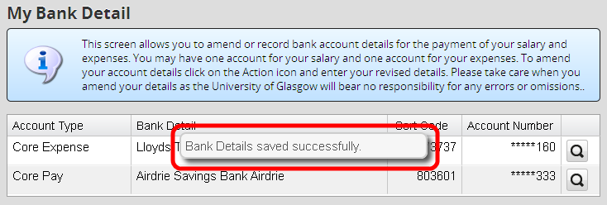

Contract Details
To view your contract details > select the Contract box from the Employee Detail menu
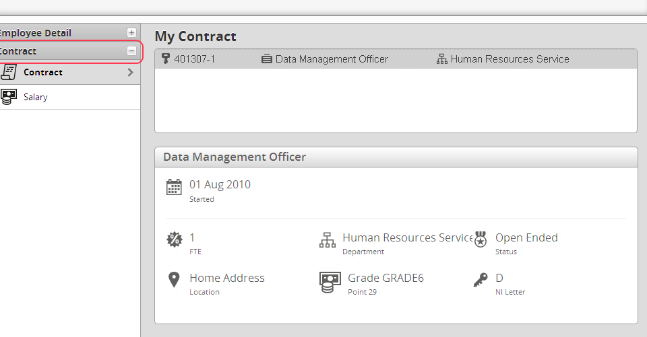

Below are descriptions of what each item is referring to:
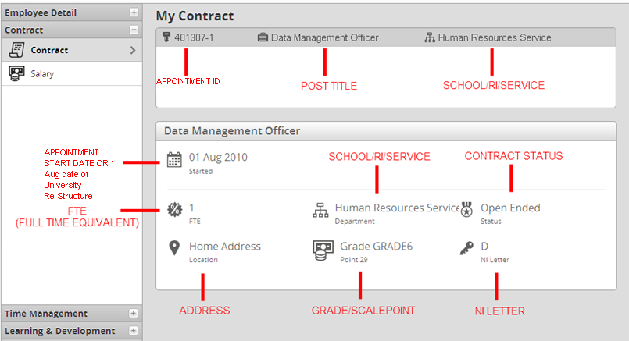
Now select the Salary option from the Contract menu:
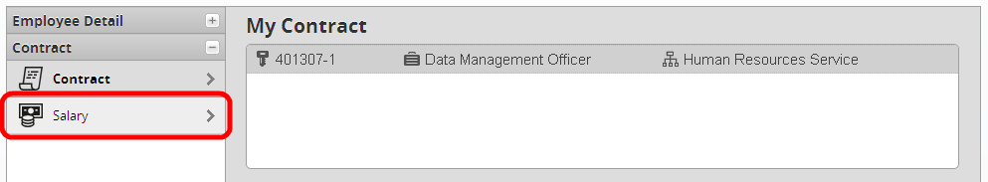
The following screen will display showing details of your salary in future release:
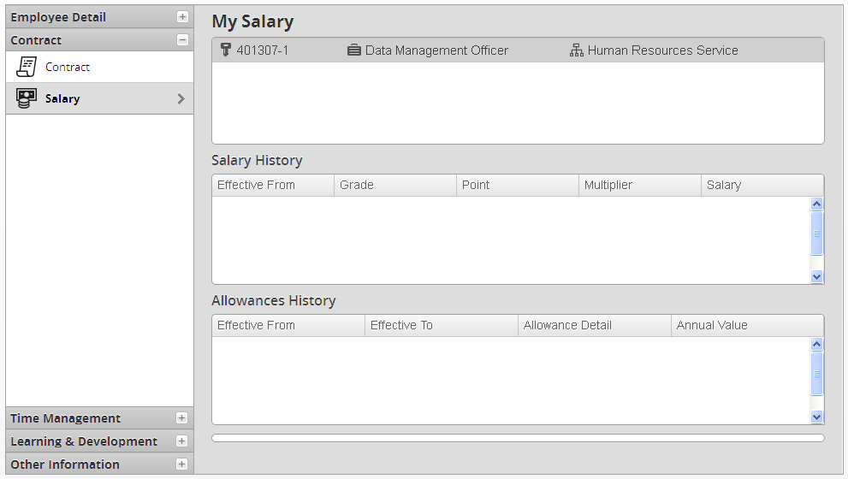

My Time
Now select the Time Management option from the Employee Detail Menu:
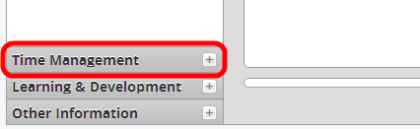
The previous screen will display and you will see the following sub-menu options:
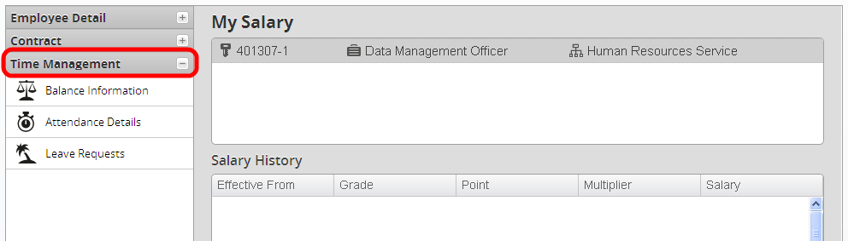

Balance Information
Select the Balance Information option from the menu:
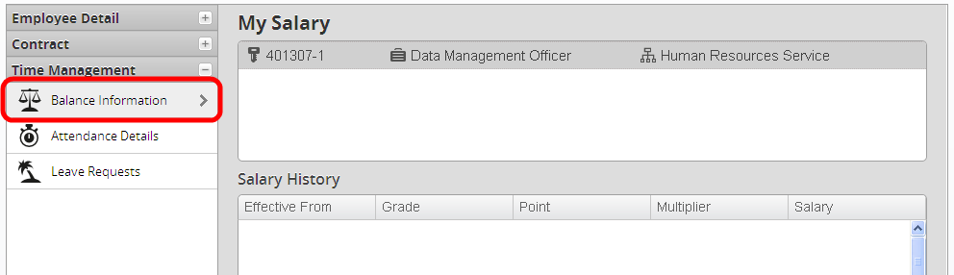

The following screen will display showing information on your annual leave balance including any balance adjustments:
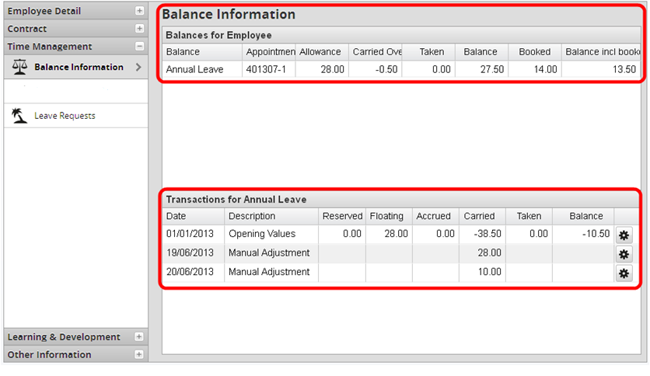
Note: Some of the manual adjustments that display here will include any adjustments done for staff members who have worked on a Public Holiday or Other Day.
You can also select the Tools icon to view any narrative attached to the balance adjustment, if there is one:
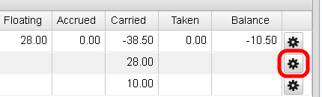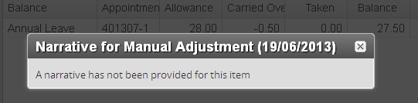

Leave Requests
Now select the Leave Requests option from the Time Management menu:
Here you will see a history of your leave requests including those that have been submitted, rejected or cancelled:
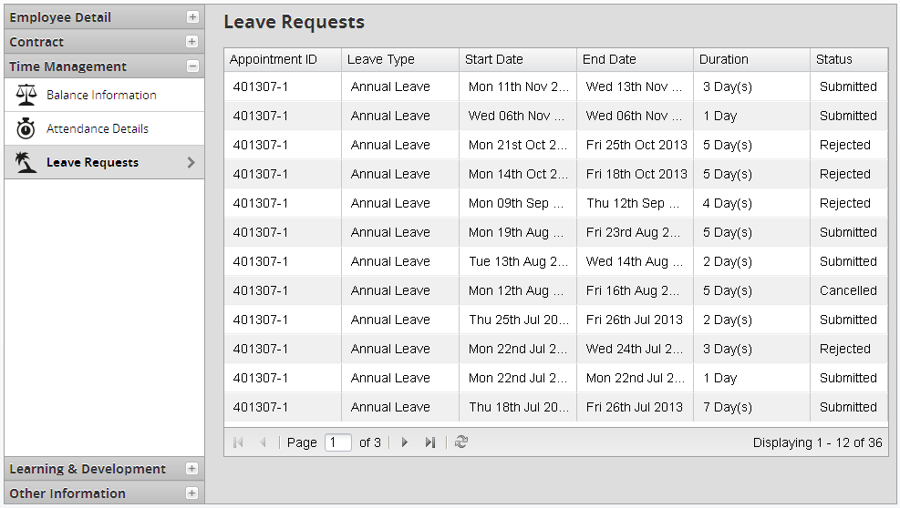

Learning & Development
At present the options available to complete are Professional Bodies; Qualifications; Languages.
Select the Learning & Development section of the Employee Detail menu:
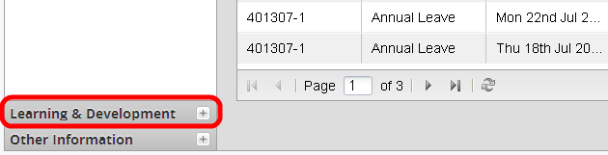

Professional Bodies

Select the Professional Bodies option from the Learning & Development menu > select the Add New button so we can add to this screen: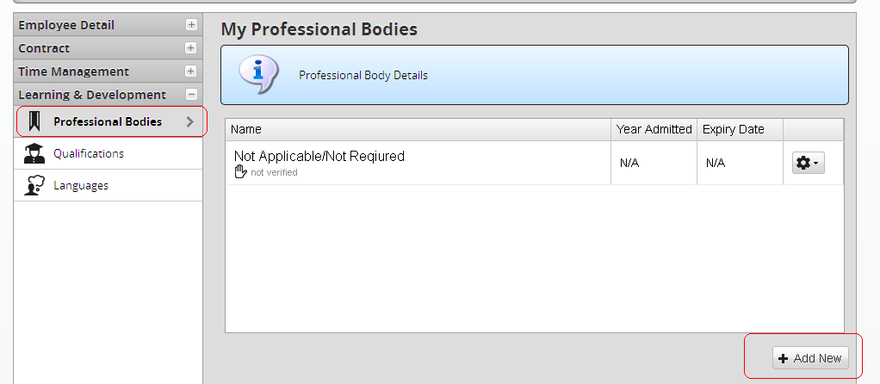

Select the relevant Professional Body from the drop down list
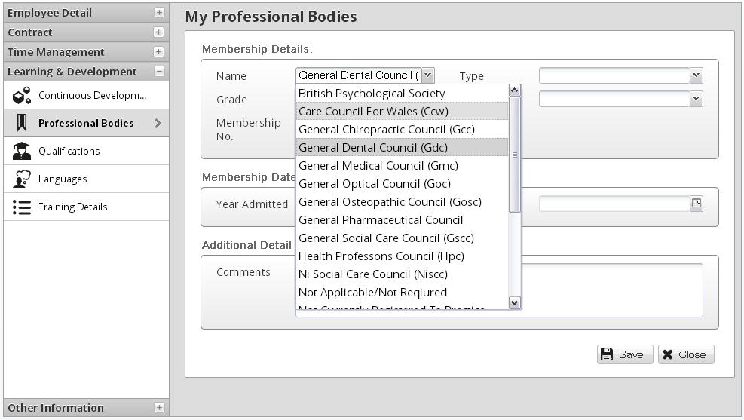

After the Professional Body has been selected, continue to fill in the rest of the information and click Save
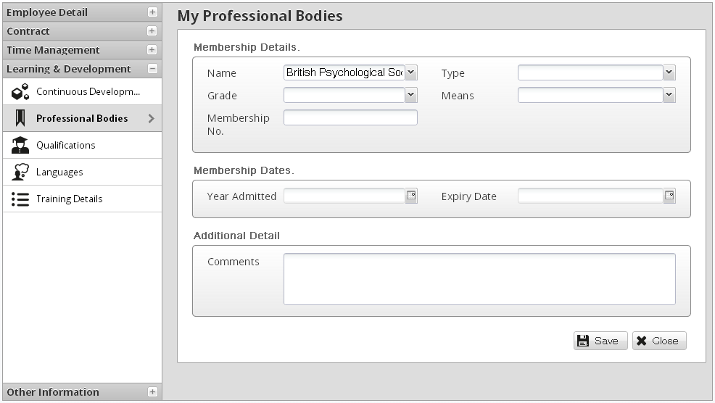
**Reference data is missing

The page will now update to include the new Professional Body
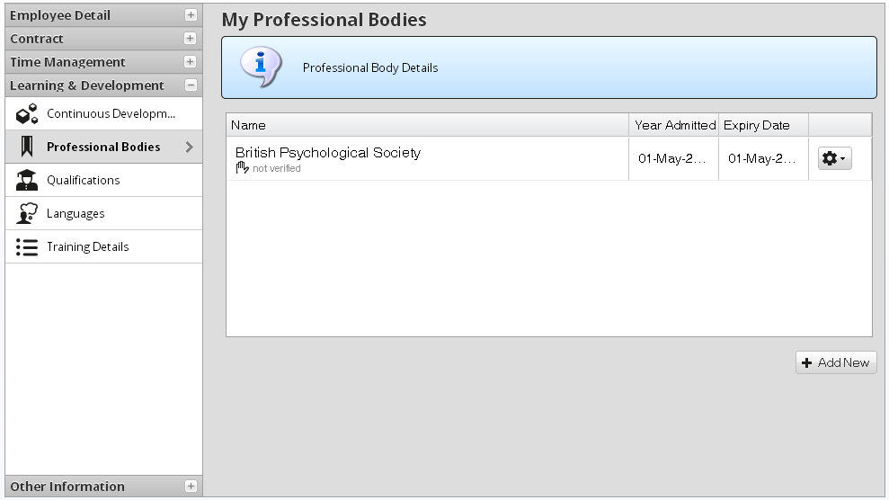

Qualifications
Select the Qualifications option from the Learning & Development menu > select the Add Qualifications button so we can add to this screen:
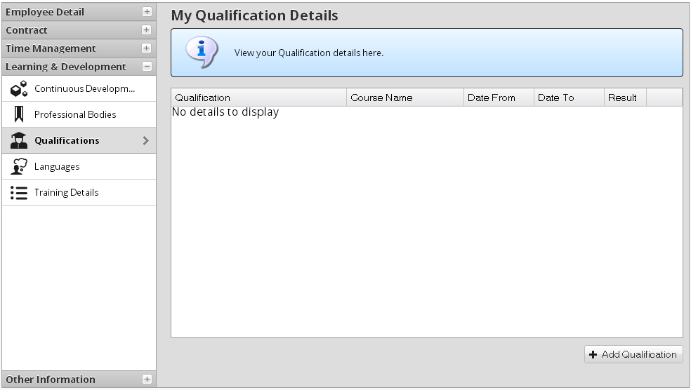
Select the relevant Qualification from the drop down list
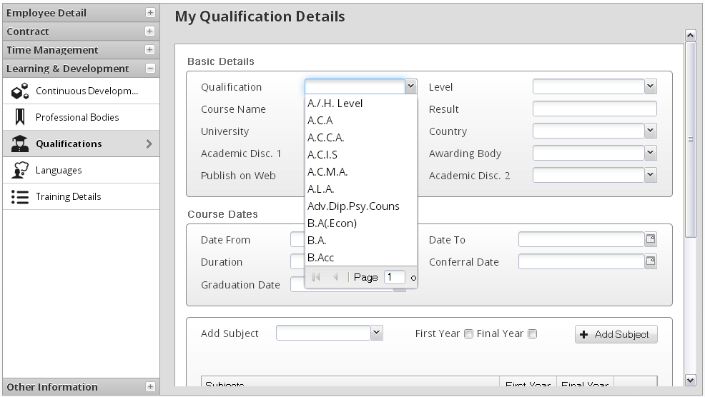

After the Qualification has been selected, continue to fill in the rest of the information and click Save
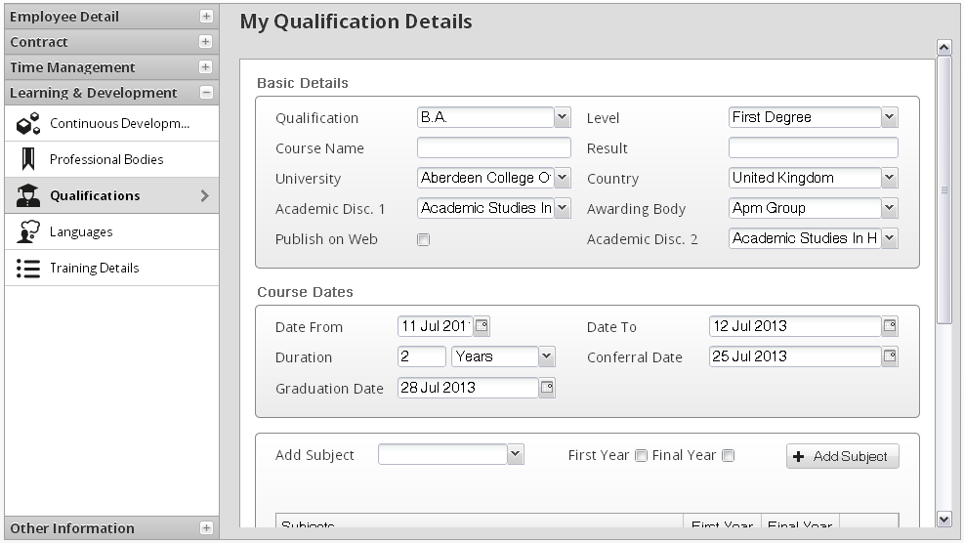

The page will now update to include the new Qualification
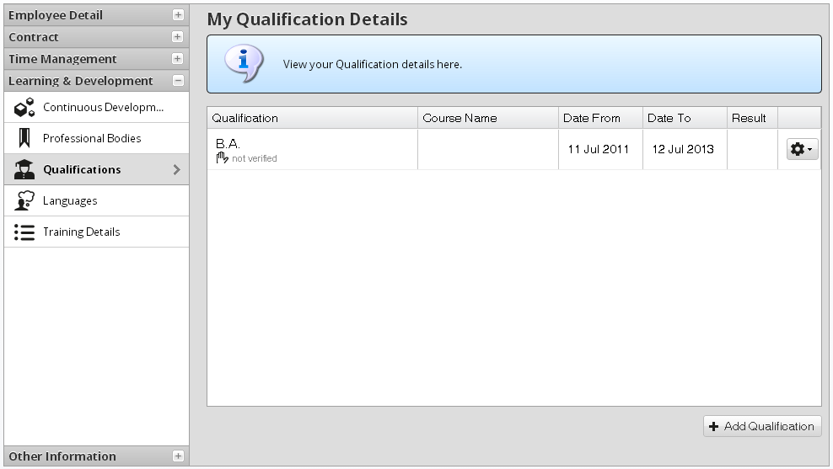

Languages
Select the Languages option from the Learning & Development menu > select the Add New button so we can add to this screen:
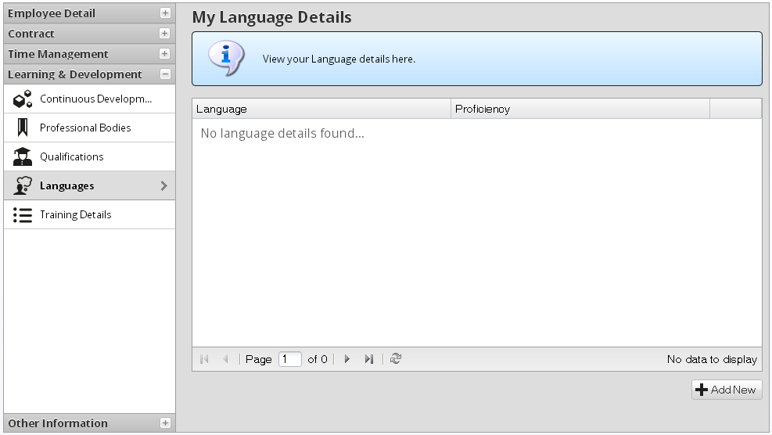

Select the relevant Language from the drop down list
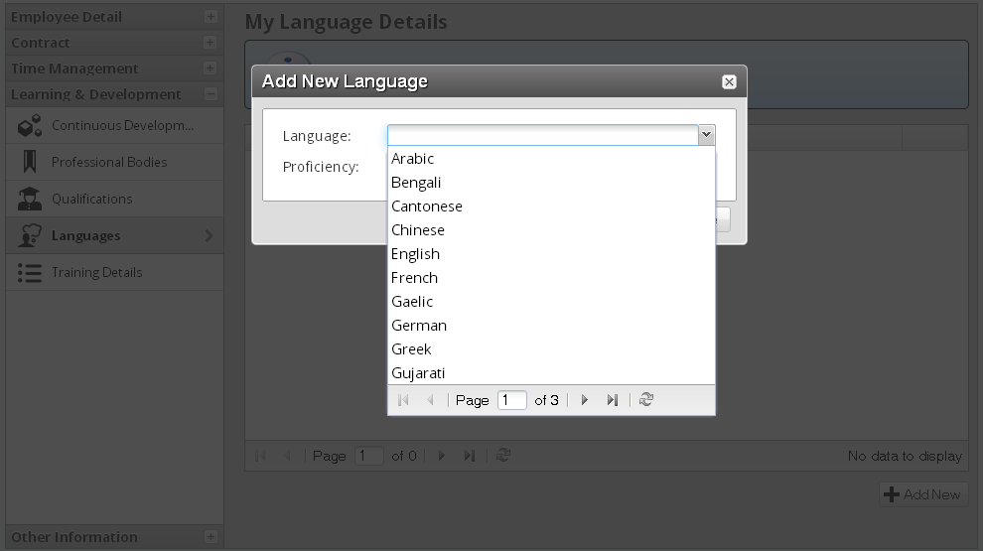

Then select the proficiency then click on
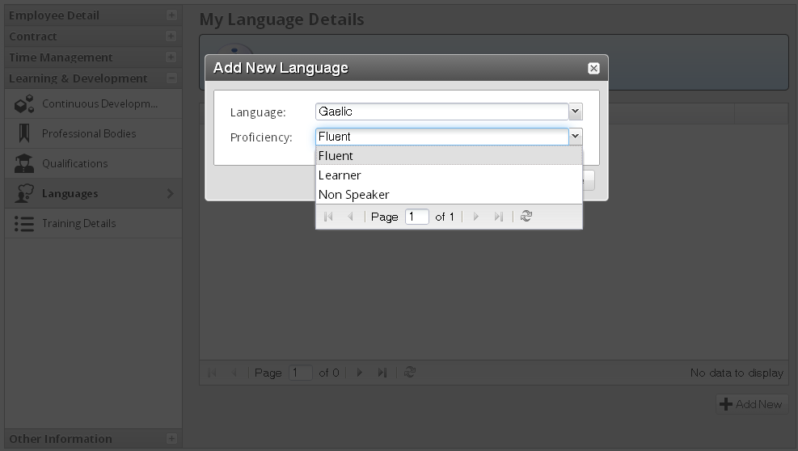

The page will now update to include the new Languages details
