Centre for Medical & Industrial Ultrasonics (C-MIU)
Laboratory 1, Room 324, James Watt South Building

CODE OF PRACTICE

The adoption and practice of good safety procedures are of paramount importance both for the health and safety of fellow workers and for the integrity of the fabric of the C-MIU laboratory.

Note: No latex products are to be brought into the laboratory
- No work may be carried out in the C-MIU Lab 1, Room 324, James Watt North Building without the prior permission of one of Professor Margaret Lucas, Professor Sandy Cochran, Dr Paul Prentice, Dr Helen Mulvana and Dr Andrew Feeney (Lab Guardian).
- Online risk assessments must be completed for specific tasks, or for the use of specific items, and it must be approved by your supervisor, the appropriate responsible person(s) (see list below) and the Lab Guardian (Dr Andrew Feeney), BEFORE ANY WORK COMMENCES. As examples, such work may involve high voltages, use of a laser, use of chemicals or biological cells/materials. The list is not exhaustive. https://risks.eng.gla.ac.uk/
- Prior to any lab access being granted, every new user must undertake an in-person lab induction with one of the following: the Lab Guardian (Dr Andrew Feeney); Dr Helen Mulvana; Dr Paul Prentice; or an authorised member of C-MIU Management. This will include an overview of activities in the lab, signposts to risks and hazards, a review of the Code of Practice, and the requirement of a signature of the new user confirming that the standards and guidelines will be adhered to at all times. If relevant, new (undergraduate or postgraduate) students will be assigned a lab buddy to ensure a safe induction to the lab and to allow time to learn the required experimental techniques.
- New staff and students should also make themselves aware of safety procedures and of the location of safety equipment in the lab.
These are:
Emergency telephone number: 4444
Fire Extinguisher (Next to entrance door, beside Area 5, see floor plan below)
First Aid kits (JWS Level 3: Janitors box, Level 4: Tuck lab)
Ear protection (Hanging inside the main lab door)
Laser safety spectacles (Hanging inside each lab, by the door)
Emergency exit (through main building entrance, through the exit leading to the Wind Tunnel lane or through James Watt North)
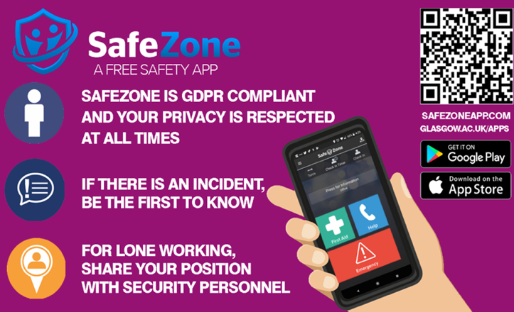
- Work outwith standard office hours and weekend working requires the permission of your supervisor. If permitted, the out-of-hours working book located in the foyer of the JWS building must be signed (on arrival and departure). You must download the Safety Zone App. The SafeZone App is very useful for every member of staff and student at the UofG as it is monitored 24 hours a day by the Campus Security team, safeguarding the safety and security of our staff and students throughout their time at UofG. Please either click here to download on your phone or use the QR code shared in image below.
- Various lasers are used in this lab, with Class IV lasers contained within the laser enclosure (sliding door entrance, to the left of the main lab entrance). DO NOT ENTER THE ENCLOSURE when the LASER IN USE sign is illuminated.
- All new lasers, and users of lasers and high power light sources in the School should register with John Nelson and watch the laser safety video owned by the University (on DVD and kept by John Nelson – Paul Prentice also has a DVD). The laser-safety video should be made available to new users of lasers within 1 week of the user reporting to the laser safety officer. The new user will then complete the University’s laser user registration form. Records of all laser users are held by the University Radiation Protection Service. Existing users of lasers should view the video at least every 5 years to maintain awareness of developing safety issues and best practice.
- For your own safety, ear protection and laser safety goggles must be used when required.
- Considerations for codes of practice and risk assessment for the James Watt School of Engineering can be found here:
(https://www.gla.ac.uk/schools/engineering/informationforstaff/safety/)
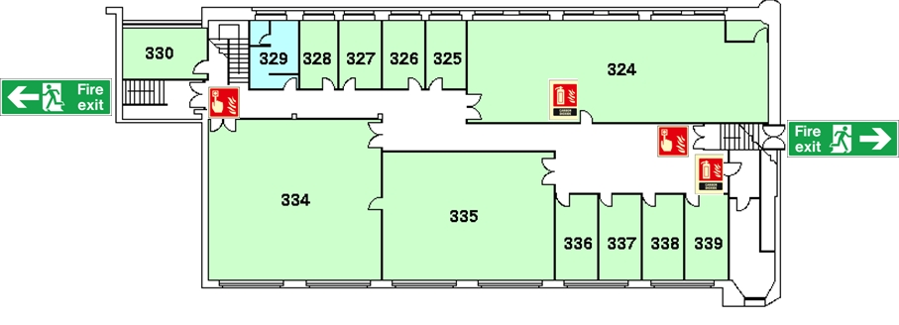James Watt building North Level 3: Floorplan

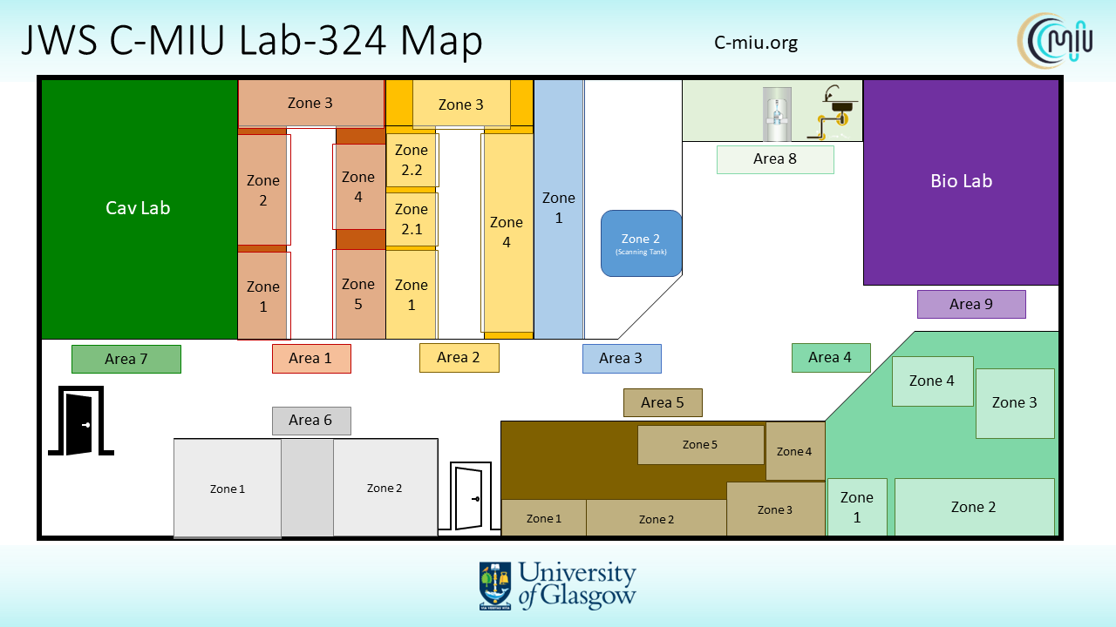
Area management floorplan

GENERAL LAB PRACTICE

  - To minimise trip hazards, extension cables should be plugged into the closest available socket.
    - Once equipment is not in use, it should be turned off and any extension cables used should be tidied to a suitable location.
    - Leads and plugs should ONLY be used on the allocated item of equipment and should NOT be swapped between equipment
    - The gain on power amplifiers should be set to zero when not in use.

  - Electrical connectors between different devices or equipment should be safe. If in doubt speak with electrical technicians (Rm 619).
  - If you are unsure how to correctly use an item of equipment, seek assistance from an appropriate responsible person(s) (see list below).
  - The fridges in the lab are used to store perishable ultrasound phantoms and contrast agents, and therefore should only be used for this intended use. Do not use to store food/drink in the lab fridges. (see list below detailing what can be stored in each fridge and freezer)
  - The hot water urn in the lab is for heating water for experiments only.
  - If outside clothing or bags are brought into the lab they should be hung on the hooks by the main entrance
  - All lab users must wear a standard lab coat at all times when working in the lab. This includes visitors who may bring their own, or borrow one of the spare lab coats available.
- Food and drink are not permitted in the lab.
- Once experimental work has been completed and the experimental setup is no longer required, the experimental area should be cleared in preparation for another researcher/experiment. The following practices should be followed after the completion of experimental work;
    - Equipment should be placed in an appropriate location ensuring its safety, minimising potential damage and allowing other researchers access to it.
    - The experimental area should be wiped or cleaned. This is NOT the responsibility of the cleaners.
- Laboratory doors should remain locked at all times to ensure security.
- If equipment is required to leave the lab, permission is required from your supervisor and the equipment owner if the two are different individuals, if necessary, seek assistance. The Lab Guardian must be notified of all equipment being relocated.
- If equipment breaks down or is not working, report the fault to your supervisor immediately.
- A fault with the fabric of the room, such as a lighting failure, should be reported through Maintenance Request found on the Estates and Buildings webpage, https://ebweb.cent.gla.ac.uk/helpdesk/default2.asp
- All non-contaminated broken glassware, slides and coverslips, blades and needles, including pipette tips must be disposed of in the sharps bins provided.
- There are two sinks in the lab. The sink in the Biolab is a general hand wash sink for all lab users. The sink in area 8 is not for hand washing, and can be used for cleaning.
- Use of space in the lab will be managed by the PIs, the Lab Guardian (Dr Andrew Feeney) and supported by C-MIU Management, in collaboration with the School Safety Coordinator. Please consult with your supervisor if space for experiments is required.

Laser work
- If you plan to use any laser equipment you must first consult John Nelson and Paul Prentice to receive appropriate training on how to safely use that device. Goggles are provided for your safety, use them at all times whilst you operate any laser. General guidelines on using lasers can be found at; http://www.gla.ac.uk/schools/engineering/studentstaff/safety/.
- Class IV lasers are contained within the interlocked laser enclosure. Do not enter the enclosure when the LASER IN USE sign is illuminated. Goggles for the appropriate wavelengths and powers are available (hanging inside the laser enclosure door) and must be used at all times a laser is operational. Lasers include:
A frequency-doubled pulsed Nd:YAG, emitting at 532 nm
Operating instructions are available at the laser enclosure safety station.
- The laser blocking blind over the window must be closed during the use of any laser, within the enclosure.
Other laser vibrometers are located in the main lab.
    - When any laser vibrometer is in use, the LASER IN USE sign outside the main lab door must be illuminated, and all lab doors must remain closed.
    - Lasers should never be directed at any entrance to, or window of, the lab.

Biological work
- If you are doing experiments in the Biolab then you will require a specific induction to the Biolab before you can undertake any work (contact Helen.mulvana@glasgow.ac.uk to arrange).
- In addition:
    - You will require specific training on the techniques you will use
    - You should prepare an appropriate RA for your activity with relevant CoSHH, and where relevant you should consult with the technicians team (eng-biotechs@glasgow.ac.uk). You should add Helen Mulvana, Andrew Feeney and the relevant technician as reviewers.
    - No work should be carried out that involves tissue of any kind or from any source, or cells of any kind or from any source, without first agreeing appropriate handling, decontamination and a waste management plan with the technician’s team, and which should be included in your RA.
    - All culture work must be carried out in the laminar flow cabinet (cell culture hood). Only cell culture work may be carried out in the laminar flow hood. A fume hood is available for non-sterile activities.
- The -20°C freezer in the Biolab may also be used to store biological waste prior to incineration. If you wish to make use of the freezer for this or any other purpose, you must first discuss this with Helen Mulvana, and by way of your RA [23, ii], the technicians.
- All solid waste products from culture work i.e. plastic petri dishes, pipettes must be placed in the Biological Waste containers which are collected for disposal (contact Elizabeth Palmer). Glassware must be disinfected after use by complete immersion (or completely filling large bottles and fully swabbing outsides) in Virkon for a minimum of 2h prior to washing and/or disposal.
- All spillages must be disinfected and cleared immediately with Virkon (1% in water) where possible (if Virkon cannot be used, for example inside the cabinet, 70% ethanol should be used instead).
- Cultures and used medium must be disinfected by mixing with Virkon for at least 24h before disposal.
- Familiarise yourself with the waste management routes and appropriate bins through signage in the Biolab or information on TEAMs. DO NOT attach the lid to any bin (sharps, biological or chemical waste) before it is full and ready for collection.

Specific named items and responsible persons
- The following people are responsible for specific equipment/areas in the lab corresponding to the “Area management floorplan” on Page 2. It should be emphasized that no work should be undertaken within these areas before training and approval has been obtained from the relevant person(s).

Location | Setup | Point of Contact (email address)
Area 1 (Zone 1) | Ultrasound Imaging Microscopy | Sandy Cochran (sandy.cochran@glasgow.ac.uk)
Area 1 (Zone 2) | Capillary preparation | Paul Prentice (paul.prentice@glasgow.ac.uk)
Area 1 (Zone 3) | Sonocat acoustic detection | Paul Prentice (paul.prentice@glasgow.ac.uk)
Area 1 (Zone 4) | TBC (to be confirmed) | Paul Prentice (paul.prentice@glasgow.ac.uk)
Area 1 (Zone 5) | Water Degassing Zone | Paul Prentice (paul.prentice@glasgow.ac.uk)
Area 2 (Zone 1) | Autocapsule Electronic Setup | Alex Hamilton (alexander.hamilton@glasgow.ac.uk)
Area 2 (Zone 2.1) | ESD-Safe Soldering Station | Ben Jacobson (ben.jacobson@glasgow.ac.uk)
Area 2 (Zone 2.2) | OnScale PC | Paul Daly (paul.daly@glasgow.ac.uk)
Area 2 (Zone 3) | 3D Printers | Paul Daly (paul.daly@glasgow.ac.uk)
Area 2 (Zone 4) | Small tank set up | Helen Mulvana (helen.mulvana@glasgow.ac.uk )
Area 2 (Zone 5) | Verasonics | Hide Metzger (hilde.metzger@glasgow.ac.uk)
Area 3 (Zone 1) | Transducer Fabrication | Paul Daly (paul.daly@glasgow.ac.uk)
Area 3 (Zone 2) | Scanning Tank | Alex Moldovan (alexandru.moldovan@glasgow.ac.uk)
Area 3 (Zone 3) | Hydrophones | Hilde Metzger (hilde.metzger@glasgow.ac.uk)
Area 4 (Zone 1) | Laboratory Oven | Paul Daly (paul.daly@glasgow.ac.uk)
Area 4 (Zone 2) | Acoustic Microphones | Alex Hamilton (alexander.hamilton@glasgow.ac.uk)
Area 4 (Zone 3) | NDT | Mahshid Hafezi (mahshid.hafezi@glasgow.ac.uk)
Area 4 (Zone 4) | Dynamic Mechanical Analysis | Mahshid Hafezi (mahshid.hafezi@glasgow.ac.uk)
Area 5 (Zone 1) | Optical Setup | Alex Hamilton (alexander.hamilton@glasgow.ac.uk)
Area 5 (Zone 2) | TBC | Alex Hamilton (alexander.hamilton@glasgow.ac.uk)
Area 5 (Zone 3) | Material Characterisation Drawers | Alex Hamilton (alexander.hamilton@glasgow.ac.uk)
Area 5 (Zone 4) | Material Characterisation Tray | Alex Hamilton (alexander.hamilton@glasgow.ac.uk)
Area 5 (Zone 5) | PCs for Impedance analyser O/P | Alex Hamilton (alexander.hamilton@glasgow.ac.uk)
Area 6 (Zone 1) | Degassed Water Storage | Paul Prentice (paul.prentice@glasgow.ac.uk)
Area 6 (Zone 2) | TBC | Alex Hamilton (alexander.hamilton@glasgow.ac.uk)
Area 7 | Cav Lab | Paul Prentice (paul.prentice@glasgow.ac.uk)
Area 8 | Sink etc. | Paul Prentice (paul.prentice@glasgow.ac.uk)
Area 9 | Bio Lab | Helen Mulvana (helen.mulvana@glasgow.ac.uk)
Area (Virtual) | COMSOL | Paul Daly (paul.daly@glasgow.ac.uk)

Access to C-MIU Setup/ Equipment Booking System and C-MIU Forum
- Access to setups within C-MIU labs are strictly regulated via membership of our online booking system on Clustermarket. Therefore, after gaining approval from your supervisor, please submit your membership request to C-MIU Centre Management. In order to gain access to C-MIU forum for discussion on different setups (some with video tutorials), please again reach out to Centre Management.

-o-
Signature spaces for recognising the completion of the formal laboratory induction process:

Name of Inductee | Signature | Date

Name of PI | Signature | Date

