This document outlines the precise steps you can follow in order to enrol your Apple device into Jamf Pro. Its main uses are:
- Ensuring users have a step by step how to on getting their Mac enrolled.
- Act as a troubleshooting document in case users see unexpected device behaviours.

Guide Name | UIE (User Initiated Enrolment) Device Enrolment Guide | Version & Date | 1.0  26/01/2023

Contents
1. Introduction 2
2. Enrolling your Mac 3
2.1. Step 1 3
2.2. Step 2 4
2.3. Step 3 5
2.4. Step 4 6
2.5. Step 5 6
2.6. Step 6 8
2.7. Step 7 9
2.8. Step 8 10

Introduction
This guide will show you step by step on how to enrol your MacBook into the new device management platform Jamf! If for any reason any of the steps below do not work or you are struggling, please don’t hesitate to get in touch with IT support and someone will be there to assist.

*PLEASE NOTE* Please do not interrupt the enrolment process once it has begun as this could lead to data loss and loss of access to your Mac account!

Enrolling your Mac

Step 1
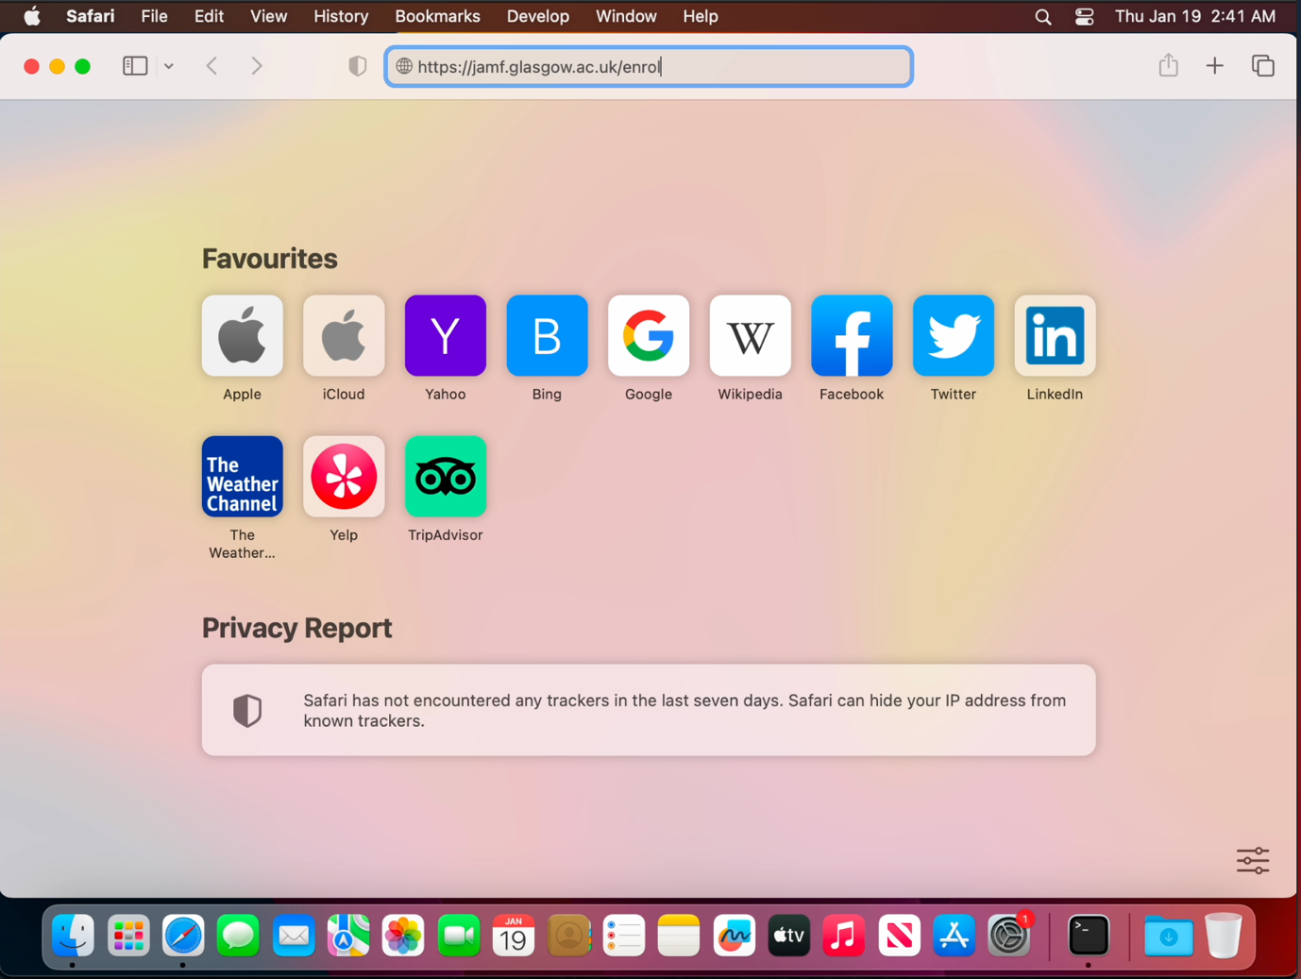Go to Safari and type https://jamf.glasgow.ac.uk/enrol then hit enter.

Step 2
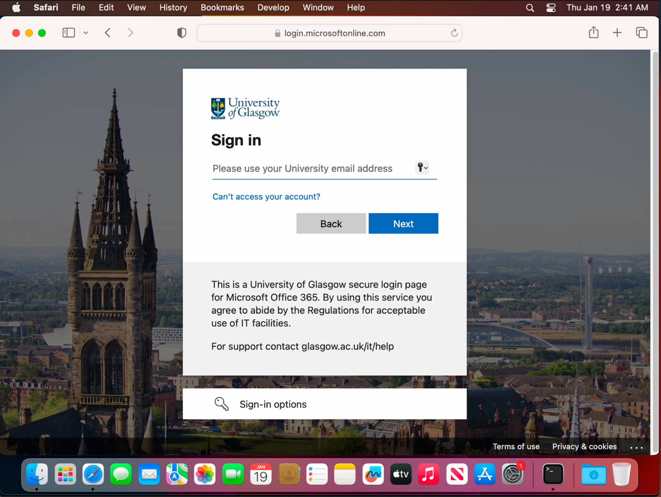You will be greeted with the Azure authentication window. This is to ensure that you have the relevant permissions to enrol a device into the organisation. Enter your credentials and follow the authentication process.
*NOTE* If you have 2FA enabled or MFA enabled you will see the below screen. Either authenticate on the Microsoft Authenticator App or your 2FA Phone number.
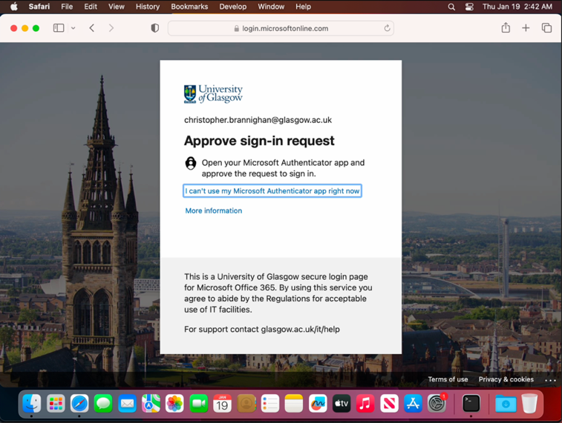

Step 3
You will be taken to an enrolment page. Here you will see a blue continue button. Click it. This will download the MDM profile needed to manage your device.
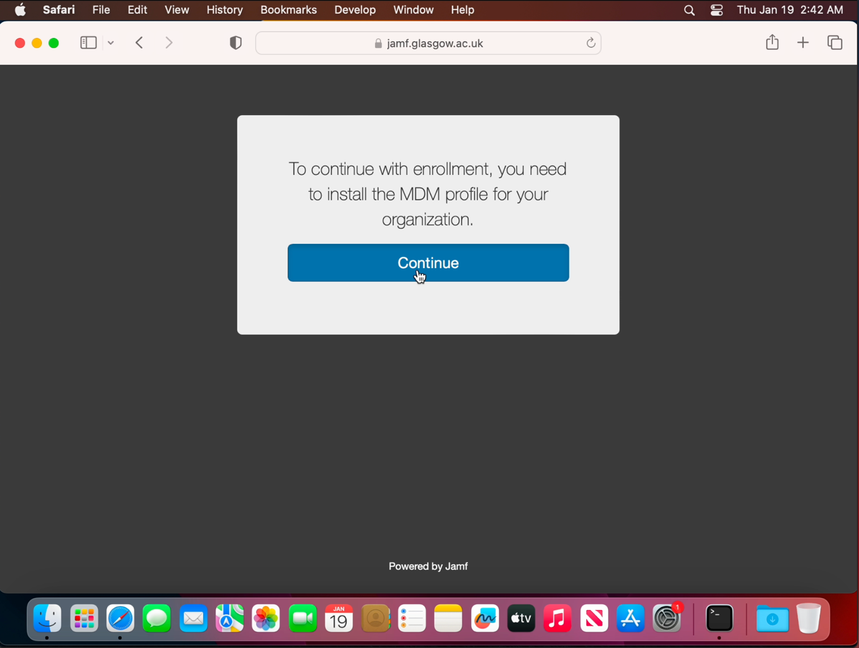

Step 4
Go to system preferences and search for “Profiles”. This will take you to the Profiles section within system preferences.
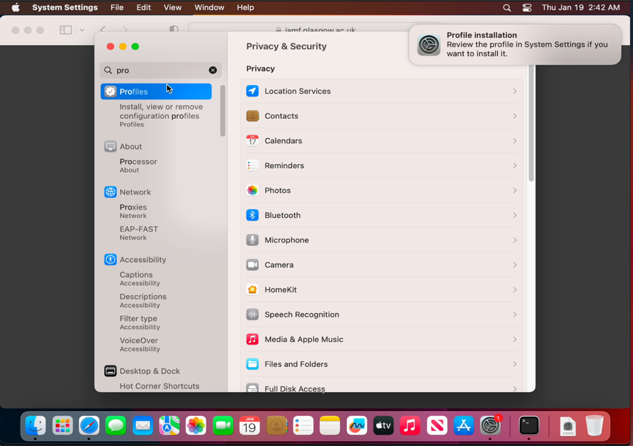

Step 5
Double click the MDM Profile and install.

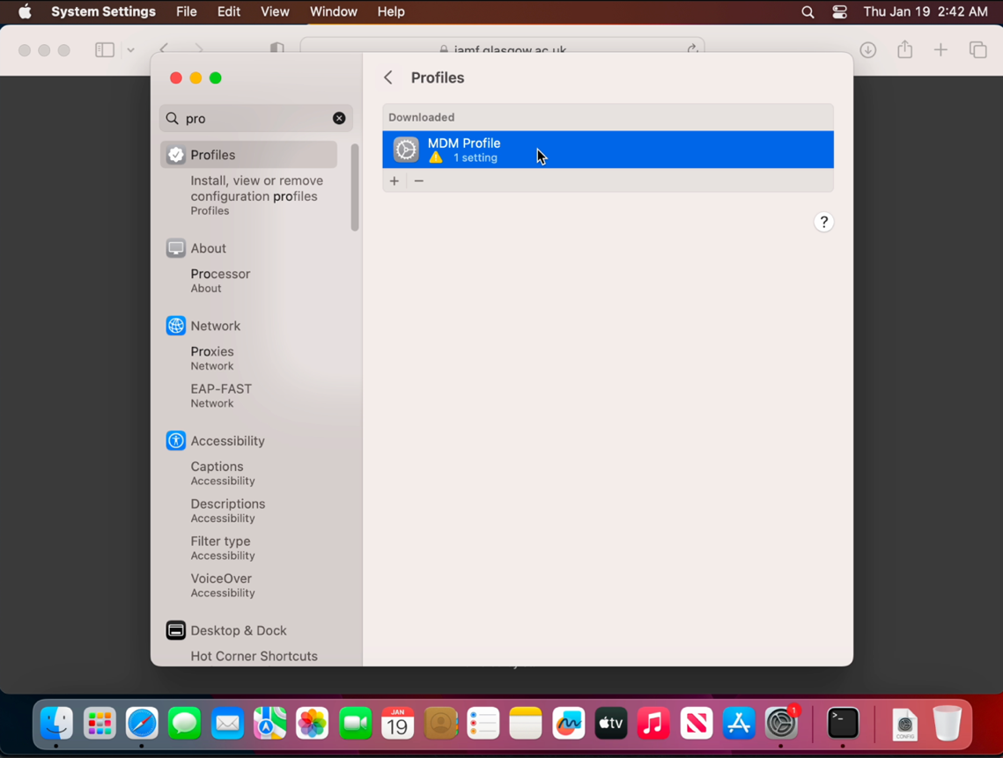

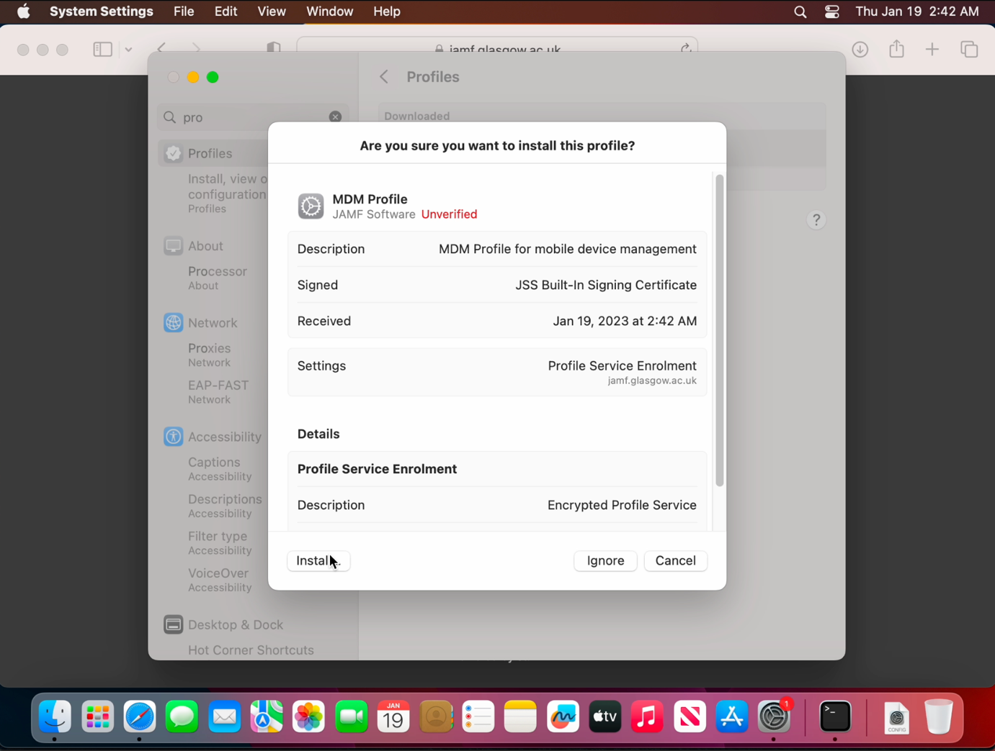

Step 6
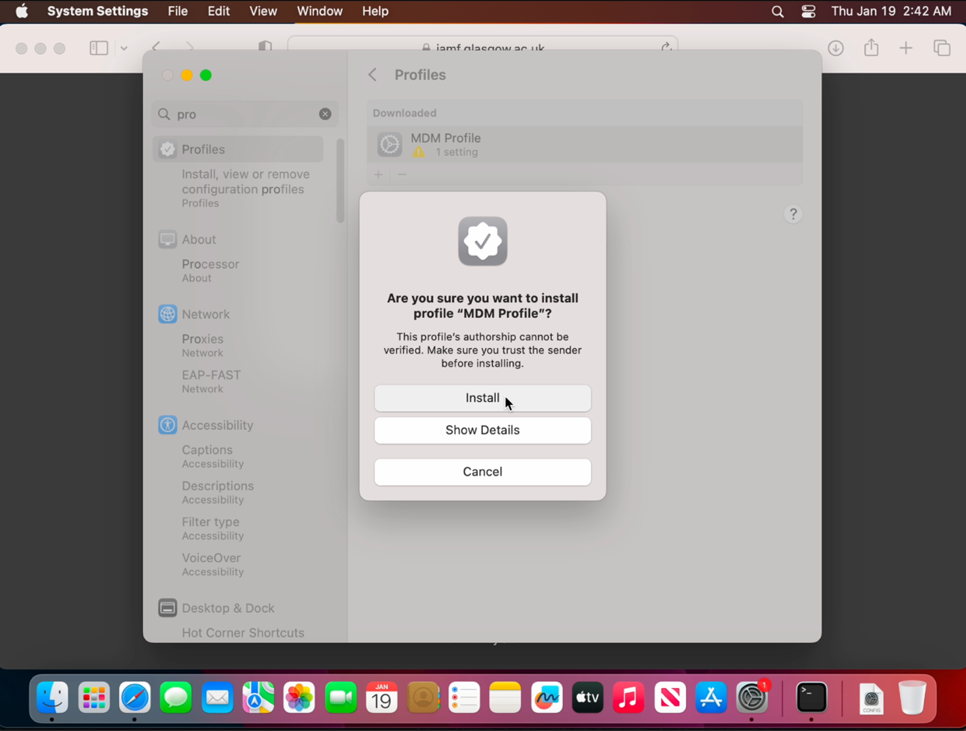You will be prompted for an admin password. This will most likely be the password you use to login to your Mac. Type this in and click enrol.
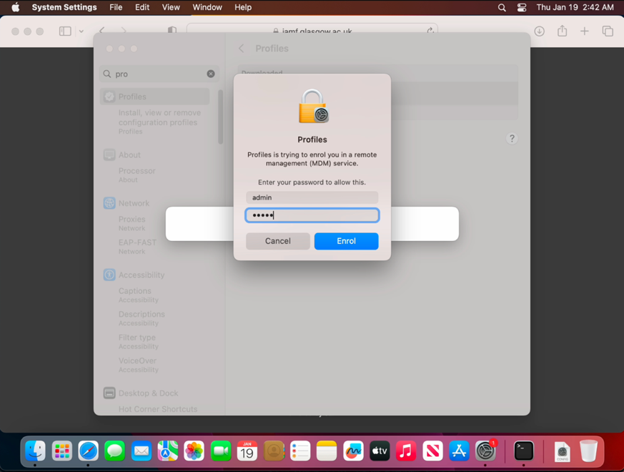

Step 7
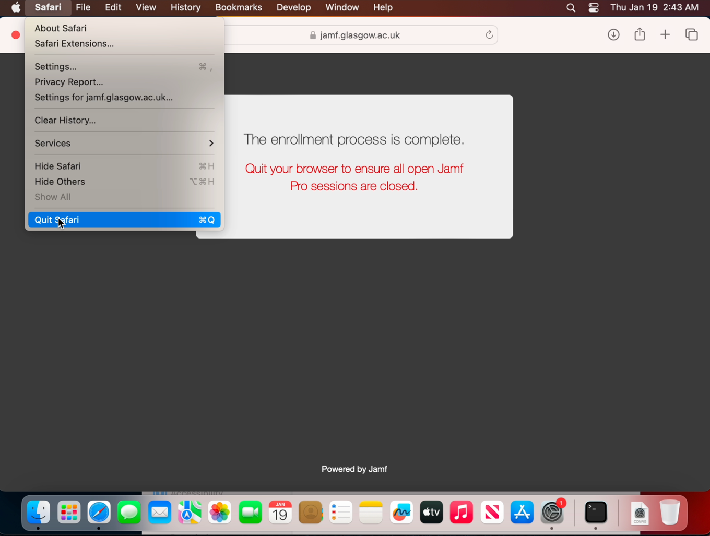You should now see on the enrolment window the following message advising enrolment is complete.

Step 8
The next screen you should see will be the “setting up my Mac” screen. Once this has completed you will be taken back to your desktop. You may notice that your Doc may have changed. Please feel free to customise your dock as you wish.
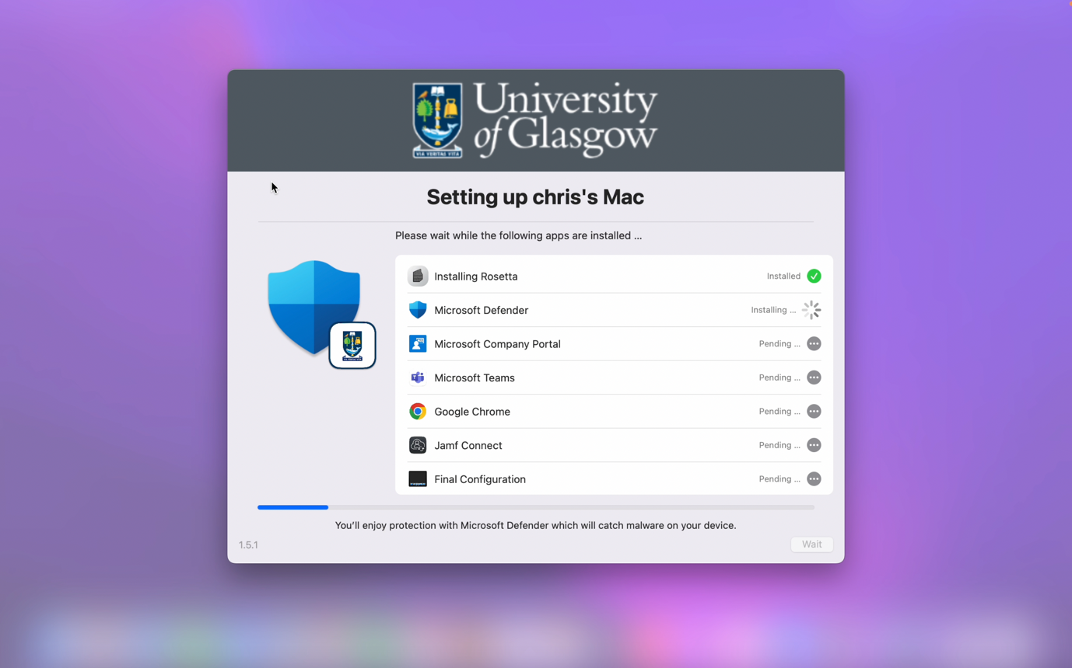

*NOTE* If you see the below screen, please select “Connect” to connect your current account to Jamf Connect. This will ensure that you log back into your current macOS account where all of your data is stored.
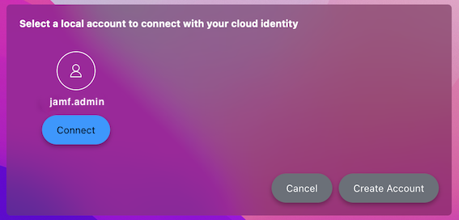

*NOTE* If you restart your machine or power off and boot back up you will be met with the FileVault authentication window. This will appear with an empty username and password box. Your username will be in the format of “firstname.lastname” and your password will be the same as your UofG password.

Revision History
Date | Author | Summary of Changes
26/01/2023 | Chris Brannighan | Document created
Approvals
Name | Title | Date of Issue | Version
Distributions
Name | Title | Date of Issue | Version
IT Service Desk

