POLICY: MANAGEMENT

SAFETY POLICY STATEMENT
Your health, safety, and welfare at work within the School of Infection & Immunity (Sii) are very important - we take this seriously and aspire to ensure for you a safe, secure, and, thus, rewarding environment.
Your health, safety and welfare at work are protected by the Health and Safety at Work Act 1974 along with other regulations and approved codes of practice. The policy of the School of Infection & Immunity ensures that arrangements are in place at every level of operation to maintain a working environment where the health and physical safety of staff, students, visitors and other occupants of our school’s buildings are assured. These practices are compliant with the relevant statutes above.
Our policy covers all members of Sii. We note however that work ongoing in our School is located within several University and NHS buildings namely, the Sir Graeme Davis Building (Glasgow Biomedical Research Centre), Joseph Black Building and MRC- University of Glasgow CVR (located in Garscube campus buildings: Sir Michael Stoker Building, Henry Wellcome, Jarrett, Ian Botham, McRobert, and Urquhart). The school also has clinical facilities at the Royal Infirmary and Gartnavel General Hospital. (Staff at the Royal Infirmary and Gartnavel General Hospital are covered by CNORIS, a risk management scheme for the NHS Scotland).
Our policy supports and underpins University policy, which can be found in detail at the University Safety and Environmental Protection Services (SEPS). The school recognises that safety requirements enacted by law are set to a minimum standard. For this reason, the school is committed to constantly reviewing safety standards and, as far as resources permit, to continually improve these standards to thereby exceed base requirements. Our policy will further complement the University’s policy by describing the organisational structure for safety in the Institute and by indicating potential hazards and precautions required to prevent accidents and ill-health.
To achieve successful management of health and safety at work, every member of staff within the school must actively participate to ensure that they behave in a manner that will not adversely affect the welfare of colleagues. The implementation of this policy is carried out through the Head of School who has delegated responsibility through the Head of College and ultimately the University Court.
All staff, students and registered visitors are required to observe the health and safety rules and standards and adhere to the School’s Health and Safety Policy Statement. Deliberate deviation from established health and safety rules and standards may result in disciplinary action. This policy statement will be reviewed by the safety committee of the School of Infection & Immunity at least annually.
Policy objectives:
• To provide safety guidance for best working practices
• To enhance UofG safety policy with details specific to activities within the school
• To ensure training needs are recognised and applied to ensure a safe working environment
To the extent that any individual has control over a University of Glasgow resource, he or she must also accept responsibility for this aspect of its performance. Thus, every member of staff who manages or directly supervises the work of others is responsible for their health and safety. They must make sure that colleagues, students, and visitors understand what they must do to ensure their own safety and the safety of others.
Professor Andy Waters
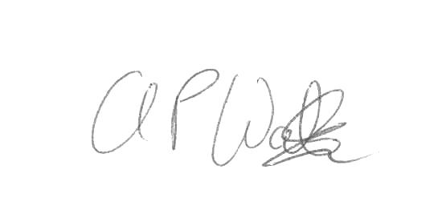
Head of School of Infection & Immunity
1 March 2023

