Equal Pay & Equality Pay Gap Analysis

- Introduction
Our World Changers Together strategy sets out our ambitions to be a world class, world-changing University with our people at its heart. The strategy sets out our commitment to attract world-changing talent and develop, empower, and reward our people in line with our values and their contribution to our success. We seek the finest minds from around the world to join Glasgow’s growing international University community. Drawing strength from each other, and inspiration from the people, societies, and cities we serve, our diverse body of staff, students and alumni come together as one Glasgow community, driven by a unifying desire to change the world for the better.

This paper sets out the University’s commitment to reducing the equality pay gaps that currently exist. It reflects the University’s position as a leading organisation with an impressive track record in this strategically significant agenda and our ambition to further enhance our employer brand in attracting and retaining the very best available talent.

Our pay and grading structures are underpinned by a systematic and analytical approach to job evaluation designed to measure the relative value of roles in a consistent, transparent, and fair way. This, coupled with the introduction of professorial zoning and banding at senior executive levels some years ago, has clearly supported the narrowing of gender pay gaps within grades across the University.

The work we undertake to address the underlying factors impacting upon the gender pay gap continues in earnest. Consistent with the University’s commitment towards becoming an anti-racist and inclusive institution, we regularly report and analyse equal pay and pay gap data relative to ethnicity and disability.

Various actions are in train to tackle these pay gaps, informed by our success in narrowing the gender pay gap, and are aligned with the key themes of our People and OD Strategy 2020-2025. These are: Living our Values; Maximising Organisational Capability and Employee Experience, which equally support the University’s World Changers Together plan.

- Defining Equal Pay and Gender Pay Gap
The University has reported on both our Equal Pay Statement and the Gender Pay Gap since 2013, in accordance with the legislative provisions of the Equality Act 2010. In 2017, the University began reporting on both Equal Pay and Pay Gaps for ethnicity, and disability.

It is of note that ‘equal pay’ and ‘gender pay gap’ are distinct legal concepts which similarly apply to ethnicity and disability.
Equal Pay legislation prohibits any less favourable treatment between women and men in their terms and conditions of employment. The Equality Act 2010 gives both women and men the right to equal pay for equal work, with women and men being legally entitled to be paid at the same rate for like work, work rated as equivalent, and work of equal value.
Guidance published by the Equality and Human Rights Commission (EHRC) describes percentage differences that fall outwith 95-105% i.e. +/-5% as constituting a statistically significant difference in pay. Gaps of over 5% require to be investigated and acted upon while gaps that exceed 3% may also warrant further investigation where a pattern or a trend emerges, for example, where all or most of the differences are in favour of one sex.

The (Gender) Pay Gap is the average difference between the aggregate hourly earnings of men and women. Factors such as age, educational background, organisational size, the availability of part-time work and occupational segregation contribute to the existence and extent of the (gender) pay gap.

The census date for pay and demographic data informing these analyses is 31 August 2022, unless otherwise stated.

2.1 Gender Pay Gap
The University has made good progress in reducing our average gender pay gap from 14.7% in 2020 to 12.8% in 2022 as illustrated in Table 1 overleaf. This represents a reduction of 11.2% points from 24.0% since the University first reported its average gender pay gap in 2013. The median pay gap has fallen from 13.7% in 2020 to 8.4% in 2022, having reduced by almost 50% from 16.2% in 2018. A similar pattern is observed across average and median allowance gaps.

Table 1. UofG Average and Median Gender Pay and Allowance Gaps 2018 - 2022
Year | Average  Pay  (%) | Median  Pay  (%) | Average Allowance Gap  (%) | Median Allowances Gap (%)
2022 | 12.8 | 8.4 | 14 | 8.4
2020 | 14.7 | 13.7 | 16.3 | 13.7
2018 | 17.9 | 16.2 | 19.3 | 16.2
Progress 2018-2022 | 5.1 | 7.8 | 6.3 | 7.8

The University’s average and median pay gaps of 12.8% and 8.4% respectively, compare extremely favourably to the equivalent pay gaps reported across the Russell Group and the HE Sector as a whole in AY 2020-21 as illustrated in Table 2 below.

Table 2. UofG Average and Median Gender Pay Gaps with Russell Group & HE Sector Benchmarks
Comparator | Average  Pay Gap  (%) | Median  Pay Gap  (%)
UofG | 12.8 | 8.4
Russell Group | 18.4 | 13.4
HE Sector | 15.5 | 12.3

Despite this positive trajectory, a gender pay gap remains. Gender pay gaps at the University are largely driven by forms of gendered occupational segregation.

2.1.2 Occupational Segregation
Occupational segregation is the distribution of the staff population across and within particular occupations and jobs based upon specific demographic characteristics, such as gender. While some occupations have become increasingly integrated over time, occupational gender segregation has resulted in others remaining highly dominated by either men or women. This remains a prevalent feature in parts of academia i.e. women tend to be under-represented in executive leadership, professorial and high-paying professional occupations and are often over-represented in support and some operational roles. Gender pay gaps at the University are driven by both vertical and horizontal occupational segregation.

2.1.3 Vertical Occupational Segregation
Figure 1 shows that women are overrepresented in roles across lower grades and under-represented across senior roles, particularly amongst the Professoriate, leading to a higher average salary for men.

Figure 1: UofG Colleague Population by Grade and Gender (31 August 2022)

Women’s representation on the Senior Management Group (SMG) was 46.7% on the census date for this exercise but has since reverted to a 50:50 gender balance. Women’s representation within the Professoriate increased to 33.1% in 2020 but has dropped slightly to 31.1% in 2023 while the proportion of women at Zones 2, 3 and 4 has increased as outlined in Table 3 below.

The increase in the proportion of women professors at Zone 4 from 4.0% in 2020 to 15.4% in 2022 is a positive change and should be considered against the challenges in talent attraction at this level, irrespective of gender.

Table 3. UofG Professorial Zones by Gender (31 August 2022)
ZONE | FEMALE (%) | MALE  (%)
1 | 33.2 | 66.8
2 | 36.2 | 63.8
3 | 20.9 | 79.1
4 | 15.4 | 84.6

2.1.4 Horizontal Occupational Segregation
Women are disproportionately represented across MPA roles, when compared to R&T and Clinical roles, which typically provide higher earning potential, as highlighted in Figure 2 overleaf. Moreover, women are more likely to work less than full-time across all of our job families than their male counterparts. These factors have a substantial impact on our overall gender pay gap.
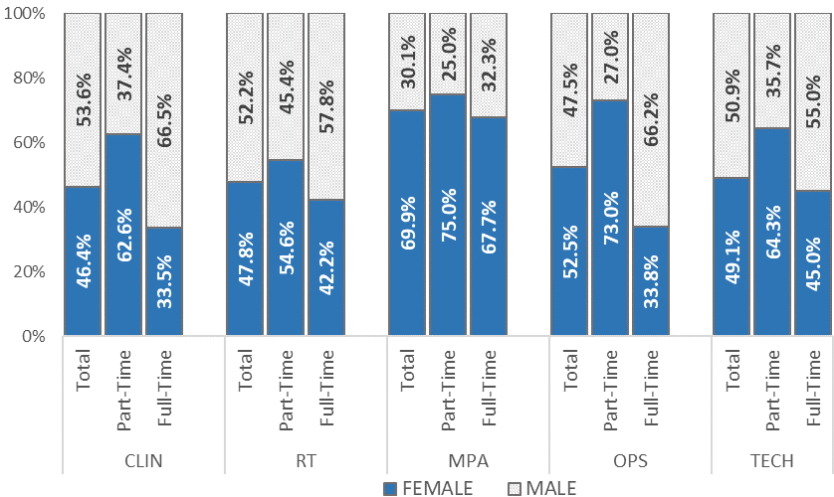
Figure 2: UofG Colleague Population by Job Family, FTE Status, and Gender (31 August 2022)

Figure 3 below outlines the distribution of our female and male populations by job family. This highlights that men are markedly more likely to be engaged in R&T related roles compared to women with 61.4% of our male colleagues working in R&T roles in comparison to 47.4% of our female colleagues. This illustrates the significance and impact of horizontal occupational segregation on our overall average and median gender pay gaps.

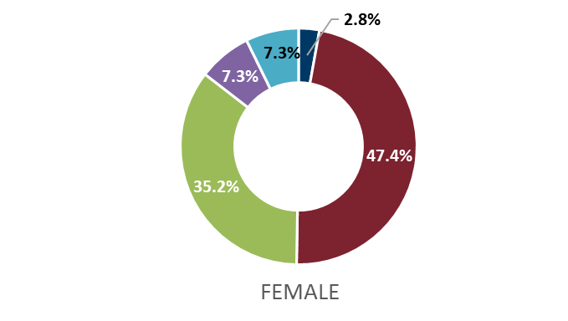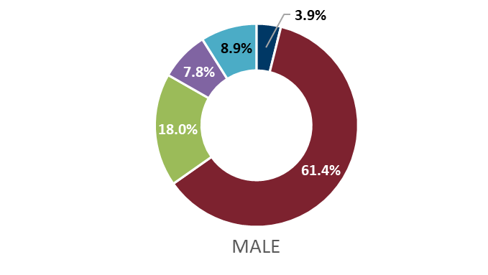
Figure 3: UofG Job Family Distribution across Female/Male Colleague Populations (31 August 2022)

Equal Pay

Table 4: Average and Median Equal Pay Gaps by Gender across Grades 1-9 (31 August 2022)
Grade | Average  Pay Gap  (%) | Median Pay Gap  (%) | Average Allowance Gap  (%) | Median Allowance Gap  (%) | Average Allowance & Bonus Gap  (%) | Median Allowance & Bonus Gap  (%)
Grade 1 | 0.0% | 0.0% | 0.0% | 0.0% | 0.0% | 0.0%
Grade 2 | -0.4% | 0.0% | -0.4% | 0.0% | -0.4% | 0.0%
Grade 3 | 2.0% | 2.1% | 2.1% | 2.8% | 2.0% | 2.8%
Grade 4 | -1.8% | -2.4% | -1.9% | -4.8% | -1.9% | -4.8%
Grade 5 | -3.0% | -2.7% | -3.1% | -2.7% | -3.2% | -2.7%
Grade 6 | -1.0% | 0.0% | -1.0% | 0.0% | -1.1% | 0.0%
Grade 7 | -0.5% | -3.0% | -0.5% | -3.0% | -0.6% | -0.5%
Grade 8 | 1.0% | 2.9% | 0.9% | 2.9% | 0.8% | 2.9%
Grade 9 | 1.3% | 0.0% | 1.4% | 0.0% | 1.4% | 0.0%

The relative pay gaps with regards to basic salary for our staff population on Grades 1-9 fall within the permitted variance of +/-5% as defined by the EHRC as outlined in Table 4 above. Further, average and median pay gaps favour women up to Grade 8 (excluding Grade 3) which correlates with the prevalence of men (54.8%) in Grade 3 roles, as outlined in Figure 1 on p.4.

Gaps exceeding 3%, notably Allowance and Bonus Gaps at Grades 4 and 5 in favour of women, should be considered in the context of the overall gender pay gap in favour of men.

Table 5: Average and Median Pay Gaps by Gender across Grades 10, Professoriate and Clinical Academics (31 August 2022)
Grade/  Zone | Average  Pay Gap  (%) | Median Pay Gap  (%) | Average Allowance Gap  (%) | Median Allowance Gap  (%) | Average  Allowance & Bonus Gap  (%) | Median  Allowance & Bonus Gap  (%)
10  (Prof. Services) | 11.3 | 10.5 | 11.7 | 10.5 | 11.6 | 10.4
1 | 3.0 | 1.5 | 4.0 | 2.9 | 4.1 | 2.0
2 | 1.8 | 2.1 | 1.7 | 3.2 | 1.8 | 3.2
3 | 3.7 | 0.2 | 5.0 | 2.9 | 5.2 | 3.6
‘Professor – Other’ | 24.7 | 25.0 | 24.8 | 25.0 | 24.9 | 25.0
‘Others’ | 28.0 | 3.7 | 28.0 | 3.7 | 27.9 | 3.7
Clinical | -4.5 | -3.5 | 4.9 | 0.0 | 4.9% | 0.0

Data relating to Grade 10 (Professional Services) highlight a consistently high gender pay gap in favour of men. The average pay gap shows a slight decrease to 11.3% from 12.6% in 2020, with the median pay gap lower than the average at 10.5%. The level of the gap coincides with the increase in the representation of women (52%) and their proportionate representation within this grade. This clearly warrants further investigation and the identification of potential actions with a view to addressing the gap.

Zones 1 and 3 report a decrease in their respective pay gaps between 2020-2022 with the Zone 1 average pay gap having reduced from 3.4% to 3.0% and the median pay gap having reduced from 4.6% to 1.5% to within permitted variance levels. The Zone 3 average pay gap has reduced from 4.0% to 3.7% and the median pay gap has reduced from 2.1% to 0.2%. The narrow gap in median pay suggests that there are individual outlying men impacting the average pay gap. Encouragingly, the almost negligible median pay gap implies greater pay equity across this zone.

Zone 2 reports a 1.0% increase in the average pay gap yet a slight decrease in the median pay gap, although these largely remain within the permitted levels of variance. This should however remain under review in relation to bonus and allowance gaps. Encouragingly, the median values for these gaps are markedly lower and tend to be within permitted ranges.

An extremely small number of Professors, denoted as ‘Professor – other’ in Table 5, have yet to complete the zoning process and this creates large variations in the average and median pay gaps for this group. Similarly, for those categorised as ‘Others’, and for whom the University does not determine the relevant pay scales, the average pay gaps are strikingly high. It is worth noting however that the median values are markedly lower, and this points to specific men who are skewing the distribution.

We are unable to disclose the pay gap at Zone 4 while maintaining colleague confidentiality due to the low numbers of men and women professors within this zone.

3. Ethnicity

3.1 Ethnicity Pay Gap
The University applies demographic categorisation in accordance with the Higher Educational Statistics Agency (HESA) for the purpose of this exercise consistent with HE practice across Scotland. Similarly, we widely apply the acronym BAME (Black, Asian and Minority Ethnic) which we have relied upon throughout our equal and pay gap reporting to denote those social groups who may have been subject to historic and contemporaneous forms of racism and exclusion.

It is recognised that such aggregate forms of conceptualisation are not ideal and may mask important differences between groups. It should be noted however that lower levels of colleague disclosure on ethnicity prohibit further breakdown into separate ethnic groupings.

The ethnicity pay gap is calculated by comparing the average and median salary of colleagues categorised as BAME with the respective statistical data for those categorised as ‘White’.

Table 6 below shows that the average and median ethnicity pay gaps have widened since 2020. The median ethnicity pay gap is narrow at 2.9% and narrower than the gender pay gap of 8.4% and sits below the sector median gap of 3.8%. It is notable however that the gap has widened by nearly 5 percentage points since 2020 at which time there was a positive variance in favour of BAME colleagues.

Table 6. UofG Average and Median Ethnicity Pay Gaps 2020- 2022
Year | Average (%) | Median (%)
2022 | 9.3 | 2.9
2020 | 2.4 | -2.0
Change 2020-2022 | + 6.9 | + 4.9

These data merit further review in the context of occupational segregation coupled with the low level of reporting by colleagues with regards to their ethnicity.

3.1.1 Vertical Occupational Segregation
Figure 4 overleaf shows that 19.7% of colleagues have either yet to complete or have chosen not to share their ethnicity information. This is particularly evident across Grades 4-6 where c.25-31% of our colleagues have not disclosed this information. The low level of reporting of ethnicity related information naturally impacts the reliability of our ethnicity pay gap reporting.
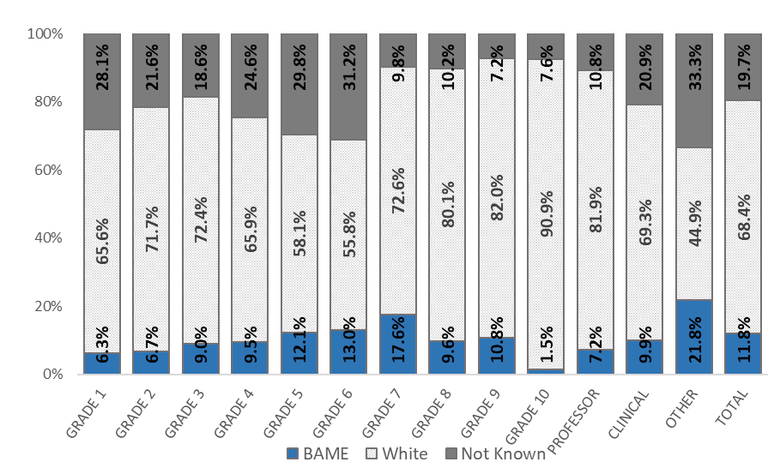
Figure 4. UofG Colleague Population by Grade and Declared Ethnicity Grouping (31 August 2022)

The proportion of colleagues disclosing their ethnicity information grouped as BAME has increased from c.9% in 2020 to c.12% in 2022. This aligns with the University’s KPI to grow the percentage of colleagues within the UK BAME category.

There is greater representation of BAME colleagues at Grade 7 which may be explained by the large population of early career researchers within this grade which directly corresponds to the increasing representation of colleagues from minoritised ethnic groups across our Research population.

3.1.2 Horizontal Occupational Segregation
Figure 5 overleaf shows the greatest representation of BAME colleagues amongst our R&T job family from which it is difficult to draw clear conclusions about horizontal occupation segregation. This might best be explained by the low levels of disclosure with respect to ethnicity related information for colleagues across all job families, however it is clearly evident that a higher proportion of our staff population employed within the R&T job family have disclosed this information.

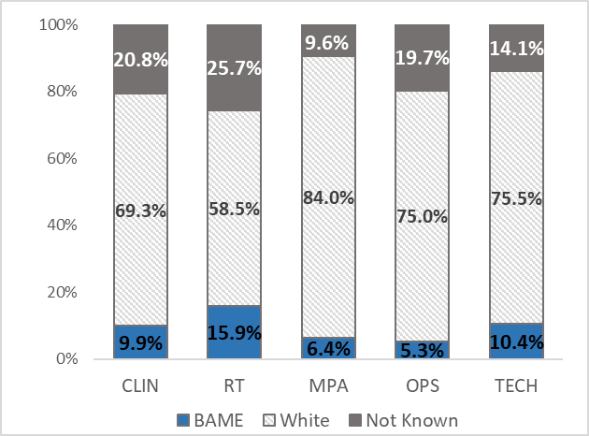
Figure 5. UofG Colleague Population by Job Family and Declared Ethnicity Grouping (31 August 2022)

Figure 6 below highlights the distribution of our BAME and White workforce by job family. This highlights, as previously suggested, that our BAME population are markedly more likely to be engaged in R&T related roles in any comparative analysis with our White workforce, with 72.0% BAME representation compared to 46.0% White.

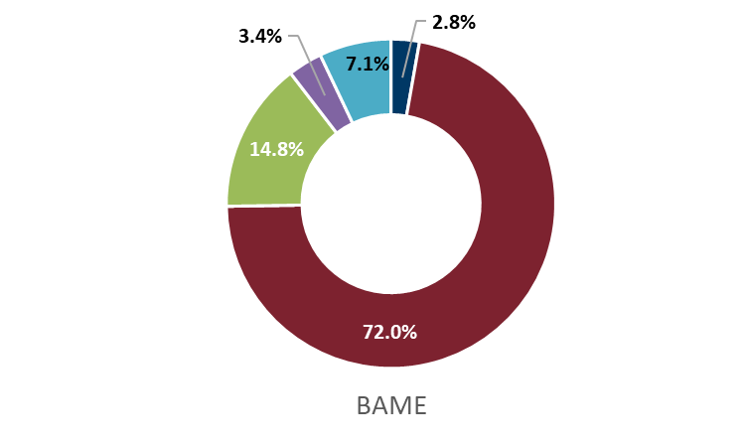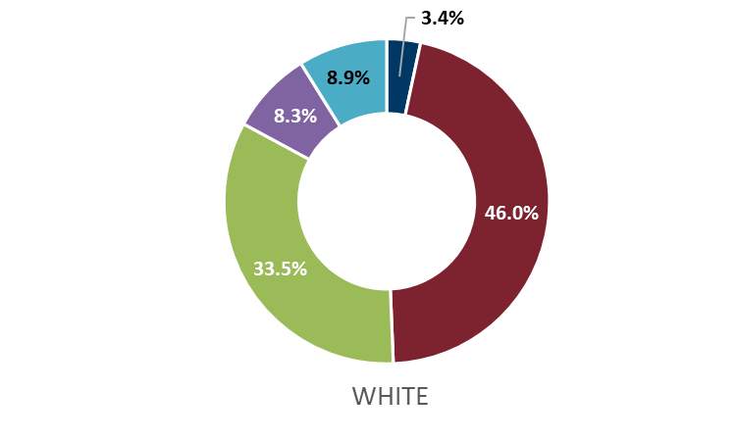

Figure 6. UofG Job Family Distribution Across Each Declared Ethnicity Grouping (31 August 2022)

3.2 Equal Pay

Table 7. Ethnicity Pay Gaps by Grade (31 August 2022)
Grade | Ethnicity Pay Gap  (%)
Grade 1 | 0.0%
Grade 2 | 0.1%
Grade 3 | 2.7%
Grade 4 | 3.1%
Grade 5 | 5.8%
Grade 6 | 2.0%
Grade 7 | 1.5%
Grade 8 | 3.2%
Grade 9 | 1.9%
Professor | -2.7%

The ethnicity pay gap across Grades 1-9 and the Professoriate fall within the permitted variance of +/-5% as defined by the EHRC as outlined in Table 7 above, with the exception of Grade 5 where there is a 5.8% gap in favour of White colleagues. It is not possible to provide Professorial Zone and Grade 10 (Professional Services) pay gap data as the level of disclosure is either too small or there is a lack of comparator data.

The validity and reliability of this data set should be considered in the context of a sizeable proportion of colleagues across our grading structure who have not shared their ethnicity information. Further, Figure 4 on p.9 shows that c.30% of colleagues on Grade 5 have not disclosed their ethnicity information which may have an impact on the level of the gap in this case. Work is ongoing in reviewing and re-calibrating the University’s pay structure which offers opportunities to explore the factors that may be influencing the ethnicity pay gap at Grade 5.

The gap has widened at Grade 8 to 3.2% in this analysis representing an increase of 1.4% to that reported in 2020. This corresponds to an increase in BAME colleagues in this grade having joined the institution on a starting salary at the base of the pay scale alongside a decrease in the number of BAME colleagues at the top of this grade.

There has been a slight increase in the ethnicity pay gap amongst the Professoriate in favour of colleagues grouped within the BAME category since last reported in 2020 from -2.3% to -2.7% in this analysis. This corresponds with a 31% increase in levels of disclosure across the Professoriate within the BAME category.

4. Disability
4.1 Disability Pay Gap
The University applies demographic categorisation in accordance with the requirements of HESA when collecting colleague disability data. Low disclosure rates make it difficult to conduct meaningful pay analysis by disability status. The disability pay gap is calculated by comparing the average and median salary of Disabled colleagues with the respective statistical data for non-Disabled colleagues.

Table 8 below shows that the average and median disability pay gaps have remained relatively static since 2020 and demonstrate substantial pay gaps in favour of non-Disabled colleagues.

Table 8. Average and Median Disability Pay Gap (31 August 2022)
Year | Average (%) | Median (%)
2022 | 12.6 | 11.1
2020 | 12.9 | 11.1
Change 2020-2022 | 0.3 | 0.0

4.1.1 Vertical Occupational Segregation
Disability pay gap data must be reviewed in the context of the low proportion of Disabled colleagues compared to those who are non-Disabled across the University, coupled with a lack of disability related reporting by 29% of our colleagues as outlined in Table 7 below.

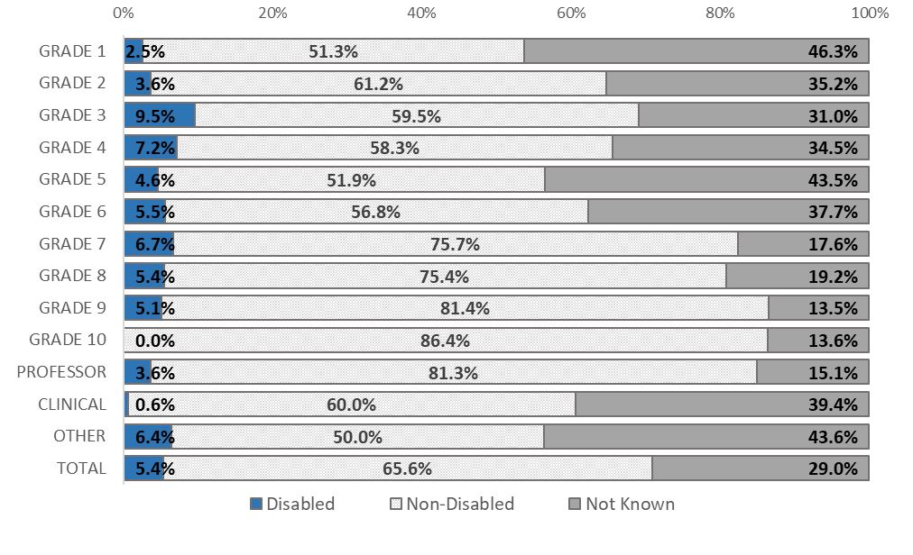Figure 7. UofG Colleague Population by Grade and Declared Disability Status (31 August 2022)

4.1.2 Horizontal Occupational Segregation
Figure 8 shows the highest representation of Disabled colleagues amongst the MPA job family while Figure 9 suggests Disabled colleagues are most likely to be engaged in roles within the R&T job family than across other job families. That said, a similar pattern is evident with respect to non-disabled colleagues. This may contribute to the low level of disability pay gaps across grade levels as outlined in Table 9 below compared to the overall disability pay gap which is impacted by the low disclosure rate.

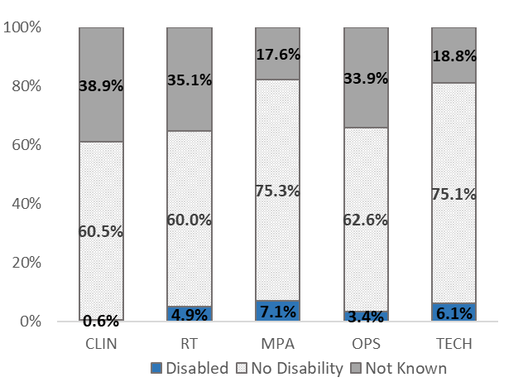
Figure 8. UofG Colleague Population by Job Family and Disability Status (31 August 2022)

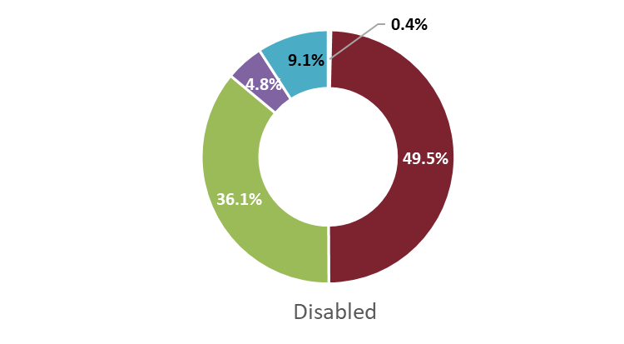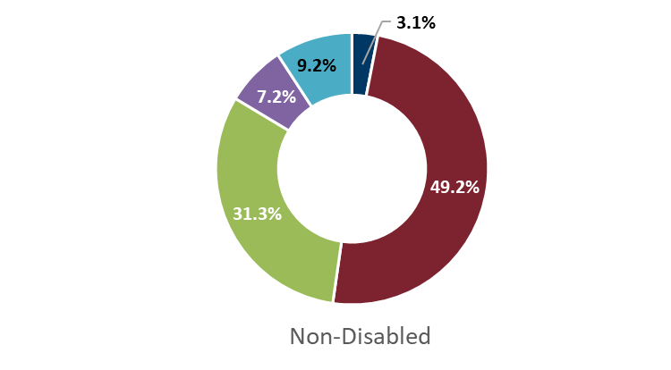

Figure 9. UofG Job Family Distribution across Disabled/Non-disabled Cohorts (31 August 2022)

4.2 Equal Pay:

Table 9. Disability Pay Gaps by Grade (31 August 2022)
Grade | Disability Pay Gap  (%)
Grade 1 | -
Grade 2 | -0.4%
Grade 3 | 2.5%
Grade 4 | 0.2%
Grade 5 | 2.0%
Grade 6 | 1.1%
Grade 7 | 0.8%
Grade 8 | -0.7%
Grade 9 | 0.6%
Professor | -0.9%

The disability pay gap across Grades 1-9 and the Professoriate fall within the permitted variance of +/-5% as defined by the EHRC as outlined in Table 9 above. The validity and reliability of this data set should be considered in the context of a sizeable proportion of colleagues across our grading structure who have not disclosed disability related information. It is not possible to provide data for Grades 1, 10 (Professional Services) and Professorial Zones, as the numbers declared are either too small or there is a lack of comparator data.

Disabled colleagues constitute 3.6% of the Professoriate and are paid on average more than their non-disabled counterparts, however, in considering this data set it should be borne in mind that 15.1% of our professorial population have not disclosed their disability status.

5. Tackling Equality Pay Gaps
The University is committed to equitable support and progression for colleagues across our workforce. Actions to begin to tackle and address our equality pay gaps reflect our strategic people themes aligned with our World Changers Together Strategy.

Additionally, specific actions are in place with regards to increasing the representation of women at senior professional and professorial level embedded in our People & OD Strategy implementation plan and Athena Swan action plans at University and School levels. These are focused upon continuing to deliver our values-led culture and related behavioural change both institutionally and within each of our Schools and Services towards the gender-inclusive UofG community to which we aspire. These action plans also increasingly incorporate actions to implement EDI campaigns, initiatives, and policies such as those enacted through the Understanding Racism, Transforming University Culture (URTUC) Action Plan and Public Sector Equality Duties (PSED) Equality Outcomes.

Living Our Values:
- Continue with ongoing process of 6-monthly campaigns to increase colleague disclosure rates across all protected characteristics, particularly ethnicity and disability, to support meaningful, data-led, analyses of equality pay gaps.

- Our new support portal and process for Disabled and Neurodiverse colleagues is contributing towards enhancing trust in our processes and further increase colleague declaration rates. This will provide additional context and understanding to pay gap analysis.

- Continue to embed our Values through the Code of Professional Conduct and Glasgow Professional Behavioural Framework to cultivate a values-led culture that promotes inclusive and equitable environment where everyone feels valued and supported to strive for excellence.

Maximising Organisational Capability:
- Review PDR Guidance for academic reviewers, enhancing inclusive advice on
supporting reviewees’ understanding of promotion criteria and requirements in working towards their career development in good time.

- Develop succession plans for every unit with a particular emphasis on STEMM-based disciplines with active support for traditionally under-represented groups forming part of these plans.

Employee Experience:
- Achieving strategic KPI targets for Equality, Diversity and Inclusion will contribute to improving representation of women, UK BAME, and Disabled colleagues across our population, particularly at senior levels, through enhanced talent attraction and management strategies with a view to improving our equality pay gaps.

- Undertake further exploration of quantitative and qualitative people-related data through regular engagement surveys and related actions based on their outcomes to examine and explore any additional factors that may be driving the gender pay gap amongst Professional Services colleagues at Grade 10.

- In line with our URTUC Action Plan:

  - Analyse data on our recruitment processes to map the candidate journey and identify barriers to conversion of applications to appointments for BAME candidates, putting in places actions to address the specific challenges that are identified.

  - Review career progression and promotion for ethnic minority academic colleagues to identify any systemic barriers.

  - Continued promotion and support of James McCune Smith PhD Scholarships for UK Black students to support the R&T ‘pipeline’.

  - Address the EDI-related findings from the REF EIA, specifically the need to address those issues identified with respect to the career journey of our BAME researchers towards research independence.

‘Gender’ here in fact refers to the protected characteristic of ‘Sex’. The language used throughout this paper and the University’s pay reporting reflects the language used in the Equality Act 2010 and associated equality duties.
Equality Act 2010 (Specific Duties) (Scotland) Amendment Regulations 2016
The University’s introduction of a pay uplift in November 2022 widened the average and median pay gaps. As part of the Equality Impact Assessment of the uplift, the University committed to reviewing the impact of that uplift mid-cycle during the pay gap reporting schedule. The backdated uplift payments are not incorporated in the data taken on the census date of 31 August 2022.
UCEA, 2023. Intersectional Pay Gaps in Higher Education 2020-21
The University has four main job families – Research and Teaching (RT), Operational (OPS), Management, Professional and Administration (MPA) and Technical and Specialist (TECH); Clinical (CLIN) colleagues hold joint contracts with the NHS.
(-) denotes a pay gap in favour of women.
‘Professor - Other’ inc. low number of professors yet to be zoned. ‘Others’ – inc. MRC, Marie Curie Fellows and those not on UofG pay structures/grades.
UCEA, 2023. Intersectional Pay Gaps in Higher Education 2020-21
Although all data by Grade here should be reviewed with caution due to the marked gaps in ethnicity reporting.
(-) denotes a pay gap in favour of colleagues grouped within ‘BAME’ category.
(-) denotes a pay gap in favour of Disabled colleagues.

