Safe Storage of Hazardous Chemicals
Accidents in the laboratory can be the result of improper storage of hazardous substances which can lead to spills, leaks and chemical reactions between incompatible substances. However, by considering how chemicals can be stored safely and securely many such incidents can be avoided.
Principles of Safe Storage
There are several key principles of safe storage which should be followed whenever possible to minimise the risk to staff and students from hazardous substances:
Clear Labelling: All chemical containers should be clearly and accurately labelled with the name of the substance and the hazard categories to which it belongs (e.g. toxic, corrosive). Whenever possible the original packaging should be used, if there is a requirement to decant materials into a new container then it should be clearly labelled as above along with the name of a responsible person who can be contacted in the event of an issue arising.
There may be some situations where it is impractical to label a container (e.g. the use of very small vials). In cases like this a secondary container such as a rack or tray should be used which can be labelled accordingly to aid in identification.
Compatibility: Generally, it is best to store “like with like” and whenever possible physically segregate incompatible substances (i.e. those that may react producing either heat or harmful vapours). See the table in Appendix one for a general overview of which chemicals can be safely stored together and which should be stored in separate locations.
Good Stock Control: Although it is often tempting to buy large quantities of a chemical to ensure the best price per gram/ml it is usually best to [purchase and store the minimum amount practical to reduce the storage requirement (and subsequent cost of disposal of unused material). If it is necessary to purchase or store a substance in large quantities (e.g. fuel or solvents) then consideration should be given to storing it outwith the laboratory in a dedicated chemical store. Stock should be regularly checked and any substances that are out of date or no longer required should be disposed of regularly to prevent a build-up of obsolete chemicals. Remember that many substances may degrade over time posing a hazard to laboratory users.
Housekeeping: Sensible, organised storage locations should always be sought with large, breakable containers, heavy equipment and chemicals stored no higher than shoulder height in areas where they are unlikely to be accidentally knocked over. Staff should not have to use steps or ladders to reach chemicals and more frequently used chemicals should be stored in easier to access locations.
Secure Storage: Some high-risk substances merit special considerations to ensure that they are securely stored and can only be accessed by authorised, competent persons who fully understand the risks associated with the substance(s) and the control measures that should be implemented when handling them. Local arrangements will vary but consideration should be given to providing a locked storage area and tighter stock control for substances such as highly toxic chemicals (e.g. cyanide salts), explosives, chemical weapon precursors and controlled drugs.

Storage Facilities
All chemicals need to be stored in a manner appropriate to the risks they pose, while it may be appropriate to store low hazard substances on an open shelf there are many others which require more robust means to ensure they are held safely. The following storage solutions are commonly found across the university:
Shelving: Many substances can be stored safely on open shelving so long as they are fit for purpose and have been correctly fitted securely. Always consider the following when using shelves for storage of chemicals:
      - Chemical containers can be heavy and care should be taken not to overload shelves as this could give rise to a risk of collapse. If a shelf appears to be distorted or bowed then it is probably overloaded and storage should be reviewed.
      - Breakable containers (especially those containing liquids or fine powders) should be stored at lower level where possible and in any event should be stored below shoulder height. Substances that are used frequently by users should be easy to access. Some chemical containers (in particular plastic containers) may degrade over time when exposed to sunlight leading to the plastic becoming brittle meaning they could break when handled releasing their contents.
      - Large, heavy and breakable containers should also be stored at lower levels although care should be taken to assess manual handling risks for users required to access these substances.
      - Care should be taken when siting shelves to ensure that they are not in areas where they are likely to be knocked over or struck by passers-by as this could cause chemical containers to be dislodged. Similarly shelving should not be overloaded such that containers protrude over the edge of shelves.
      - Shelves used for chemical storage should be fitted with lips (or other suitable restraints) where practical to reduce the risk of chemicals being pushed off the shelf (especially in cases where a shelf is located between two facing work areas. Chemical containers should not be stacked on top of one another and any damaged chemical containers should be removed for disposal.
Corrosive Cabinets: Acids, alkalis and other corrosive materials will damage traditional metal storage cabinets over time. Corrosive substances should be stored in corrosion resistant cabinets which are made of (or coated with) acid resistant materials such as PTFE, HDPE and other plastics. Corrosive cabinets should also include a tray designed to catch any leaks or spillages in each storage area. Cabinets used to store corrosive materials should be clearly marked with the corrosive hazard warning symbol (see appendix 2).
Flammable Cabinets: Flammable substances such as solvents should be stored in metal cabinets with a minimum fire resistance of half an hour (more modern 90min fire rated cabinets are available and should be used where available). Cabinets should be fitted with an appropriate tray to collect any leaks or spillages and should be clearly marked with the flammable hazard warning symbol (see appendix 2).
Ventilated cabinets: Some storage cabinets are equipped with a ventilation system. These are designed to store substances that produce noxious, strong-smelling or harmful vapours under conditions of normal storage and will remove any vapours safely from the cabinet. Ventilated cabinets can be either free-standing (with a dedicated extraction system) or may be situated beneath a fume cupboard using the existing ductwork to remove and vapours.
Fridges / Freezers: Many substances need to be stored at reduced temperatures to prevent degradation or hazardous reactions from taking place. Fridges and freezers may be used for this purpose so long as a suitable risk assessment has been carried out. Flammable substances should not be stored in an appliance where there is a risk of ignition from an internal light, thermostat or other device and for this reason it is usually better to avoid using normal domestic appliances if possible. Laboratory fridges and freezers are available and are more likely to meet any such safety requirements. For malodourous substances a ventilated refrigerator can be considered to reduce the risk of vapours escaping into the workspace.
Note: Fume cupboards must not be used as storage areas for chemicals and should be kept clear of materials and containers when they are not needed for an ongoing process. To minimise the risk of an accident clutter should be kept to a minimum and unused materials disposed of or returned to their usual storage area as soon as practical. When materials are stored in a fume cupboard they can disrupt the airflow reducing the efficiency of the extraction system and increasing the risk of a hazardous release.
Substance Specific Guidance:
Acids: Smaller quantities of acids can be safely stored in a vented cabinet or even a wooden cabinet so long as a suitable tray is used to collect spillages and leaks. Where possible acid resistant cabinets should be used as fumes from acids will cause corrosion to metal storage cabinets and fittings over time and these should be subject to regular inspection to identify any damaged areas. Acid chlorides, anhydrides and substances which give off acidic fumes should be stored in the same manner as acids.
Oxidising acids such as nitric acid and perchloric acid should not be stored in wooden cabinets as they may interact strongly with organic materials giving rise to a risk of fire.
Combustible organic acids (e.g. glacial acetic acid) should not be stored with oxidising acids or mineral acids due to the risk of fire. It may be more appropriate to store organic acids with organic solvents where dedicated cabinets are not available. It is not recommended that flammable gas cannisters are stored with organic acids due to the risk of corrosion over prolonged exposure to acid vapours.
Alkalis: Alkaline substances are also strongly corrosive and should be stored in a similar manner to acids with small quantities stored in a suitable cabinet with appropriate spill control trays present.
Although both acids and alkalis are classed as corrosive compounds every effort should be made to store them separately as concentrated acids and alkalis will react strongly on contact producing heat and hazardous fumes.
Chlorinated Solvents: Chlorinated solvents such as chloroform and trichloroethylene should be stored in ventilated cabinets preferably separately from flammable solvents (as in some cases chlorinated and no-chlorinated solvents can react violently on mixing in the presence of other chemicals). Chlorinated solvents can produce highly toxic phosgene gas when involved in fires and should therefore be stored separately from fuels.
Chlorinated solvents will react strongly with alkali metals (lithium, sodium, potassium etc.) and these substances should never be stored together.
Drugs and Medicines: Dangerous (and controlled) drugs, medicines and drug precursors (including veterinary drugs) should be stored securely in locked cupboards with access controlled by authorised keyholders. A detailed inventory of storage and use of controlled drug compounds should be accurately maintained. In some cases, there may be a requirement to store some substances at reduced temperature in which case a refrigerator / freezer fitted with a suitable lock may be used.
Flammable Solvents: Flammable solvents (e.g. alcohols, toluene, hexane etc.) should only be stored in specialised flammable solvent containers. These are available commercially and consist of a cupboard with containment for any spilled solvent. The construction is generally of metal and the container should have at least 30min fire resistance with 90min resistance being preferable. They should be properly labelled e.g. "Highly flammable" (see appendix 2). The cabinet or bin must be kept securely closed at all times to prevent spread of fire.
The amount of flammable (including waste solvents) in an area should not exceed 50l litres in total where possible. Flammable solvents should not to be stored in fume cupboards since the airflow will fan any fire and may also spread flammable vapours and hence a fire into the associated ducting and subsequently to other parts of the building via the ventilation ducting. Ventilation openings in a ventilated cabinet could also cause the fire to be drawn into the cabinet where flammable solvents stored inside could become involved.
Oxidising agents (such as peroxides, perchlorates and nitrates) must never be stored with flammable solvents since fires and explosions can result should they come into contact after a spillage, even without a naked flame or heat.
Noxious Substances: Noxious substances such as amines, mercaptans and lachrymators can produce a very strong-smelling vapour which can extremely unpleasant and irritating. Ventilated cabinets should be used to store such chemicals to ensure any vapours are extracted as quickly as possible. If a ventilated cabinet is not available then containers of noxious substances should be stored in a tightly sealed, secondary container and only opened in a fume cupboard. Under these circumstances it can be acceptable to use a fume cupboard for storing noxious substances provided that the fume cupboard is used only for this purpose and not used to undertake any experimental activity although this should be a last resort.
Oxidising Agents: Oxidising agents such as peroxides, nitrates and perchlorates should be stored separately from other substances, in particular combustible solvents and other organic compounds. Ideally, they should be stored in a metal cabinet or bin and should be separated from any combustible materials e.g. wooden shelves, paper or fabric.
Note: Perchloric acid is especially hazardous and can react explosively with metals and organic material. Additional storage precautions may be required e.g. storing in a container of sand within a non-combustible cabinet or bin. Please see the separate SEPS guidance note for further information.
Poisons: The Poisons Act 1972 (and Poisons List Order 1982) lists a number of substances known as Scheduled Poisons including most of the better-known poisons such as arsenic, cyanide salts and strychnine. Poisons, which fall under part 2 of the schedule (or Part 1 of the Poisons List Order) should be kept in a locked cabinet, specific for the purpose, in the laboratory. A designated responsible person should hold the key and a logbook should be kept to accurately record when a poison is used, how much and by whom. Specific guidance is available in the SEPS guidance note on highly toxic substances.

Further Guidance and Support
Further information and guidance on the safe storage of chemicals can be obtained by contacting Safety and Environmental Protection Service who will be happy to answer any questions and provide support:
General Office: 0141 330 5532
Chemical Safety Adviser: 0141 330 2799
E-mail: safety@glasgow.ac.uk

Appendix 1: Chemical Incompatibility Table
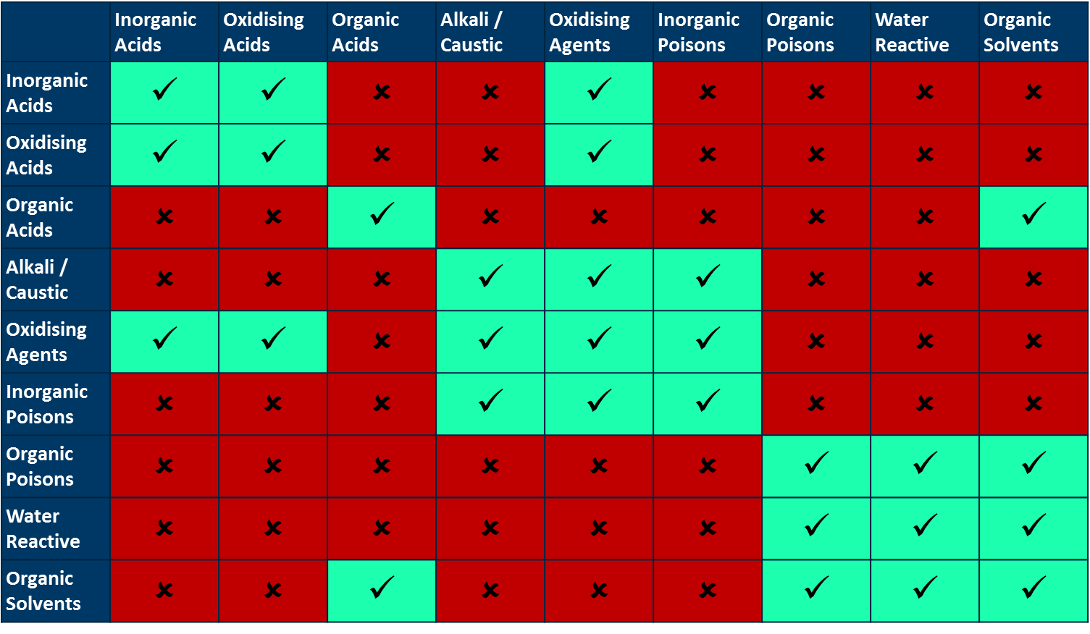
This table can be used to give a general idea of which chemicals can be safely stored together and which should be separated whenever possible. It is not an exhaustive guide and further information (e.g. safety data sheets) should always be consulted when making a final decision on storage methods.

Appendix 2: Example hazard warning signs for chemical cabinets
Corrosive Substances (e.g. acids, alkalis)
Flammable Substances (e.g. alcohols)

