University of Glasgow regisration:

To register to MiVision Premium, navigate to:
https://mivision.hsbc.co.uk/1/mv-m3-ugg-prod/pm/base/logon.asp?standardlogon=Y
- On the homescreen, DO NOT ENTER ANYTHNG IN THE 2 BOXES. You need to click on on ‘Activate User Account’ underneath the login section.
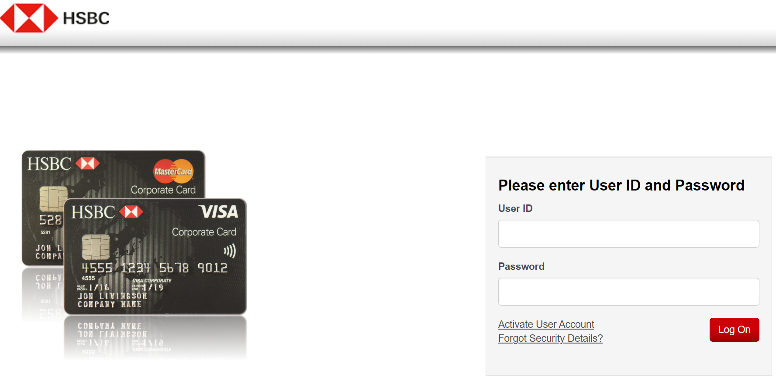

- Enter in your University email address and either your full card number for card-holders, or your userID. (GUID)
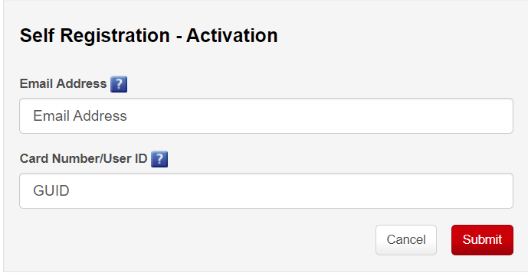

- You will be emailed an activation code, enter it in the next screen.
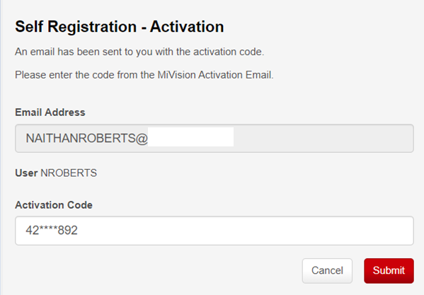
- Press OK to continue, the system acknowledges a successful match and you can continue the registration process.
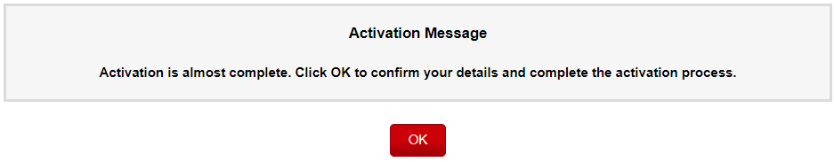
- A window will open, please enter:
- Password (needed for first registration, you can use single sign on later on)
- Confirm Password
- Security Number (needed for single sign on and asked whenever you log in.)
- Confirm Security Number

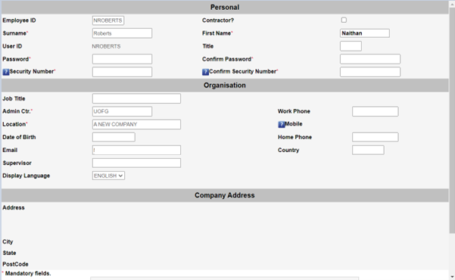
SECURITY NUMBER: this must be an 8 digits number that you will remember, it cannot be sequential 1 2, 3 – 8. You will be asked for 3 random digits from your 8 digits security number every time you log in to enable you to access the portal.

- Scroll to bottom, press update.
Note: If you press update and nothing happens, please ensure popups are enabled for https://mivision.hsbc.co.uk/
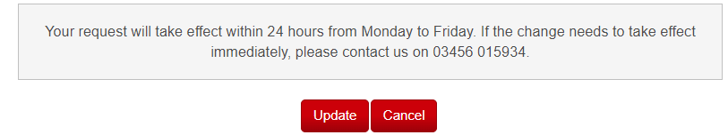
- When successfully completed registration you can login, the site will request security number.
If you security number is 123456789, the below answer would be 1,3,6.
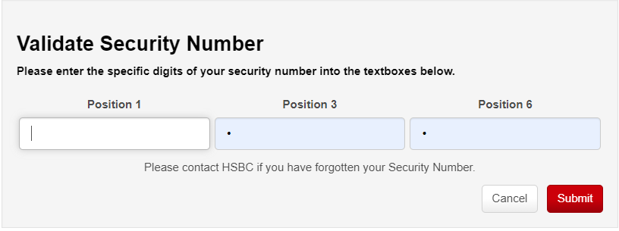
- You have now registered to the tool, you can now use single sign on going forward by going to: https://mivision.hsbc.co.uk/1/mv-m3-ugg-prod

