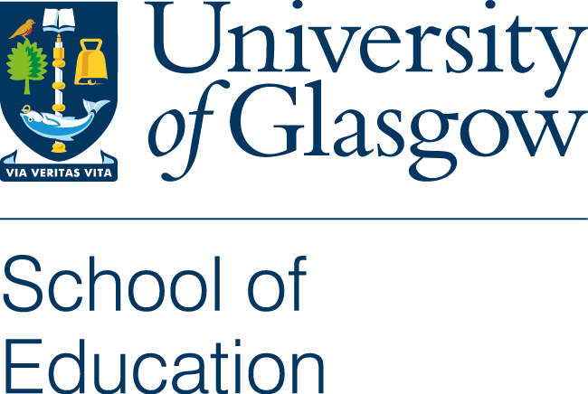

Guidance for all applicants

- Application

Submit only the documents that have been requested (Covering letter, CV and criteria grid). Please do not include any other documentation with your application. References, if required, will be requested at a later stage.

Use the criteria grid to provide responses showing how you address each of the essential and desirable criteria.

- Selection for interview and submission of scholarly outputs

Applicants who are shortlisted will be invited for interview. Prior to the interview shortlisted applicants are asked to provide three examples of their recent publications or scholarly outputs. These are reviewed prior to the interview by the Director of Research or the Director of Learning and Teaching and / or a subject specialist.

As part of the interview process applicants are asked to make a presentation related to the subject area. All staff and postgraduate students in the School of Education are invited to the presentations. The number attending varies from post to post but is typically 10 to 20 participants.

The presentation is scheduled to last for 20 minutes with a further 10 minutes for questions and discussion. Following the presentation, a rapporteur collates feedback from those participating and shares this with the interview panel as part of its deliberation process. A copy of the feedback sheet that is used is available here.

Interviews are normally scheduled for 30-45 minutes. The panel consists of staff from the School / subject area and a member of staff from another School. Panels are usually convened by the Head or Deputy Head of School. During the interview panel members will ask questions relating to the essential and desirable criteria for the post. Questions are usually focused on key themes relating to the post such as motivation for applying; experience and expertise in learning and teaching; research and scholarship profile and future plans; working collegially as part of a team, supervising and mentoring early career academics; and external partnerships and collaborations. At the end of the interview (time permitting) there is an opportunity for applicants to ask questions or seek clarifications relating to the post or working at the School of Education / University of Glasgow.

