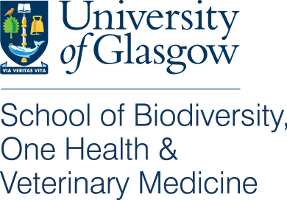
Educational Memorial Programme

Owner consent form for body donation

Name of Pet: …………………………… Species: ………………………………………………………
Breed: ……………………………………………….. Age: …………………… Sex: ………………..

- I am the owner/am legally responsible for the animal named above.
- I have received, read and understand the owner information pamphlet provided by the University of Glasgow for its Educational Memorial Programme.
- I hereby give permission for the University of Glasgow, School of Biodiversity, One Health and Veterinary Medicine to use my pet’s body for the education of the School’s veterinary students in anatomical studies or post mortem examinations.
- I understand that pertinent tissues and information collected during post-mortem examination may be stored for further teaching and approved research studies.
- I am aware that after anatomical or post mortem investigations, the body of my pet will be cremated and I will only be able to have my pet’s ashes returned to me if I specifically request and pay for this at my Veterinary Practice and that there may be a delay in the return of the ashes (up to 4 weeks).
- I understand that no post mortem report will be provided.
- I give permission, that if necessary and to increase the information and teaching value obtained from my pet, my pet’s health history may be transmitted to/within the University of Glasgow. All information which could identify me as the owner of this animal will be removed.

I consent for my animal`s body to be donated Yes No
(tick as appropriate)

I have requested individual cremation and to have my pet’s ashes
returned to me Yes No
(tick as appropriate)

Owner name (printed): …………………………………………………. Signature: …………………………………………………
Date: ……………………….
Name of Attending Veterinary Surgeon (printed): ……………………………………………………………………………..
To be filled in by attending veterinarian:
Animal has received chemotherapeutic agents within the last 15 days: Yes No

Clinical diagnosis / diagnoses: ………………………………………………………………………………………………………………

Signature: ……………………………………………………… Date: …………………………………………….
Veterinary Clinic or Practice:……………………………………………………………………………………………………………….
Stamp: ………………………………………………………………………………………………………………………………………………..

Thank you very much for your support and generosity. This will help train our future vets, further knowledge of disease affecting our pets and advance animal healthcare.

This donation scheme has been approved by the University of Glasgow Ethics Committee 41a/17
For further information please contact the Glasgow EMP coordinators at:
Tel. 0141 330 7768
Email: vet-emp@glasgow.ac.uk
Website: www.glasgow.ac.uk/emp

