Title of abstract in bold
L.C. Presenting-Author-Underlined-Bold*ª, N.E. Matic^{b}, T.B. Phase^{a,b}
ª Department of Chemistry, University of London, London, E17 3OX, UK
^{b} School of Engineering, University of Berlin, Berlin, Germany
*add email address of corresponding author

Enter your abstract body text here. Please use this same template for both talk and poster presentations, and submitting your file as a pdf is preferred.
This should be a comprehensive abstract about the work you wish to present at the conference, although there is a strict 1-page limit per abstract. Please be aware that all accepted abstracts will be included in the conference proceedings, available in printed form to all attending delegates, and freely available to download to the public on the conference website.
Default font is Calibri (or any other sans serif font) 12pt, with 1.15 line spacing. Please ensure at least a 2 cm margin around all 4 sides of the page, and do not exceed the 1-page limit. You are welcome (and in fact encouraged!) to use figures to illustrate your abstract (Figure 1). The proceedings will be available in colour, but we recommend that graphs and figures are designed so that they also work effectively when printed in black and white.

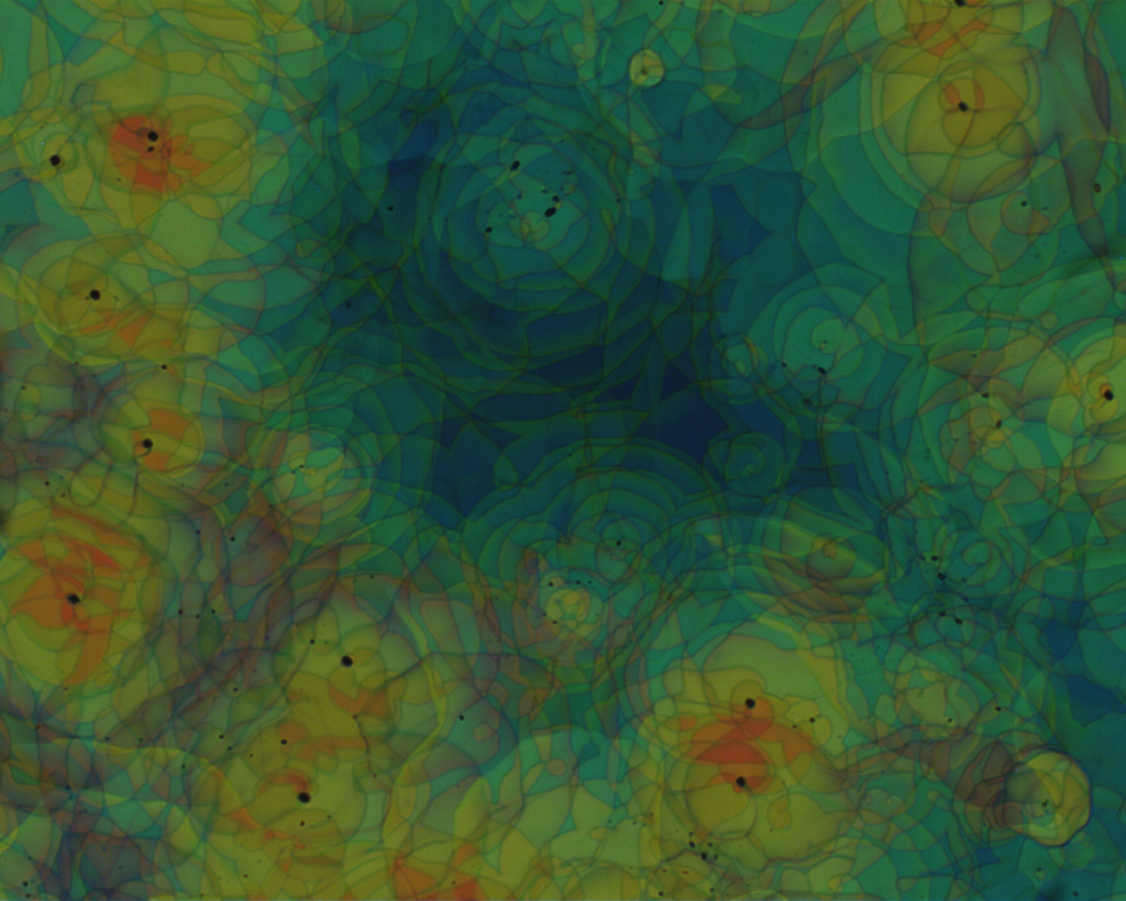
Figure 1. Captions for figures are in smaller 10pt font.

Please include a references section at the end, adopting the referencing style illustrated below, and with in-text citations that look like this [1], or this [1,2], or this [1-3].
The authors would like to acknowledge Phil Hands, Mark Wilson and Doug Cleaver, whose previous BLCS abstract templates have been copied and modified here.

References
[1] A.N. Other and N.E. Matic, J.Appl. Phys. 26 (1), 389-340, (2001)
[2] A.N. Other, L.C. Author, et. al, Proc. SPIE 5518, Liquid Crystals VIII, 136-143, (2004)
[3] Note that references are in smaller (11pt) font

