Appendix 1

A new external Moodle has been created to collate all the required teaching resources for these sessions. You will need to create an external Moodle account (this is separate from any Moodle account you may already have that you access using a GUID)

It may take 24 hours to create and account and for it to become ‘live’. Please take this into account when preparing to teach the students.

Once you have created your account you will have access to the following external Moodle page: MBChB Clinical Skills for Tutors Moodle. This page has subgroups for communication skills, clinical procedural skills, clinical examination skills and simulation. The VS Handbooks for Y1 and Y2; the VS Clinical skills Handbook, and the clinical examination skills videos will all be here in the examination skills section.

How to create your external Moodle account:

Click this link to the video showing how to create an external Moodle account. The enrolment key is PEFR21. Do not share this with students.

Below is a step-by-step guide to creating your account:

Go to: https://glasgowonline.gla.ac.uk/

Go to: the bottom of the page and click ‘Create new account’

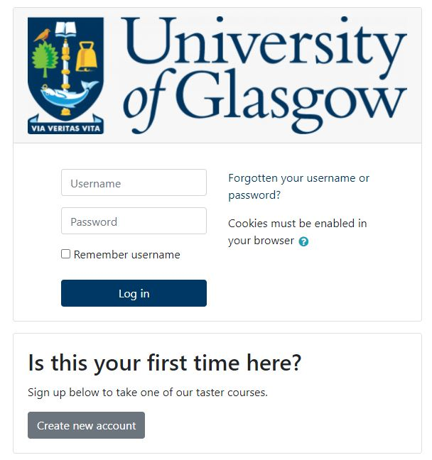
Complete your details, including a unique username and password that you'll be able to remember, and an email address that your first time login details will be sent to.

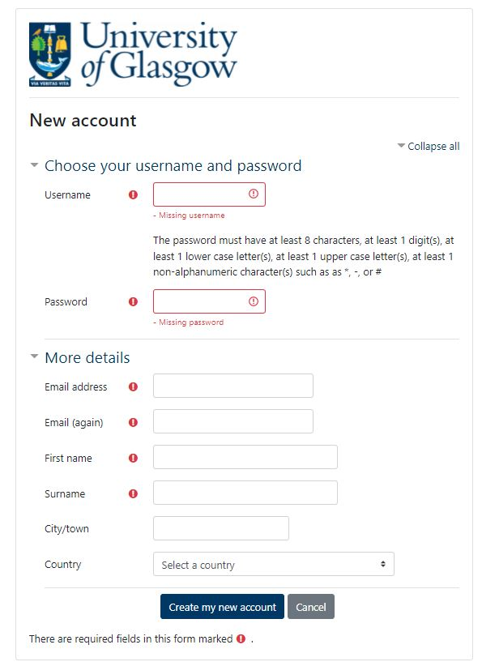

Click the button that you understand and agree to the site policy agreement and then click ‘Create my new account’.
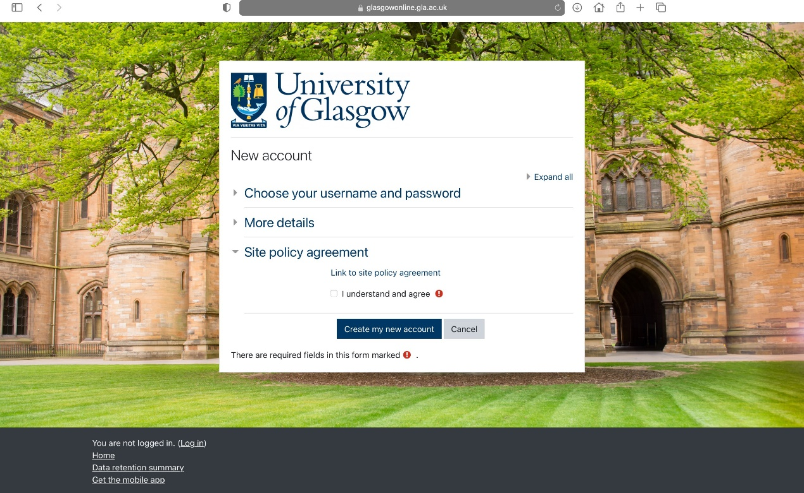

Your details on how to log on for the first time will be sent to the email address you provided above. The first time that you access your external Moodle account you'll come to the dashboard like below. Click ‘Browse or Search our Available Courses’.
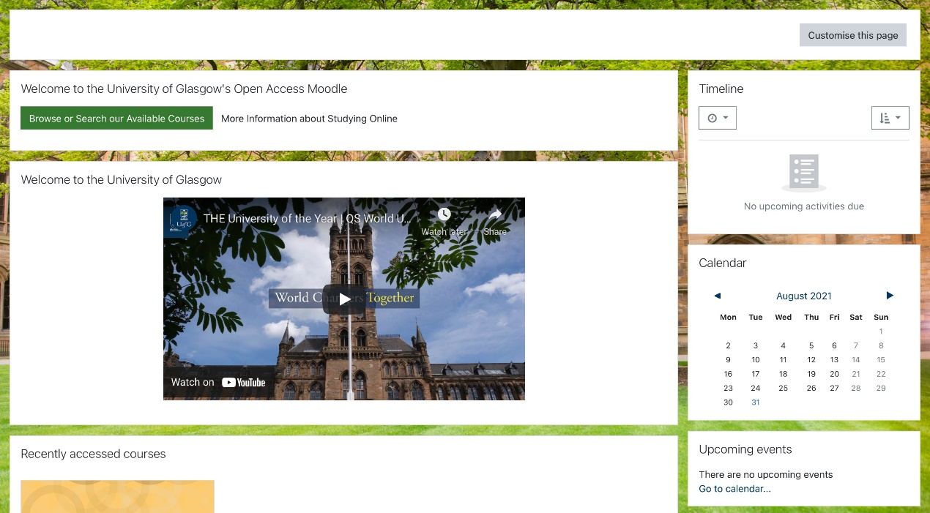

You can either type in the search courses box ‘MBChB clinical skills for tutors’ or click on the College of Medical, Veterinary and Life Sciences Courses tab and you’ll see MBChB clinical skills for tutors here:
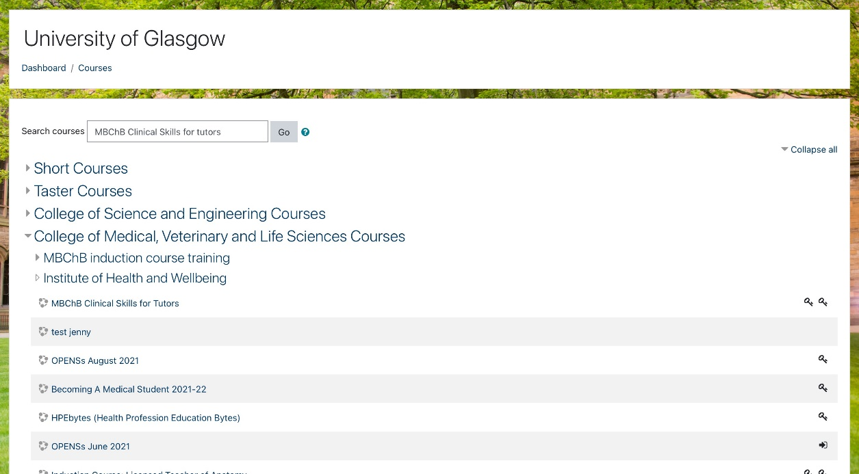

The first time that you click on the course you'll be asked to enter your enrolment key. The enrolment key is PEFR21,

You will be able to access the content that you require for teaching your session within the desired tab.
