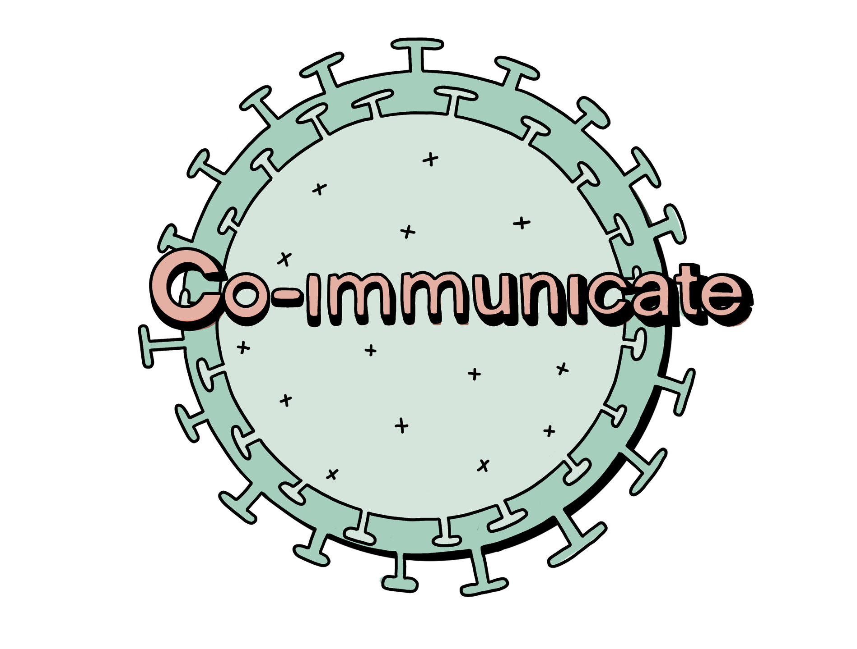
Co-IMMUNicate post-activity worksheet

Your name:

- Do you know what a vaccine is?

Yes No

- How much do you know about what’s in a vaccine?

Not much Some A lot

- Do you think we can predict someone’s risk of being infected from their blood?

Yes No

- Do you think vaccines can protect more people than just those who get the vaccine?

Yes No

- How much did you learn about vaccines this week?

Not much Some A lot

- What was your favourite Co-IMMUNicate activity?

Virus Tag Vaccination Prediction Vaccination Jenga

- How much did you enjoy the Co-IMMUNicate activities?

Not much Some A lot

- What could we have done to make the activities better?

- Do you have any other comments?

