EON-XR PLATFORM DESIGN BRIEF

A GUIDE FOR FACULTY AND TEACHERS
Part I – Faculty/Teachers Creating Lessons
Part II – Student Self-directed Learning

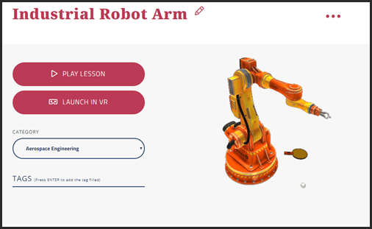

Contents
A GUIDE FOR FACULTY AND TEACHERS 1
INTRODUCTION 4
PART I – FOR FACULTY CREATING LESSONS FOR STUDENTS 5
1. IDENTIFYING WHERE TO USE THE EON-XR PLATFORM IN YOUR COURSES 5
How do you want the EON-XR Platform to be used? 5
How can you identify where to use the EON-XR Platform? 5
Using Program Learning Outcomes to Identify where the EON-XR Platform can be used 5
Using Course learning Outcomes to identify where the EON-XR Platform can be used 6
2. BUILDING LESSONS FOR STUDENT INSTRUCTION OR ACTIVITIES 6
Guides to writing learning outcomes from four different universities and countries 6
Lesson Planning Template 7
Criteria for Producing Quality Lessons 7
Quantitative Criteria 7
Suggested Lesson Activity Specifications 8
Qualitative Criteria 8
PART II – STUDENT SELF-DIRECTED LEARNING: CREATING ASSIGNMENTS FOR STUDENTS USING THE EON-XR PLATFORM 12
SETTING STUDENT ASSIGNMENTS WITH EON-XR PLATFORM? 12
Selecting topics suited to the EON-XR Platform 12
Process Questions or Questions That Require Critical Thinking 12
Providing Students with the Lesson Planning Template and Criteria 13
SUGGESTED STAGES OF ASSIGNMENT DEVELOPMENT FOR STUDENTS 13
Grading Criteria/Rubrics 14
Qualitative Criteria 14
Quantitative Criteria 15
PEER SHARING AND FEEDBACK 15
SUMMARY 16
Appendix 1 17

INTRODUCTION
“It is in the process of building EON-XR Platform lessons themselves
that student learn.”
The purpose of this guide is to provide some suggestions as to how you might use the EON-XR Platform for better student learning. At EON, we believe that the EON-XR Platform is not just an enhancement of current pedagogical practice, but that it can realise human learning capabilities in new ways.
There are two parts to the guide:
- Part I is for faculty to create lessons for students to do as learning activities
- Part II is a guide for you to give students the task of building a learning experience themselves, using the EON-XR Platform. (For the most part, you will probably do this for students doing projects or assignments, but it may be for other reasons)
A short guide for students on how to create “lessons” complements Part II - EON-XR Platform Assignment Design Brief– A Guide for Students
The guides are built on several principles for effective student learning, particularly the idea that students actively construct their understanding through doing. Learning is not a consumer activity. We learn through making meaning as we actively do something. The EON-XR Platform is like a catalyst for active learning in that using it automatically requires students to construct meaning through doing. For this reason, we believe that one of the most powerful ways the EON-XR Platform can be used is through students themselves building the lessons.
The development of EON-XR Platform lessons by students involves them in four stages:
Planning – Research – Building Lesson – Peer Sharing and Evaluation
This Guide is not intended as a set of directives, rather suggestions, and we hope that it will be used in that spirit. It is also not meant to be a one-size-fits-all guide. We expect users of the Guide will want to adapt it in their own ways, to their own purposes and teaching contexts.
We also appreciate that teaching and learning practices vary across countries and institutions and that there are different there are times when any individual teacher will want to use a variety of approaches. So, while we place some emphasis in this document on a constructivist approach to student learning, the EON-XR Platform can equally be used for direct instruction. It can form an important part of a lecture, for example, or in a collaborative session where the teacher is taking the lead. EON Reality is happy to engage with you to find the best approaches to using the EON-XR Platform in your circumstances.
We also hope that you can communicate with us if you have any suggestions for improving this Guide, or if you discover new ways of effectively using the EON-XR Platform that we have not taken account of.

PART I – FOR FACULTY CREATING LESSONS FOR STUDENTS

IDENTIFYING WHERE TO USE THE EON-XR PLATFORM IN YOUR COURSES
This Guide assumes that you have already enrolled in training in how to use the EON-XR Platform and know how to use the functionality to build lessons. The emphasis in the Guide is less on the technical aspects of the platform, than on the process of using it for quality lesson building.
Underpinning this section are the following important principles:
- Students learn through doing and constructing
- 3D and immersive environments bridge the gap between factual and theoretical knowledge, and real-world application
- A variety of activities (and media) around a single topic improves relational learning
- Students probably learn more from one another than (directly) from teachers

How do you want the EON-XR Platform to be used?
There are several choices in using the EON-XR Platform. Do you want to use a 3D lesson, with either a 3D object, or an immersive environment? Do you want students to do the lessons individually or collaboratively? Do you want to use the lessons to incorporate into your own direct instruction?

How can you identify where to use the EON-XR Platform?
It might be useful to think of how you can extend student learning in new ways, rather than using the EON-XR Platform as a supplement to current learning. Higher education teaching has been undergoing a transformation over the last 25 years or so in part because of an increase in research about how humans learn, but also because of the introduction of new technological capabilities.
At the same time, there has been a wider recognition that the approaches of the past can lead to poor outcomes. It is interesting to look at the work of two physicists, Eric Mazur and Carl Weinberg (as well as others) who conclude that physics students can pass exams but graduate without knowing how the physics they learn plays out in the real world. This is not restricted to physics. Employers will often point to a disconnect between the theory and facts student learn at university and their ability to use what they know in the real world.
It is also a problem of facts and theories taking precedence over conceptual knowledge.
The best way to use the EON-XR Platform is to identify first, where you think this gap exists between theoretical knowledge and real-world application and problem-solving. Because the EON-XR Platform engages students in a way that is closer to the real-world, these are likely to be the places where the EON-XR Platform can help bridge the gap.
Secondly, identify those places in your curriculum where students have difficulty learning concepts. Can those concepts lend themselves to 3D representation, or immersive representation? This might be a place where the EON-XR Platform can assist.

Using Program Learning Outcomes to Identify where the EON-XR Platform can be used
Another way to identify where to use the EON-XR Platform is to identify Program Learning Outcomes (and Course Learning Outcomes).
The Program Learning Outcome in this box for an engineering program is a good example of a broad and complex outcome. But it gives us some clues about the courses feeding into the program. Students will be required to demonstrate that they can design a system, component, or process. This is not something that can be demonstrated through a written text. They will need to design something. The question you can now ask is: how can the achievement of this outcome be supported by the EON-XR Platform?
“An ability to design a system, component, or process to meet desired needs within realistic constraints such as economic, environmental, social, political, ethical, health and safety, manufacturability, and sustainability” Engineering Program Outcome

The next step is to trace this program outcome back to its various sources in courses where students are required to demonstrate their ability to design a system, component or process.

Using Course learning Outcomes to identify where the EON-XR Platform can be used
By the end of this module, students will be able to: Illustrate the cell cycle and differentiate the different stages which occur throughout.
Medical Course learning Outcome
Shortcutting this approach, you can go straight to the course-level learning outcomes, where you will find much more specific and easily measurable outcomes.
This learning outcome appears to lend itself to visual and 3D representation, so it would suit

BUILDING LESSONS FOR STUDENT INSTRUCTION OR ACTIVITIES
The EON-XR Platform can be used to incorporate direct instruction into lectures, or other types of classes, and it can also be used to create activities that students will do. In this case, you may assign the lessons to students to undertake individually, or you can get students into groups where they collaborate.
Whichever of these you use, the lesson will be easier to create if you have clear learning outcomes, which you also communicate to the students. (You can enter Learning Objectives in the lesson itself, on the EON-XR Platform and in the Lesson Planning Template – Appendix 1)
If you are not accustomed to writing student learning outcomes, there are many good guides that you can access online. It is worth looking at several of these to learn how to do it.

Guides to writing learning outcomes from four different universities and countries
- University of Wisconsin-Madison, USA: “Writing Learning Outcomes”
https://assessment.provost.wisc.edu/student-learning-outcomes/writing-student-learning-outcomes/

- Newcastle University, UK: “Guidance on writing learning Outcomes”
https://www.ncl.ac.uk/ltds/assets/documents/res-writinglearningoutcomes.pdf

- University of Melbourne, Australia: “Writing learning Outcomes; a practical guide for academics”
https://melbourne-cshe.unimelb.edu.au/__data/assets/pdf_file/0007/2296861/MCSHE-Learning-Outcomes-Guide-web-Nov2015.pdf

- Nanyang Technological University, Singapore: “Intended Learning outcomes”
http://www.ntu.edu.sg/tlpd/tlr/DesigningYourCourse/WCO/Pages/IntendedLearningOutcomes.aspx
An example of a learning outcome for an EON-XR Lesson might look like this: “if you complete this lesson, you will be able to:
- rebuild a disassembled starter motor
- describe how the starter motor functions
- describe the role of the starter motor in a car
Achieving the learning outcome in the box is clearly going to be more effective if it is done through the EON-XR Platform, than through other means, rt from working with a real starter motor. This last is an important point. In a lot of higher education students do not have access to the real-world objects. This means that they learn (and are tested) in ways that do not move the theoretical knowledge to functional knowledge.
A clue to identifying where the EON-XR Platform can be used is to identify points in a course where traditionally students have trouble going from knowledge to application in the real world. The EON-XR Platform can act as the simulated real-world medium between the theoretical knowledge and the applied skills.

Lesson Planning Template
We have provided a Lesson Planning Template in Appendix 1. This template can be used by you to document the purpose of your lesson and how you construct it. It can also be used by students to plan lessons if they are creating lessons themselves.
The purpose of this Planning Template is to assist in giving the lesson coherence and purpose (see Criteria for Producing Quality Lessons, below), rather than being a random set of activities.

Criteria for Producing Quality Lessons
EON has produced two sets of criteria for producing quality lessons. The criteria are also used to evaluate students’ lessons and for students to use with one another in giving feedback.
There are quantitative criteria, (see Suggested Lesson Activity Specifications) and there are qualitative criteria (see Qualitative Criteria below). Note that in both cases these are not the kind of criteria a teacher or faculty member might use to judge the quality of the content in students’ work. They are designed to evaluate the effective use of the EON-XR Platform only. Both these sets of criteria serve as proxies for an engaging, quality lesson. If the criteria are met, the lesson is likely to be effective in engaging users in learning.

Quantitative Criteria
The following activities and functionalities can be used in the EON-XR Platform in 3D lessons, 360 lessons include voice memos, videos (including 360 videos) and quizzes.
Introduction  Memo  Build  Locate  Identify  Quiz | Screen recording function  Video  Exploded view  X Ray view  (Animation)*  Dissection
Table 1 EON-XR Options and Functions *not all models have animation

It is suggested that a good, engaging lesson, should involve as many of the activities as possible. Also, the activities should, as far as possible, be linked in such a way as they build students’ understanding, rather than staying with a string of facts.
Here, and in the EON-XR Design Brief for Students, it is recommended that a minimum number of activities to keep engagement and foster deeper learning are the following, though this is a matter of suitability to the subject matter.
Sequencing of the activities requires thought too, as described below under Qualitative Criteria.

Suggested Lesson Activity Specifications
Table 2 Lesson Activity specifications
•Introduction with 1 x Audio Narration & 1 video (1 min in length for each voice-over, either text to speech or voice recording)
•2 x Contextual Information points (Memos) – (Either editing the current annotations or to add new ones, to allow the lesson to be more relevant and contextual)
•1 x Audio Narration (1 min in length for each voice-over, either text to speech or voice recording)
•3 x Activities (Choose any suitable 3 out of the 4 types of activities possible. The choice must be made so the activity becomes meaningful and at the right challenge level. Not too easy and not too difficult)
•1 x Additional supporting media - YouTube video (Choose a suitable section or sub-section where this video would add value to the 3D lesson.)
•1 x 3D Screen Recording of a lesson focus on process such as a step by step procedure (Ensure recording is clear with clear voice and good step-by-step explanation)

These specifications are recommended to make a rich, varied and engaging lesson. How they are used effectively is further elaborated in the following section on Qualitative Criteria.

Qualitative Criteria
The qualitative criteria are based on four primary rubrics:
- Coherence
- Structure
- Variety
- Time on Task
These are outlined in the Table 3 following, and further elaborated into grading rubrics on page 14.
Table 3 qualitative specifications/criteria
Coherence
This refers to the overall unity of the lesson. The lesson needs to have overall meaning in terms of the learning outcomes and the learner should be able to achieve the learning outcomes by the end of the lesson. Coherence also means that what is learned makes sense and has significance. It is not, for example, trivial factual learning.
Structure
This refers to the way the parts of the lesson have been put together so that they inform each other and build learning. it requires thinking about how learning reinforcement works and the judicious use of, say quizzes. What the structure of a good lesson requires is a degree of purposeful sequencing.
Variety
This refers to ensuring that the lesson makes the fullest use of all the functionalities available to the lesson. Research indicates that a variety of approaches to learning (different activities and points of view) increases student engagement. A lesson that wholly consisted of memos and videos, for example, or which only had one activity, would not satisfy this criterion.
Time on Task
Drawn from Chickering and Gamson’s “Seven Principles of Good Undergraduate Education”, this refers to the fact that learners should be given sufficient time to learn, that learning does not happen quickly, and it requires effort and thought. To be valuable, an EON-XR Learning Activity (Lesson) should not be something students breeze through in a minute or two, and this depends on how the lesson is constructed to engage the learner in activity and thought, leading to a deeper understanding.

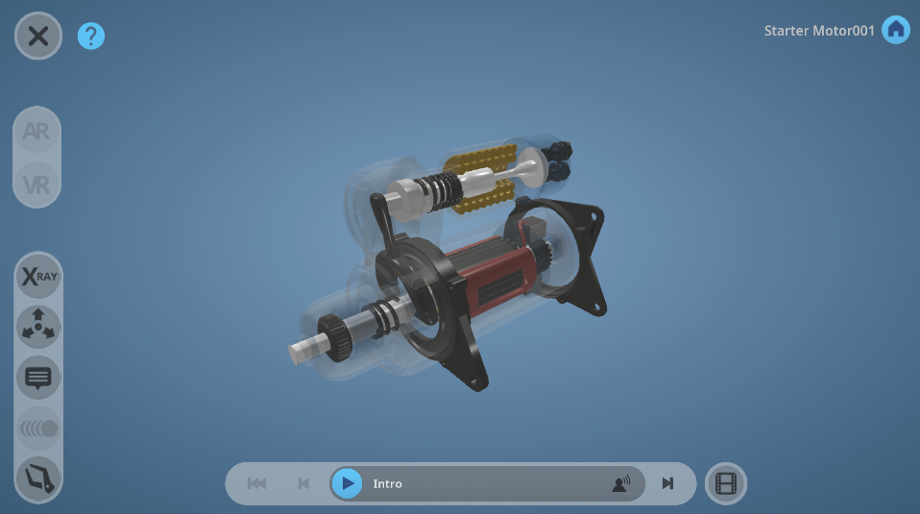
Figure 1 EON-XR Platform 3D lesson - Starter Motor
Suppose we take the above example of the model of a starter motor, for which we had already written some learning outcomes.
We want the students to be able to put together a disassembled starter motor as one of the learning outcomes.
The following figure represents one possible sequence that is designed to achieve the learning outcome through directing attention, observation, constructive activity, and questioning reinforcement.

Figure 2 Possible Sequence of Activities
- Introduction
The purpose of the Introduction is not just to give introductory information, but also to give the learner some directions as to where to go, and what to pay attention to. It might say, for example: “Next go to the video, which contains important information about how a starter motor is constructed and what you need to do in the following activity. After watching the video, come back to the starter motor and do the first “Locate” activity.
- Video
The video needs to be carefully chosen so that it both illustrates and extends what has been promised in the introduction. It should perhaps have an introduction to the starter motor, and a description of its parts.

- Locate
The purpose of putting the Locate activity next is to get students to find the coil, the central part of the starter motor, which they should have seen in the previous video. By doing this, they are having information from the video reinforced.
- Build
Having located the most inner part of the starter motor, stuents can now build th rest of the starter motor around the coil.
- Quiz
Quizzes are best used as reinforcement points in sequences, not as summative assessment right at the end of the lesson. The stem of a question here might be something like: what is the purpose of the field brush? This tops off the knowledge of the strucre of the starter motos with some conceptua (functional) knowledge.
The posibility of having learning activity sequences like this is a great strength of the EON-XR Platform for building student learning.

PART II – STUDENT SELF-DIRECTED LEARNING: CREATING ASSIGNMENTS FOR STUDENTS USING THE EON-XR PLATFORM
In Part II of this design brief for faculty and teachers, we set out some approaches to using the EON-XR Platform for creating student assignments. (Please also refer to the EON-XR Platform design Brief for students.)
One of the most powerful way to use the EON-XR Platform is for students themselves to create “lessons”. They are learning about the subject matter by the process of building a lesson that makes sense to others. They need to undertake research on the topic, use discrimination in choosing videos and other information, and generally make a coherent and meaningful whole that will be useful to their peers.
Students may do this as an assignment, as formative assessment, or as a shared activity.
The process involves preparation, research, building the lesson, peer-to-peer sharing and evaluation.

SETTING STUDENT ASSIGNMENTS WITH EON-XR PLATFORM?
Creating an assignment for students involves the same steps as creating a lesson yourself with additional scaffolding for the students. An important consideration is what kind of topic or topics you set, whether or not you specify the 3D model, or 360 photograph, and whether the students work individually, or in groups.

Selecting topics suited to the EON-XR Platform
The EON-XR Platform suits topics where you want students to build knowledge and skills that address current areas of difficulty, whether that be in terms of conceptual learning or bridging the gap between theory and application. Clearly, it is best to choose topics where 3D, real-world, visualisation and manipulation are going to improve student engagement and learning.

Process Questions or Questions That Require Critical Thinking
Getting students to learn through exploration and the construction of knowledge requires careful thought about the kinds of questions you set for an assignment. It is not a good idea, for example, if the topic encourages the repetition of factual knowledge only, or the labelling of the parts of a model.
It is better if you set students the kind of questions that encourage exploration, conceptual thinking, or skills such as
- Create a lesson that shows how the heart oxygenates blood
- Build a lesson that explains the effects of chirality
- Your lesson should demonstrate the structural fundamentals of Ancient Greek architecture
- Users of your lesson should be able to practice IV placement on mannequins
Each of these questions requires thinking about process. On the other hand, a question that said “Build a lesson to show the anatomy of the heart” may lend itself instead to showing a model of the heart with labels for the names of the parts. The framing of the question will affect the outcome.

Providing Students with the Lesson Planning Template and Criteria
To ensure students give serious thought to how their lesson will be constructed and that it achieves the learning outcomes, it is a good idea to ask them to complete the Lesson Planning Template (Appendix 1). The completed template will serve as a useful form of feedback after they have finished the assignment by enabling a comparison of what was intended with what was created.
Students should also be given the quantitative and qualitative criteria (see above in Part I Table 2 and Table 3).
This assists in knowing what is expected of them and should ensure that there is sufficient content in the lesson.

SUGGESTED STAGES OF ASSIGNMENT DEVELOPMENT FOR STUDENTS
Table 4 sets out possible steps for the development of an EON-XR Platform lesson by students. If the lesson is to have meaning in terms of student learning, it needs require planning and thought. The kind of information put into the memos, for example, and the choice of videos, require research and critical discrimination. This includes considerations of academic integrity such as not using copyright material.

Table 4 Four-Step process for Student Development of Lessons

Grading Criteria/Rubrics
The following tables provide the means of evaluating the lessons in terms of the qualitative and quantitative criteria. The quantitative criteria form a simple checklist. This is to ensure that students do not present lessons that, for example, only have one video (and nothing else), or only have an introduction (and nothing else).

Qualitative Criteria
Note: These criteria are indicative, as are the three grade levels attached. It is expected that teachers and faculty will want to modify both the content of the criteria and the grade levels to suit their own context. These criteria can be given to students at the same time as the assignment, so they understand what is expected of them
 | Outstanding | Satisfactory | Below Average
Coherence  *Note: the word “activities” here refers to Introduction,  Memo, Build, Locate,  Identify, Quiz | All activities* in the EON-XR Lesson are explicitly directed to achieving the learning outcomes and progressively build knowledge and skill | Activities* are directed to the achievement of the learning outcomes, but without being explicit | It is not clear how the activities* are directed towards achieving the learning outcomes
Structure | The lesson is carefully structured to ensure that learning is reinforced through sequences of connected activities and directing learners’ attention | Although there is a sequence of activities*, they do not have a strong purpose in guiding the learners through the activities | Most of the activities* appear to be randomly and independent of one another.
Variety | The lesson maximises the affordances of the EON-XR Platform by deploying all the appropriate activities at least once | The lesson uses several of the possible and appropriate activities but could have stretched further. | The lesson has limited use of the range of activities available
Time on Task | The lesson is designed so that learners need to take some time to work through it and complete it, taking time to think and explore | The lesson has enough in it to keep the learner engaged, but not deeply absorbed | The learner can finish the lesson quickly because it does not engage their attention
Table 5 Qualitative Grading Criteria/Rubrics

Quantitative Criteria
 | Yes | No
•Introduction with 1 x Audio Narration & 1 video (1 min in length for each voice-over, either text to speech or voice recording)
•2 x Contextual Information points (Memos) – (Either editing the current annotations or to add new ones, to allow the lesson to be more relevant and contextual)
•1 x Audio Narration (1 min in length for each voice-over, either text to speech or voice recording)
•3 x Activities (Choose any suitable 3 out of the 4 types of activities possible. The choice must be made so the activity becomes meaningful and at the right challenge level. Not too easy and not too difficult)
•1 x Additional supporting media - YouTube video (Choose a suitable section or sub-section where this video would add value to the 3D lesson.)
•1 x 3D Screen Recording of a lesson focus on process such as a step by step procedure (Ensure recording is clear with clear voice and good step-by-step explanation)
Table 6 Quantitative Grading Criteria/rubrics

PEER SHARING AND FEEDBACK
Once the students have created their lessons, further learning can take place through sharing the lessons and getting feedback. We suggest that each student gets feedback from 3 other students (if those numbers are possible) and that the feedback is not trivial – such as “It’s good, I like it” – but grounded in the criteria set out above.
- Does the lesson have enough activities in it?
- Does the lesson demonstrate coherence, good structure and variety, and allow time on task?
- Is the lesson engaging and can users learn something significant from it?
This can help students the next time they are asked to use the EON-XR Platform to build lessons. By getting feedback against the criteria they begin to internalise a set of common standards. This is an important part of becoming an educated professional in the world. It is the ability to have a sense of commonly accepted standards of quality by which they can evaluate their own performance and be self-regulating.

SUMMARY
Whether building lessons yourself as a teacher or faculty member for direct instruction or for students to undertake as learning activities, or if students are building the lessons themselves for assignments, there are several key steps. So far, we have been through a number of steps you can use for creating lessons yourself, or for getting students to create lessons.
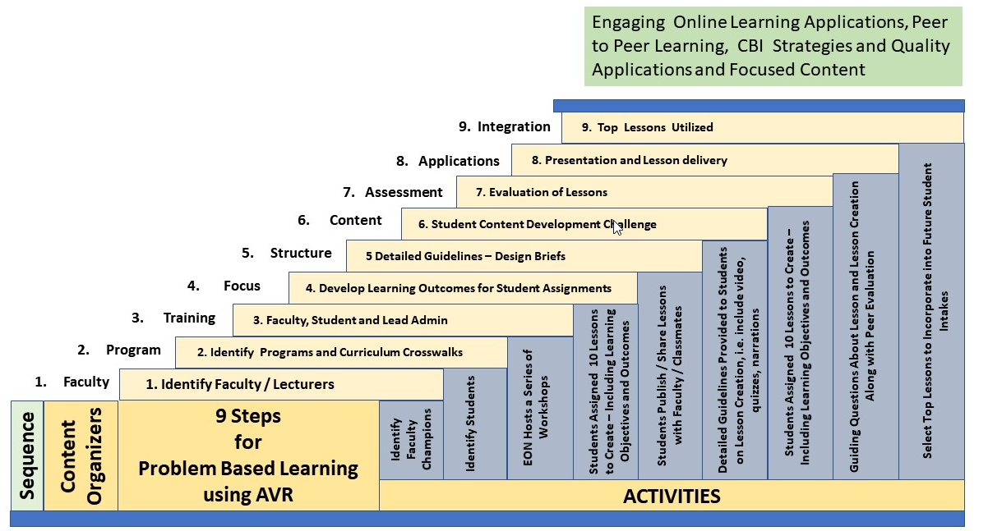
The following integrated table gives a more comprehensive picture of all the possible steps you might take beginning with choosing the faculty and courses that might implement the EON-XR Platform, and the training.
Table 7. 9 Steps for Problem-Based Learning Using EON-XR Platform

Appendix 1
Table 8 LESSON PLANNING TEMPLATE
LESSON INTRODUCTION: (Applications, how to use EON-XR, Other Lesson Context)
Enter Introduction Text Here:

INTENDED LESSON LEARNING OUTCOMES/OBJECTIVES: (What do you expect users to know and be able to do by the end of the lesson)

LESSON NAME: | INSTITUTE NAME:  INSTRUCTOR NAME:  COURSE NAME AND NUMBER:  OTHER:
DESCRIPTION: (What will users see, what happens in this lesson?)  Digital Asset/Model Name:  Location: | User Actions: (e.g. explore model, Xray, exploded view)
SCRIPT INFORMATION  Text to Speech: Yes No  Audio uploaded file: Yes No  File name:  Location: | INTRODUCTION SCRIPT: (Intro)
MAJOR TOPICS COVERED: | LEARNING TARGETS:
SUPPLEMENTARY MATERIALS:  Video Used: Yes No  Copyrights: Yes No | Video name:  Video description:  Location (URL or folder)  Location:
LESSON OPTIONS: | AR APPROACH: (How will learners use AR – in groups, other?)  VR APPROACH: (How will learners use VR, i.e. headgear, glasses, etc.?)
Memo: (Describe how many memos will be used and where) | Memo Scripts:  1.  2.  3.  ….
Screen recording:  Major points to highlight: | Sequence:  Script:
Build:

Locate:

Identify:

Quizzes: (How many quizzes are there, and where will they be located?) | Quiz questions:

