Blackboard Ally How-to: Course Report and Individual Reports
Blackboard Ally automatically scans all documents uploaded into Moodle, and returns an ‘Accessibility score’ that identifies barriers to accessibility and gives instructions on how to remove them.
This document shows how to use the course report and the individual reports. The course report compiles all identified issues that can be filtered according to priority and/or issue identified. The individual reports are accessed in context alongside the document and enable them to be identified and fixed individually.
This document uses examples of Word documents, but the process may differ with other document formats.

Opening the BB Ally Report for the whole course
- Click on the Settings cog (1) > More… (2)
- Then on Reports (3) > Accessibility report (4)
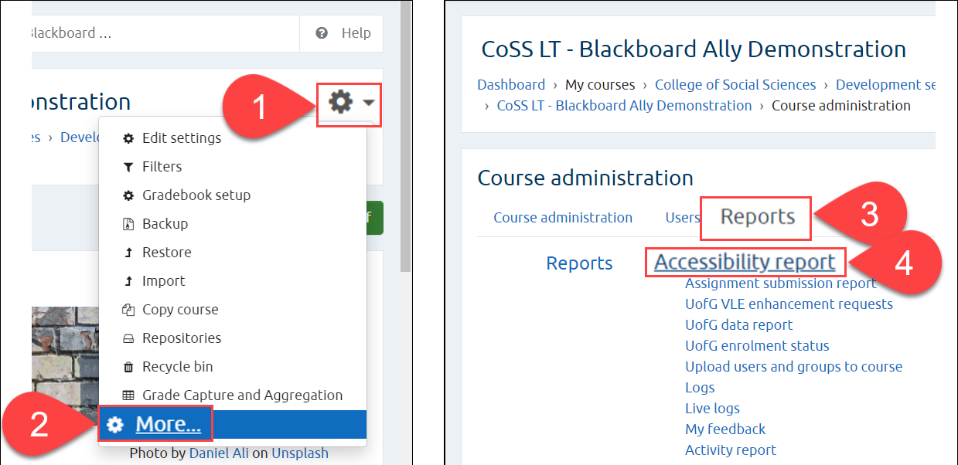

Interpreting and Using the BB Ally Course Report
- The graphic on the top left returns the overall score for the course (1)
- View all issues by clicking on the Content tab, or the View button (2)
- Select by issue type by clicking on the pie chart (3)
- Click on the Start button for Content with the easiest issues to fix (4)
- Click on the Start button to Fix low scoring content (5)
- At the bottom, the Remaining issues can be ordered by Severity or by Issue (6)
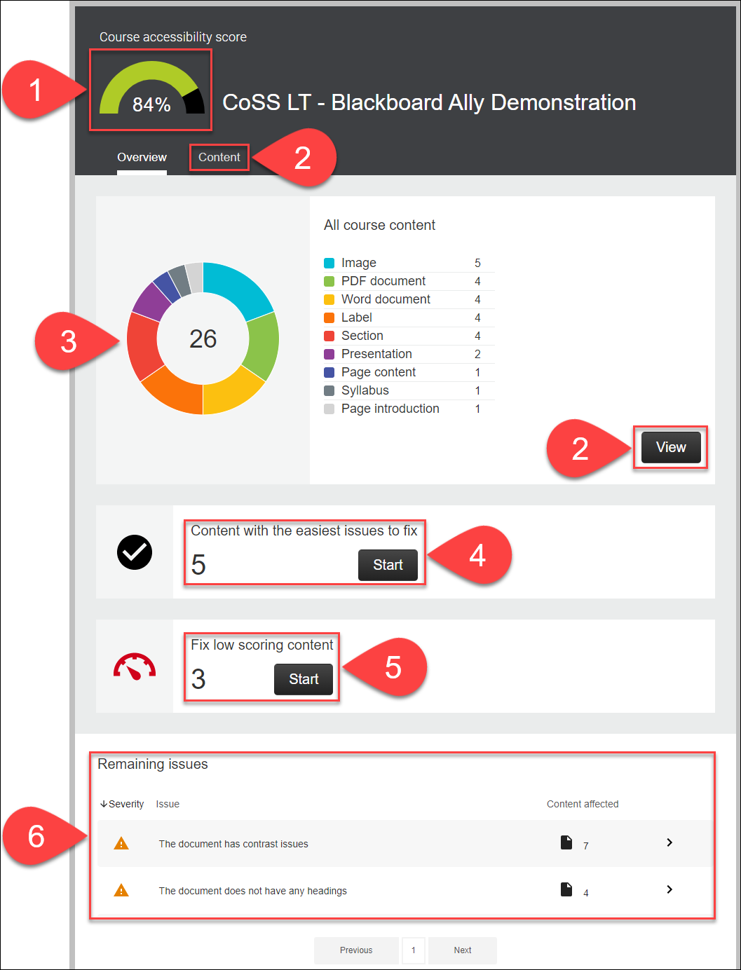

Opening BB Ally for Individual Documents
- All uploaded documents are given a rating by BB Ally, according to the following scale:
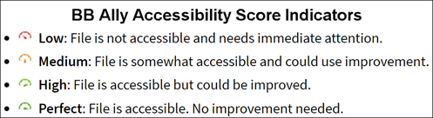
- Click on the indicator icon to open BB Ally
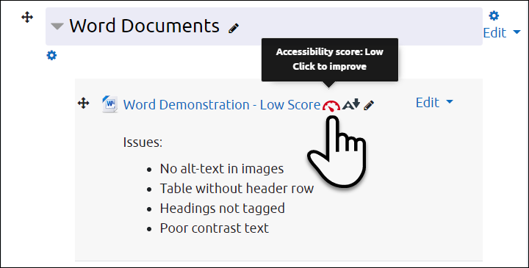

Selecting Issues to Correct
- When you open BB Ally, the original document is shown on the left and the most prominent issue is shown on the right. Click on All issues (1) to see everything flagged in the document.
- Click on the individual issues for specific details and instructions (2)
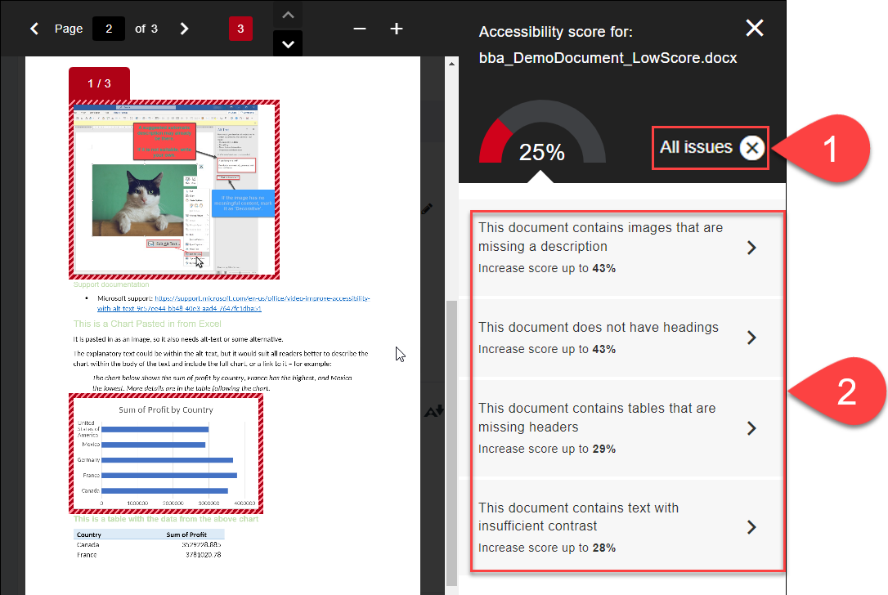

Choosing the Right Instructions in BB Ally
- In Step 1, choose the right instructions based on the software you are using – probably Microsoft Office 365, but sometimes you may have to choose Office 2016 (1)
- In Step 2, you can Print instructions if you like (2)
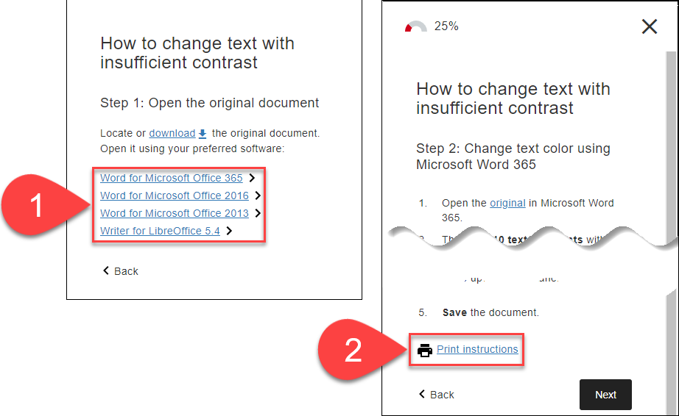

Further Resources
- Microsoft Support - General
  - Improve accessibility with the Accessibility Checker
  - Make your Word documents accessible to people with disabilities
  - Make your PowerPoint presentations accessible to people with disabilities
- Blackboard Ally Quick Start
- TEL@CoSS: Blackboard Ally
- University of Glasgow:
  - Accessible Moodle Courses
  - Accessibility- What is it and How can I Create Accessible Content?

This Moodle guide was created by TEL@CoSS and is licensed under a Creative Commons Attribution-NonCommercial-ShareAlike 4.0 International License.

