Blackboard Ally How-to: Use Optical Character Recognition
This document shows how to use BB Ally to create an ‘OCRed’ document from a ‘scanned PDF’.
Optical Character Recognition (OCR) is the electronic conversion of an image of text into machine-encoded text, meaning that it can be recognised by a screen reader. Sometimes, a PDF is scanned without OCR – this usually happens with older documents that were manually scanned or were downloaded before OCR was as common as now.
If this happens, BB Ally will score the document as 0% accessible.
There are three solutions:
- Find a new version of the document – for example from a journal website
- Add a library link to an electronic version of the document
- Use BB Ally to create an ‘OCRed PDF’ using the Alternative Document function (see below)

Identify if Document Needs OCR
- With Editing turned on, click on ‘Dial’ icon beside the document to open BB Ally
- View explanation and instructions. ‘This PDF is scanned’ means that the PDF does not have OCR. Click on ‘What this means’ for more explanation, and ‘How to fix this’ for instructions.
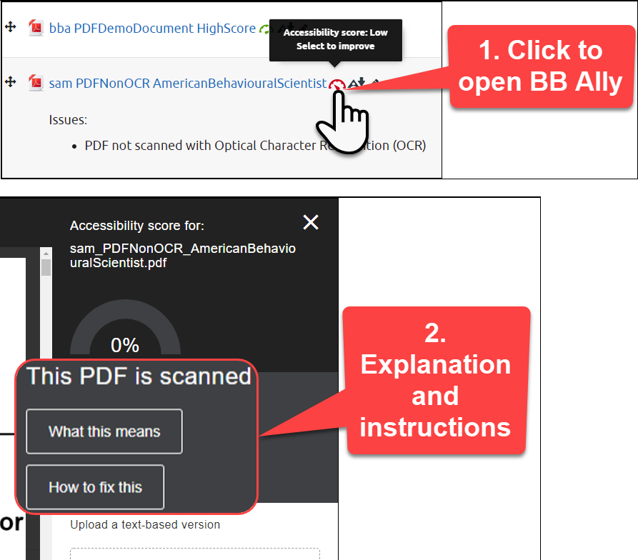

Obtaining an OCR Copy from BB Ally
- Click on ‘Alternative formats’ icon beside the document
- Select ‘OCRed PDF’
- Download
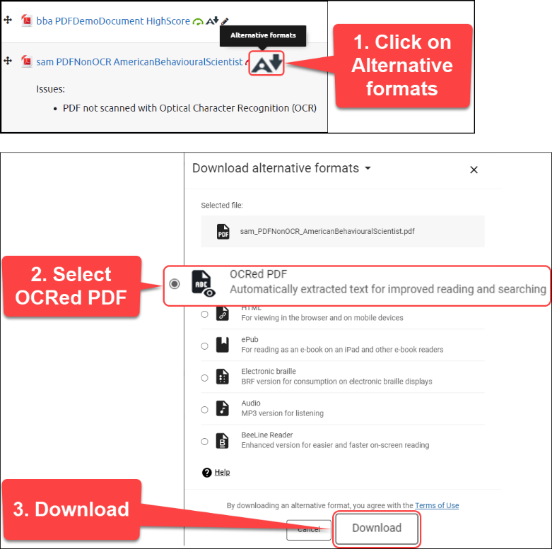
- Click on ‘Dial’ icon to open BB Ally
- Upload replacement file
  - NB: this will not necessarily fix all the issues, but it will improve the accessibility of the document
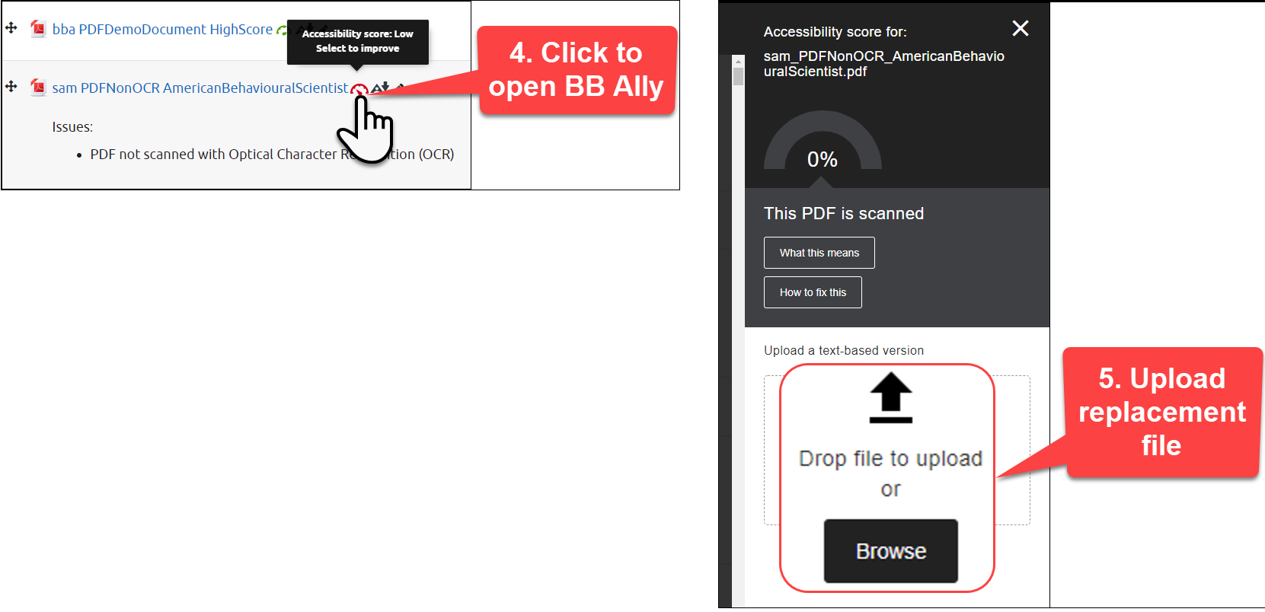

Further Resources
- Blackboard
  - Blackboard Ally Quick Start
  - Scanned PDFs
- TEL@CoSS: Blackboard Ally
- University of Glasgow:
  - Accessible Moodle Courses
  - Accessibility- What is it and How can I Create Accessible Content?

This Moodle guide was created by TEL@CoSS and is licensed under a Creative Commons Attribution-NonCommercial-ShareAlike 4.0 International License.

