Blackboard Ally How-to: Table Headers
This document shows how to use BB Ally to identify documents with missing table headers and how to rectify this issue.
The top row of a table usually indicates the content of the columns. When the header row is tagged in the software, a screen reader will read both the table cell and the header associated with it, helping them understand the context and meaning of the cell’s content.
This document uses examples of Word documents, but the process may differ for other document formats.

Opening BB Ally
- All uploaded documents are given a rating by BB Ally, according to the following scale:
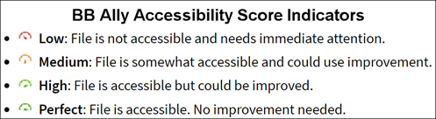
- Click on the indicator icon to open BB Ally
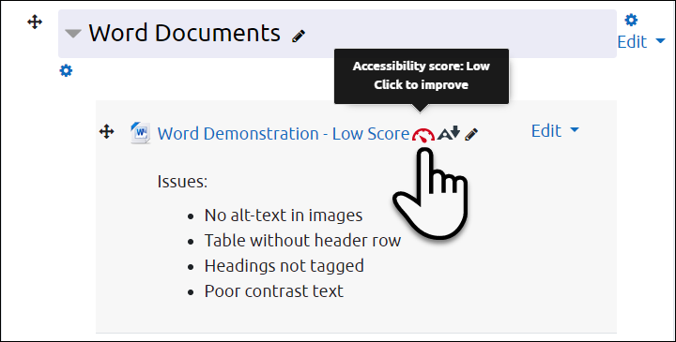

Selecting Issues to Correct
- When you open BB Ally, the original document is shown on the left and the most prominent issue is shown on the right. Click on All issues (1) to see everything flagged in the document.
- Click on the individual issues for specific details and instructions (2)
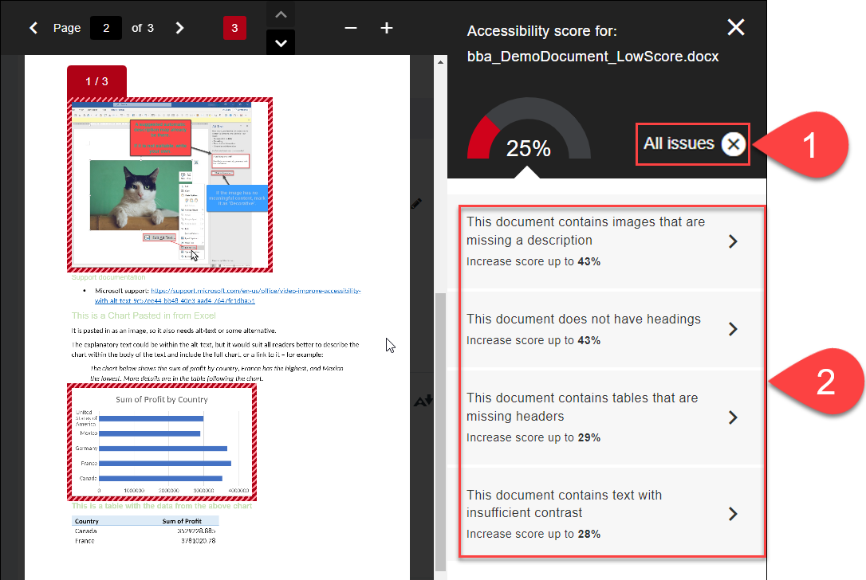

Adding Table Headers
- Images needing Alt-text are highlighted on the left (1)
- If you have a document with updated table headers, you can replace the existing one by uploading the new document directly (2), or
- Follow the instructions by clicking on How to set table headers (3)
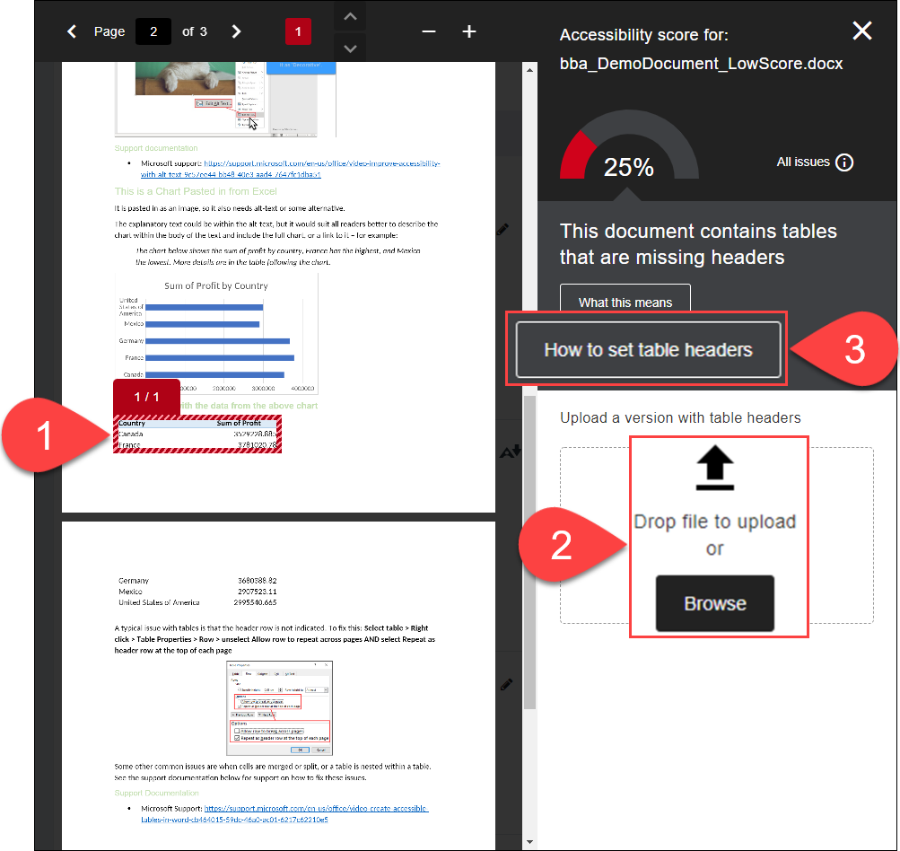

Choosing the Right Instructions in BB Ally
- In Step 1, choose the right instructions based on the software you are using – probably Microsoft Office (1) – the instructions for Office 2016 usually also apply to Office 365
- In Step 2, you can Print instructions if you like (2)
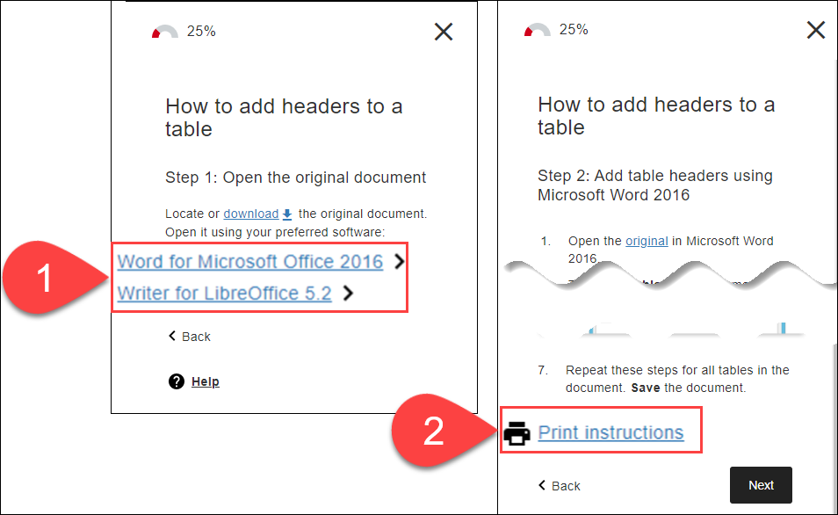

Further Resources
- Microsoft Support - General
  - Improve accessibility with the Accessibility Checker
  - Make your Word documents accessible to people with disabilities
  - Make your PowerPoint presentations accessible to people with disabilities
- Microsoft Support – Table Headers
  - Create accessible tables in Word (Video)
  - Turn Excel table headers on or off
  - PowerPoint: Use table headers
- Blackboard Ally Quick Start
- TEL@CoSS: Blackboard Ally
- University of Glasgow:
  - Accessible Moodle Courses
  - Accessibility- What is it and How can I Create Accessible Content?

This Moodle guide was created by TEL@CoSS and is licensed under a Creative Commons Attribution-NonCommercial-ShareAlike 4.0 International License.

