Blackboard Ally How-to: Fix Contrast Issues
This document shows how to use BB Ally to identify documents with insufficient contrast and how to rectify this issue. It also provides links to University Of Glasgow recommended colours, and an online contrast analyser.
If your document has a high level of contrast between text and background, more people can see and use the content. There are also some colours that are difficult for colourblind people to distinguish from each other – for example, red and green.
The easiest way to have suitable contrast is to have black text against a white background, but there may be times when other colours are suitable. Colour contrast issues can be especially relevant when using charts or other colour-coded visuals.
This document uses examples of Word documents, but the process may differ for other document formats.

Opening BB Ally
- All uploaded documents are given a rating by BB Ally, according to the following scale:
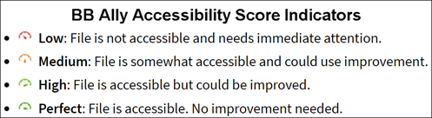
- Click on the indicator icon to open BB Ally
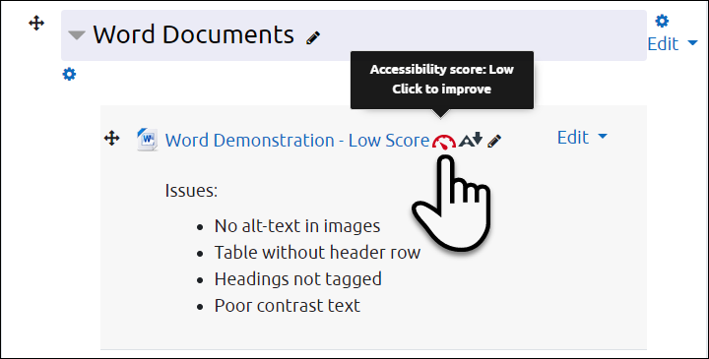

Selecting Issues to Correct
- When you open BB Ally, the original document is shown on the left and the most prominent issue is shown on the right. Click on All issues (1) to see everything flagged in the document.
- Click on the individual issues for specific details and instructions (2)
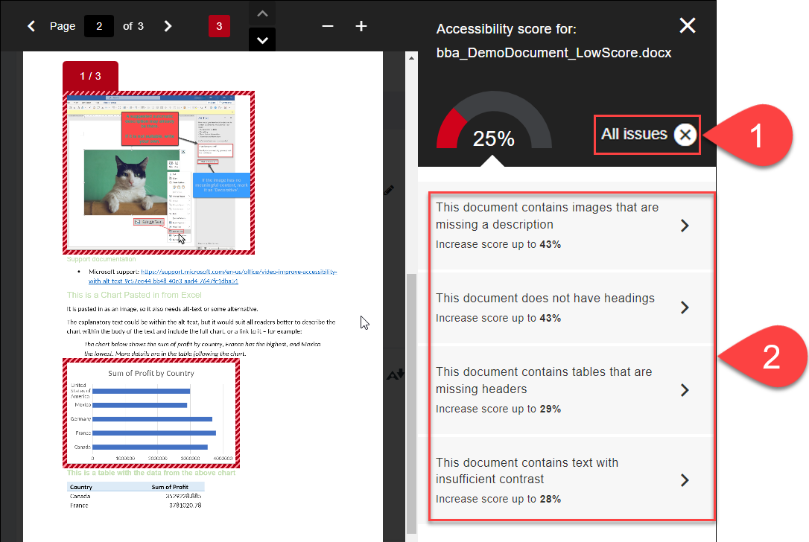

Fixing Contrast Issues
- Text needing adjustment are highlighted on the left (1)
- If you have a document with corrected contrast, you can replace the existing one by uploading the new document directly (2), or
- Follow the instructions by clicking on How to set table headers (3)
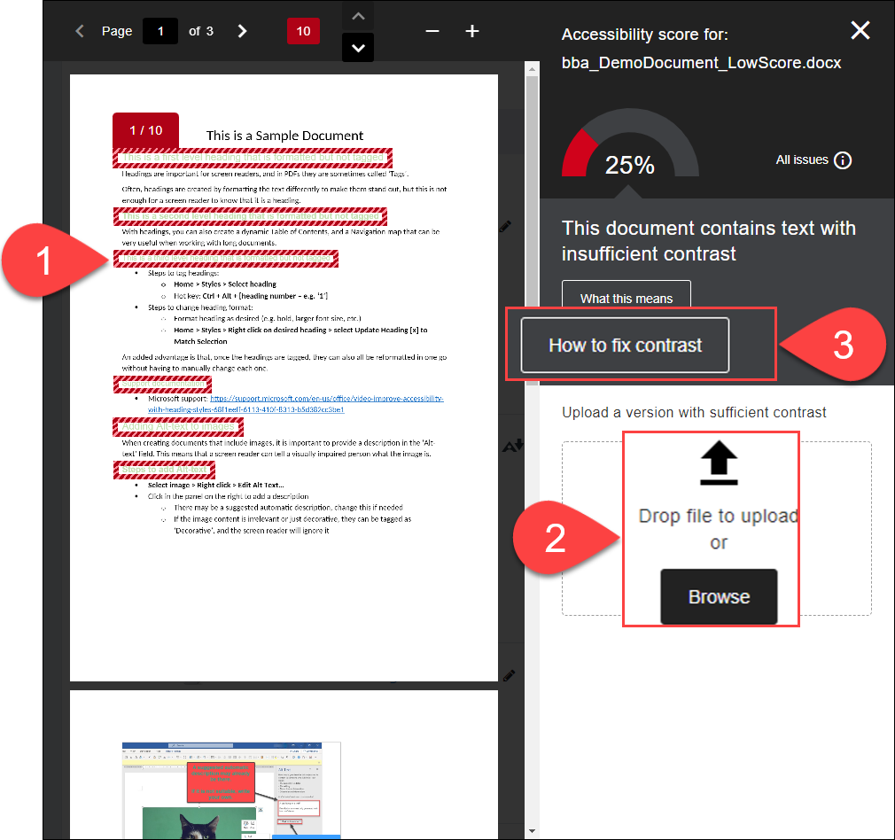

Choosing the Right Instructions in BB Ally
- In Step 1, choose the right instructions based on the software you are using – probably Microsoft Office 365 (1)
- In Step 2, you can Print instructions if you like (2)
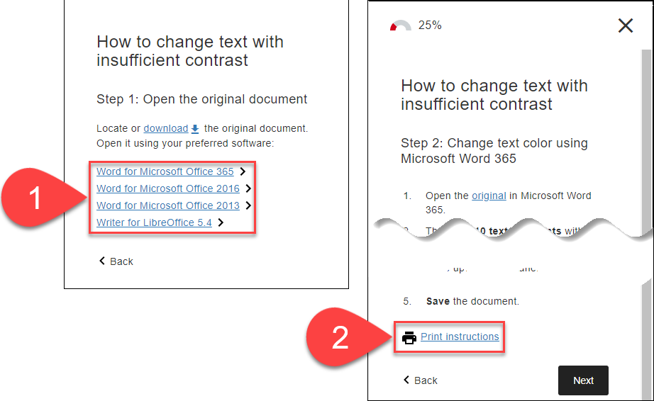

Choosing the Right Colours
The Brand Toolkit webpage has details of the recommended colours for use in university materials, including a colour palette, secondary colours, and colours that work well together.
Note that four different codes are used to express the blend that constitute the visible colour:
- PMS: Pantone Matching System – e.g. PMS2955
- CMYK: Cyan, Magenta, Yellow, Key (Black) – e.g. C100 M60 Y10 K53
- RGB: Red, Green, Blue – e.g. R0 G56 B101
- #: Hexadecimal Colours – e.g. #003865
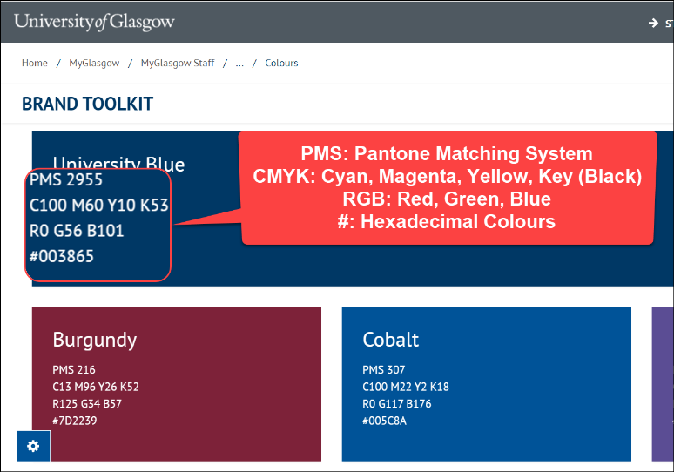

Analysing for Sufficient Colour Contrast
The Adobe Colour Contrast Analyser checks colour contrast and offers suggestions for better contrast.
- Enter Text Color and Background Color using Hexadecimal Colours code
- This will return a Contrast Ratio – the higher the ratio, the better
- See the Preview
- View Contrast Suggestions in the right panel
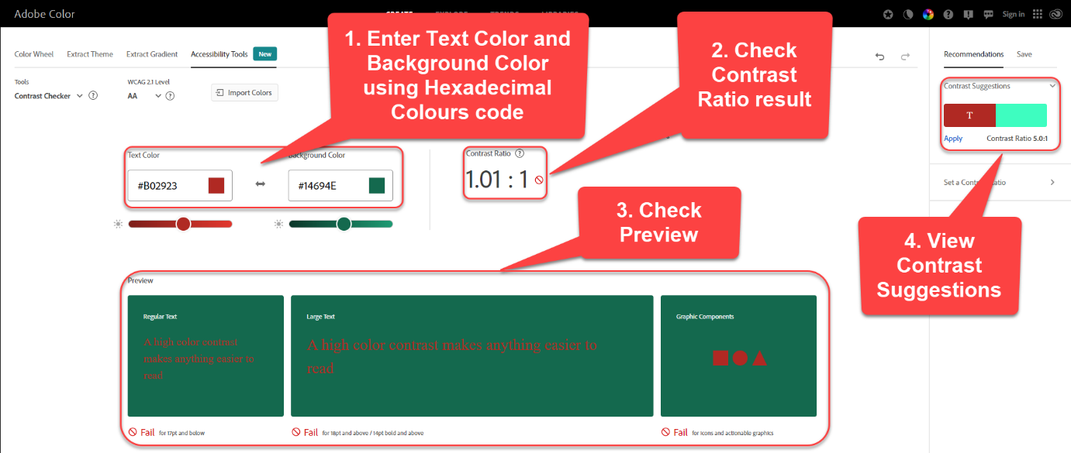
You can also use the Color Wheel to customise the colours.
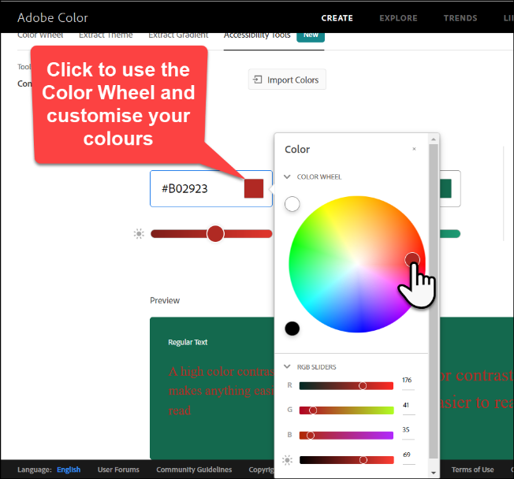

Further Resources
- Microsoft Support - General
  - Improve accessibility with the Accessibility Checker
  - Make your Word documents accessible to people with disabilities
  - Make your PowerPoint presentations accessible to people with disabilities
- Microsoft Support – Contrast
  - Use accessible text colour
- Blackboard Ally Quick Start
- TEL@CoSS: Blackboard Ally
- University of Glasgow:
  - Accessible Moodle Courses
  - Accessibility- What is it and How can I Create Accessible Content?

This Moodle guide was created by TEL@CoSS and is licensed under a Creative Commons Attribution-NonCommercial-ShareAlike 4.0 International License.

