Blackboard Ally How-to: Format Headings
This document shows how to use BB Ally to identify documents where headings are not properly formatted and how to rectify this issue.
Headings (such as titles and subtitles) usually stand out by being bigger and/or formatted differently. These visually mark different sections of the text, allowing readers to scan and focus in on what they are most interested in.
However, screen readers do not detect the formatting and the visually impaired reader cannot benefit from these visual markers.
When text is marked (or ‘tagged’) as being headings, screen readers software can recognise them as titles and subtitles, making it possible to produce a table of contents and allowing readers to jump between different sections.
This document uses Word documents as examples, but the process may differ with other document formats.

Opening BB Ally
- All uploaded documents are given a rating by BB Ally, according to the following scale:
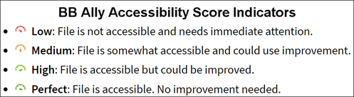
- Click on the indicator icon to open BB Ally
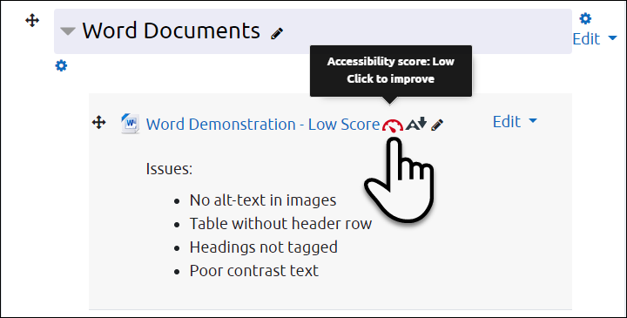

Selecting Issues to Correct
- When you open BB Ally, the original document is shown on the left and the most prominent issue is shown on the right. Click on All issues (1) to see everything flagged in the document.
- Click on the individual issues for specific details and instructions (2)
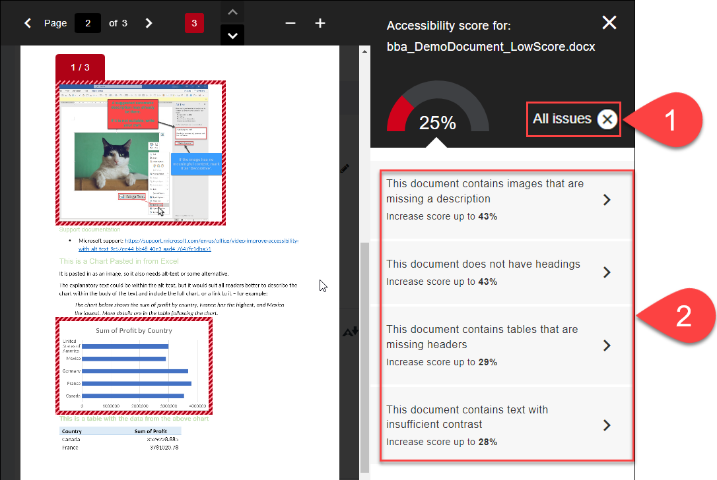

Correcting Headings
- If you have a document with updated headings, you can replace the existing one by uploading the new document directly (1), or
- Follow the instructions by clicking on How to add headings (2)
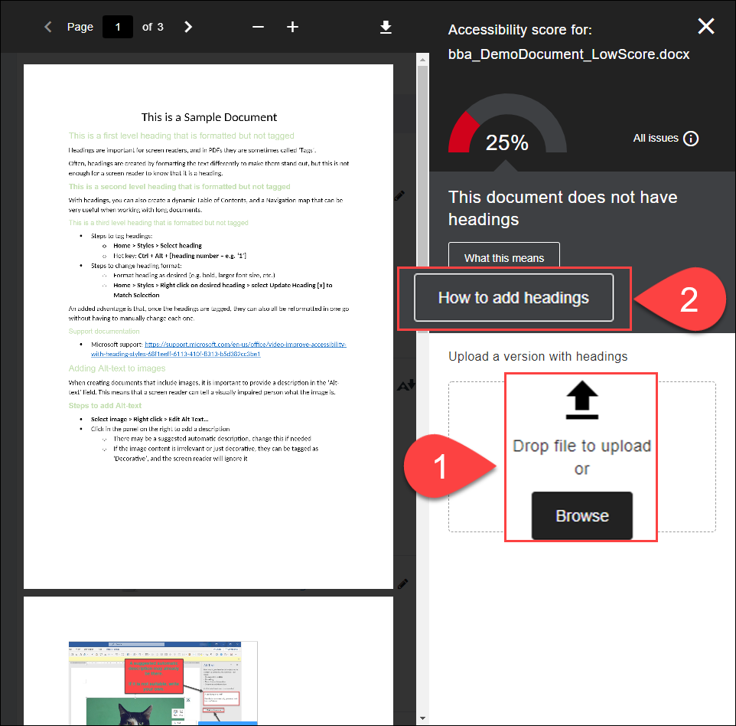

Choosing the Right Instructions in BB Ally
- In Step 1, choose the right instructions based on the software you are using – probably Microsoft Office (1) – the instructions for Office 2016 usually also apply to Office 365
- In Step 2, you can Print instructions if you like (2)
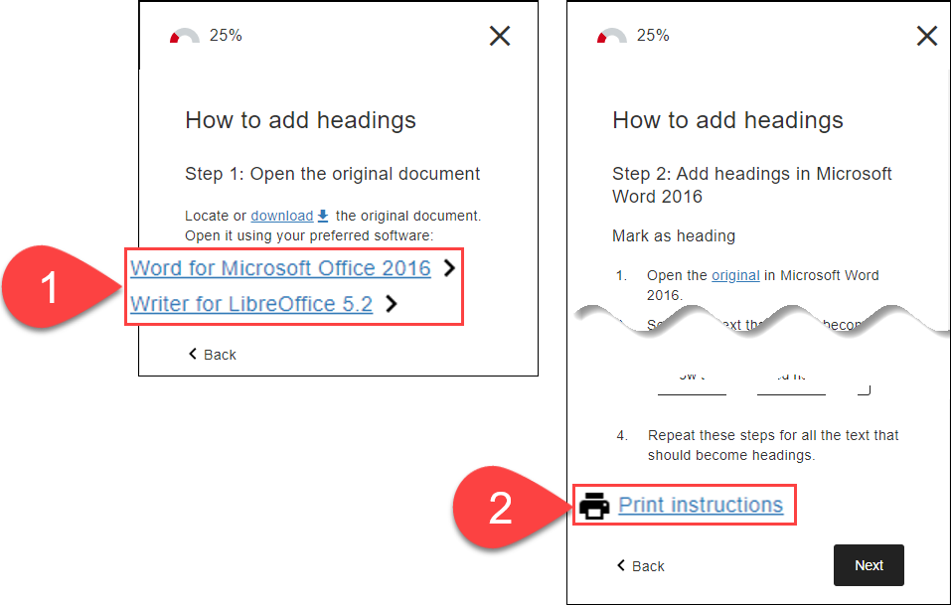

Further Resources
- Microsoft Support - General
  - Improve accessibility with the Accessibility Checker
  - Make your Word documents accessible to people with disabilities
  - Make your PowerPoint presentations accessible to people with disabilities
- Microsoft Support – Headings
  - Improve accessibility with heading styles – Word (Video)
  - Add a heading (Word)
- Blackboard Ally Quick Start
- TEL@CoSS: Blackboard Ally
- University of Glasgow:
  - Accessible Moodle Courses
  - Accessibility- What is it and How can I Create Accessible Content?

This Moodle guide was created by TEL@CoSS and is licensed under a Creative Commons Attribution-NonCommercial-ShareAlike 4.0 International License.

