Blackboard Ally How-to: Add Alt-Text to Images
This document shows how to use BB Ally to identify documents missing alt-text and how to rectify this issue.
BB Ally will flag images without alt-text. If the image is standalone, then the alt-text can be added directly within BB Ally. For images within a document, the document needs to be updated separately and reuploaded.
This document uses examples of Word documents, but the process may differ for other document formats.

Opening BB Ally
- All uploaded documents are given a rating by BB Ally, according to the following scale:
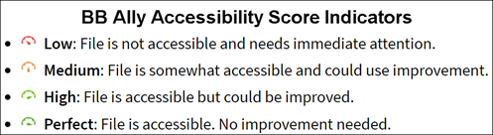
- Click on the indicator icon to open BB Ally
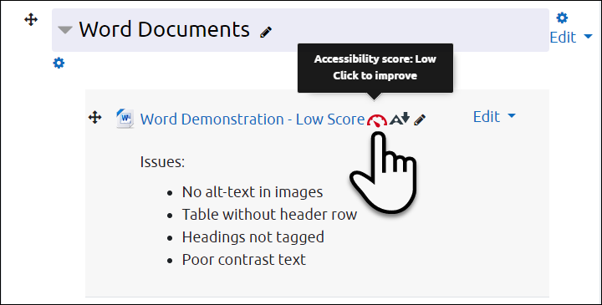

Selecting Issues to Correct
- When you open BB Ally, the original document is shown on the left and the most prominent issue is shown on the right. Click on All issues (1) to see everything flagged in the document.
- Click on the individual issues for specific details and instructions (2)
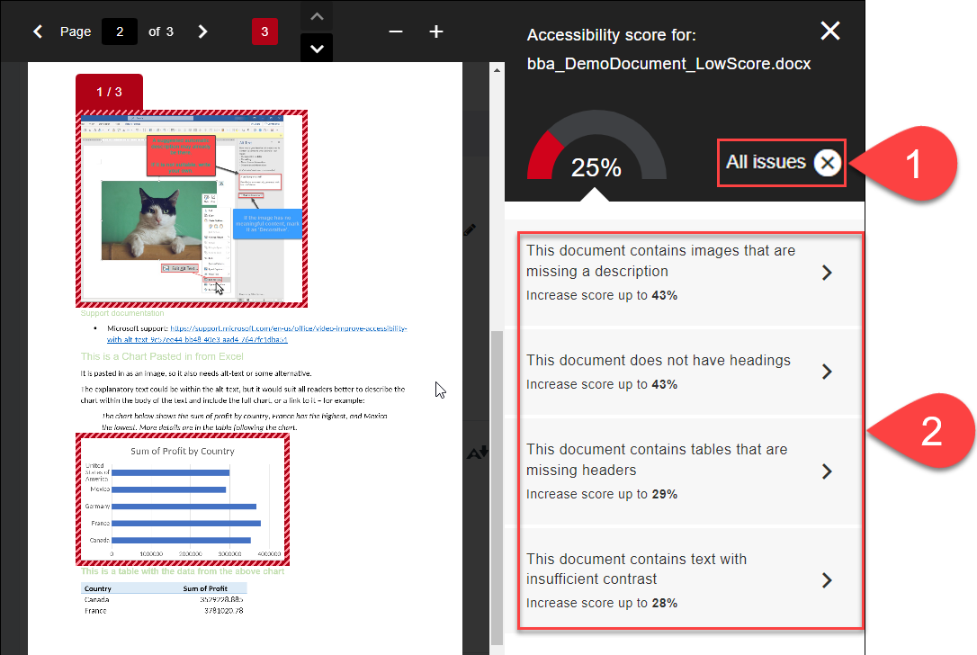

Adding Missing Alt-Text
- Images needing Alt-text are highlighted on the left (1)
- If you have a document with containing the images with alt-text, you can replace the existing one by uploading the new document directly (2), or
- Follow the instructions by clicking on How to add descriptions (3)
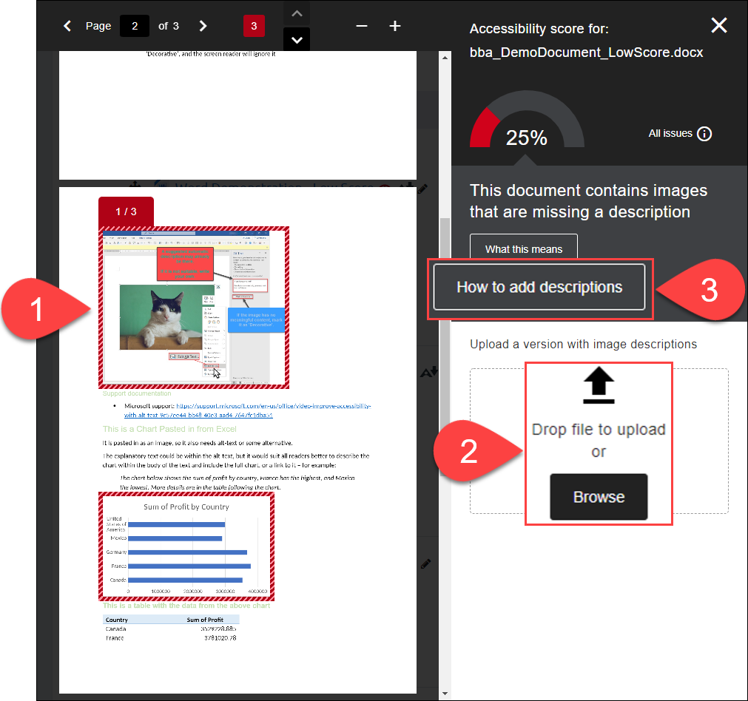

Choosing the Right Instructions in BB Ally
- In Step 1, choose the right instructions based on the software you are using – probably Microsoft Office 365 (1)
- In Step 2, you can print out the instructions if you like (2)
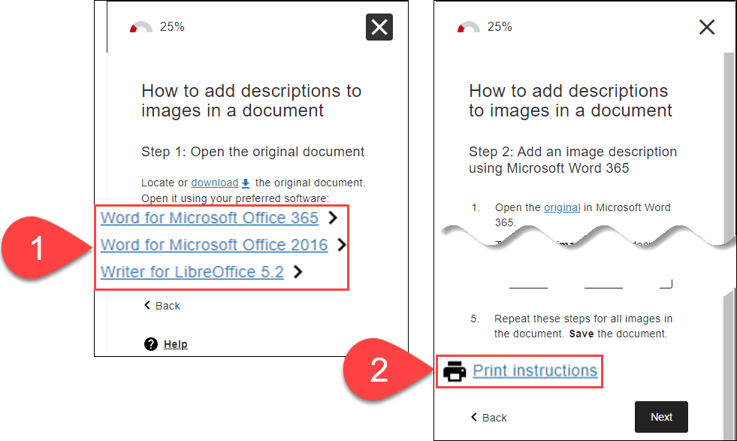

Further Resources
- Microsoft Support – General
  - Improve accessibility with the Accessibility Checker
  - Make your Word documents accessible to people with disabilities
  - Make your PowerPoint presentations accessible to people with disabilities
- Microsoft Support – Alt-text
  - Improve accessibility with alt text in Word (Video)
  - Adding Alt-Text in Word, PowerPoint, and Excel
  - Everything you need to know to write effective alt text
- Blackboard Ally Quick Start
- TEL@CoSS: Blackboard Ally
- University of Glasgow:
  - Accessible Moodle Courses
  - Accessibility- What is it and How can I Create Accessible Content?

This Moodle guide was created by TEL@CoSS and is licensed under a Creative Commons Attribution-NonCommercial-ShareAlike 4.0 International License.

