Five Steps to Check Your Content
1. Go to any of your Moodle courses and Turn Editing On
2. Look for the Accessibility Score indicator
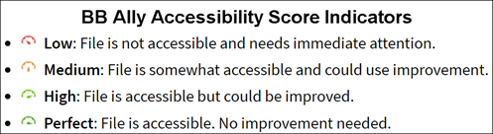
3. Click on one that needs improvement
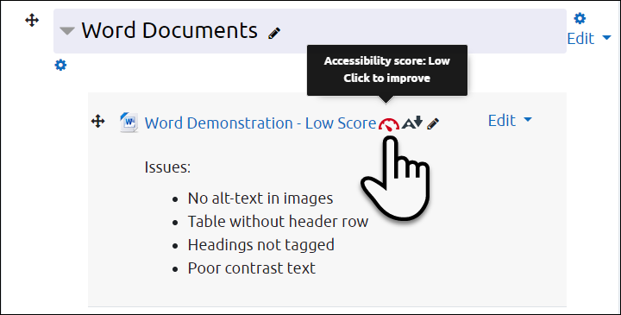
4. Follow the instructions
- When you open BB Ally, it will highlight the most important issue it has found and give a description and instructions on how to fix it
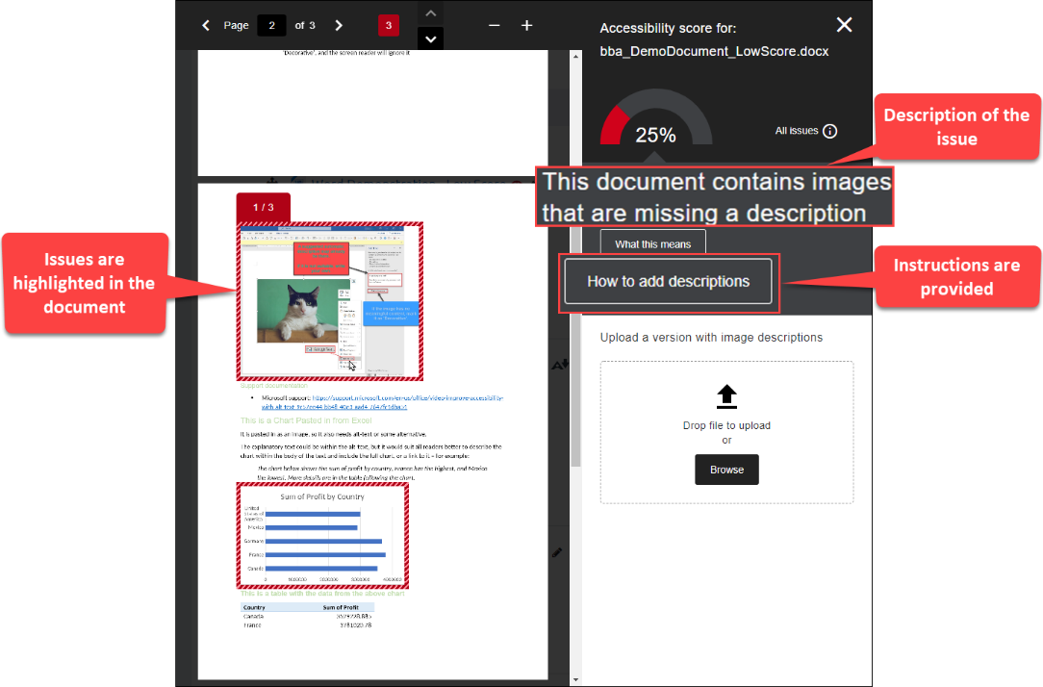
5. See further resources
- Blackboard Ally Quick Start
- TEL@CoSS: Blackboard Ally
- University of Glasgow:
  - Accessible Moodle Courses
  - Accessibility- What is it and How can I Create Accessible Content?
- Microsoft Support - General
  - Improve accessibility with the Accessibility Checker
  - Make your Word documents accessible to people with disabilities
  - Make your PowerPoint presentations accessible to people with disabilities

This Moodle guide was created by TEL@CoSS and is licensed under a Creative Commons Attribution-NonCommercial-ShareAlike 4.0 International License.

