THE TITLE OF YOUR GREAT PROJECT GOES HERE

Presenting Author First Name Last Name¹, Coauthor Name², Another Coauthor³

¹University Affiliation, presentingauthor@email.edu
²Another University
³Third University

This is a great abstract about the most amazing project ever. You can use photos, figures, tables, and text as needed as long as it fits on one page. These pages will be combined into a single word document, then into a PDF document which will be available for download by workshop attendees. We will not be providing printed abstract books.

Presentations at the workshop will be in either poster or oral format. We are trying to encourage more active participation over traditional talk formats, so posters are encouraged. The poster and oral sessions will be complemented by facilitated discussions and practical workshops (topic suggestions welcome).

Email your completed abstract template to the team at cosmo2020scotland@gmail.com using the subject line ‘ABSTRACT SUBMISSION’. In the body of your email, please indicate your preferred presentation style option (e.g. ‘poster only’, ‘talk preferred’, or ‘talk or poster’). Feel free to include any other suggestions for discussions or workshops in your email as well!

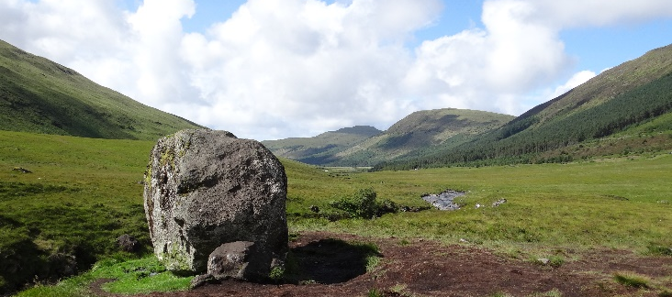
Figure 1 – A beautiful boulder in Scotland.

