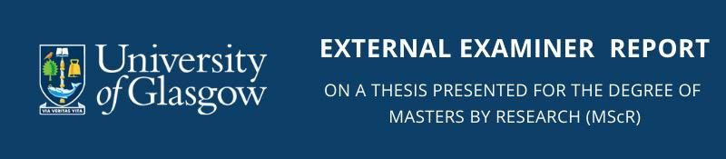

Name of Candidate
Title of Thesis
External Examiner
Institution of Examiner
Email
As this report might be required under the Freedom of Information Act, it is recommended that you should write the report on the assumption that it may be disclosed when requested. We would also request that you do not identify individual students within the report. MSc (R) word count requirement - no minimum with a maximum of 50,000 words.

General Report

Has the candidate indicated clearly which parts of the work, if any, are claimed to be original and their relation to the work of others in the same field?
If the thesis contains little or no original material, has the candidate’s work contributed significantly to an understanding of the subject of which this thesis forms a part?
Has there been adequate reference to other published work?
Is the literary style and presentation satisfactory?
To what extent are any criticisms made, major or minor?

Specific Recommendation (please X as appropriate)

Note: If contemplating recommending outcome 4 (withholding an award but permitting resubmission for a second examination) or 5 (outright failure), Examiners are encouraged to consider permitting the candidate to defend the thesis at an oral examination unless the quality of the thesis as submitted is too poor for this to be useful. If an oral examination is held, the Examiners will be asked to sign a Joint Report. If no oral exam is required, the joint Report will be signed by the Internal Examiner and Convener only, taking into account the External’s individual Report.

I recommend:

1 | That the candidate be approved for the award of the degree of MSc (R) without further conditions
2 | That the candidate be approved for the award of the degree of MSc (R) subject to satisfactory  completion of minor amendments to the thesis
3 | That, though the thesis is satisfactory, the candidate be required to undergo an oral examination before  a final decision is reached by the Examiners
4 | (First submission only) That the candidate not be approved for the award of degree of MSc (R) (with or without undergoing an oral examination) and should be informed that:  the content, presentation or both of the thesis is unsatisfactory, but that the candidate may revise  the thesis and resubmit it in support of a further application for the degree
5 | That the candidate be not approved for the award of the degree of MSc (R) and be not permitted to resubmit this thesis in support of any further application for the degree.

Signature ………………………………………………………………………... Date ……………………………

