Updating Diversity Details
All information provided is treated in strict confidence and held in accordance with relevant Data Protection legislation. Colleagues have the option to choose ‘Prefer Not to Say’ in those areas considered Protected Characteristics.
Your Diversity Details, including information on disability and your personal background, are held within your ‘My Profile’ area of the HR/Payroll system (People XD).
- To access/update your Diversity information within the ‘My Profile’ information – ensure you are viewing the Employee Dashboard view. You may need to select this from the drop down menu at the top left hand corner of the screen.
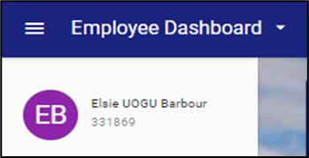

- Once in the Employee Dashboard view, click on the circle containing either your profile picture or your initials (if no picture has been uploaded) to the left of your name and staff ID number. The circle may flip to show the words ‘My Profile’ as you do this.
- Your Employee Details are then shown. You can update a number of these general fields (Contact Details/Address/Next of Kin etc) if they are blank or need to be updated.
- From the left hand navigation menu select Diversity (next option down from the Employee Detail section).
- You are then given two further menu options:
- Background
- Disability
Background Details
In the Background screen, you can update fields such as:
- Gender Identity
- Sexual Orientation
- Ethnic Origin
- Pronouns
- Religion
- Carer Status
- Date of Marriage
- Previous Surname
- Parent/ Guardian
Please note some of the fields are non-editable, such as Sex and Nationality, and can only be updated by your local HR team.
- Click the ‘Save’ button at the bottom right of the screen.
Disability Details (includes long term health conditions)
Even if you are not disabled or have a long-term health condition knowing this helps the University to develop our strategic plans, policies and resources.
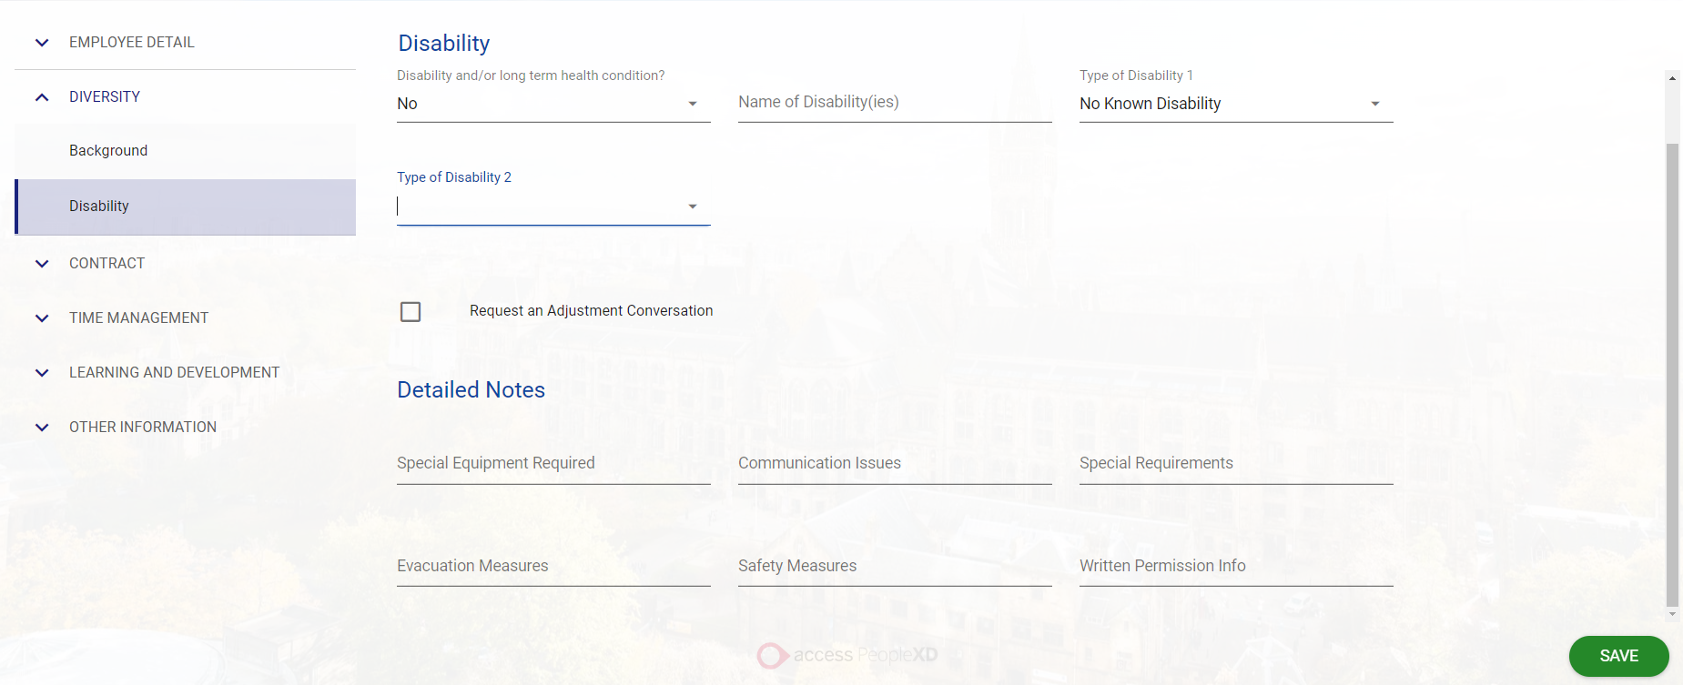
- In the Disability screen, update your disability information.
- There are four ‘General Details’ fields. Complete all relevant fields.
- Disability and/or long term health condition – options are Yes / No / Prefer not to say
- Name of Disability(ies) – free text field
- Type of Disability 1 – select from the drop-down options (includes ‘No Known Disability’)
- Type of Disability 2 – select from the drop-down options (includes ‘No Known Disability’)
Please note this information is not automatically made available to your line manager.
- If you wish to discuss any workplace needs (reasonable adjustments) relating to your disability or health condition tick the ‘Request an Adjustment Conversation’ box.

This will sends an automated message to your line manager to set up a discussion and all parties are signposted to the available resources to support constructive dialogue.

- You can enter information about any equipment which you may feel is required or evacuation/safety measures.

Note: this does not replace the option to discuss adjustments at any other point, which is the recommended route, as it also allows for tracking the progress of related dialogue/adjustments (i.e. that meetings have taken place) and supports the setting of periodic reminders to review adjustments.

- Click the ‘Save’ button at the bottom right of the screen.
Colleagues can find more information on how their data is processed in the privacy notice.
Colleagues who prefer not to follow the above route can still approach their line manager to request support however this would not include the functionality of automatic reminders etc.

