Integrating Mentimeter with ZOOM - Learner Guidance

This guide will demonstrate how to link your ZOOM account to Mentimeter to allow you to vote and interact with Mentimeter presentations during ZOOM sessions. It also covers the steps to vote during a live presentation. Please note, the minimum version of Zoom you require is version: 5.7.4

How to link your ZOOM account to Mentimeter
Step 1: Click on the Apps button in your ZOOM app landing screen

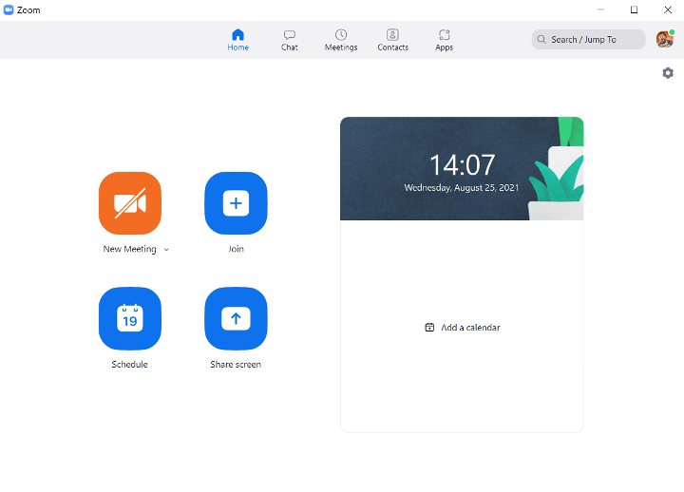
Step 2: When you click on Apps you will see the my apps page. You need to select the ‘Discover’ option. When you do, Mentimeter should be listed as a suggestion. Click on the Mentimeter App and then add it.

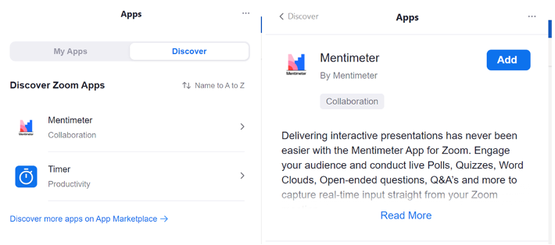

Step 3: You will now be asked to authenticate into ZOOM. To do this click Sign in with SSO and enter the address: uofglasgow
Once entered you will see the below image. Please click authorise.

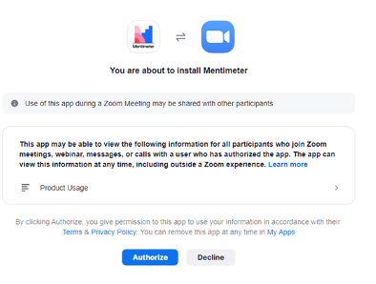

You can ignore the next window you will be taken to (this is to log into Mentimeter) and you can exit ZOOM if you wish.

How to vote during a live presentation

In a ZOOM meeting where Mentimeter is being used the member of staff will send you the presentation link on ZOOM. This will appear as a popup box asking you view the presentation. Please accept this.
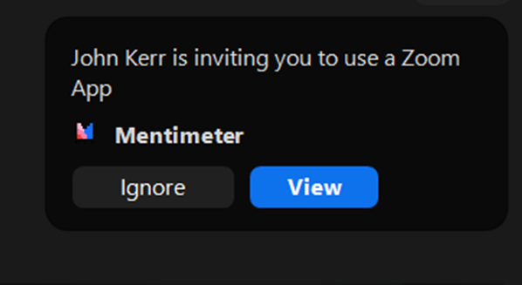

You may be presented with a login box to Mentimeter. This can be ignored as the presentation will commence when the member of staff starts the presentation.

You can vote using the side panel which brings up the various voting options.

