Integrating Mentimeter with ZOOM

This guide will demonstrate how to link your Mentimeter presentations to your ZOOM account to offer ZOOM-based Mentimeter engagement. The minimum version of Zoom you require is version: 5.7.4

Please note that learners will also have to enable the Menti app on ZOOM in order to vote via ZOOM. The steps they need to undertake are located in this document.

We recommend you share these steps in advance of any places ZOOM+Menti usage to allow learners to add this. Remember, you can always default to Mentimeter direct and share the code or link to learners to vote

Step 1: Click on the Apps button in your ZOOM app landing screen on the top bar.

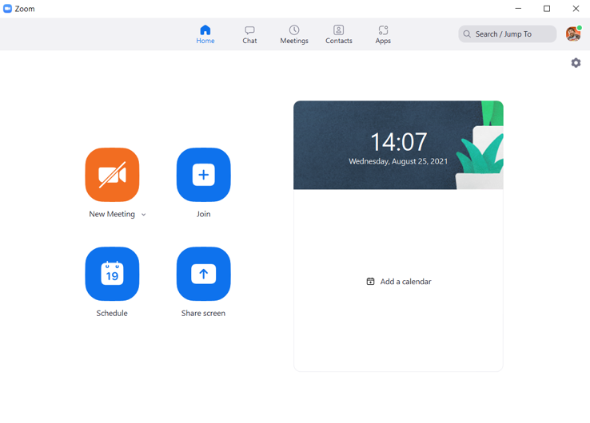
Step 2: When you click on Apps you will see the my Apps page. You need to select the ‘Discover’ option. When you do, Mentimeter should be listed as a suggestion. Click on the Mentimeter App and then add it.

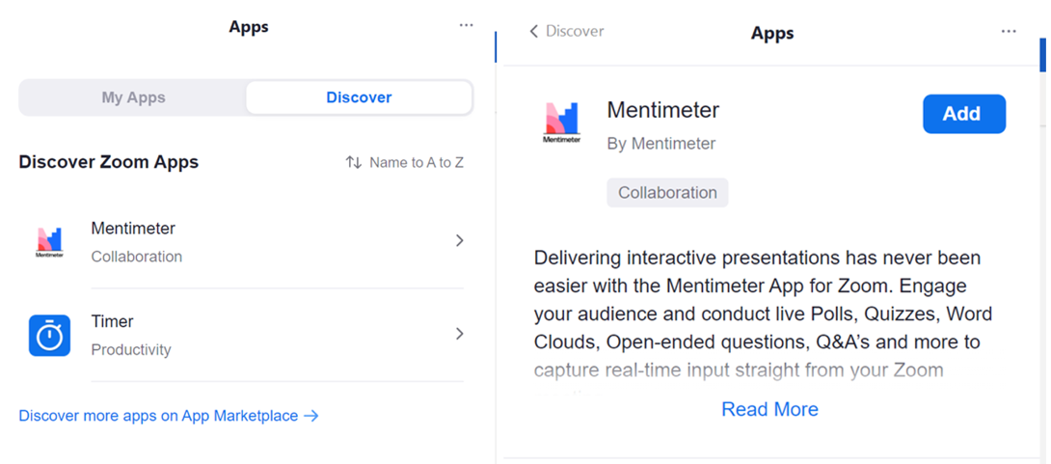

Step3: You will now be asked to authenticate into ZOOM. To do this click Sign in with SSO and enter the address: uofglasgow [the full address will read uofglasgow.zoom.us]
Once entered you will see the below image. Please click authorise.

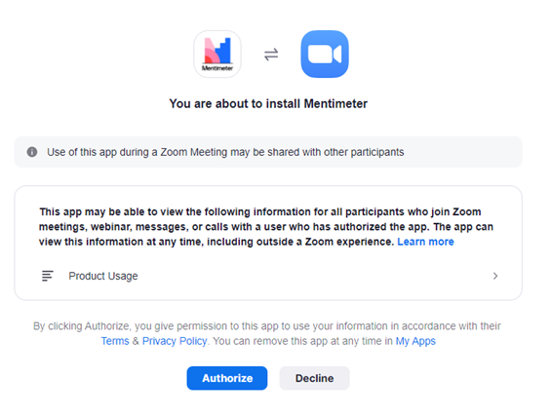

Step 4: Now we recommend that you launch a test ZOOM meeting to authenticate into Mentimeter. This is a one-time authentication and will save you time if you complete it now. Launch a test ZOOM meeting, you will see an Apps button located towards the bottom right of your ZOOM meeting task bar. Select it.

Step 5: After you click the Apps button, you should be prompted to sign into your Mentimeter account. First, it will ask you authorise the app installation and then the side panel on Zoom will load the Mentimeter Login panel. Please select the ‘Log in with SSO’ option at the bottom towards the bottom.

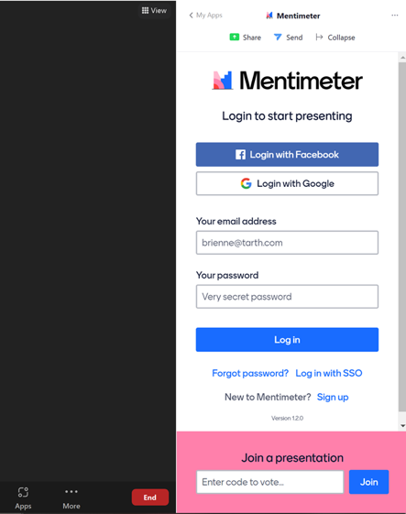

Step 6: Once you click the SSO option, a new window or tab will open, and you will be prompted to put in the ‘company name’, which is: University of Glasgow. Then you will be given a verification code to complete the authentication process.
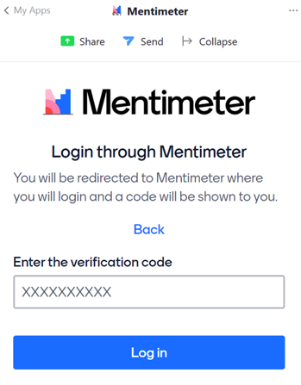
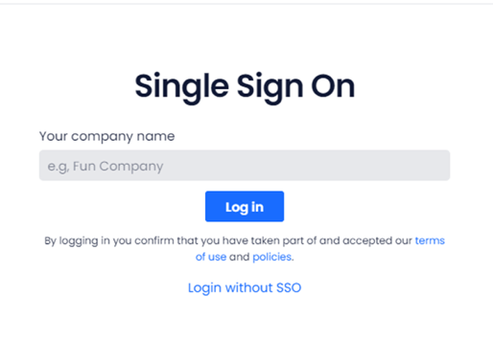

Step 7: After the authentication process is finished, the Mentimeter panel on your Zoom window will now show all your Mentimeter presentations and the participation options to Share and Send.

To share a presentation, pick the one you need then hit the Send button at the top first. This will invite all participants to join as a viewer. They will be presented with a login box to Mentimeter. They do not have to log in if they are voting and can ignore this login box. They must click the accept button to view your slides. Now hit the share button to start presenting you slides and to allow the voting box to appear!
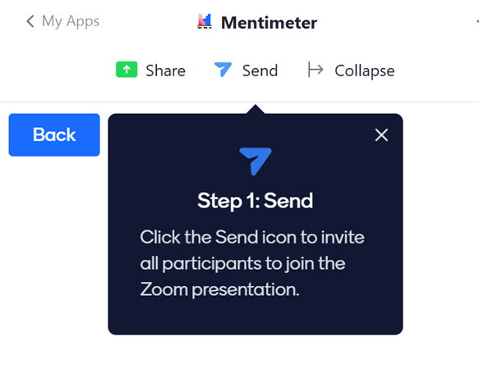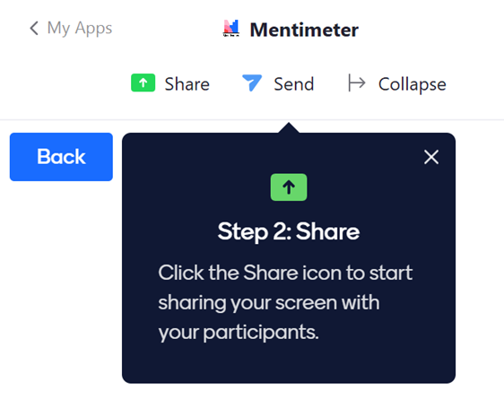
Step8: When presenting, the presentation will appear full screen, but you can close this and it will resume on the ZOOM side panel, similar to the chat panel. You can use your left and right arrow keys to move backwards and forwards.

