Listen, Reflect & Act Tool
What is it?
Based on Borton’s Model of Reflection (1970), this tool provides a structure to facilitate learning. It is based around three key questions:
- What?
- So what?
- Now what?

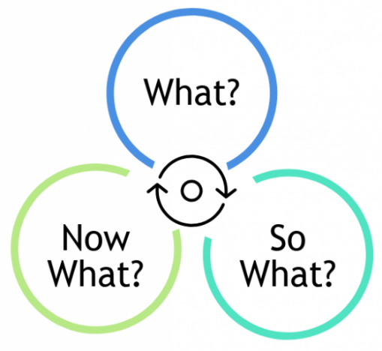
Why would I use it?
You can use this tool to help you organise and make sense of ‘data’ and to identify appropriate actions. Data in this context is qualitative, and it might be in relation to feedback that you’ve received about the change itself, the process or someone’s experiences of this or other activities. It can therefore be used in conjunction with your communication and engagement plan, to also help you keep track and communicate, actions taken in response to feedback.
How do I use it?
Using the template, capture the ‘data’, whether its thoughts, experiences or observations arising through stakeholder meetings, or perhaps the outputs from participation or consultation activities.
In response to each point captured in ‘What’, work your through the sequence of ‘So What’ and ‘Now What’, using the prompts as required.
Listen, Reflect & Act Tool
What? | So What? | Now What?
What ‘data’ did we receive? What points were raised? | So what does this data tell us or teach us or highlight that is important in the context of our change? | Now what action do we need to take in response to this data to make things better, or resolve or improve the way in which we are changing, or planning to change?

