Student Dashboard:
Assessment and Feedback

Produced by: World Changing Glasgow Transformation Team. Correct as at 1 February 2021

We are changing the landscape of how you can access your assessment and feedback information.

The new Student Dashboard: Assessment and Feedback, enables you to have a single place to view all assessments, grades, and feedback. Built into Moodle, you will be able to view upcoming assessments, due dates, and links to the Moodle submission area.

The following guide shows how to interact with the Dashboard and get the most out of this new tool.

Alternative formats for guides and tips for using the Dashboard, can be found at: www.gla.ac.uk/myglasgow/worldchangingglasgow/assessmentfeedback-traininghub

We welcome any feedback on our guides, please contact us at worldchangingglasgow@glasgow.ac.uk

Getting Started

Navigate to your Dashboard through the Moodle Learning Environment via:

The Assessment Dashboard button on your Moodle toolbar, or

The Assessment Dashboard button on your Moodle homepage

Once open, the Assessment Dashboard will provide a quick view of your assessments from current enrolled courses and your past courses.

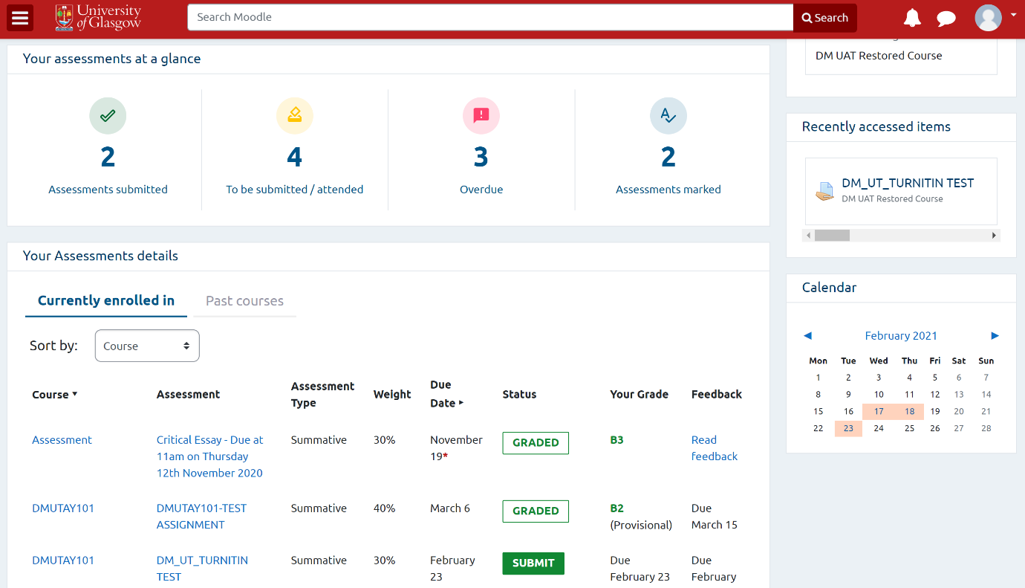

This will include all types of assessments, including those not using Moodle for completion and/or submission.

Your assessments at a glance

This section contains an overview of your current assessments, including:

- Number of assessments submitted
- Number of assessments due to be submitted
- Number of assessments overdue
- Number of assessments marked and returned

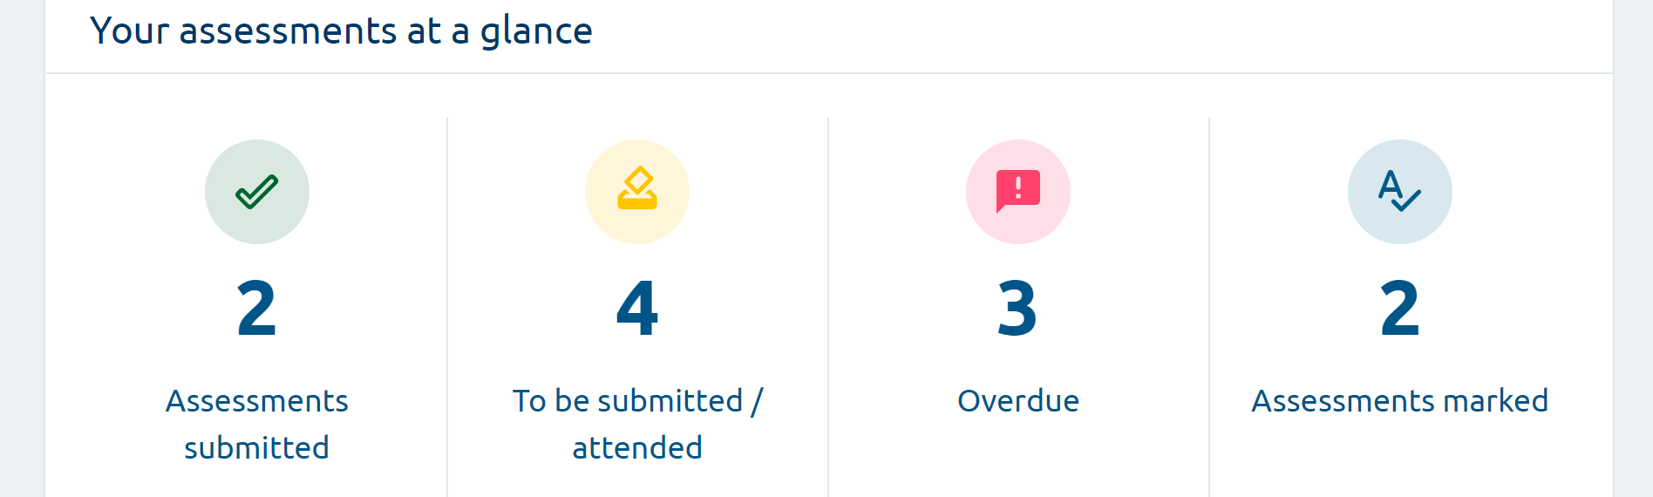

Your assessments details

This section holds a detailed breakdown of your assessments and will facilitate the planning, submission, and review of your assessments.

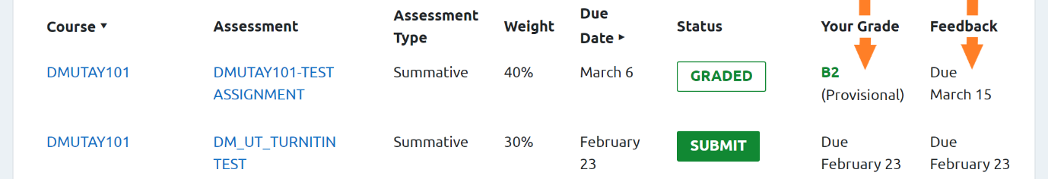

For each of your courses, you can view assessment information including Assessment Type, Weight, Due Date, Status, Your Grade and Feedback.

Assessment Type means that you can see if the assessment is formative or summative. Weight refers to the percentage amount each assessment contributes to your overall grade for the course.

You can select to sort your information by Course or Due Date to help you plan ahead.

Your assessment status

Assessment Status will show the point your assessment is in its journey. It will also act as a quick navigational link to any actions required to progress your assessment to the next stage.

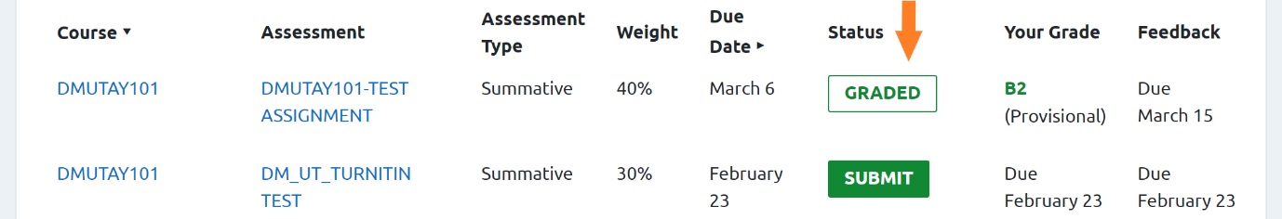

The status of the assessment will be one of the following:

SUBMISSION NOT OPEN - you cannot submit yet
SUBMIT - ready for you to upload your assessment
OVERDUE - your assessment is late
NOT SUBMITTED - the assessment period is closed without submission
SUBMITTED - the assessment has been successfully uploaded
GRADED - the assessment has been marked

The status of an assessment will only appear for courses you are currently enrolled in, and not courses you have undertaken in previous years.
How to submit an assessment

Select SUBMIT for the appropriate course. You will be taken to the submission area.

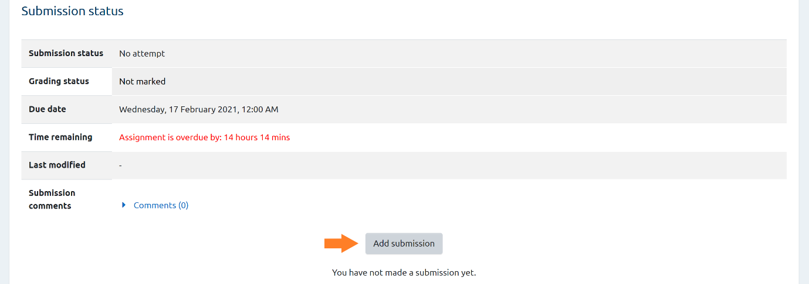

Once in the submissions area, select or drag and drop your submission into the File Submissions box. Then Save Changes and return to the Dashboard.

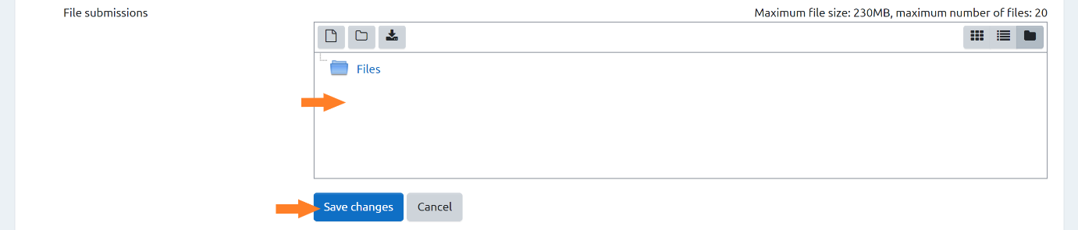

Your grades and feedback

The Grades and Feedback columns in the Dashboard will display the grade and link to the feedback for an assessment once it is marked.

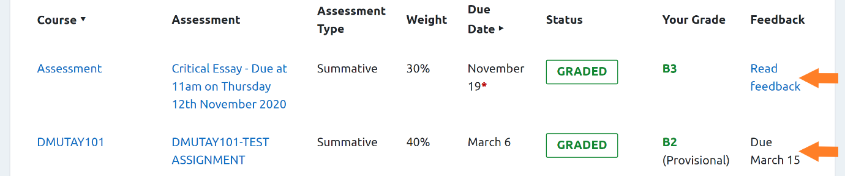

When feedback is not yet available, the dashboard will indicate a Due date.

Once feedback is ready, the status will change. Select Read Feedback.

This link will take you to the Feedback area of Moodle, where you can see your Grade and read feedback, click to see feedback in Turnitin Feedback Studio, or open feedback files, e.g. an annotated PDF or an audio file, if your lecturer has provided these.

