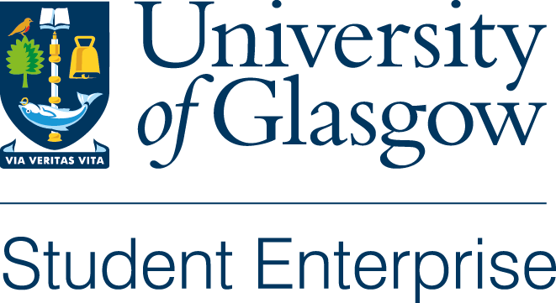

Jay Smith Creativity and Innovation Award 2021
The Jay Smith Creativity and Innovation Award was launched in 2017 through funding generously provided by Jay Smith, a local businessman, to promote entrepreneurship within the student body. The funding available for 2021 is £550 and will be awarded to a current student with a creative / innovative idea for a new product or service. The winner of this award will also be able to access the Business StartUp Summer Workshop Programme and the mentorship and bespoke workshops being offered through the Summer Company Programme. Incubation space will also be available once we are able to return to campus.
All that is required is an outline of your business idea and how the funding would help you progress your idea.
The closing date for applications is Sunday 9th May at 5pm.
Those shortlisted will be invited give a 10 minute pitch on their business idea to our virtual selection panel w/b 17th May 2021.
--------------------------------------------------------------------------------------------------------------------------
Applicant’s Name:
Address:
City:
Postcode:
Email address:
Mobile No:
Course and year of study:
--------------------------------------------------------------------------------------------------------------------------------------
- Business Outline:

- How would the funding available help you progress your business idea?

Please return completed applications to studententerprise@glasgow.ac.uk by the deadline of 5pm on Sunday 9th May 2021. Those selected to pitch will be advised on Wednesday 12th May 2021.

