Haiku/Senryu Poetry Competition
Calling all students and staff, all poets and non-poets from the University of Glasgow!

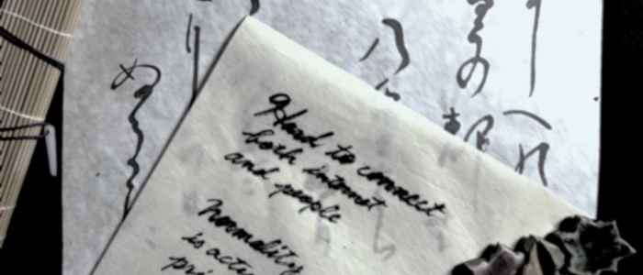
Are you a student who often has an unstable connection when a Zoom class is about to start? Are you a lecturer who has forgotten to record your lecture? Are you an administrator who misses your work computer? Are Zoom meetings/lectures draining your energy?

All students and staff of the University of Glasgow are invited to submit contemporary Haiku/Senryu on COVID-19 by Friday 16 April 2021.

What is Haiku/Senryu?
Haiku is a traditional Japanese unrhymed poem, written in a 5/7/5 meter, which often focuses on images from nature. Senryu (also in 5/7/5), by contrast, usually refers to human nature or emotions, often with a sense of humour.

Guidelines: Up to five Haiku/Senryu in English on the theme below may be submitted and considered (original, self-authored, unpublished, and not entered for any other competition). The Haiku/Senryu should be one to three lines (or even a one word ‘atomic poem’) with no strict syllable count. Some examples of Senryu by Japanese university students are listed below.

Since English and Japanese are very different, we do not require the traditional 5/7/5 structure. (You are welcome to try to keep this structure, if you wish!) We are looking for a poem which is brief, simple, clear and, if possible, witty. (We welcome entries in Scots and Gaelic with English translation.)

Theme: COVID-19 and remote study/teaching/working

Awards: There will be four awards (a first, second, third and special prize) for each of the two categories: students and staff.

Thanks to the generous donation from the Japan Alumni Association of the University of Glasgow, the STUDENT authors of the winning Haiku/Senryu will receive:
- First place: £100
- Second place: £75
- Third place: £50
- Special prize: £30
Note: a prize will be awarded to the winning authors, not each Haiku/Senryu (i.e. no winner will receive more than one prize). There is no cash award for staff, but think of the honour!

Deadline: Friday 16 April 2021

How to submit: Send an email from your University of Glasgow account to <Japan_Scotland@glasgow.ac.uk> with the subject ‘Haiku/Senryu poetry competition entry’, using the form below.

Judges (alphabetically):
- Dr Stephen Baker, President, Japan Scotland Association
- Professor Alan Riach, poet; Scottish Literature, University of Glasgow
- Dr Taeko Seki, President Emeritus, Japan Scotland Association
- Mr Kenneth Shimizu, Representative of Japanese Alumni Association of the University of Glasgow
- Professor Alan Spence, poet; Creative Writing, University of Aberdeen
- Mr Nozomu Takaoka, Consul General of Japan in Edinburgh
- Dr Saeko Yazaki, Theology and Religious Studies, University of Glasgow
Gaelic consultant: Mr Gillebride/Gilbert MacMillan, Celtic and Gaelic, University of Glasgow

Examples of Senryu by Japanese university students about online teaching:
Hard to connect
both internet
and people

Not enough
money, conversation
or sunshine

Became a better typist, but
poorer talker

New custom before class –
tidying up
my room

Remote learning
All I’ve really gained
Is fat

For every class
An assignment
Frankly impossible

My sister
took my PC
and left me the phone

Online class:
a pencil in one hand
ice cream in another

During lockdown
I finally found
what I want to do

Normality
is actually
priceless

The organiser would like to thank the staff of the School of Critical Studies for their administrative support.

University of Glasgow Haiku/Senryu Poetry Competition Form

Theme: COVID-19 and remote study/teaching/working

Deadline: Friday 16 April 2021

Please tick: |  | Student |  | Staff
Student ID:
Name:
Email address:
College / Unit:
School / Subject Area:

Haiku/Senryu (1-3 lines, or even one word*):
Up to five Haiku/Senryu in English** on the specified theme may be submitted and considered (see the guidelines and examples above).

1. | 2. | 3.
4. | 5.

* A one-word poem should be given under the generic title ‘Present circumstances’.
** We welcome entries in Scots and Gaelic with English translation.

How to submit:
Send this form from your University of Glasgow account to <Japan_Scotland@glasgow.ac.uk> with the subject ‘Haiku/Senryu poetry competition entry’.
Please take the auto-message as acknowledgement of receipt of your submission. For any enquiries, we will respond to you as soon as we can.

Note:
Submitted Haiku/Senryu and the author’s name may be made public. No other personal information will not be divulged.
--------------------------------------------------------------------------------------------------------------------------
[For official use only]

Student |  | Staff
1. |  | 2. |  | 3. |  | 4. |  | 5.

19 September 2020, Nihon Keizai Newspaper (evening), p. 7, translated by Saeko Yazaki.

