# Introducing FutureLearn Campus

FutureLearn Campus allows anyone with an @glasgow.ac.uk, @student.ac.uk or @research.ac.uk email address, free, upgraded access to Glasgow’s live MOOC portfolio as well as a large range of MOOCs from other institutions (until September 2020 but may continue past this point). Benefits of this include: upgraded access to the course and a free digital certificate once pass conditions are met (for non-Glasgow courses, certificates need to be claimed by September).

To access the FutureLearn Campus landing page, please go to <https://www.futurelearn.com/campus/university-of-glasgow>

The self-service subscription journey includes an eligibility check you must complete.

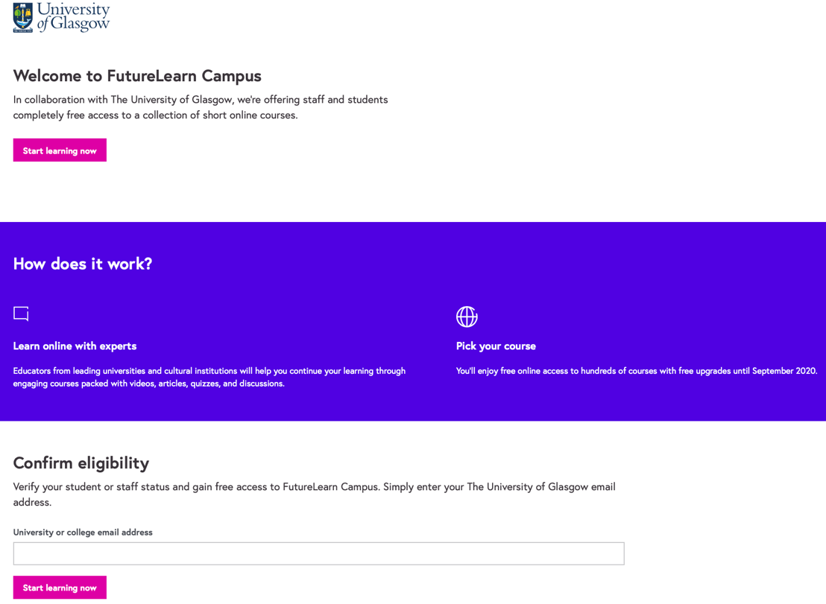

You must enter your organisational email address at this stage. Provided the domain name matches, a verification code is sent to the address provided. You will be asked to enter this code to prove that the address is your own. This is called email verification.

After successfully verifying your eligibility, you will be asked to sign in or register for a FutureLearn account and to connect it to their organisational email address.

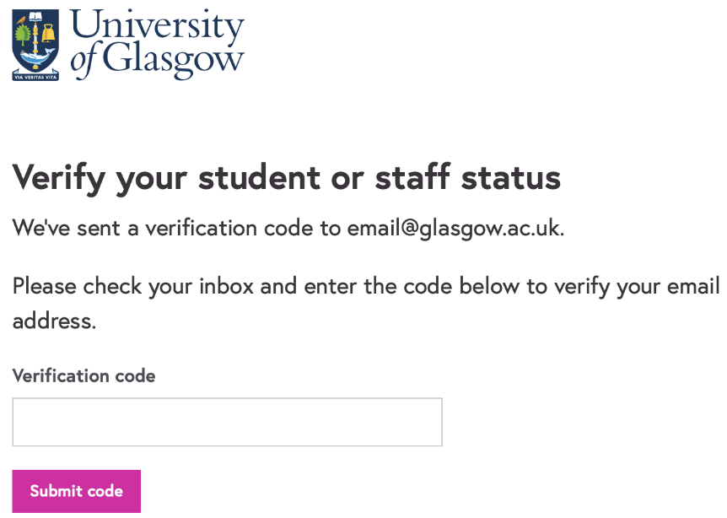

At this point you are subscribed to FutureLearn Campus and are invited to pick some courses to join.

## Discovering and upgrading on courses

Once you have successfully subscribed to FutureLearn Campus, you can use a new 'Included in FutureLearn Campus' filter on the courses page to find courses that you can upgrade on for free. You can also look for the 'Included in FutureLearn Campus' label on course cards.

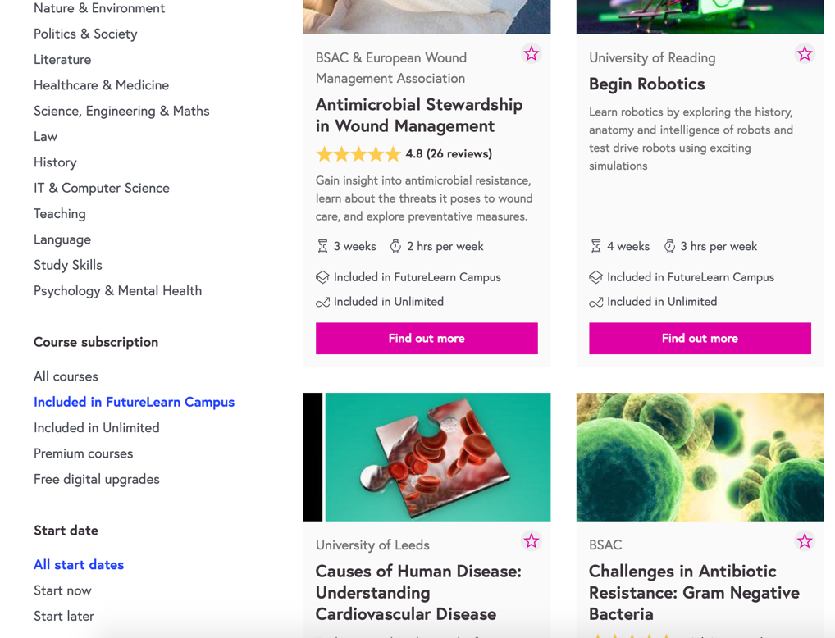

To gain your free upgrade, click through to the course description page followed by the 'Join course for free' button. You are then presented with the option to join with a free upgrade.



