10 December 2020, 2:00 GMT, Online from Paris, France

This is the script of the performance / presentation given by
Alison Phipps, UNESCO Chair, University of Glasgow
Tawona Sitholé, Artist in Residence UNESCO RILA Chair, University of Glasgow

ALISON: Chères Assistant Director General for Social and Human Sciences, Mme Gabriela Ramos, Director for Cultural Policies and Development, Mme Paola Leonscini Bartoli, Mme Ann Belinda Preis, Kia Ora Piki, Friends, Colleagues, Co-Workers,

TAWONA: Hekani.

“Everyone has the right freely to participate in the cultural life of the community, to enjoy the arts and to share in scientific advancement and its benefits.”

ALISON: In this spirit of Article 27 of the Declaration of Human Rights we bring you the findings and recommendations from our work in UNESCO Art Lab.

In this opening we’ll provide you with an overview of our process, and the framework we have settled on: The Imperative of Cultural Justice.

TAWONA: who shouted daybreak  in the middle of the night  that was just me  daydreaming in darkness  but when i’m awake  i see shadows of silhouettes  training for occupation | it was not real work  and it was not really working  yet words so convincing  looks so convincing  if seeing is believing  then i disagree with my eyes
ALISON: We came together as Art Lab to consider the value and practice of art and culture in the fraught situations of humanitarian work.

We came together because UNESCO was concerned that there was a gap between the research being undertaken, and the policy and the practice of artists working in crisis and protracted conflict.

We came together as a group of experts.

We discovered that we are a group of humans with considerable, painful and generously volunteered lived experience of conflict and humanitarian suffering, first hand, second hand and mediated through our art.
We came together online, after a first meeting in Geneva, and as people who work closely with the messy, embodied contexts of suffering and survival, of grief and joy – at a time in the history of humanity when we were separated physically.
We number amongst us those who have lived and continue to live the suffering, and those who suffer in solidarity and companionship.

We number amongst us those exquisite intercultural translators of the cries of pain and the cries of hope, the cries for peace and justice - the artists themselves.

TAWONA: who shouted liberty  in the middle of oppression  that was just me  again  daydreaming in darkness  but when i’m awake  i see mixed messages | from the mixed-up messenger  and speeches lengthening  and lessons lessening  yet words so convincing  looks so convincing  if seeing is believing  then i disagree with my eyes
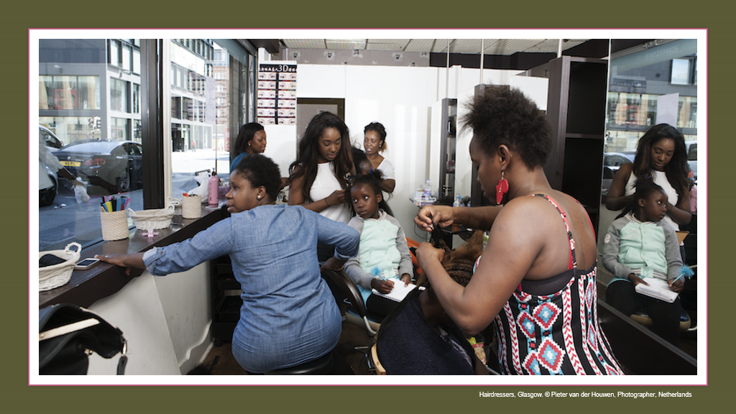

ALISON: We gathered from the four directions, to listen to the earth’s cries and the people’s voices of pain and defiance, listening in to many languages, understanding, not understanding, and seeking directions.

TAWONA: Literature on the applied use of arts in humanitarian and conflict situations is wide-ranging. The working groups opted to produce an indicative review, as opposed to a systematic academic review, identifying key resources based on multi-vocality and multi-genre formats. We reviewed the literature on ethical charters, decolonising ethical practices, first person narratives, and on UN policies on arts and cultural work. All Art-Lab Platform members agreed on the need for a decolonializing approach, ethical principles and methodology, under Article 27.

ALISON: First of all we shared our stories. We are all story- tellers but in different idioms. We found common ground in what we have been hearing and experiencing amongst the people and the land. In seeking evaluation for such arts and cultural work we have stalled, stumbled and resisted. We have been thoughtful, lost, angry and joyful.

TAWONA: We built a database. And we thought critically through careful dialogue. We were mindful of the dis-ease and exclusions that can be engendered by academic and artistic expertise, and by policy jargon. We have sought to offer a framework for our methodology that is as congruent with cultural justice as it is with the log-frames, audit trails and metrics that accompany interventions.

The Framework

ALISON: Kāti: Ethics first requires a pause. Just requires a moment before the hammer falls. PAUSE | TAWONA: [Alison holds up Calabash] Titiro: Look, witness, take it in!
ALISON: [Tawona holds up calabash] Kōrero: Gather round, start to find a common language, listen to words you may not at first understand. | TAWONA: Koru: Always we begin again. Like the seasons of the land. The fern, unfurling.

TAWONA: who shouted unity  in the middle of separation  that was just me  once again  daydreaming in darkness  but when i’m awake  i see division and inequality | the mathematics of reality  even in another time  averages would be mean  yet words so convincing  looks so convincing  if seeing is believing  then i disagree with my eyes
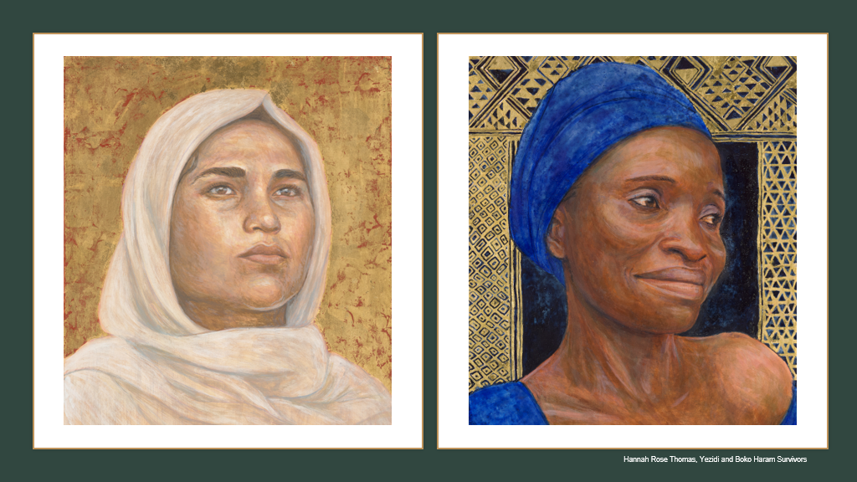

ALISON: The Imperative of Cultural Justice

Cultural Justice is a concept rooted in ethical philosophy and psychology. It originated amongst peoples with long, long histories of struggles for cultural rights, human rights, migrant rights, indigenous rights.

Early thinkers in English introducing definitions of Cultural Justice include Linda Waimarie Nikora (1993) and Marion Maddox (2009).

What is Cultural Justice?

In 2000 Ray Nairn (in Nikora 2000) defined Cultural Justice as embodying ‘an understanding of justice that requires that things are tika (just right) and not merely legal.’ Within psychological professions ‘cultural justice is about ensuring that all facets of the profession and discipline are structured, delivered and practised in a fashion that means a balance of justice and rightness for all groups involved.’

Cultural Justice, therefore, is vital for artists, academics, activists and humanitarian workers who may wish to engage in arts and cultural work with people in situations of conflict and displacement. As such it is focused on ‘doing no harm.’
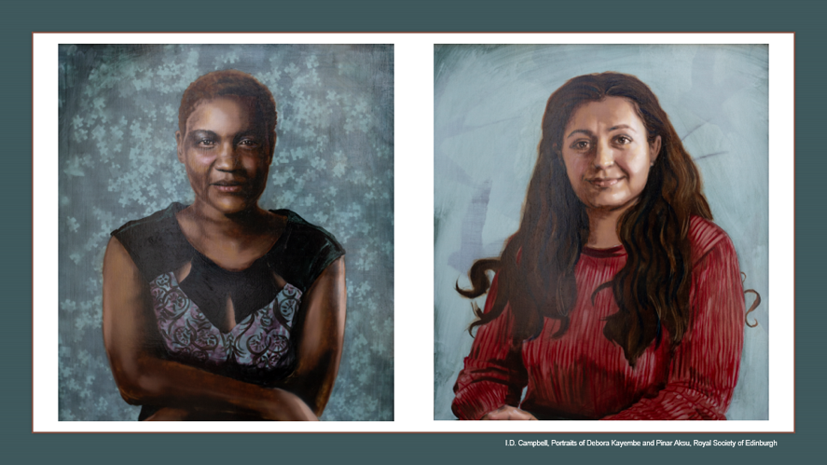

TAWONA:
Culturally Just.
Culturally Right.
Tika.
Just Right

ALISON: This concept was taken up by UNESCO in a publication in 2009 but has not received further critical attention nor has a framework been elaborated, to our knowledge. It comes from within the scholarship derived by and with those struggling for liberation from suffering in humanitarian contexts. It rests on the precious UN international declarations which have been painstakingly put in place. In particular the 2018 Report of the Special Rapporteur in the field of cultural rights (A/HRC/37/55 : 17)
TAWONA: “Because of the nature of aesthetic engagement” concludes the Special Rapporteur, “initiatives in the field of culture can make robust and distinctive contributions to creating, developing and maintaining more rights-respecting societies, especially in the aftermath of violence and in deeply divided societies. […] Cultural processes and art-making based on the exercise of cultural rights, participatory and inclusive work with local populations that aims at building bridges across social divisions, and public rituals and ceremonies that increase recognition of human dignity can often be essential to reaching a wide range of human rights goals.”
ALISON: The language of audit, resource allocation and measured impact, of strategic aims and log frames has not sat at all well with the language of ethical practices and the arts.
TAWONA: So we bring you freshened persectives, as new as they are millennia old.

Our recommendations are framed by the language of evidence, cultural rights, charters, advocacy, testimony, witnessing and decolonsing ethical practices.

Our recommendations open a pathway for the moral imagination into frameworks and charters to come, which might administer cultural justice. These bridge the gap between the often violent language of audit, derived from the military, and open pathways from the declarations on cultural rights.

ALISON: We recommend working towards the imperative of Cultural Justice through UNESCO Art Lab.

TAWONA: We recommend instigating a World Cultural Forum.

ALISON: We recommend congruence with calls and cries of the people.

TAWONA: We have uncovered many resources which can aid this work.

ALISON: And this is our cause for celebration, today, the International Day of Human Rights in the year of the Julien calendar, 2020, under the small last quarter of a waning moon.

TAWONA: who called for celebration  in the middle of misery  that was just me  yet again  daydreaming in darkness  but when i’m awake  i see nothing | nothing but things hot off the press  that make the blood run cold  i see ignorance sitting pretty  and wisdom sitting lonely  yet words so convincing  looks so convincing  if seeing is believing  then i disagree with my eyes
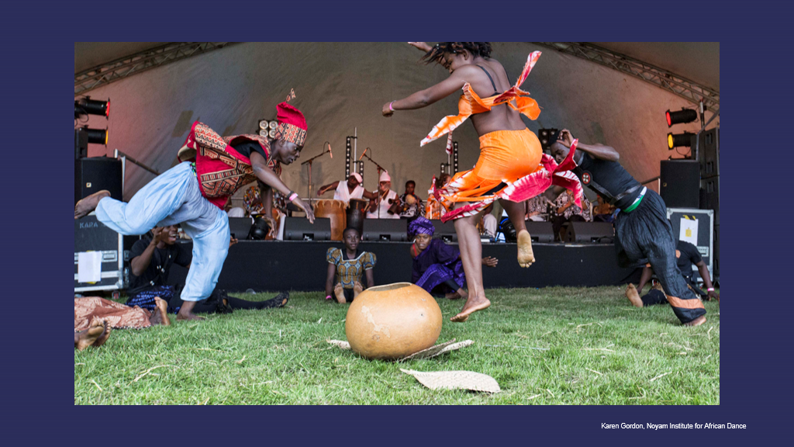
Sources of Further Information

Art-Lab #4 Programme & meeting document
Art-Lab review Biographies
Key recommendations from the Art-Lab review: presented on the 10th of December 2020 during "Art-Lab #4-The imperative of cultural justice: arts for inclusion, equity and human rights"

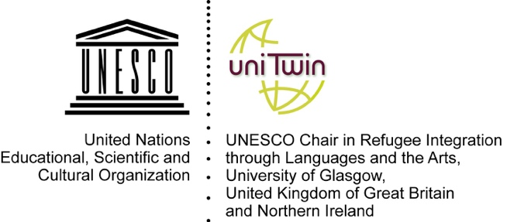 | 