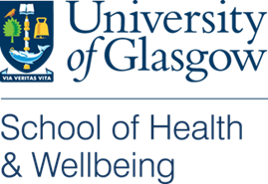

Testing ways to increase participation in bowel cancer screening (TEMPO study)

The problem we are looking at:
Bowel cancer screening is offered to men and women aged 50 to 74 across Scotland to help find bowel cancer early when it is easier to treat. They are sent a test kit every 2 years as part of the Scottish Bowel Cancer Screening Programme.
Bowel cancer screening can save lives, but many people do not return their test. We know that people who mean to take part often do not get round to it.
We want to know whether additional screening information can help people use their screening tests.

What are we going to do?
We will add a new planning support tool to the screening information people receive.
This type of tool has helped people to plan how to do other things, like being active and taking medication. Members of the public helped us to develop a tool for bowel cancer screening.
We will also add a suggested deadline to the letter people receive with their test. Our research suggests that more people could return their test if there is a deadline. We will try different deadlines: 1 week, 2 weeks and 4 weeks.
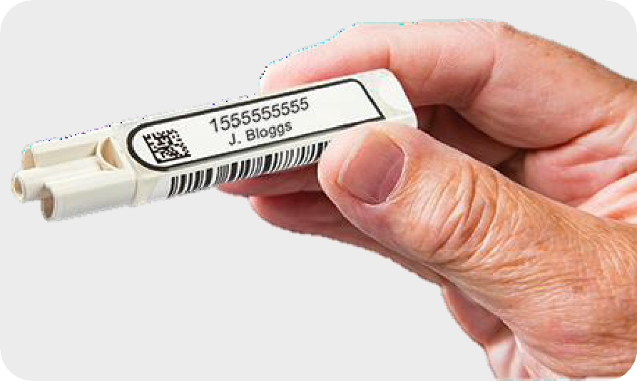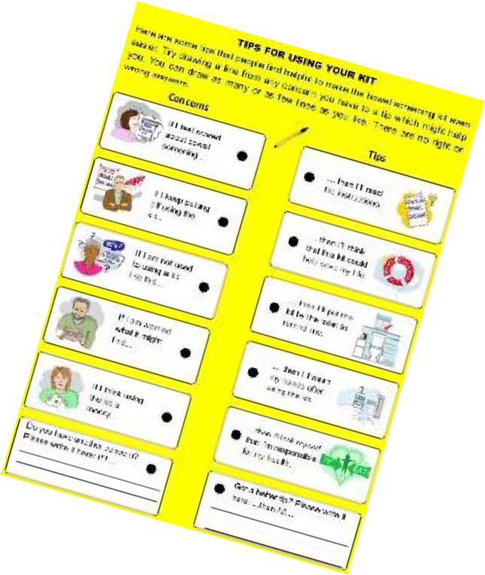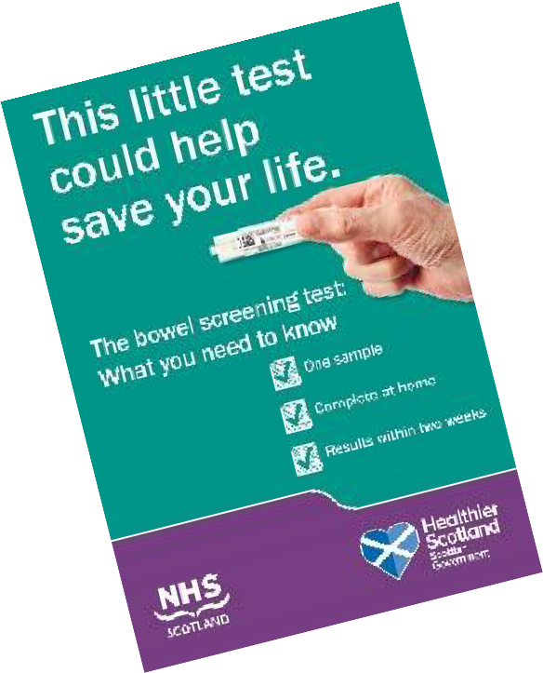

Who will be in the study?
We will send the new screening information to randomly chosen groups of people who are being sent bowel screening tests.
We will compare those groups to other people who received the usual information. We will look at 40,000 people in total.
If more people return their test with the new information, this could mean the new information helps people use their bowel screening tests.

What else will we do?
We will ask 2,000 people to fill in questionnaires to find out what they thought of the new information. We will ask people who did and did not return their tests, so that we can compare them.
We will talk to 40 people to look more in depth at what they thought about the new information.

For further information please contact:
Ben Young, School of Health and Wellbeing, University of Glasgow Email: ben.young@glasgow.ac.uk
This study is funded by the Scottish Government’s Chief Scientist Office and Cancer Research UK
Last updated: 02 June 2023

