Submitting A Staff Request

Staff requests are used to start a Recruitment campaign.
In order to raise a staff request you must be nominated by your Head of Department/Service. Once nominated, you will be able to raise staff requests for the whole department/service.
Before starting a new request it is useful to check that you know the type of appointment, the funding details, the financial impact this appointment will have and any supporting documentation you may require.
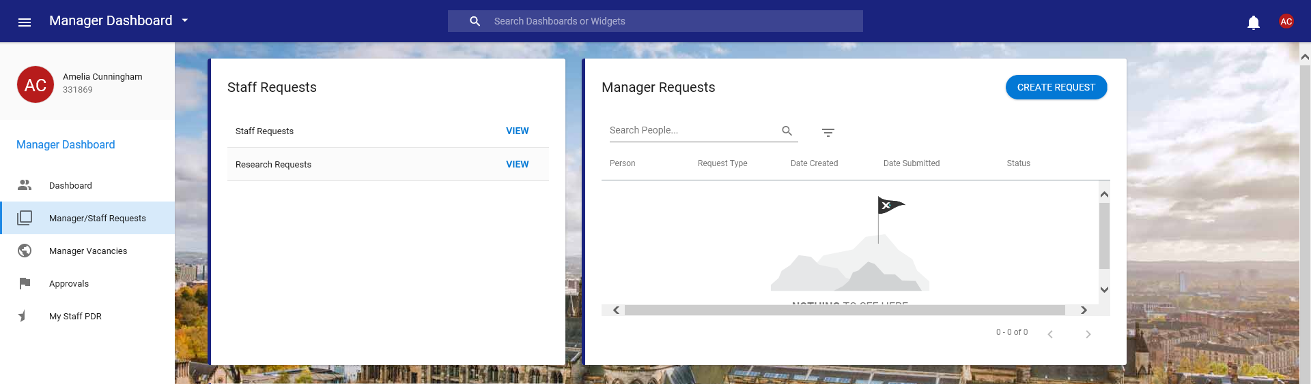
Staff requests are submitted via the Manager/Staff Requests tab in the Manager Dashboard. You need to select the “View” button along from Staff Requests.

After selecting this option, a new window will appear which contains information relating to previously submitted or planned staff requests.
The donut displayed on the left hand side of the screen provides information in a snapshot regarding the number of staff requests at each status of the process. You can see at a glance how many of your staff requests you have submitted, had approved or had rejected. It is not possible to view that group of staff requests by clicking on the key.
If you would like to filter your requests in order to look at a particular group you should use the free text search box to look for key words or alternatively use the drop down list to look for requests of particular statuses e.g. all your rejected requests or all your submitted requests.

Copying a Previous Staff Request
To complete a staff request you should always try and copy one that you have previously submitted. In the above screen you can see a list of all previously submitted requests, to copy one you should press the button at the end of the row and select to Copy the request. Once a request has been copied the screen will refresh and you can begin to complete the staff request fields.
Down the left hand side are the stages of the request with information you must fill in at each level. To move from level to level you can either use the “Next” button or select the stage from the left hand side.
As you are copying a previous request, the majority of the information will already be filled in and correct however you should always review this information to make the staff request applicable to your new vacancy. Items such as notes, work patterns and start/end dates all need amended to reflect this new request.
It is likely that with your new staff request there will be new dates associated with the cost allocations, as you have copied a previous request there will already be information within this field. To make amendments you should delete all information regarding the previous cost allocations by selecting the ”Clear” button and then entering the data from scratch.
Once you have completed all the appropriate fields you will need to “Save” the information and then be asked whether you want to submit the request or not.
Creating a New Staff Request from a post
There will be times when it is not possible to copy a previous request and so you must create a request for the very first time. To do this, select the “View” button along from Staff Requests and choose the “Your Establishment” option from the left of the screen.
The screen will refresh and you can either search for a post by completing hierarchy information and pressing Apply or, you can scroll down the page slightly and enter the post number (if you know it) and find your post that way.
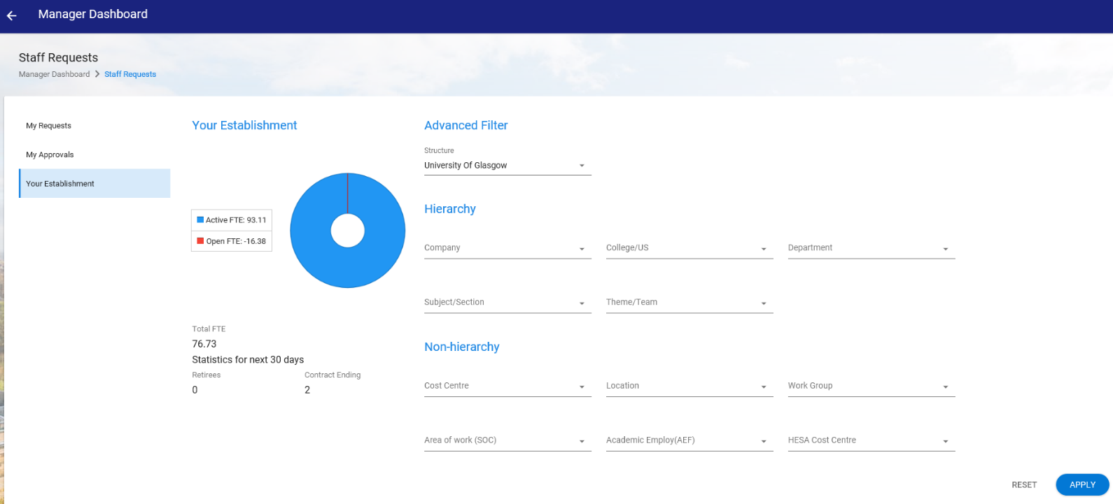
There will also be a list of posts you have access to, and you will be able to view their grade and title. If you have a large amount of access you may wish to filter these results by Post Title using the dropdown menu.
Once you have identified the post you wish to use, press the button and select “Create Request from Post”. A new window will appear allowing you to fill in your request using the drop-down menu’s and free text fields. To navigate from section to section please use the roadmap down the left side of the screen or alternatively by using the “Next” button.
Position Screen
College/US Ref ID
This field can be used to record your local reference number, this would allow the staff request ID to be matched against local records throughout the vacancy process.
Contract Details
Please be realistic with your Planned Start Date; consider the length of time required for the approval process, the length of time the post will be advertised for and the successful candidates potential notice period. The start date will impact on your salary forecast, the more accurate your date is the more accurate your forecast will be.
Job Details
Please do not amend the “Post Title” drop down. The title in this field is the generic/umbrella title and should remain as it is. To input a more specific Job Title please enter the information into the Job Title box.
On this page there is a new question that asks whether the Job Description has been amended. Your response to this question will decide whether the vacancy goes to Human Resources for grading as part of the approval process.
Vacancy Details
The Vacancy Details screen now contains a field where you can fill in text that will be used for the advert.
Documents
The document screen is available for uploads should you have any. Common items uploaded may be email communication or successful grant application letters.

Cost Allocations
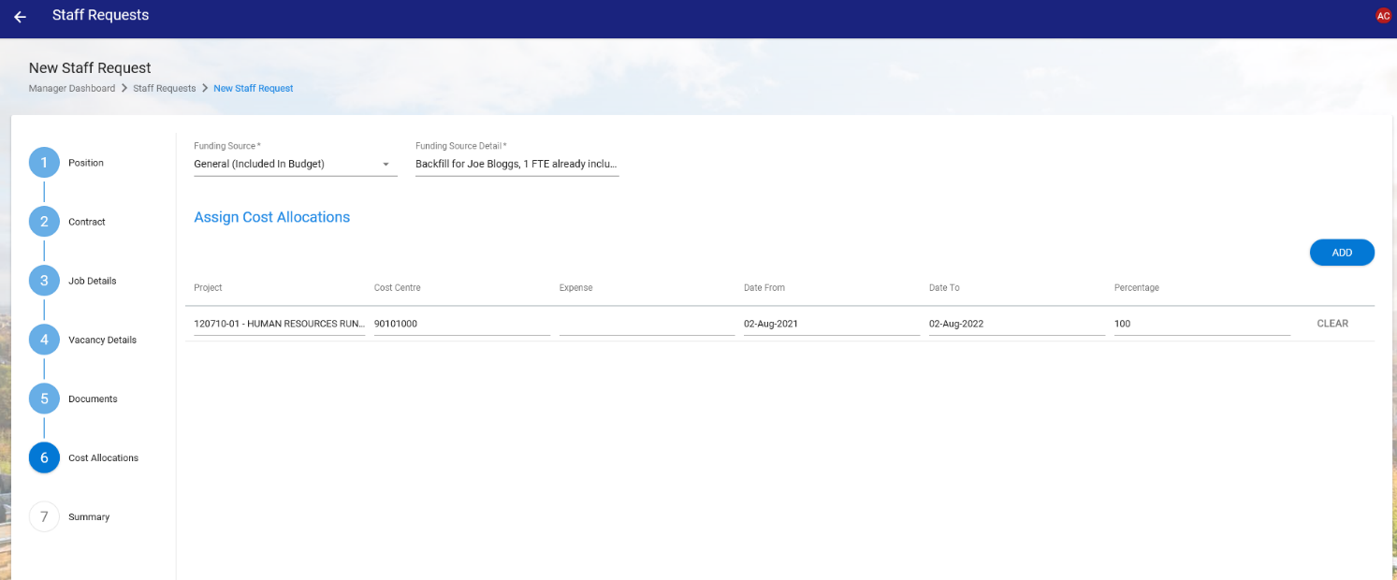
The dates associated with your cost allocations should normally cover the period of the post. Within the cost allocations screens you can enter multiple lines of funding data. Click ‘Add’ to add a new line.

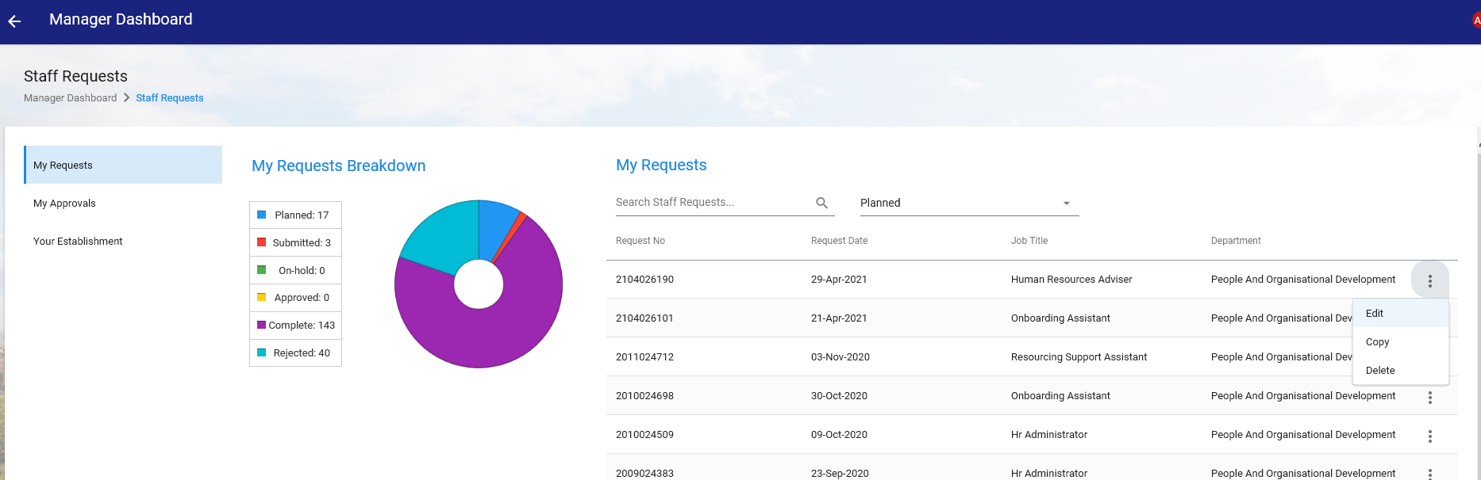
Once you have entered all the data you can press save within the summary page and this will save your staff request. Saved requests can be accessed and edited by clicking ‘My Requests’ from the left sidebar menu, selecting ‘Planned’ from the status dropdown, and then clicking the ellipsis button and choosing ‘Edit’.

If you have completed all of the mandatory fields, you will then be given the option to Submit your staff request. You can choose to submit now, or you can return to your saved staff request and submit at another time.

