Prospective Nursing Student Health Assessment
CONFIDENTIAL

Please read these instructions carefully:

Now that you have been offered a place at the University of Glasgow, we need to know about any impairments or health conditions which could affect you in your training so that, where appropriate, we can advise the Nursing and Healthcare School of any support needs you may require and how these can be provided.

We also need to ask about conditions which could pose a risk to patients so that we can assess these and consider how any risk can be avoided, whilst assisting you to successfully complete your course. Most health problems and impairments, even if substantial, should not impede you from being accepted for training but the Nursing and Healthcare School has to ensure that you are capable, with support if needed, of acquiring the core clinical skills and competences to qualify and that you are able to work safely with patients.

The University of Glasgow is committed to providing equality of opportunity for students with impairments and health conditions to complete their studies. Appropriate support can be provided for almost all circumstances, even if the effects of impairment or ill-health are substantial. However, because of a requirement to ensure patients are not harmed through involvement in nursing training, if you have a condition which would make it impossible for you to complete training, even with adjustments and support, then you cannot be accepted onto the undergraduate Nursing course. In this circumstance, the University of Glasgow will endeavour to offer you a place on an alternative course.

You should not assume that your impairment or health condition will prevent you taking up a place and we would be pleased to discuss with you at the earliest opportunity any concerns you may have.

As a potential future nurse, you have a duty to provide relevant information to the Nursing and Healthcare School’s Occupational Health advisers. Failure to disclose information about a physical or mental health problem that could affect patient safety would be a breach of this duty and could result in disciplinary action. All medical and sensitive personal information you provide will be held in confidence by the University of
Glasgow’s Occupational Health Unit. The Nursing and Healthcare School will only be informed of the effects of a health problem or impairment, if relevant to your educational needs or patient safety, and of recommendations on support or adjustments that could be of assistance to you.

- Please answer each of the following questions, providing brief detail on any questions answered ‘yes’. If additional space is required, please continue on a separate sheet of paper.

- You should then complete and sign the declaration in Section 4 and then you must submit the questionnaire to the Occupational Health Unit

- Once you have completed all sections, you should then send the form to the University of Glasgow’s Occupational Health Unit at the address below. Keep a copy of your form for reference. Please also ensure there is sufficient postage on your envelope as we do not collect items with insufficient postage from the Post Office

If you declare any impairment or health condition which may require adjustment to the course programme, or affect fitness for work with patients, an Occupational Health Adviser will contact you to assist you further within the next few weeks.

Data Protection Information
If you join the University of Glasgow this questionnaire will form the basis of your Occupational Health (OH) record. If you do not join, your questionnaire will be destroyed.
- Records are held in confidence by the University’s Occupational Health Unit, in line with the GMC’s guidance on Confidentiality.
- You may obtain access to your OH record by contacting the Occupational Health Unit.
- If you do require further information, contact the Occupational Health Unit at 63 Oakfield Avenue, Glasgow G12 8LP or by telephone +44 (0) 141 330 7171; or via ohu@admin.gla.ac.uk

SECTION 1 – Personal Information

Given Name
Family Name

 | Male/Female |  | Title: (Mr, Ms, Mrs etc)
Date of Birth
Your Contact address: |  | Your GP’s Name

Doctor’s
Address

Post Code:

Home Phone: GP Phone:

Mobile Phone:

Your email address: Overtype your email address here, or write CLEARLY in the boxes below

SECTION 2 - YOUR HEALTH & FUNCTION CAPABILITIES

1 Do you have problems with any of the following? Yes No

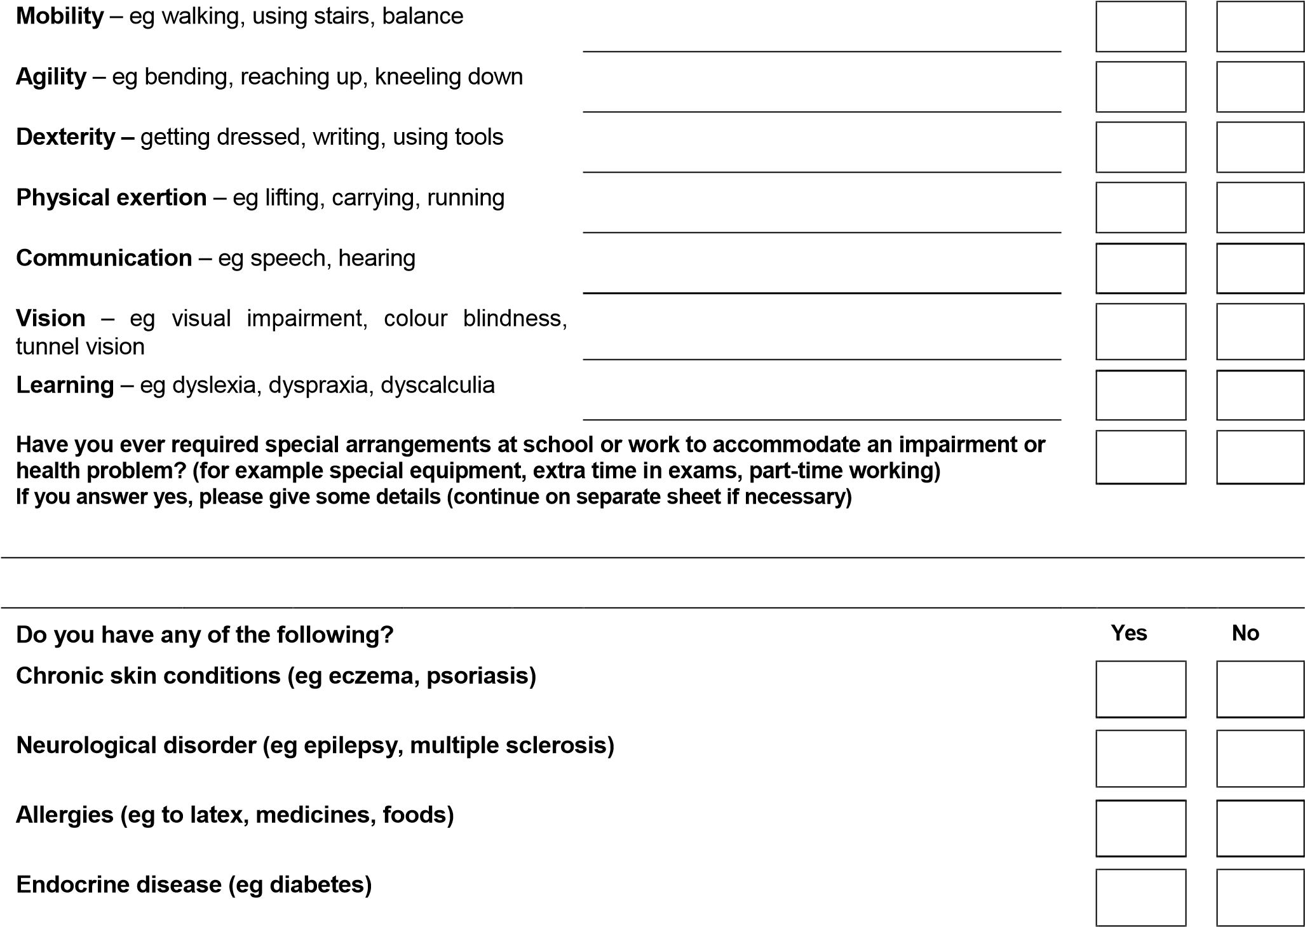

2

3

If you answer yes to any of the above, please give details (eg. When condition developed, severity, effects, treatment) – continue on a separate sheet if necessary)

Continued

Have you ever been affected by: Yes No
Sudden loss of consciousness? (eg fit or seizure)

Chronic fatigue syndrome? (or similar condition)

Mental health problems? (eg anxiety, depression, phobias, OCD, nervous breakdown, personality disorder, over-dose or self-harm, drug or alcohol dependency)

An eating disorder? (eg bulimia, anorexia nervosa, compulsive eating)

An illness requiring more than two weeks’ absence from school or work? (within the last 3 years)

If you answered YES to any of the questions above, then please give details here (continue on separate sheet if necessary)

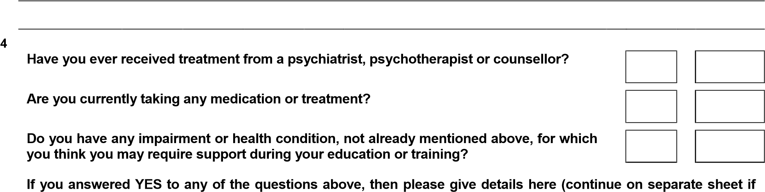
necessary)

5 Have you ever had chickenpox or shingles? Is so, please give date(s)

6 Tuberculosis

Have you ever been vaccinated against Tuberculosis? (BCG Vaccine) If so please give date

Yes/No* | *Please delete as appropriate If yes, please confirm date

If your answer to question no 6 is NO, please answer question 6A, by following this link for the most recent incidence of prevalence from the World Health Organisation:

https://www.tbfacts.org/tb-statistics/

Yes No
- Were you born in or have you ever lived, for more than 3 months, in a country where
Yes

No

TB prevalence is high

- Have your parents or grandparents ever immigrated from one of these countries, at any time?

SECTION 3 – Immunisation Record Vaccinations

You must complete this list of immunisations. This information may be available from your childhood vaccination book, school records, parents and GP.

Please Give Dates | Not had

DTP Combined vaccine (Diphtheria, Tetanus and Poliomyelitis)

1st |  | 2nd
Measles, Mumps & Rubella (MMR)

Meningitis ACWY

Varicella (chicken pox)

No
Have you started a Hepatitis B course? Yes

If YES, then please give dates | First

Second

Third

Booster (if needed)

Hepatitis B Antibody titre level at end of programme  (if known) – NB this test must have been carried out  by an approved UK Lab (provide proof). | iu/l

SECTION 4 - CONSENT FOR REPORT AND DECLARATION

If you have a significant health problem or impairment, we may need to obtain further details from your doctor to help us assess and advise the dental school on your fitness or support needs.
Your consent is required for this.

Under the Access to Medical Reports Act 1988 you have the right to:-

- See a report before it is sent.

- Ask for changes to be made to the report, if you think it is incorrect or misleading. Your doctor should be willing to discuss any changes with you but is not obliged to agree to them. If you cannot reach agreement with your doctor on changes you can:
  - Add a statement of your own to the report
or
  - Refuse to allow the report to be sent.

- See the report up to six months after it has been supplied. This would be arranged with the doctor providing the report.

If you do wish to see a report, we will let you know when we write to your doctor. You then have up to 21 days to arrange with him/her to see it. It will not be sent to you automatically. If you do not complete arrangements within 21 days then your doctor will assume that you have changed your mind and will send the report to the Occupational Health Unit at the University of Glasgow

Your doctor does not have to show you any part of the report if he or she thinks that it contains information that may seriously harm your physical or mental health, or where the identity of a person who has supplied information about you in confidence could be revealed. In these circumstances, your doctor should tell you that this is the case.

Prospective Student should tick the relevant boxes and sign below

The information I have provided on my health and capabilities is correct to the best of my knowledge and belief.
I agree to University of Glasgow Occupational Health Service obtaining a report from my doctor if required and (choose one of the options below).

I do not want to see the report before it is sent.
I do want to see the report before it is sent.
I would like to receive a copy of the report, but do not require to see it before it is sent to the University Occupational Health Service.
I accept the conditions under which my personal data will be processed.

Signed: ___________________________ Date: _________________________________

Confidential

CONSENT TO BEING TESTED FOR BLOOD-BORNE VIRUSES - NURSES
Hepatitis B, Hepatitis C and HIV are chronic viral infections that can be transmitted to patients if the patient is accidentally exposed to an infected health care worker’s blood during surgery or other exposure prone procedure (EPP).
To prevent any risk to patients and comply with NHS safety policies, dental students must be tested for signs of these infections before joining the course.
Your consent is required before you can be tested
If you are found to be infected, you may be unable to join the course.
If you do not agree to being tested, you cannot join the course.
Further information on these infections, how they are transmitted and the tests is attached to this form. You should read this, decide whether you want to have a test, and then tick the relevant boxes below.
If you need more information before you decide you can talk, in complete confidence, with an OH Adviser when you attend the screening day.
If you know, or think, that you may have been at risk of infection, then you should inform the OH Adviser before having a test.
If you are assessed as high risk for Tuberculosis we will carry out an additional blood test for Tuberculosis but this is only required in a very small number of cases.
Name |  |  |  |  | Date of Birth
 |  |  |  |  |  |  |  |  | Yes |  | No
I consent to have blood taken for Hepatitis B screening
I consent to have blood taken for Hepatitis C screening
I consent to have blood taken for HIV screening
I consent to have blood taken for Tuberculosis Screening

I consent to have blood taken for Varicella Screening
(if I have no history of having Varicella (chickenpox)* and Tuberculosis if indicated)
Signature |  |  |  | Date

*This may sound like a lot of blood but normally it is just one small tube full, so please don’t worry.
All medical and sensitive personal information provided on this form will be held IN CONFIDENCE by the University’s Occupational Health Unit and will not be released to others without your express, informed consent.
This Consent Form and your fully completed Health Questionnaire, MUST BE RETURNED to Occupational Health, University of Glasgow, 63 Oakfield Avenue, Glasgow, G12 8LP, as soon as you have completed it. Delays in completion may jeopardise starting your course.
Background: the need to get tested
Hepatitis B, Hepatitis C and HIV are chronic viral infections where the virus is usually present in the bloodstream.
There are some circumstances, unique to health care, and very relevant to Nursing, in which the infection can be transmitted from a health care worker to a patient. If an infected health care worker cut or injured him/herself whilst carrying out types of treatment classified as exposure-prone procedures (EPPs), which includes many dental procedures, their blood can get into the patient’s body and cause infection.
All three infections are often ‘silent’ illnesses in their early stages: a person may show no signs of illness and be unaware they are infected.
To avoid any risk to patients, anyone who will be involved in performing EPPs, on patients, now has to be tested for signs of infection before they can begin such work. All nursing students are involved in EPPs from early on in the course and therefore testing is compulsory.
Anyone who declines to be tested will not be allowed to enter the Bachelor of Nursing course.
- The infections

HIV (Human Immunodeficiency Virus) is a chronic infection which, over a period of years, progressively damages a person’s immune system, eventually causing AIDS. Treatments are now available that can halt or slow down progression of the illness although they cannot fully eradicate the infection.
Hepatitis B and Hepatitis C both cause chronic infection of the liver. Over time, this can lead to cirrhosis and death from liver failure or cancer. A vaccine is available to protect against Hepatitis B. There is no vaccine yet for Hepatitis C. Treatments can eradicate chronic infection in about 50% of cases.
As infection with these viruses usually causes no immediate illness, a person may be unaware that he / she is infected. These infections are uncommon in the UK. The general HIV prevalence in the UK is around 0.1%. Hepatitis C prevalence is approximately 0.4%. Hepatitis B prevalence is approximately 0.1%. Infection rates are higher in some behavioural risk groups or people originating from areas of the world where infection rates in the general population are high e.g. in Africa and some SE Asian countries.
- Risk factors for infection with blood-borne viruses

You may have been at risk of infection if:
- You have ever injected drugs using equipment shared with someone else
- You have been accidentally exposed to blood of a person infected with one of these viruses
- You have had unprotected penetrative sex (i.e. without using a condom)
- You have had a tattoo or body piercing in places with inadequate procedures for sterilising the equipment if re-used
- Your mother was infected with one of these viruses at the time of your birth

or if you have had any of the following medical treatments:

- A blood transfusion at a time before testing of donated blood was introduced (in the UK, this is before 1980 for Hepatitis B, 1985 for HIV, 1991 for Hepatitis C)
- Medical or dental treatment in countries where equipment may not be sterilised properly between uses

In the UK, the most common risk factor for Hepatitis C infection is sharing of injection equipment for street drugs. HIV infection is most commonly transmitted through unprotected sex. Hepatitis B is mainly transmitted through unprotected sex or IV drug use in the UK. In countries with a high prevalence, transmission from the mother at birth is the most common means of transmission for Hepatitis B.

- Benefits of having a test

- If negative, you will be allowed to take part in surgery/other EPPs.
- If you have been worrying about possibly being infected, a test can give you certainty. If negative, it can provide you with peace of mind. If positive, you can start to take control of your problem.
- You will not need to be re-tested when you begin work as a qualified nurse.
- You’ll be able to plan your career. If you are negative, the whole range of medical careers will be open to you. If positive for one of the viruses, then you’ll be unable to follow a surgical career unless you have treatment to successfully eradicate the infection but can plan for a career in one of the many non-surgical specialities. Currently, eradicative treatment is only possible for Hepatitis B & C.
- Early diagnosis is of proven benefit. For Hepatitis C, it is easier to cure the infection in the earlier stages. For HIV, once diagnosed, a person can be monitored and anti-viral treatment started before irreversible damage to the immune system occurs.
- If you are infected, you can take steps to limit the risk of transmission to others, including sexual partners.

  - Disadvantages of being tested
There are some potential disadvantages to being tested, which you should be aware of:
- Discovering that you are infected with one of these viruses is stressful. It may cause disabling anxiety in some individuals.
- If you find out that you are infected you may have difficulty obtaining life insurance.
NB Insurance companies do not refuse cover or charge more for insurance simply because a person has had a test for HIV or Hepatitis.
- Some countries will not grant visas to foreign nationals infected with HIV.
- You may encounter prejudicial behaviour from others if they discovered you were infected.

  - Confidentiality
Your test result, and any personal information you provide to an OH adviser in connection with your test, is held in confidence by the University OH Unit. The Nursing School will be informed only of whether or not you have been health-cleared. If you tested positive for any of the infections, the school would be advised only that you were not cleared for involvement in surgery/other EPP.
- What if you don’t have a test?
You will not be able to join the course.
- How to get tested

- You will be offered a test when you attend the University Occupational Health Screening before the nursing course commences. If you think that you may be infected, then tell the OH nurse. She will then arrange for you to see the Occupational Physician for a more detailed discussion if necessary, before you are tested.
- You should also let the OH nurse know if you think you may have been at risk of infection in the past 3 months. The antibodies detected by the tests do not appear until some weeks after infection, so a test carried out in the first 3 months after an exposure may not be reliable. We will arrange to test you later in the term.

- What if I may be at risk of infection after starting the course?
As a nursing student, if you think you may have been exposed to a serious infection such as HIV or Hepatitis, you have an ethical duty to seek professional advice and a test, if so advised. If you tested positive then this could jeopardise your place in the Nursing School.
More information
You can get general details about the infections and screening tests for them from the web sites listed below. If you have any outstanding questions or concerns, you can talk these through with an OH Adviser when attending the OH screening, before giving your consent.

Information on Tuberculosis: https://www.thetruthabouttb.org/
Information on Hepatitis C: www.hepcuk.info
Information on Hepatitis B: http://www.nhs.uk/conditions/Hepatitis-B/Pages/Introduction.aspx
Information on HIV & HIV tests: www.tht.org.uk/informationresources
The specific page on HIV testing is: www.tht.org.uk/informationresources/hivandaids/testingforhiv/
Page 8 of 8

