 |  |  |  | REQUEST TO LEAVE UNATTENDED OPERATING EQUIPMENT
Name of Researcher |  |  |  |  |  | Contact Telephone
Name of Supervisor |  |  |  |  |  | Contact Telephone
In the event of an emergency it is safe to switch off?
Electricity Supply |  |  |  |  | Water Supply
Heating Equipment |  |  |  |  | Compressed Gas
Actions to take in the event of a leak or spillage?
Any other special instructions?
Substance(s) Involved and Reaction Scheme |  |  |  |  |  |  |  | (tick all hazards that apply)
 |  |  |  |  |  |  |  | 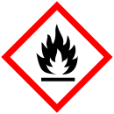  Flammable |  |  |  | 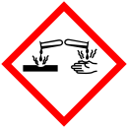  Corrosive
 |  |  |  |  |  |  |  | 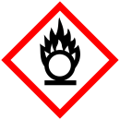  Oxidiser |  |  |  | 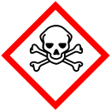  Toxic
 |  |  |  |  |  |  |  | Explosive |  |  |  | Compressed Gas
 |  |  |  |  |  |  |  | Biohazard |  |  |  | 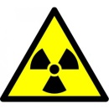  Radiation
Special Hazards:

CoSHH Assessment Reference
Location of Experiment
Signature
Experiment Start Date |  |  |  |  |  |  | Experiment End Date

