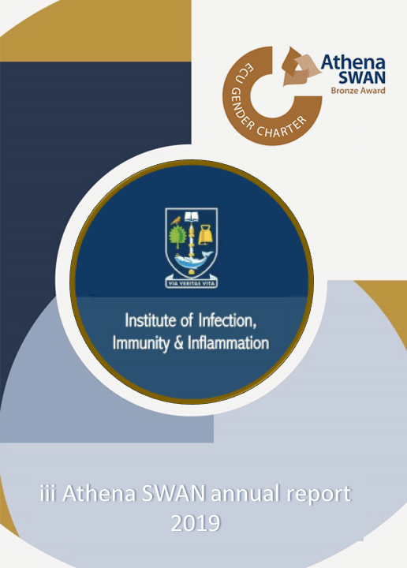

iii Athena SWAN Annual report 2019

It has been almost three years since we submitted our successful Athena SWAN bronze award, and the iii’s Athena SWAN self-assessment team (SAT) are now working hard on the Silver application to be submitted in November. Since the bronze application, we have been focussing on three main aims:

- Create a supportive and inclusive Institute culture
- Increase female promotion and recruitment at senior levels
- Improve career development for all

We believe we are making progress on each of these aims. However, there are still many areas that we can work on together to improve the Institute environment for all. Evidence for improvement and areas that still require attention have been highlighted by our recent survey. We are working hard to put all the data from the survey together and to compare this to the 2016 survey. Below are some important highlights that summaries some of our key findings.

Creating a supportive and inclusive institute culture
We have seen a major increase in positive responses in the survey to questions about the Institute culture. In the 2016 survey, only 49 per cent of female respondents agreed that the Institute’s working environment is supportive to all genders. This has increased to 78 per cent in 2019, while male respondents have remained steady in agreement at 80 per cent. This data suggests that the changes we have seen in the Institute over the last three years have had a particularly positive effect on female Institute members.

Some of these changes are likely to include greater adherence to the core hour policy with an increase in both female and male respondents agreeing that meetings are planned between 10am and 4pm. In 2016, 56 per cent of female respondents and 66 per cent of males agreed with this statement, while in 2019 this has increased to 77 per cent and 79 per cent, respectively.

The increase in females agreeing that the Institute culture is inclusive could also be a result of improved communication from management: in 2016, 44 per cent of female respondents agreed with this statement; this has increased to 55 per cent in 2019, bringing this in line with male respondents (57 per cent in 2016 and 58 per cent in 2019). While this is a clear improvement, there is still work to be done to improve communication. This will form part of the Silver application’s action plan. Similarly, we have seen an increase in the percentages of both females and males who agree that there is fair representation of males/females on iii’s committees. This has increased from 29 per cent of female respondents to 59 per cent, and 57 per cent to 71 per cent for male respondents.

Increase female promotion & recruitment at senior level
It is clear to all that there is a predominance of males in senior positions within research and teaching in iii. We are, however, making progress in increasing the number of women in senior positions. In 2016, there were four Grade 9 females while in 2019 this has increased to seven. This has been a result of both recruitment and promotion, and we believe the improvements in Institute culture will help us to recruit and promote more senior females in the future.

Reasons for these changes may include that, at research fellow/lecturer career stages, females feel encouraged to develop their careers - 83 per cent agreed with this statement - and that many, 67 per cent, benefit from advice from formal and/or informal mentors.

Improve career development for all

We are all aware that the career ladder in science is not straightforward and that progression requires demonstrable success, usually in the form of competitively won grants and papers. Through the Network for Early Career Researcher Development (NERD) programme, iii postdocs have the opportunity to gain valuable advice and training on grant and CV writing. NERD have also hosted talks from scientists who have successfully pursued non-academic careers and provide a forum for postdocs from across the college to form supportive networks. The fantastic job NERD does was recognised in June through a University of Glasgow Research Culture Award, accepted by Lilach Sheiner on behalf of the NERD team.

Performance and Development Review (PDR) is an important opportunity for discussions with line managers about training opportunities and career development more generally. The checklist system introduced in 2017 was used more extensively in the last round of PDR, increasing from 42 per cent to 57 per cent returned from 2017 to 2018. By comparing the 2016 and 2019 iii’s surveys, we can see a clear increase in the percentage of respondents who agree that PDR is useful for career progression: in 2016 20 per cent of female and 29 per cent of male respondents agreed with this statement; this increased to 50 per cent and 40 per cent, respectively, in 2019.

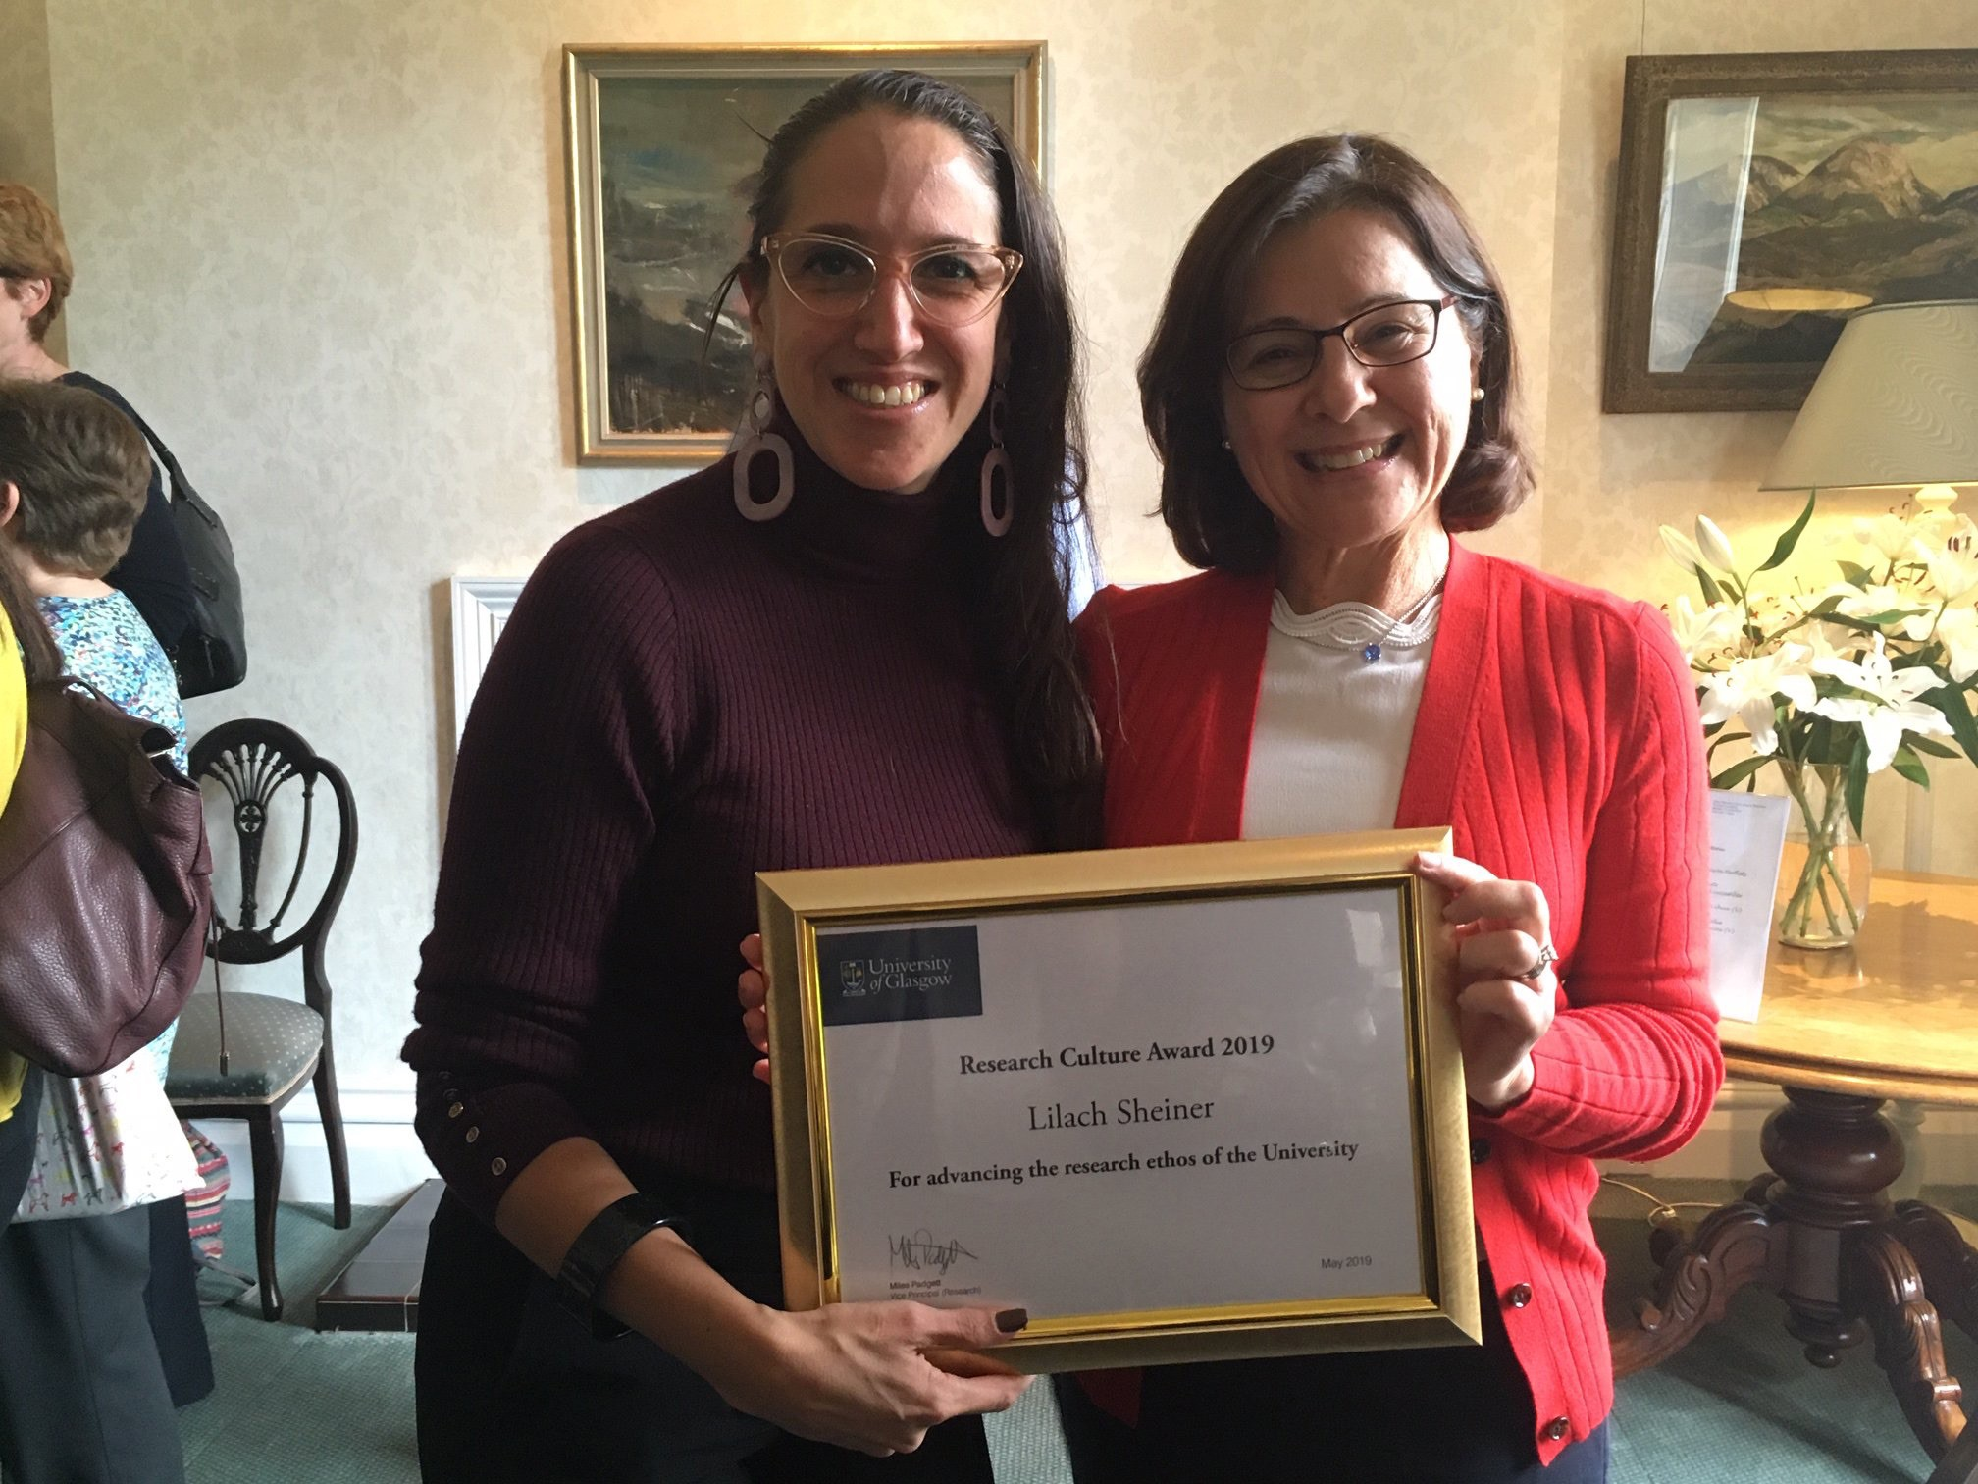
Lilach Sheiner (left) collects the NERD Research Culture Award, May 2019. Pictured with Rhian Touyz

The SAT also co-ordinate two additional schemes that aim to provide support for career development for research and teaching staff. The iii’s Athena SWAN mentorship scheme contains 36 matched pairs and feedback is broadly positive. We recognise that the mentorship scheme is most helpful for postdoctoral staff and that more senior staff could benefit from more structured support as they plan grant and paper writing. Currently, we are running a ‘career mapping scheme’ with eight Grade 8 or 9 staff and will review the success of this scheme in 2020.
Inclusion of support and technical staff

Athena SWAN awards now take into account all staff within the Institute, regardless of their job family. To provide baseline information on our support staff’s views on Athena SWAN-related subjects, we conducted a survey in 2018. Overall, the responses were positive and there was no clear gender bias. The results from this survey broadly reflect those of the 2019 Institute survey, and these will help shape various actions in the Silver application.

Institute Athena SWAN events

Finally, we continue to deliver workshops and events to provide information, support and encouragement for all. Workshops that have taken place this year include those on PDR, promotion and regrading for support staff. We also had a wonderful time at the Christmas Bench & Bairns party, and many of you joined us to celebrate inspirational females on International Women’s Day.
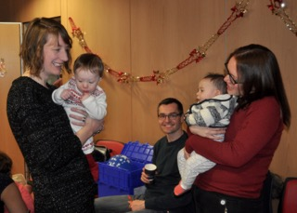
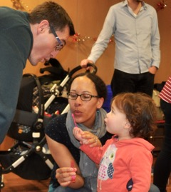
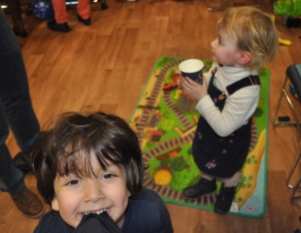
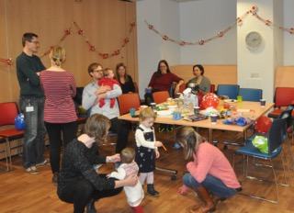
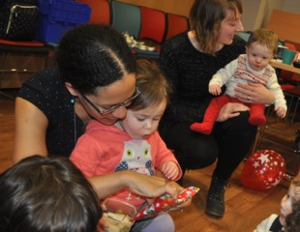
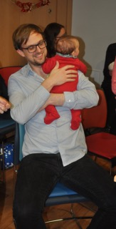
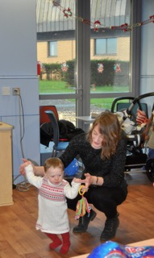
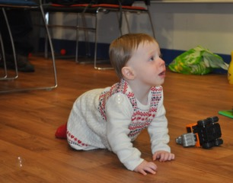
Fun for all at the Christmas Bench & Bairns party

