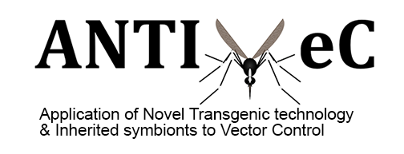

ANTI-VeC International Conference Bursaries

Mosquito Sensory Biology Symposium

6-8 September 2019

University College London, UK

Application Form

Please complete each section and send the completed application as a PDF file to:
anti-vec-network@glasgow.ac.uk by 2nd August 2019

1. Applicant Details
Name
Position
Highest Qualification
Year Awarded
Current Department & Research Organisation
Country of Residence
* Applicants must be based for work in UK or DAC-list countries
Address
Email
Telephone Number
Please confirm you are an ANTI-VeC Network Member | Yes/No*  *please delete as appropriate

2. Abstract Submission

Have you submitted an abstract for a poster presentation to the organising committee at University College London?

Yes No

Title of abstract

Abstract text

3. Supporting Statement
Please describe how attending this conference will contribute to your personal development in ANTI-VeC associated research
(maximum 200 words)

4. ANTI-VeC Funding
Please detail any funding you have received to date from the ANTI-VeC Network (maximum 200 words)

5.1 Conference attendance costs
Please itemise the total cost of your conference attendance.

Please also include details of additional funding secured (if any) to support your attendance at the conference.

Total amount requested must not exceed £2,500.
Item | Amount (GBP)
Conference Registration Fees | £
Travel (e.g. flight, train, other transport) | £
Accommodation | £
Subsistence (meals) | £
Visa Cost | £
Other (e.g. travel insurance, vaccinations): | £
TOTAL AMOUNT REQUESTED | £
Additional funding secured (if applicable) | Please provide details

5.2 Justification of Resources
Please provide a detailed breakdown of the costs you have requested in section 5.1 (maximum 200 words)

6. Required additional documents – please include the following with your application:
- Abstract submission confirmation

- Letter of Support from your PhD Supervisor / Research Group Leader

8. Signature – please sign and date this form before submission
Signature:

Date:

For any queries about the application process please email anti-vec-network@glasgow.ac.uk

