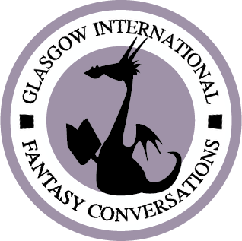

Speakers 2019

Brian Attebery: Timor Mortis Conturbat Me: Fantasy and Fear
What is the difference between fear and horror? They reside in different genres, for one thing. Fantasy can toy with horror but it more frequently invokes fear—fear of the unknown, fear of death, fear of the other. Unlike horror fiction, fantasy offers ways of incorporating and managing fear so that it doesn’t become, as it has too often become in the political world, an excuse for inaction or suppression or violence.
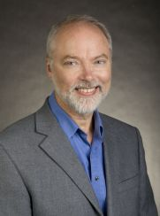Brian Attebery
Fantasy tends toward what J.R.R. Tolkien called eucatastrophe, the “sudden and miraculous grace” that takes us from despair to joy. This talk will explore some of the ways fantasy teaches us to handle great fear, with examples ranging from the folktale about “The Boy Who Went Forth to Learn Fear” to Ursula K. Le Guin’s Earthsea stories. If we can remember the lessons from within what Diana Wynne Jones called the mythosphere, we might not be so vulnerable to fear-mongering as a strategy for control in the outside world.
Brian Attebery is professor of English at Idaho State University and the editor of Journal of the Fantastic in the Arts. He edited The Norton Book of Science Fiction (1997) with Ursula K. Le Guin and Karen Joy Fowler and is the author of Stories About Stories: Fantasy and the Remaking of Myth (2014), Decoding Gender in Science Fiction (2002) and Strategies of Fantasy (1992).
You can read more about Professor Attebery on his university webpage.

Mel Gibson: ‘For the love of Mary Anning, a pack of dinosaurs?!’ The Mythosphere, STEM subjects, agentic girlhood and comics
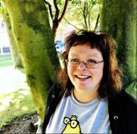Mel Gibson
Comics are a famously intertextual medium, often drawing on other comics, but also tapping into the Mythosphere in the broadest sense. Approaching the Fantastic through two comparatively recent comics, Lumberjanes and Ms Marvel, both known for their girl-friendliness and diverse representations, I will discuss the heady mixture of ‘beliefs, legends, myths and hopes’ that inform the titles.
The former begins with the Lumberjanes engaging with re-envisioned versions of Apollo and Artemis, and a range of supernatural creatures feature throughout the series. Simultaneously, the stories draw on tropes from adventure narratives, for instance solving puzzles and exploring secret caves. Interwoven with both, however, is a depiction of agentic girls interested in STEM subjects. Indeed, the quotation in the title, when two of the Lumberjanes are running through a fantastical land where dinosaurs roam, is immediately linked back with science and female pioneers.
Ms Marvel, in contrast, draws on the Marvel Universe through the appearance of various superheroes, as well as characters like Loki, who also appear in other parts of the Mythosphere. Here too, there is a combination of magic and science, with several of the central girl characters committed to working in those fields. In addition, that Ms Marvel herself is a writer of fan fiction means that she, like the readers, is very much both producer and product, linking real reader and fictional character through shared practices.
Both comics, I argue, epitomise the way that fantasy ‘delights in breaking down borders and defying expectations’ in combining science, fantasy, agentic girlhood and intersectionality in distinctive ways.
Dr Mel Gibson is an Associate Professor in Childhood Studies at Northumbria University. Her research on comics is usually about historical and contemporary titles for girls and women. She is also interested in how people use comics in their lives. She has additionally written about fantasy fictions, both novels and picturebooks.
You can find more information about Dr Gibson on her university webpage.

Kirsty Logan: Twice Upon a Time: the Lure of Retelling
Myth and fairytale retelling are more popular than ever, and provide unique opportunities for writers to subvert, rework and stand on giants’ shoulders to shine their spotlight further into the unknown. I intend a personal exploration of why writers and readers love retellings – why do we never tire of (as Angela Carter put it) new wine in old bottles?
What narrative gaps are there for writers to explore? How can we be conscious of a story’s existing meaning, and – allowing that to do some of the narrative work – subvert expectations?
By using specific examples from my published work, I will explore the appeal for writers (and readers) of retelling and reworking existing stories.
Kirsty Logan
Kirsty Logan is a professional daydreamer. Her first story collection, The Rental Heart & Other Fairytales, won the Scott Prize, the Polari First Book Prize, and the Saboteur Award. Her first novel, The Gracekeepers, won a Lambda Literary Award and was selected for the Radio 2 Book Club and the Waterstones Book Club. Her third book, A Portable Shelter, won the Gavin Wallace Fellowship and was published as a limited edition illustrated hardback which sold most of its print run on pre-order. Things We Say in the Dark, a collection of feminist horror stories, is forthcoming. Her short fiction and poetry has been translated into Japanese and Spanish, adapted for stage, recorded for radio and podcasts, exhibited in galleries, and distributed from a vintage Wurlitzer cigarette machine.
Kirsty has performed her work at festivals and events all over the world, including Belgium, Denmark, Finland, Germany, Iceland, Ireland, Malaysia, Spain, and all over the UK. As well as writing fiction, Kirsty also reviews books and works as a writing mentor for the WoMentoring Project. She is currently working on her sixth book, a series of film projects, and a musical collaboration. She lives in Glasgow.
For more on Kirsty’s works, including upcoming Horror collection ‘Things We Say in the Dark’, please head to www.kirstylogan.com.

